Table of Contents
UNITED STATES
SECURITIES AND EXCHANGE COMMISSION
WASHINGTON, DC 20549
_________________________________________________________________________
FORM 10-Q
_________________________________________________________________________

x |  |  | QUARTERLY REPORT PURSUANT TO SECTION 13 OR 15(d) OF THE SECURITIES EXCHANGE ACT OF 1934
For the quarterly period ended June 30, 2026
OR
o |  |  | TRANSITION REPORT PURSUANT TO SECTION 13 OR 15(d) OF THE SECURITIES EXCHANGE ACT OF 1934
For the transition period from ___________ to ___________
Commission File Number: 001-42144
_________________________________________________________________________
WEBTOON Entertainment Inc.
(Exact Name of Registrant as Specified in its Charter)
_________________________________________________________________________
Delaware |  |  | 81-3830533
(State or other jurisdiction of  incorporation or organization) |  |  | (I.R.S. Employer  Identification No.)
222 N. Pacific Coast Highway  Suite 2300  El Segundo, CA |  |  | 90245  (Zip Code)
(Address of principal executive offices)
Registrant’s telephone number, including area code: (323) 424-3795
_________________________________________________________________________
Securities registered pursuant to Section 12(b) of the Act:
Title of each class |  |  |  |  |  | Trading  Symbol(s) |  |  |  |  |  | Name of each exchange  on which registered
Common stock, par value $0.0001 per share |  |  |  |  |  | WBTN |  |  |  |  |  | Nasdaq Global Select Market
_________________________________________________________________________
Indicate by check mark whether the registrant (1) has filed all reports required to be filed by Section 13 or 15(d) of the Securities Exchange Act of 1934 during the preceding 12 months (or for such shorter period that the registrant was required to file such reports), and (2) has been subject to such filing requirements for the past 90 days. Yes x No o
Indicate by check mark whether the registrant has submitted electronically every Interactive Data File required to be submitted pursuant to Rule 405 of Regulation S-T (§232.405 of this chapter) during the preceding 12 months (or for such shorter period that the registrant was required to submit such files). Yes x No o
Indicate by check mark whether the registrant is a large accelerated filer, an accelerated filer, a non-accelerated filer, smaller reporting company, or an emerging growth company. See the definitions of “large accelerated filer,” “accelerated filer,” “smaller reporting company,” and “emerging growth company” in Rule 12b-2 of the Exchange Act.
Large accelerated filer |  |  | o |  |  |  |  |  | Accelerated filer |  |  | x
Non-accelerated filer |  |  | o |  |  |  |  |  | Smaller reporting company |  |  | o
 |  |  |  |  |  |  |  |  | Emerging growth company |  |  | o
If an emerging growth company, indicate by check mark if the registrant has elected not to use the extended transition period for complying with any new or revised financial accounting standards provided pursuant to Section 13(a) of the Exchange Act. o
Indicate by check mark whether the registrant is a shell company (as defined in Rule 12b-2 of the Exchange Act). Yes o No x
As of July 31, 2026, the registrant had 135,711,070 shares of common stock, par value $0.0001 per share, outstanding.

Table of Contents
Table of Contents
 |  |  | Page
Glossary |  |  | ii
Cautionary Note Regarding Forward-Looking Statements |  |  | iii
PART I-FINANCIAL INFORMATION |  |  | 1
Item 1. Unaudited Financial Statements. |  |  | 1
Condensed Consolidated Balance Sheets |  |  | 1
Condensed Consolidated Statements of Operations and Comprehensive Loss |  |  | 3
Condensed Consolidated Statements of Stockholders’ Equity and Group Equity |  |  | 4
Condensed Consolidated Statements of Cash Flows |  |  | 5
Notes to the Condensed Consolidated Financial Statements |  |  | 7
Item 2. Management’s Discussion and Analysis of Financial Condition and Results of Operations. |  |  | 25
Item 3. Quantitative and Qualitative Disclosures About Market Risk. |  |  | 38
Item 4. Controls and Procedures. |  |  | 38
PART II-OTHER INFORMATION |  |  | 40
Item 1. Legal Proceedings. |  |  | 40
Item 1A. Risk Factors. |  |  | 41
Item 2. Unregistered Sales of Equity Securities and Use of Proceeds. |  |  | 41
Item 3. Defaults Upon Senior Securities. |  |  | 41
Item 4. Mine Safety Disclosures. |  |  | 41
Item 5. Other Information. |  |  | 41
Item 6. Exhibits. |  |  | 42
Signatures |  |  | 43

i
Table of Contents
GLOSSARY
As used in this Quarterly Report on Form 10-Q (this “Report”), unless stated otherwise or the context otherwise requires:
•“amateur creator(s)” means creators who do not currently monetize their content as Paid Content on our platform as they are subject to our standard terms and conditions without Paid Content revenue sharing provisions. Amateur creators may monetize through other methods, including advertising if they meet certain viewership and subscriber thresholds.
•“Coins” means our in-app currency, which our users can purchase, earn by completing certain advertisement-associated actions or receive during in-app promotional events.
•“creators” means individuals who upload content to our platform and whose content remains available on our platform. Total creators include both amateur and professional creators.
•“eBookJapan” means our eBook (including digital manga, which is manga in a digital format), web-comic and web-novel offering in Japan dedicated to professional creators.
•“episode” means a periodically uploaded chapter or installment of a web-comic or web-novel title.
•“Fast Pass” means a digital pass that provides users with early access to upcoming episodes for ongoing series of content on our platform, which must be purchased with Coins.
•“IP Adaptations” means adaptations of certain content on our offerings into other media formats such as film, streaming series, games and merchandise.
•“LINE MANGA” means our web-comic and digital manga offering in Japan dedicated to both amateur and professional creators.
•“manga” means a style of Japanese comic books and graphic novels typically presented in print format.
•“MAU” or “monthly active users” means users who visited our offerings at least once in the applicable calendar month, averaged over each month in the given period.
•“MPU” or “monthly paying users” means users who have paid to access Paid Content in the applicable calendar month, averaged over each month in the given period.
•“Munpia” means, as context requires, Munpia Inc., one of our wholly-owned subsidiaries in Korea, or Munpia, the namesake web-novel offering and web-novel creator community in Korea run by Munpia Inc.
•“NAVER” means NAVER Corporation, a global information communications technology (ICT) company and our parent, and its subsidiaries and affiliates, excluding WEBTOON, unless context otherwise requires.
•“NAVER SERIES” means our eBook, web-comic and web-novel offering in Korea dedicated to professional creators.
•“NAVER WEBTOON” means NAVER WEBTOON Ltd., one of our wholly-owned subsidiaries in Korea that operates our offerings including WEBTOON and WEBTOON Korea.
•“offering” means our mobile applications, websites or specific sections within such applications and websites where our creators post content, including WEBTOON, WEBTOON Korea, LINE MANGA, NAVER SERIES, eBookJapan, Munpia and Wattpad.
•“Paid Content” means content on our offerings that our users need to pay to access, including through the use of Coins.
•“Paid Content Average Revenue per Paying User” or “ARPPU” means the average Paid Content revenue in a given month divided by the number of monthly paying users for such month, averaged over each month in the given period.
•“Paying ratio” means, with respect to a given period, the ratio of MPU divided by MAU.
•“Paying user” means, with respect to a given period, a user who has paid to access Paid Content on our platform.
•“professional creator(s)” means creators who monetize through Paid Content on our platform under formal creator agreements with Paid Content revenue sharing provisions.
•“title” means a sequential web-comic or web-novel story that is comprised of episodes.
•“Title Purchase” means a digital pass that provides users with access to all episodes from a series that is no longer publishing new episodes.
•“Wattpad” means, as context requires, Wattpad Corp., one of our wholly-owned subsidiaries in Canada which was acquired by NAVER in May 2021 and subsequently acquired by us from NAVER in June 2023, or Wattpad, the namesake global web-novel offering with a global community of creators who are mostly amateur creators that is run by Wattpad Corp.
•“web-comics” means digitally created and serialized stories expressed through vertical, continuous and graphical content.
•“web-novels” means digitally created, serialized and text-based stories.
•“WEBTOON” means, as context requires, WEBTOON Entertainment Inc., a Delaware corporation, and its consolidated subsidiaries, or WEBTOON, the namesake global web-comic offering run by NAVER WEBTOON.
•“WEBTOON Korea” means the NAVER WEBTOON platform, our web-comic offering in Korea.

ii
Table of Contents
CAUTIONARY NOTE REGARDING FORWARD-LOOKING STATEMENTS
This Report contains forward-looking statements within the meaning of the safe harbor provisions of the U.S. Private Securities Litigation Reform Act of 1995. Forward-looking statements do not relate strictly to historical or current facts and reflect management’s assumptions, views, plans, objectives and projections about the future. Forward-looking statements may be identified by the use of words such as “anticipate,” “intend,” “plan,” “goal,” “seek,” “believe,” “project,” “estimate,” “expect,” “strategy,” “future,” “likely,” “may,” “should,” “will” and similar references to future periods. Examples of forward-looking statements include, among others, statements we make regarding:
•expected operating results, such as revenue growth and earnings;
•economic and industry trends;
•the demand for our platform in general;
•our ability to continue to attract and empower creators to create engaging content;
•our ability to grow and retain our user base and strengthen our brand;
•our ability to increase engagement with users and strengthen our community;
•our ability to attract and retain our senior management team or key personnel;
•our ability to continue to innovate and expand our advertising business;
•our ability to increase paying ratio and strengthen our monetization capability;
•our ability to increase revenues from our intellectual property operations;
•our beliefs about and objectives for future operation;
•future acquisitions or investments;
•our ability to continue to grow across our current markets and expand into new markets;
•our ability to continue to innovate and enhance our offerings;
•the impact of our product development initiatives, including our use of artificial intelligence;
•the functionality and economics of our platform on mobile operating systems;
•our ability to maintain the security and availability of our platform;
•our ability to obtain, maintain, protect and enhance our intellectual property;
•the increased expenses associated with being a public company;
•our business model and expectations and management of future growth, including expansion in international markets and expenditures associated with such growth; and
•our ability to compete with existing and new competitors in existing and new markets.
Because forward-looking statements are based on current beliefs, expectations and assumptions regarding future events, they are subject to risks, uncertainties and changes that are difficult to predict and many of which are outside of our control. You should realize that if underlying assumptions prove inaccurate, or known or unknown risks or uncertainties materialize, our actual results and financial condition could vary materially from expectations and projections expressed or implied in our forward-looking statements.
More information on factors that could cause our actual results and financial condition to differ from those expressed in forward-looking statements is included from time to time in our reports filed with the Securities and Exchange Commission (the “SEC”), including in our Annual Report on Form 10-K for the year ended December 31, 2025, filed with the SEC on March 5, 2026 (the “Annual Report”), particularly under Part I. Item 1A, “Risk Factors.” Investors should understand that it is not possible to predict or identify all such factors and should not consider the risks described above and under Part I. Item 1A. “Risk Factors” of our Annual Report to be a complete statement of all potential risks and uncertainties.
All forward-looking statements speak only as of the date of this Report and are expressly qualified in their entirety by the cautionary statements included in or incorporated by reference into this Report. Except as is required by law, we expressly disclaim any obligation to publicly release any revisions to forward-looking statements to reflect events after the date of this Report.

iii
Table of Contents
PART I-FINANCIAL INFORMATION

Item 1. Unaudited Financial Statements.

WEBTOON Entertainment Inc.
Condensed Consolidated Balance Sheets
(unaudited)
(in thousands of USD, except share and per share data)
 |  |  | As of
 |  |  | June 30,  2026 |  |  |  |  |  | December 31,  2025
Assets
Current assets:
Cash and cash equivalents |  |  | $ | 583,145 |  |  |  |  | $ | 581,806
Receivables1, net of allowance for credit losses of $1,917 and $3,378 at June 30, 2026, and December 31, 2025, respectively |  |  | 191,311 |  |  |  |  |  | 176,779
Prepaid expenses and other current assets, net2 |  |  | 72,473 |  |  |  |  |  | 72,647
Total current assets |  |  | 846,929 |  |  |  |  |  | 831,232
Property and equipment, net |  |  | 12,390 |  |  |  |  |  | 8,339
Operating lease right-of-use assets |  |  | 22,674 |  |  |  |  |  | 23,705
Debt and equity securities |  |  | 65,986 |  |  |  |  |  | 69,669
Intangible assets, net |  |  | 144,459 |  |  |  |  |  | 157,804
Goodwill, net |  |  | 328,462 |  |  |  |  |  | 336,825
Equity method investments |  |  | 75,859 |  |  |  |  |  | 80,440
Deferred tax assets |  |  | 24,641 |  |  |  |  |  | 22,302
Other non-current assets, net3 |  |  | 69,028 |  |  |  |  |  | 65,194
Total assets |  |  | $ | 1,590,428 |  |  |  |  | $ | 1,595,510
Liabilities and equity
Current liabilities:
Accounts payable4 |  |  | $ | 133,662 |  |  |  |  | $ | 136,962
Accrued expenses5 |  |  | 60,940 |  |  |  |  |  | 66,690
Current portion of operating lease liabilities6 |  |  | 8,105 |  |  |  |  |  | 9,617
Contract liabilities |  |  | 103,841 |  |  |  |  |  | 89,994
Taxes payable |  |  | 4,080 |  |  |  |  |  | 4,136
Provisions and defined pension benefits |  |  | 7,465 |  |  |  |  |  | 8,766
Other current liabilities |  |  | 3,467 |  |  |  |  |  | 2,457
Total current liabilities |  |  | 321,560 |  |  |  |  |  | 318,622
Non-current liabilities:
Long-term operating lease liabilities7 |  |  | 14,525 |  |  |  |  |  | 14,055
Defined severance benefits |  |  | 22,838 |  |  |  |  |  | 25,069
Deferred tax liabilities |  |  | 6,100 |  |  |  |  |  | 5,755
Other non-current liabilities |  |  | 3,619 |  |  |  |  |  | 3,737
Total liabilities |  |  | $ | 368,642 |  |  |  |  | $ | 367,238
Commitments and Contingencies (Note 8)
Redeemable non-controlling interest in subsidiary |  |  | $ | 24,459 |  |  |  |  | $ | 24,540
Stockholders' equity:
Common stock, $0.0001 par value (2,000,000,000 authorized, 135,663,014 shares and 130,776,161 shares issued and outstanding as of June 30, 2026, and December 31, 2025, respectively) |  |  | $ | 14 |  |  |  |  | $ | 13
Additional paid-in capital |  |  | 2,187,794 |  |  |  |  |  | 2,137,926
Accumulated other comprehensive loss |  |  | (145,831) |  |  |  |  |  | (114,363)
Accumulated deficit |  |  | (877,827) |  |  |  |  |  | (853,124)
1
Table of Contents
Total stockholders' equity attributable to WEBTOON Entertainment Inc. |  |  | 1,164,150 |  |  |  |  |  | 1,170,452
Non-controlling interests in consolidated subsidiaries |  |  | 33,177 |  |  |  |  |  | 33,280
Total equity |  |  | 1,197,327 |  |  |  |  |  | 1,203,732
Total liabilities, redeemable non-controlling interest, and equity |  |  | $ | 1,590,428 |  |  |  |  | $ | 1,595,510
1.Includes amounts due from related parties of $59,283 and $55,156 as of June 30, 2026, and December 31, 2025, respectively. (See Note 15. Related Party Transactions)
2.Includes amounts due from related parties of $4,881 and $4,730 as of June 30, 2026, and December 31, 2025, respectively. (See Note 15. Related Party Transactions)
3.Includes amounts due from related parties of $33,529 and $33,913 as of June 30, 2026, and December 31, 2025, respectively. (See Note 15. Related Party Transactions)
4.Includes amounts due to related parties of $20,010 and $18,765 as of June 30, 2026, and December 31, 2025, respectively. (See Note 15. Related Party Transactions)
5.Includes amounts due to related parties of $5,898 and $6,849 as of June 30, 2026, and December 31, 2025, respectively. (See Note 15. Related Party Transactions)
6.Includes amounts due to related parties of $4,866 and $5,221 as of June 30, 2026, and December 31, 2025, respectively. (See Note 15. Related Party Transactions)
7.Includes amounts due to related parties of $2,714 and $5,371 as of June 30, 2026, and December 31, 2025, respectively. (See Note 15. Related Party Transactions)
The accompanying notes are an integral part of these unaudited Condensed Consolidated Financial Statements.

2
Table of Contents
WEBTOON Entertainment Inc.
Condensed Consolidated Statements of Operations and Comprehensive Loss
(unaudited)
(in thousands of USD, except share and per share data)
 |  |  | Three Months Ended |  |  |  |  |  |  |  |  |  |  |  | Six Months Ended
 |  |  | June 30, 2026 |  |  |  |  |  | June 30, 2025 |  |  |  |  |  | June 30, 2026 |  |  |  |  |  | June 30, 2025
Revenue1 |  |  | $ | 338,465 |  |  |  |  | $ | 348,271 |  |  |  |  | $ | 659,337 |  |  |  |  | $ | 673,978
Cost of revenue2 |  |  | (250,329) |  |  |  |  |  | (260,992) |  |  |  |  |  | (488,153) |  |  |  |  |  | (515,088)
Marketing3 |  |  | (38,336) |  |  |  |  |  | (31,070) |  |  |  |  |  | (68,856) |  |  |  |  |  | (62,613)
General and administrative expenses4 |  |  | (65,368) |  |  |  |  |  | (64,972) |  |  |  |  |  | (125,927) |  |  |  |  |  | (131,674)
Operating income (loss) |  |  | (15,568) |  |  |  |  |  | (8,763) |  |  |  |  |  | (23,599) |  |  |  |  |  | (35,397)
Interest income |  |  | 4,485 |  |  |  |  |  | 4,910 |  |  |  |  |  | 8,859 |  |  |  |  |  | 10,023
Interest expense |  |  | (17) |  |  |  |  |  | (2) |  |  |  |  |  | (34) |  |  |  |  |  | (4)
Gain (loss) on equity method investments, net |  |  | 988 |  |  |  |  |  | 507 |  |  |  |  |  | 542 |  |  |  |  |  | (62)
Other income (loss), net5 |  |  | 2,472 |  |  |  |  |  | (1,367) |  |  |  |  |  | 467 |  |  |  |  |  | 1,303
Income (loss) before income tax |  |  | (7,640) |  |  |  |  |  | (4,715) |  |  |  |  |  | (13,765) |  |  |  |  |  | (24,137)
Income tax benefit (expense) |  |  | (6,937) |  |  |  |  |  | 832 |  |  |  |  |  | (9,609) |  |  |  |  |  | (1,715)
Net income (loss) |  |  | $ | (14,577) |  |  |  |  | $ | (3,883) |  |  |  |  | $ | (23,374) |  |  |  |  | $ | (25,852)
Net income (loss) attributable to WEBTOON Entertainment Inc. |  |  | (15,248) |  |  |  |  |  | (4,326) |  |  |  |  |  | (24,703) |  |  |  |  |  | (26,715)
Net income (loss) attributable to non-controlling interests and redeemable non-controlling interests |  |  | 671 |  |  |  |  |  | 443 |  |  |  |  |  | 1,329 |  |  |  |  |  | 863
Other comprehensive income (loss):
Foreign currency translation adjustments, net of tax |  |  | (9,171) |  |  |  |  |  | 41,120 |  |  |  |  |  | (32,918) |  |  |  |  |  | 47,692
Share of other comprehensive loss of equity method investments, net of tax |  |  | (48) |  |  |  |  |  | 568 |  |  |  |  |  | (63) |  |  |  |  |  | 425
Total other comprehensive income (loss), net of tax |  |  | (9,219) |  |  |  |  |  | 41,688 |  |  |  |  |  | (32,981) |  |  |  |  |  | 48,117
Total comprehensive income (loss) |  |  | $ | (23,796) |  |  |  |  | $ | 37,805 |  |  |  |  | $ | (56,355) |  |  |  |  | $ | 22,265
Total comprehensive income (loss) attributable to WEBTOON Entertainment Inc. |  |  | (24,072) |  |  |  |  |  | 35,802 |  |  |  |  |  | (56,171) |  |  |  |  |  | 19,803
Total comprehensive income (loss) attributable to non-controlling interests and redeemable non-controlling interests |  |  | 276 |  |  |  |  |  | 2,003 |  |  |  |  |  | (184) |  |  |  |  |  | 2,462
Weighted average shares outstanding
Basic |  |  | 135,250,711 |  |  |  |  |  | 130,358,706 |  |  |  |  |  | 134,439,157 |  |  |  |  |  | 129,980,922
Diluted |  |  | 135,250,711 |  |  |  |  |  | 130,358,706 |  |  |  |  |  | 134,439,157 |  |  |  |  |  | 129,980,922
Income (loss) per share attributable to WEBTOON Entertainment Inc.
Basic |  |  | $ | (0.11) |  |  |  |  | $ | (0.03) |  |  |  |  | $ | (0.18) |  |  |  |  | $ | (0.21)
Diluted |  |  | $ | (0.11) |  |  |  |  | $ | (0.03) |  |  |  |  | $ | (0.18) |  |  |  |  | $ | (0.21)
1.Includes amounts earned from related parties of $24,551 and $18,278 for the three months ended June 30, 2026, and June 30, 2025, respectively, and $42,794 and $35,991 for the six months ended June 30, 2026, and June 30, 2025, respectively. (See Note 15. Related Party Transactions)
2.Includes amounts incurred from related parties of $28,259 and $28,399 for the three months ended June 30, 2026, and June 30, 2025, respectively, and $55,330 and $56,530 for the six months ended June 30, 2026, and June 30, 2025, respectively. (See Note 15. Related Party Transactions)
3.Includes amounts incurred from related parties of $613 and $(2,870) for the three months ended June 30, 2026, and June 30, 2025, respectively, and $(1,116) and $(5,451) for the six months ended June 30, 2026, and June 30, 2025, respectively. (See Note 15. Related Party Transactions)
4.Includes amounts incurred from related parties of $8,031 and $7,023 for the three months ended June 30, 2026, and June 30, 2025, respectively, and $15,848 and $13,936 for the six months ended June 30, 2026, and June 30, 2025, respectively. (See Note 15. Related Party Transactions).
5.Includes amounts earned from related parties of $384 and $424 for the three months ended June 30, 2026, and June 30, 2025, respectively, and $792 and $835 for the six months ended June 30, 2026, and June 30, 2025, respectively. (See Note 15. Related Party Transactions)

The accompanying notes are an integral part of these unaudited Condensed Consolidated Financial Statements.

3
Table of Contents
WEBTOON Entertainment Inc.
Condensed Consolidated Statements of Stockholders' Equity and Group Equity
(unaudited)
(in thousands of USD, except share and per share data)
 |  |  | Common Stock |  |  |  |  |  |  |  |  |  |  |  | Additional  paid-in  capital |  |  |  |  |  | Accumulated  other  comprehensive  loss |  |  |  |  |  | Accumulated  deficit |  |  |  |  |  | Total stockholders' equity  attributable to  WEBTOON Entertainment  Inc. |  |  |  |  |  | Non-  controlling  interests in  consolidated  subsidiaries |  |  |  |  |  |  |  |  |  | Total equity
 |  |  | Shares |  |  |  |  |  | Amount
Balance as of December 31, 2024 |  |  | 128,587,944 |  |  |  |  |  | $ | 13 |  |  |  |  | $ | 2,103,931 |  |  |  |  | $ | (124,620) |  |  |  |  | $ | (507,197) |  |  |  |  | $ | 1,472,127 |  |  |  |  | $ | 47,754 |  |  |  |  |  |  |  |  | $ | 1,519,881
Net Income (Loss) |  |  | — |  |  |  |  |  | — |  |  |  |  |  | — |  |  |  |  |  | — |  |  |  |  |  | (22,389) |  |  |  |  |  | (22,389) |  |  |  |  |  | 233 |  |  |  |  |  |  |  |  |  | (22,156)
Foreign currency translation adjustments, net of tax |  |  | — |  |  |  |  |  | — |  |  |  |  |  | — |  |  |  |  |  | 6,533 |  |  |  |  |  | — |  |  |  |  |  | 6,533 |  |  |  |  |  | 22 |  |  |  |  |  |  |  |  |  | 6,555
Equity in income of equity method investees |  |  | — |  |  |  |  |  | — |  |  |  |  |  | — |  |  |  |  |  | (143) |  |  |  |  |  | — |  |  |  |  |  | (143) |  |  |  |  |  | — |  |  |  |  |  |  |  |  |  | (143)
Equity-based compensation and others |  |  | 1,584,337 |  |  |  |  |  | — |  |  |  |  |  | 11,419 |  |  |  |  |  | — |  |  |  |  |  | — |  |  |  |  |  | 11,419 |  |  |  |  |  | 212 |  |  |  |  |  |  |  |  |  | 11,631
Balance as of March 31, 2025 |  |  | 130,172,281 |  |  |  |  |  | $ | 13 |  |  |  |  | $ | 2,115,350 |  |  |  |  | $ | (118,230) |  |  |  |  | $ | (529,586) |  |  |  |  | $ | 1,467,547 |  |  |  |  | $ | 48,221 |  |  |  |  |  |  |  |  | $ | 1,515,768
Net income (loss) |  |  | — |  |  |  |  |  | — |  |  |  |  |  | — |  |  |  |  |  | — |  |  |  |  |  | (4,326) |  |  |  |  |  | (4,326) |  |  |  |  |  | 245 |  |  |  |  |  |  |  |  |  | (4,081)
Foreign currency translation adjustments, net of tax |  |  | — |  |  |  |  |  | — |  |  |  |  |  | — |  |  |  |  |  | 39,560 |  |  |  |  |  | — |  |  |  |  |  | 39,560 |  |  |  |  |  | 865 |  |  |  |  |  |  |  |  |  | 40,425
Equity in income of equity method investees |  |  | — |  |  |  |  |  | — |  |  |  |  |  | — |  |  |  |  |  | 568 |  |  |  |  |  | — |  |  |  |  |  | 568 |  |  |  |  |  | — |  |  |  |  |  |  |  |  |  | 568
Equity-based compensation and others |  |  | 420,395 |  |  |  |  |  | — |  |  |  |  |  | 7,376 |  |  |  |  |  | — |  |  |  |  |  | — |  |  |  |  |  | 7,376 |  |  |  |  |  | 224 |  |  |  |  |  |  |  |  |  | 7,600
Balance as of June 30, 2025 |  |  | 130,592,676 |  |  |  |  |  | $ | 13 |  |  |  |  | $ | 2,122,726 |  |  |  |  | $ | (78,102) |  |  |  |  | $ | (533,912) |  |  |  |  | $ | 1,510,725 |  |  |  |  | $ | 49,555 |  |  |  |  |  |  |  |  | $ | 1,560,280
Balance as of December 31, 2025 |  |  | 130,776,161 |  |  |  |  |  | $ | 13 |  |  |  |  | $ | 2,137,926 |  |  |  |  | $ | (114,363) |  |  |  |  | $ | (853,124) |  |  |  |  | $ | 1,170,452 |  |  |  |  | $ | 33,280 |  |  |  |  |  |  |  |  | $ | 1,203,732
Net Income (Loss) |  |  | — |  |  |  |  |  | — |  |  |  |  |  | — |  |  |  |  |  | — |  |  |  |  |  | (9,455) |  |  |  |  |  | (9,455) |  |  |  |  |  | 365 |  |  |  |  |  |  |  |  |  | (9,090)
Foreign currency translation adjustments, net of tax |  |  | — |  |  |  |  |  | — |  |  |  |  |  | — |  |  |  |  |  | (22,629) |  |  |  |  |  | — |  |  |  |  |  | (22,629) |  |  |  |  |  | (622) |  |  |  |  |  |  |  |  |  | (23,251)
Equity in income of equity method investees |  |  | — |  |  |  |  |  | — |  |  |  |  |  | — |  |  |  |  |  | (15) |  |  |  |  |  | — |  |  |  |  |  | (15) |  |  |  |  |  | — |  |  |  |  |  |  |  |  |  | (15)
Equity-based compensation and others |  |  | 1,192,168 |  |  |  |  |  | — |  |  |  |  |  | 7,036 |  |  |  |  |  | — |  |  |  |  |  | — |  |  |  |  |  | 7,036 |  |  |  |  |  | — |  |  |  |  |  |  |  |  |  | 7,036
Issuance of common stock through private placement, net |  |  | 2,666,757 |  |  |  |  |  | — |  |  |  |  |  | 32,483 |  |  |  |  |  | — |  |  |  |  |  | — |  |  |  |  |  | 32,483 |  |  |  |  |  | — |  |  |  |  |  |  |  |  |  | 32,483
Balance as of March 31, 2026 |  |  | 134,635,086 |  |  |  |  |  | $ | 13 |  |  |  |  | $ | 2,177,445 |  |  |  |  | $ | (137,007) |  |  |  |  | $ | (862,579) |  |  |  |  | $ | 1,177,872 |  |  |  |  | $ | 33,023 |  |  |  |  |  |  |  |  | $ | 1,210,895
Net Income (Loss) |  |  | — |  |  |  |  |  | — |  |  |  |  |  | — |  |  |  |  |  | — |  |  |  |  |  | (15,248) |  |  |  |  |  | (15,248) |  |  |  |  |  | 373 |  |  |  |  |  |  |  |  |  | (14,875)
Foreign currency translation adjustments, net of tax |  |  | — |  |  |  |  |  | — |  |  |  |  |  | — |  |  |  |  |  | (8,776) |  |  |  |  |  | — |  |  |  |  |  | (8,776) |  |  |  |  |  | (219) |  |  |  |  |  |  |  |  |  | (8,995)
Equity in income of equity method investees |  |  | — |  |  |  |  |  | — |  |  |  |  |  | — |  |  |  |  |  | (48) |  |  |  |  |  | — |  |  |  |  |  | (48) |  |  |  |  |  | — |  |  |  |  |  |  |  |  |  | (48)
Equity-based compensation and others |  |  | 1,027,928 |  |  |  |  |  | 1 |  |  |  |  |  | 10,349 |  |  |  |  |  | — |  |  |  |  |  | — |  |  |  |  |  | 10,350 |  |  |  |  |  | — |  |  |  |  |  |  |  |  |  | 10,350
Balance as of June 30, 2026 |  |  | 135,663,014 |  |  |  |  |  | $ | 14 |  |  |  |  | $ | 2,187,794 |  |  |  |  | $ | (145,831) |  |  |  |  | $ | (877,827) |  |  |  |  | $ | 1,164,150 |  |  |  |  | $ | 33,177 |  |  |  |  |  |  |  |  | $ | 1,197,327
The accompanying notes are an integral part of these unaudited Condensed Consolidated Financial Statements.

4
Table of Contents
WEBTOON Entertainment Inc.
Condensed Consolidated Statements of Cash Flows
(unaudited)
(in thousands of USD)
 |  |  | For the Six Months Ended
 |  |  | June 30, 2026 |  |  |  |  |  | June 30, 2025
Operating activities:
Net income (loss) |  |  | $ | (23,374) |  |  |  |  | $ | (25,852)
Adjustments to reconcile net loss to net cash used in operating activities:
Provision for credit losses |  |  | (446) |  |  |  |  |  | 894
Depreciation and amortization |  |  | 15,341 |  |  |  |  |  | 16,844
Operating lease expense |  |  | 5,123 |  |  |  |  |  | 4,479
Gain on foreign currency, net |  |  | (6,790) |  |  |  |  |  | (3,644)
Deferred tax benefit |  |  | (2,773) |  |  |  |  |  | (5,005)
Loss on debt and equity securities, net |  |  | 672 |  |  |  |  |  | 2,376
Change in severance benefit, net |  |  | 1,847 |  |  |  |  |  | 1,165
(Gain) loss on equity method investments, net |  |  | (542) |  |  |  |  |  | 62
Stock-based compensation |  |  | 19,730 |  |  |  |  |  | 25,498
Other non-cash items |  |  | 275 |  |  |  |  |  | (2,336)
Changes in operating assets and liabilities
Changes in receivables |  |  | (23,218) |  |  |  |  |  | (3,088)
Changes in other assets |  |  | (19,600) |  |  |  |  |  | (9,545)
Changes in accounts payable |  |  | (1,828) |  |  |  |  |  | (5,317)
Changes in accrued expenses |  |  | (2,204) |  |  |  |  |  | (16,251)
Changes in contract liabilities |  |  | 18,571 |  |  |  |  |  | 10,286
Changes in income tax receivable |  |  | 6,405 |  |  |  |  |  | (7,717)
Changes in other liabilities |  |  | 1,238 |  |  |  |  |  | 8,762
Changes in operating lease liabilities |  |  | (4,678) |  |  |  |  |  | (3,330)
Payments of severance benefits, net of cash transferred |  |  | (1,846) |  |  |  |  |  | (1,232)
Net cash used in operating activities |  |  | $ | (18,097) |  |  |  |  | $ | (12,951)
Investing activities:
Proceeds from maturities of short-term investments |  |  | 9,278 |  |  |  |  |  | 32,257
Proceeds from sale of property and equipment |  |  | 82 |  |  |  |  |  | 225
Purchases of property and equipment |  |  | (4,763) |  |  |  |  |  | (2,297)
Purchases of debt and equity securities |  |  | (643) |  |  |  |  |  | (3,790)
Payment made for short-term investments |  |  | (10,167) |  |  |  |  |  | (16,619)
Payment made for loan receivable |  |  | (77) |  |  |  |  |  | (823)
Purchases of intangible assets |  |  | (4,027) |  |  |  |  |  | (4,460)
Acquisition of businesses, net of cash |  |  | — |  |  |  |  |  | (148)
Other investing activities |  |  | — |  |  |  |  |  | 1,366
Net cash (used in) provided by investing activities |  |  | $ | (10,317) |  |  |  |  | $ | 5,711
Financing activities:
Proceeds from issuance of common stock related to private placement, net |  |  | 32,682 |  |  |  |  |  | —
Other financing activities |  |  | 307 |  |  |  |  |  | 229
Net cash provided by financing activities |  |  | $ | 32,989 |  |  |  |  | $ | 229
Effect of exchange rate changes on cash and cash equivalents |  |  | (3,236) |  |  |  |  |  | 16,155
Cash and cash equivalents:
Net increase in cash and cash equivalents |  |  | 1,339 |  |  |  |  |  | 9,144
Cash and cash equivalents at beginning of the period |  |  | 581,806 |  |  |  |  |  | 572,402
5
Table of Contents
Cash and cash equivalents at end of the period |  |  | $ | 583,145 |  |  |  |  | $ | 581,546
Supplemental disclosure:
Income taxes paid |  |  | $ | 5,978 |  |  |  |  | $ | 14,298
Interest paid |  |  | $ | — |  |  |  |  | $ | 1
Purchase of property and equipment included in accounts payable |  |  | $ | 1,792 |  |  |  |  | $ | —
Purchase of intangible assets included in accounts payable |  |  | $ | 1,162 |  |  |  |  | $ | —
Reclassification of long-term advances to current |  |  | $ | (5,321) |  |  |  |  | $ | 49,443
Increase in right-of-use assets recognized from new lease agreements |  |  | $ | 4,882 |  |  |  |  | $ | 12,477
Reclassification of construction in progress to property and equipment |  |  | $ | 833 |  |  |  |  | $ | —
The accompanying notes are an integral part of these unaudited Condensed Consolidated Financial Statements.

6
Table of Contents
WEBTOON Entertainment Inc.
Notes to Condensed Consolidated Financial Statements
(unaudited)

Note 1. Description of Business and Summary of Significant Accounting Policies
Organization and Description of Business
WEBTOON Entertainment Inc. (the "Parent"), together with its subsidiaries, (the "Company", "we", “us” or “our”), is a majority-owned subsidiary of NAVER Corporation (“NAVER”), who is a leading online and web-comic platform service company. We provide hosting services for web-comics through both web and mobile applications and offer thousands of titles with episodes that are updated on a daily basis. We offer extensive and diverse genres of content, including fantasy, romance, and science fiction, on our platform. Platform refers to the various offerings through which we engage with users across diverse geographical markets including Korea, the United States, Japan, Southeast Asia, and Europe.
Basis of Presentation
The unaudited Condensed Consolidated Financial Statements reflect all normal recurring adjustments that are, in the opinion of management, necessary for fair statement of the results of the interim period. Certain information and note disclosures normally included in the annual consolidated financial statements prepared in accordance with accounting principles generally accepted in the United States of America (“U.S. GAAP”) have been condensed or omitted pursuant to such rules and regulations. The unaudited Condensed Consolidated Financial Statements should be read in conjunction with the audited Consolidated Financial Statements as of and for the year ended December 31, 2025, included in the Company's Annual Report on Form 10-K for the year ended December 31, 2025, filed with the SEC on March 5, 2026. Interim results are not necessarily indicative of the results for a full year.
Reclassifications
Certain amounts reported for prior years have been reclassified to conform to the current year's presentation. None of these reclassifications impacted reported operating or net loss for any presented period.
Concentrations of Credit Risk
Cash and cash equivalents, receivables and loan receivables are potentially subject to concentration of credit risk. Cash and cash equivalents are placed with several financial institutions that management believes are of high credit quality. The Company’s receivables include amounts concentrated with three payment gateway companies representing 51.7% and 55.3% of the total receivables balance as of June 30, 2026, and December 31, 2025, respectively. Three borrowers represent 88.7% and 88.9% of the total loan receivables balance as of June 30, 2026, and December 31, 2025, respectively.
Performance Stock Units
During the six months ended June 30, 2026, the Company granted awards in the form of "Performance Stock Units" ("PSUs"), which provide recipients with the right to receive shares of the Company's common stock upon vesting, subject to the achievement of a market condition based on the Company's total shareholder return ("TSR") relative to a custom peer group over the performance period, and the recipient's continued service with the Company.
Compensation expense for PSU awards is recognized ratably over the requisite service period based on the grant-date fair value, regardless of whether the market condition is ultimately achieved. The grant-date fair value of PSU awards is estimated using a Monte Carlo simulation model and is not subsequently remeasured. All of the outstanding PSU awards at June 30, 2026, are classified as equity awards in accordance with ASC 718, given that these awards will be settled in shares of the Company's common stock upon vesting. See Note 9. Stock-Based Compensation for more information on the Company's PSU awards.
Goodwill and Impairment of Goodwill
Goodwill represents the excess of the purchase consideration over the fair values of the identifiable assets acquired and liabilities assumed in a business combination. In accordance with ASC 350, “Intangibles—Goodwill and Other,” goodwill is not amortized but is tested for impairment at the reporting unit level annually, as of October 1. Goodwill is also tested for impairment between annual tests if an event occurs or circumstances change that would more likely than not reduce the fair value of a reporting unit below its carrying amount (a “triggering event”). When a triggering event is identified, the Company performs a quantitative impairment test by comparing the fair value of the reporting unit to its carrying amount. The Company estimates the fair value of its reporting units using a discounted cash flow methodology, a Level 3 fair value measurement under ASC 820 that involves significant management assumptions and judgments, including projected revenue growth, gross margins, and the selection of an appropriate discount rate. An impairment charge
7
Table of Contents
is recognized for the amount by which a reporting unit’s carrying amount exceeds its fair value, limited to the amount of goodwill allocated to that reporting unit. See Note 5 for the results of the Company’s evaluations for the periods presented.
Recent Accounting Pronouncements
On January 1, 2026, the Company adopted ASU 2025-05 and elected the practical expedient for measuring expected credit losses on a prospective basis. The adoption did not have a material impact on the Company's unaudited Condensed Consolidated Financial Statements.
Except for ASU 2025-05 adopted on January 1, 2026, there have been no significant changes to our accounting policies as described in our Annual Report on Form 10-K for the year ended December 31, 2025.

Note 2. Revenue
Disaggregation of Revenue
The following table shows revenues disaggregated by revenue stream for the three and six months ended June 30, 2026, and June 30, 2025, respectively:
 |  |  | Three Months Ended |  |  |  |  |  |  |  |  |  |  |  | Six Months Ended
 |  |  | June 30, 2026 |  |  |  |  |  | June 30, 2025 |  |  |  |  |  | June 30, 2026 |  |  |  |  |  | June 30, 2025
 |  |  | (in thousands of USD) |  |  |  |  |  |  |  |  |  |  |  | (in thousands of USD)
Paid Content |  |  | $ | 263,941 |  |  |  |  | $ | 274,913 |  |  |  |  | $ | 525,379 |  |  |  |  | $ | 535,139
Advertising |  |  | 47,124 |  |  |  |  |  | 45,220 |  |  |  |  |  | 86,806 |  |  |  |  |  | 85,118
IP Adaptations |  |  | 27,400 |  |  |  |  |  | 28,138 |  |  |  |  |  | 47,152 |  |  |  |  |  | 53,721
Total |  |  | $ | 338,465 |  |  |  |  | $ | 348,271 |  |  |  |  | $ | 659,337 |  |  |  |  | $ | 673,978
The revenue stream disaggregation above takes into consideration how the nature, amount, timing, and uncertainty of revenue and cash flows are affected by economic factors.
Paid content revenue is generated from the provision of platform services that enable users to access content. Paid content revenue also includes $2.6 million and $2.9 million of physical book sales through the platform for the three months ended June 30, 2026, and 2025, respectively, and $5.0 million and $5.5 million of physical book sales through the platform for the six months ended June 30, 2026, and 2025, respectively.
Advertising revenue represents amounts earned for the display of advertisements on our offerings or product placement within content.
IP Adaptations revenue originates from the internal development of film, streaming series, or other rich media format adaptations commissioned by third party studios or streaming platforms. The composition of this revenue stream was primarily as follows for the three months ended June 30, 2026, and 2025, and the six months ended June 30, 2026, and 2025:
•Licensing fees (from sublicensing content to third parties): $8.0 million and $2.9 million, respectively, and $11.0 million and $6.0 million, respectively.
•Merchandise sales (from external platforms, IP royalties, and pop-up stores): $1.9 million and $0.9 million, respectively, and $3.3 million and $2.0 million, respectively.
The following table shows disaggregation of revenue by geography for the three months ended June 30, 2026, and 2025, and six months ended June 30, 2026 and 2025:
 |  |  | Three Months Ended |  |  |  |  |  |  |  |  |  |  |  | Six Months Ended
 |  |  | June 30, 2026 |  |  |  |  |  | June 30, 2025 |  |  |  |  |  | June 30, 2026 |  |  |  |  |  | June 30, 2025
 |  |  | (in thousands of USD) |  |  |  |  |  |  |  |  |  |  |  | (in thousands of USD)
Korea |  |  | $ | 138,490 |  |  |  |  | $ | 125,746 |  |  |  |  | $ | 258,911 |  |  |  |  | $ | 243,487
Japan |  |  | $ | 150,403 |  |  |  |  | $ | 177,881 |  |  |  |  | 304,694 |  |  |  |  |  | 342,139
Rest of World |  |  | $ | 49,572 |  |  |  |  | $ | 44,644 |  |  |  |  | 95,732 |  |  |  |  |  | 88,352
Total |  |  | $ | 338,465 |  |  |  |  | $ | 348,271 |  |  |  |  | $ | 659,337 |  |  |  |  | $ | 673,978
8
Table of Contents
Contract Liabilities
Contract liabilities primarily include payments received for virtual currency prior to the Company satisfying its performance obligation to deliver content to the customer.
We recognized revenues of $81.0 million and $65.0 million during the three months ended June 30, 2026, and 2025, respectively, and $83.7 million and $72.2 million during the six months ended June 30, 2026, and 2025, respectively, that were included within Contract liabilities on the Condensed Consolidated Balance Sheets as of the beginning of the respective period.
Our remaining performance obligations were $103.8 million and $90.0 million as of June 30, 2026, and December 31, 2025, respectively, and we expect to recognize the entire amounts within one year of the respective dates.

Note 3. Loss per share
Basic earnings (loss) per share is computed using the weighted-average number of outstanding shares of common stock during the period, including vested restricted stock units ("RSUs"). Diluted earnings (loss) per share is computed using the weighted average number of outstanding shares of common stock and potentially dilutive common shares outstanding during the period. Potentially dilutive common shares consist of incremental shares issuable upon the assumed exercise of stock options and vesting of unvested RSUs and PSUs. Diluted earnings (loss) per share also reflects the effect of dilutive securities issued by the Company’s subsidiaries and equity method investees, which are settled in shares of the respective entity and, if dilutive, are included as an adjustment to the numerator rather than the share count.
The following table sets forth the computation of basic and diluted earnings (loss) per share for the three and six months ended June 30, 2026, and 2025, respectively, (in thousands of USD, except share and per share amounts):
 |  |  | Three Months Ended |  |  |  |  |  |  |  |  |  |  |  | Six Months Ended
 |  |  | June 30, 2026 |  |  |  |  |  | June 30, 2025 |  |  |  |  |  | June 30, 2026 |  |  |  |  |  | June 30, 2025
Basic earnings (loss) per share:
Net income (loss) attributable to WEBTOON Entertainment Inc. |  |  | $ | (15,248) |  |  |  |  | $ | (4,326) |  |  |  |  | $ | (24,703) |  |  |  |  | $ | (26,715)
Add: allocation to subsidiary / equity method investee participating security 1 |  |  | (39) |  |  |  |  |  | (38) |  |  |  |  |  | (146) |  |  |  |  |  | (125)
Net income (loss) attributable to WEBTOON Entertainment Inc. common shareholders |  |  | $ | (15,287) |  |  |  |  | $ | (4,364) |  |  |  |  | $ | (24,849) |  |  |  |  | $ | (26,840)
Shares used in computation:
Weighted-average common shares outstanding |  |  | 135,250,711 |  |  |  |  |  | 130,358,706 |  |  |  |  |  | 134,439,157 |  |  |  |  |  | 129,980,922
Basic earnings (loss) per share: |  |  | $ | (0.11) |  |  |  |  | $ | (0.03) |  |  |  |  | $ | (0.18) |  |  |  |  | $ | (0.21)
Diluted earnings (loss) per share:
Net income (loss) attributable to WEBTOON Entertainment Inc. common shareholders |  |  | $ | (15,287) |  |  |  |  | $ | (4,364) |  |  |  |  | $ | (24,849) |  |  |  |  | $ | (26,840)
Subsidiary and equity method investee earnings adjustment for dilutive securities |  |  | — |  |  |  |  |  | (3) |  |  |  |  |  | — |  |  |  |  |  | (7)
Diluted net income (loss) attributable to WEBTOON Entertainment Inc. common shareholders |  |  | $ | (15,287) |  |  |  |  | $ | (4,367) |  |  |  |  | $ | (24,849) |  |  |  |  | $ | (26,847)
Shares used in computation:
Weighted-average common shares outstanding |  |  | 135,250,711 |  |  |  |  |  | 130,358,706 |  |  |  |  |  | 134,439,157 |  |  |  |  |  | 129,980,922
Dilutive effect of stock options and unvested RSUs |  |  | — |  |  |  |  |  | — |  |  |  |  |  | — |  |  |  |  |  | —
Dilutive effect of unvested PSUs |  |  | — |  |  |  |  |  | — |  |  |  |  |  | — |  |  |  |  |  | —
Diluted weighted-average common shares outstanding |  |  | 135,250,711 |  |  |  |  |  | 130,358,706 |  |  |  |  |  | 134,439,157 |  |  |  |  |  | 129,980,922
Diluted earnings (loss) per share |  |  | $ | (0.11) |  |  |  |  | $ | (0.03) |  |  |  |  | $ | (0.18) |  |  |  |  | $ | (0.21)
___________________________________________________________________________
9
Table of Contents
1.Represents net income/(loss) allocable to Jakga Company Inc. ("Jakga") redeemable convertible preferred stock which is a participating security per ASC 260.
The following potentially dilutive outstanding securities were excluded from the computation of diluted net earnings (loss) per share because their effect would have been anti-dilutive for the periods presented, or issuance of such shares is contingent upon the satisfaction of certain conditions which were not satisfied by the end of the period:
 |  |  | Three Months Ended |  |  |  |  |  |  |  |  |  |  |  | Six Months Ended
 |  |  | June 30, 2026 |  |  |  |  |  | June 30, 2025 |  |  |  |  |  | June 30, 2026 |  |  |  |  |  | June 30, 2025
Stock options |  |  | 10,305,297 |  |  |  |  |  | 10,753,510 |  |  |  |  |  | 10,305,297 |  |  |  |  |  | 10,753,510
Unvested RSUs |  |  | 3,373,326 |  |  |  |  |  | 3,417,189 |  |  |  |  |  | 3,373,326 |  |  |  |  |  | 3,417,189
Unvested PSUs |  |  | 267,720 |  |  |  |  |  | — |  |  |  |  |  | 267,720 |  |  |  |  |  | —
Total |  |  | 13,946,343 |  |  |  |  |  | 14,170,699 |  |  |  |  |  | 13,946,343 |  |  |  |  |  | 14,170,699
Stock options and convertible preferred stock issued by the Company’s subsidiaries and equity method investees, which are settled in shares of the respective entity, were also excluded because their effect would have been anti-dilutive for the periods presented.

Note 4. Prepaid Expenses and Other Assets, net
Other Current Assets, net
 |  |  | As of
 |  |  | June 30, 2026 |  |  |  |  |  | December 31, 2025
 |  |  | (in thousands of USD)
Advance payments, net |  |  | $ | 40,354 |  |  |  |  | $ | 38,138
Prepaid expenses |  |  | 18,903 |  |  |  |  |  | 14,635
Term deposits |  |  | 11,187 |  |  |  |  |  | 10,774
Other current assets, net |  |  | 2,029 |  |  |  |  |  | 9,100
Total other current assets, net |  |  | $ | 72,473 |  |  |  |  | $ | 72,647
Advance payments are primarily comprised of the advance payments for production of film contents and the payment of minimum guarantees to creators or publishers for their provision of content, such as web-comics, on the Company’s platform.
The advance payments for production of film contents are directly related to the contract that will be used to satisfy a future performance obligation and are expected to be recovered. These costs are amortized on a systematic basis consistent with the transfer of services to the customer to which the asset relates. The Company recorded amortization expense of $13.3 million and $13.3 million during the three months ended June 30, 2026, and 2025, respectively, and $19.7 million and $24.9 million during the six months ended June 30, 2026, and 2025, respectively. The Company's balance of advance payments, net due to film production contracts was $32.3 million and $29.0 million as of June 30, 2026, and December 31, 2025, respectively.
The advance payments for minimum guarantees are amortized as associated commission expenses payable to creators or publishers are incurred. When the Company determines the estimated future commission expenses payable are less than the carrying amount of such advance payments, the remaining portion of that advance payment is charged to expense in the period in which such determination is made.
As of June 30, 2026, and December 31, 2025, $8.6 million and $8.7 million, respectively, of the term deposit balance was pledged to Sumitomo Mitsui Banking Corporation as a compensating balance deposit on contract liabilities of the Company’s subsidiary in accordance with the Payment Services Act in Japan.
10
Table of Contents
Other Non-Current Assets, net
 |  |  | As of
 |  |  | June 30, 2026 |  |  |  |  |  | December 31, 2025
 |  |  | (in thousands of USD)
Advance payments, net |  |  | $ | 31,817 |  |  |  |  | $ | 25,486
Long-term loans, net |  |  | 28,762 |  |  |  |  |  | 30,890
Other non-current assets, net |  |  | 8,449 |  |  |  |  |  | 8,818
Total other non-current assets, net |  |  | $ | 69,028 |  |  |  |  | $ | 65,194
Long-term advance payments represent the portion of advance payments expected to remain on the balance sheet beyond one year. When the Company determines the estimated future commission expenses payable are less than the carrying amount of the long-term advance payments, the remaining portion of that long-term advance payment is charged to expense in the period in which such determination is made. The Company's balance of advance payments, net due to film production contracts was $12.5 million and $7.3 million as of June 30, 2026, and December 31, 2025, respectively.

Note 5. Goodwill, net
The changes in the carrying amount of goodwill for the six months ended June 30, 2026, are as follows:
 |  |  | (in thousands of USD)
Goodwill, net at December 31, 2025 |  |  | $ | 336,825
Foreign currency translation adjustments |  |  | (5,993)
Goodwill, net at March 31, 2026 |  |  | $ | 330,832
Foreign currency translation adjustments |  |  | (2,370)
Goodwill, net at June 30, 2026 |  |  | $ | 328,462
The changes in the carrying amount of goodwill during the three and six months ended June 30, 2026 were attributable solely to foreign currency translation adjustments.
During the fiscal year ended December 31, 2025, the Company recorded a goodwill impairment charge principally related to its Wattpad and Munpia reporting units, as described in Note 7, “Goodwill, net and Intangible Assets, net,” to the consolidated financial statements included in the Company’s Annual Report on Form 10-K for the fiscal year ended December 31, 2025.
During the three and six months ended June 30, 2026, the Company evaluated its reporting units for triggering events in accordance with ASC 350-20-35-30. This evaluation considered macroeconomic conditions; industry and market considerations; cost factors; the overall financial performance of the reporting units relative to the projections used in the 2025 annual quantitative impairment test; other entity-specific events; events affecting the reporting units; and trends in the Company’s share price. Based on this evaluation, the Company concluded that no triggering events occurred during either period and, accordingly, did not perform an interim goodwill impairment test for the three or six months ended June 30, 2026. No goodwill impairment was recognized during either period.
Similarly, for the three months ended March 31, 2026, the Company performed the same triggering-event evaluation and concluded that no triggering events had occurred; accordingly, no interim goodwill impairment test was performed for that period. There can be no assurance that the estimates and assumptions underlying the Company’s goodwill evaluations will prove accurate, and material impairment charges may be required in future periods.

11
Table of Contents
Note 6. Property and Equipment, net
Property and equipment, net consists of the following:
 |  |  |  |  |  |  |  |  |  |  |  | As of
 |  |  |  |  |  | Estimated Useful Lives |  |  |  |  |  | June 30, 2026 |  |  |  |  |  | December 31, 2025
 |  |  |  |  |  | (in years) |  |  |  |  |  | (in thousands of USD)
Land |  |  |  |  |  | Indefinite |  |  |  |  |  | $ | 571 |  |  |  |  | $ | 110
Buildings |  |  |  |  |  | 40 |  |  |  |  |  | 872 |  |  |  |  |  | 174
Equipment |  |  |  |  |  | 3-5 |  |  |  |  |  | 13,940 |  |  |  |  |  | 13,775
Leasehold improvements |  |  |  |  |  | Lesser of lease term or useful life |  |  |  |  |  | 3,147 |  |  |  |  |  | 3,280
Construction in progress |  |  |  |  |  |  |  |  |  |  |  | 3,030 |  |  |  |  |  | 295
Property and equipment |  |  |  |  |  |  |  |  |  |  |  | $ | 21,560 |  |  |  |  | $ | 17,634
Less: Accumulated depreciation |  |  |  |  |  |  |  |  |  |  |  | (9,170) |  |  |  |  |  | (9,295)
Property and equipment, net |  |  |  |  |  |  |  |  |  |  |  | $ | 12,390 |  |  |  |  | $ | 8,339

Note 7. Leases
Supplemental disclosure of cash flow information related to operating leases is as follows for the six months ended June 30, 2026, and 2025, respectively:
 |  |  | Six Months Ended
 |  |  | June 30, 2026 |  |  |  |  |  | June 30, 2025
 |  |  | (in thousands of USD)
Cash paid for amounts included in the measurement of operating lease liabilities |  |  | $ | 4,678 |  |  |  |  | $ | 3,330
Right-of-use assets obtained in exchange for operating lease liabilities |  |  | $ | 4,882 |  |  |  |  | $ | 12,477
In March 2025, LINE Digital Frontier entered into two lease agreements for office space. The leases commenced in March 2025, and expire in February 2030, with monthly payments of $0.1 million each, at a discount rate of 2.9%. Upon commencement, each of the two leases was recognized as a right-of-use asset in the amounts of $6.0 million and $6.0 million, respectively.
The Company subleases a portion of its operating lease right-of-use assets for buildings. Sublease income was $0.1 million and $0.1 million for the three months ended June 30, 2026, and 2025, respectively, and $0.1 million and $0.2 million for the six months ended June 30, 2026, and 2025, respectively, and is included within Other income (loss), net on the Condensed Consolidated Statements of Operations and Comprehensive Loss.
In April 2026, the Company commenced an operating lease for approximately 24,787 square feet of office space located at 222 N. Pacific Coast Highway, El Segundo, California, which serves as the Company's new headquarters. The lease has a term of seven years and eight months, expiring in November 2033.
The lease also obligates the Company to pay its proportionate share (approximately 4.1%) of building operating expenses in excess of a 2026 base year amount. These costs represent variable lease payments and are recognized as incurred.
The Company has one option to extend the lease for a period of five years at the then-prevailing fair market rent. The Company has determined that exercise of this option is not reasonably certain, and accordingly the option period has been excluded from the measurement of the lease liability and right-of-use asset.
Upon commencement, the Company recognized an operating lease right-of-use asset of $4.8 million and a corresponding operating lease liability of $4.8 million, measured at the present value of remaining lease payments using an incremental borrowing rate of 5.4%. The right-of-use asset and lease liability reflects a reduction for the $3.5 million tenant improvement allowance treated as a lease incentive.

12
Table of Contents
Note 8. Commitments and Contingencies
Contingencies
The Company records a loss contingency, consistent with ASC 450, when it is probable that a liability has been incurred and the amount of the loss can be reasonably estimated. The Company also discloses material contingencies when it believes a loss is not probable but reasonably possible. Accounting for contingencies requires us to use judgment related to both the likelihood of a loss and the estimate of the amount or range of loss.
IP Adaptations Fund
In July 2026, subsequent to June 30, 2026, the Company committed $40.0 million as a 40% limited partner in NW Webcomic Adaptation Fund, L.P. (the “Fund”). As of the date of this filing, $10 million has been funded at the initial closing on August 6, 2026, and the Company’s remaining unfunded commitment was $30 million. Under the Fund’s Agreement of Limited Partnership, limited partners are required to contribute 25% of their commitments at the initial closing and 25% of their commitments on each of the first three anniversaries of the initial closing. In addition, each partner’s obligation to fund capital for the purpose of repaying Fund indebtedness is unconditional and not subject to any excuse right or defense. See Note 19. Subsequent Events, for further information regarding this commitment.
RI Games Holdings Inc.
Subsequent to June 30, 2026, the Company entered into agreements providing for the acquisition, in two stages, of a controlling interest in RI Games Holdings Inc. The agreements include obligations of the Company to fund future subscriptions for shares of RI Games Holdings Inc. See Note 19. Subsequent Events for a description of the Company’s purchase commitments and contingent obligations related to this transaction.
Legal Proceedings
The Company is involved in a number of claims pending with various courts, or otherwise unresolved as of June 30, 2026. Adverse results in these claims may include awards of damages and may also result in, or even compel a change in the Company’s business practices, which could materially impact the Company’s future financial results. The Company cannot determine the potential loss or a range of possible losses for cases in their initial stages or where there is an unclear and inconsistent interpretation of laws related to the industry-specific grievances across various jurisdictions. Though the outcome of pending lawsuits and claims cannot be anticipated with certainty, the Company does not expect adverse results from its pending lawsuits and claims, as of June 30, 2026. The timing and outcome of ongoing legal proceedings are uncertain by nature. Therefore, while management deems the chance of a significant loss for all pending claims, whether asserted or unasserted, to be remote, the resolution of one or more of these legal matters against the Company during the same reporting period in excess of management’s projections could negatively impact the Company’s unaudited Condensed Consolidated Financial Statements for that reporting period.
Securities Litigation
On September 5, 2024, a purported stockholder filed a putative class action lawsuit against the Company, its directors, and the underwriters of the Company’s initial public offering completed on June 28, 2024 (the “IPO”) in the federal court for the Central District of California, purportedly on behalf of all purchasers of shares of the Company’s common stock pursuant or traceable to the IPO Prospectus and the Company’s Registration Statement on Form S-1 (File No. 333-279863) relating to our IPO (the “Registration Statement”). The complaint alleges that the Registration Statement was materially false and misleading in violation of Sections 11 and 15 of the Securities Act of 1933. On October 10, 2024, the court ordered that the defendants are not required to answer or otherwise respond to the complaint, deferring any response until after the court rules on any motion by a purported class member to serve as lead plaintiff. On December 12, 2024, the court appointed a lead plaintiff and lead counsel. On February 3, 2025, the lead plaintiff filed an amended complaint, and on March 4, 2025, the Company, its directors, and the underwriters of the IPO moved to dismiss the amended complaint. On March 11, 2025, the lead plaintiff filed an opposition to this motion to dismiss, and on March 18, 2025, the Company, its directors, and the underwriters filed a reply in support of the motion to dismiss. On November 14, 2025, the court issued an order granting in part and denying in part the motion to dismiss. On December 2, 2025, the court issued an amended order granting in part and denying in part the motion to dismiss. On January 9, 2026, the WEBTOON defendants and underwriter defendants filed answers to the operative complaint. On July 8, 2026, the parties notified the court that they had reached an agreement-in-principle that resolves all of the putative class’s claims, and requested a stay of all case deadlines. On August 7, 2026, the parties filed a stipulation of settlement with the Court. A hearing on plaintiff’s motion for preliminary approval of the settlement is set for September 8, 2026. Until such time the Court preliminarily approves the settlement, it is not yet binding or effective. The settlement terms are subject to the Court’s review and determination of whether they are fair, reasonable, and adequate. Furthermore, the settlement is subject to termination based on requests for exclusion from the settlement class. As such, as of the date of this filing, the Company has determined that it is not possible to reasonably estimate a loss contingency. The Company has insurance policies in place
13
Table of Contents
with respect to any future settlement payment. The Company does not expect any future settlement to have a material impact to the financial statements.

On November 15, 2024, a purported stockholder filed a shareholder derivative lawsuit against the Company’s directors, naming the Company as a nominal defendant, in the federal court for the Central District of California. The complaint focuses on the same allegations as the putative securities class action described above, including that the Company’s Registration Statement was materially false or misleading. The complaint includes claims for violations of Section 14 (a) of the Exchange Act, breach of fiduciary duties, and unjust enrichment, abuse of control, gross mismanagement, waste of corporate assets, and contribution under Section 11(f) of the Securities Act of 1933, and Section 31D of the Exchange Act of 1934. On January 13, 2025, by stipulation of the parties, the court ordered the shareholder derivative lawsuit stayed pending resolution of the Company’s motion to dismiss in the putative securities class action. On April 24, 2026, by stipulation of the parties, the court ordered the shareholder derivative lawsuit stayed until the end of the fact discovery period in the securities class action (currently scheduled for November 30, 2026). At this early stage of the proceedings, the Company can neither predict the ultimate outcome of the litigation nor estimate any range of possible losses.
On May 5, 2026, a purported shareholder filed a shareholder derivative lawsuit against the Company’s directors, naming the Company as a nominal defendant, in the federal court for the Central District of California. The complaint focuses on similar allegations as the putative securities class action described above, including that the Company’s Registration Statement was materially false or misleading. The complaint includes claims for breach of fiduciary duties, aiding and abetting breach of fiduciary duties, unjust enrichment, waste of corporate assets, and contribution under Section 11(f) of the Securities Act of 1933, and Section 31D of the Exchange Act of 1934. At this early stage of the proceedings, the Company can neither predict the ultimate outcome of the litigation nor estimate any range of possible losses.

Note 9. Stock-Based Compensation
Restricted Stock Units
The table below summarizes the Company’s RSU activity for the six months ended June 30, 2026:
 |  |  | Number of RSUs |  |  |  |  |  | Weighted Average Grant-Date Fair Value
Balance as of December 31, 2025 |  |  | 3,298,513 |  |  |  |  |  | $ | 13.69
Granted |  |  | 2,604,726 |  |  |  |  |  | $ | 9.43
Forfeited |  |  | (160,830) |  |  |  |  |  | $ | 13.79
Vested |  |  | (2,369,083) |  |  |  |  |  | $ | 11.61
Balance as of June 30, 2026 |  |  | 3,373,326 |  |  |  |  |  | $ | 11.86
As of June 30, 2026, the total unrecognized compensation expense related to unvested RSUs was $31.9 million and is expected to be recognized over the remaining weighted-average service period of 1.6 years using the straight-line method and graded-vesting methods, as appropriate, net of estimated forfeitures.
Performance Stock Units
On March 26, 2026, the Company granted Performance Stock Units ("PSUs") to certain employees under the 2024 Omnibus Incentive Plan. The vesting of PSUs is subject to a market condition based on the Company's total shareholder return ("TSR") relative to a custom peer group over the performance period from January 1, 2026, through December 31, 2028, and the recipient's continued service with the Company.
The PSUs are eligible to be earned and vest from 0% to 200% of the target number of shares granted, depending on the Company's relative TSR percentile ranking among the peer group at the end of the performance period. The grant-date fair value of the PSU awards was estimated using a Monte Carlo simulation model, resulting in a weighted-average grant-date fair value of $13.27 per target share. The simulation was performed using an expected volatility of 69.8%, a risk-free interest rate of 3.9%, and an expected dividend yield of 0%.
14
Table of Contents
The table below summarizes the Company’s PSU activity for the six months ended June 30, 2026:
 |  |  | Number of PSUs |  |  |  |  |  | Weighted Average Grant-Date Fair Value
Balance as of December 31, 2025 |  |  | — |  |  |  |  |  | $ | —
Granted |  |  | 267,720 |  |  |  |  |  | $ | 13.27
Forfeited |  |  | — |  |  |  |  |  | $ | —
Vested |  |  | — |  |  |  |  |  | $ | —
Balance as of June 30, 2026 |  |  | 267,720 |  |  |  |  |  | $ | 13.27
As of June 30, 2026, total unrecognized compensation expense related to unvested PSU awards was $3.1 million, which is expected to be recognized over a weighted-average remaining service period of approximately 2.7 years using the straight-line method.
The following table summarizes the Company's Phantom Unit activity for the six months ended June 30, 2026:
 |  |  |  |  |  | Number of Phantom Units |  |  |  |  |  | Weighted Average Grant-Date Fair Value
Balance as of December 31, 2025 |  |  |  |  |  | 328,748 |  |  |  |  |  | $ | 9.04
Granted |  |  |  |  |  | — |  |  |  |  |  | $ | —
Forfeited |  |  |  |  |  | (6,802) |  |  |  |  |  | $ | 9.04
Vested |  |  |  |  |  | (198,941) |  |  |  |  |  | $ | 9.04
Balance as of June 30, 2026 |  |  |  |  |  | 123,005 |  |  |  |  |  | $ | 9.04

The following table summarizes the effects of all stock-based compensation in the Condensed Consolidated Statements of Operations and Comprehensive Loss for the periods presented:
 |  |  | Three Months Ended |  |  |  |  |  |  |  |  |  |  |  | Six Months Ended
 |  |  | June 30, 2026 |  |  |  |  |  | June 30, 2025 |  |  |  |  |  | June 30, 2026 |  |  |  |  |  | June 30, 2025
 |  |  | (in thousands of USD) |  |  |  |  |  |  |  |  |  |  |  | (in thousands of USD)
Cost of revenue |  |  | $ | 3,023 |  |  |  |  | $ | 1,194 |  |  |  |  | $ | 4,566 |  |  |  |  | $ | 5,974
Marketing |  |  | 361 |  |  |  |  |  | 189 |  |  |  |  |  | 574 |  |  |  |  |  | 1,025
General and administrative expenses |  |  | 8,721 |  |  |  |  |  | 5,862 |  |  |  |  |  | 14,590 |  |  |  |  |  | 18,499
Total |  |  | $ | 12,105 |  |  |  |  | $ | 7,245 |  |  |  |  | $ | 19,730 |  |  |  |  | $ | 25,498

Note 10. Stockholders' Equity
On January 8, 2026, the Company entered into a Securities Purchase Agreement (the “Purchase Agreement”) with a wholly-owned indirect subsidiary of The Walt Disney Company (“Disney”). Pursuant to the Purchase Agreement, the Company issued and sold 2,666,757 shares of its common stock, par value $0.0001 per share (the “Shares”), to Disney for an aggregate purchase price of approximately $32.8 million. The Shares represented an approximate 2% equity interest in the Company at the time of issuance. The issuance and sale of the Shares were consummated as a private placement in reliance on the exemption from registration provided by Section 4(a)(2) of the Securities Act, as a transaction not involving a public offering.
The Company evaluated the transaction under ASC 480, Distinguishing Liabilities from Equity, ASC 815, Derivatives and Hedging, and SEC Regulation S-X Rule 5-02.27 and concluded that the Shares should be classified as permanent equity on the consolidated balance sheets because the Shares are not mandatorily redeemable, do not contain embedded derivative features requiring bifurcation, and are also not redeemable at the option of the holder or upon the occurrence of an event outside the Company’s control. In connection with the issuance of the Shares, the investor was granted customary pro rata tag-along rights in the event of certain common stock transfers by the Company’s major shareholders, as well as customary protective consent rights over certain fundamental corporate actions (such as voluntary bankruptcy proceedings or disproportionately adverse amendments to organizational documents). The Company determined these rights are strictly protective rather than substantive participating rights, do not obligate the Company to
15
Table of Contents
transfer assets or issue additional shares, and do not grant the investor significant influence or a controlling financial interest. The issued Shares are included in the Company's weighted-average shares outstanding and proportionately dilute basic and diluted earnings per share.

Note 11. Income Taxes
The Company’s income tax provision for the six months ended June 30, 2026, is determined using an estimate of the Company’s annual effective tax rate, adjusted for any discrete items reflected in the relevant period. Income tax (benefit) expense was $9.6 million and $1.7 million, with effective tax rates of (69.8)% and (7.1)%, during the six months ended June 30, 2026 and 2025, respectively. This includes a discrete tax benefit of $1.7 million and a discrete tax expense of $1.1 million for the six months ended June 30, 2026 and 2025, respectively, due to the return-to-provision true-up adjustments in Korea and Japan tax return filings.
The change in effective tax rate is primarily driven by the change in jurisdictional profits and losses. The provision for income taxes differs from the U.S. statutory federal tax rate of 21% primarily due to state income taxes, foreign income taxes, and the non-recognition of deferred tax assets due to a full valuation allowance against deferred tax assets in the U.S. and taxable loss generating subsidiaries in Korea, Canada, and Japan.
In evaluating the realizability of these deferred tax assets, we consider on a jurisdictional basis, the period of sustained taxable losses, the existence of taxable temporary differences, and available sources of future taxable income. As of June 30, 2026, we cannot objectively assert that these deferred tax assets are more likely than not to be realized and therefore we have maintained a valuation allowance. We intend to continue maintaining a valuation allowance on these deferred tax assets until there is sufficient positive evidence to support the reversal of all or some portion of these allowances. It is reasonably possible that within the next 12 months, we may have enough positive evidence to release part or all of the remaining valuation allowance in Japan. This release would reduce our income tax expense for the period, significantly impacting our net earnings. The timing and amount of the release depend on the Company’s actual profitability.

Note 12. Retirement Benefits
Defined severance benefits
The following table provides the components of net periodic benefit costs (income):
 |  |  | Three Months Ended |  |  |  |  |  |  |  |  |  |  |  | Six Months Ended
 |  |  | June 30, 2026 |  |  |  |  |  | June 30, 2025 |  |  |  |  |  | June 30, 2026 |  |  |  |  |  | June 30, 2025
 |  |  | (in thousands of USD) |  |  |  |  |  |  |  |  |  |  |  | (in thousands of USD)
Current service costs |  |  | $ | 1,243 |  |  |  |  | $ | 1,231 |  |  |  |  | $ | 2,515 |  |  |  |  | $ | 2,421
Interest expense |  |  | 329 |  |  |  |  |  | 277 |  |  |  |  |  | 668 |  |  |  |  |  | 545
Actuarial gain |  |  | (1,287) |  |  |  |  |  | (917) |  |  |  |  |  | (1,336) |  |  |  |  |  | (1,801)
Net periodic benefit costs (income) |  |  | $ | 285 |  |  |  |  | $ | 591 |  |  |  |  | $ | 1,847 |  |  |  |  | $ | 1,165
Defined severance contribution
Defined severance expense was $0.7 million and $0.5 million for the three months ended June 30, 2026, and 2025, respectively, and $1.3 million and $1.0 million for the six months ended June 30, 2026, and 2025, respectively.

Note 13. Segment and Geographic Information
Segment Information
The Company operates as one reportable segment, which derives its revenue from paid content, advertising, and IP adaptations revenue streams. Our chief operating decision maker (“CODM”) is the Chief Executive Officer. The CODM reviews financial information presented on a consolidated basis for the purposes of allocating resources and evaluating financial performance. The CODM manages the Company as a consolidated ecosystem because the revenue streams are interrelated, and resources are shared.
The CODM uses net income (loss) as reported in our Condensed Consolidated Statements of Operations and Comprehensive Loss to assess performance and allocate resources such as employees and capital expenditures. Additionally, the net income (loss) is used to monitor trends in year-over-year or quarter-over-quarter performance comparisons and to compare actual results to forecasts.
16
Table of Contents
The CODM receives and reviews expenses included in segment operating performance regularly. However, the CODM reviews general and administrative expenses on a more disaggregated basis to ensure the resources are in line with its business and operating needs.
The measure of segment revenue and assets are reported on the Condensed Consolidated Statements of Operations and Comprehensive Loss as total sales and the Condensed Consolidated Balance Sheets as total assets, respectively.
All intercompany and intra-entity transactions and balances have been eliminated.
The following table presents reportable segment profit and loss, including significant expense categories, attributable to the Company's reportable segment for the periods presented:
 |  |  |  |  |  | Three Months Ended |  |  |  |  |  |  |  |  |  |  |  | Six Months Ended
 |  |  |  |  |  | June 30, 2026 |  |  |  |  |  | June 30, 2025 |  |  |  |  |  | June 30, 2026 |  |  |  |  |  | June 30, 2025
 |  |  |  |  |  | (in thousands of USD) |  |  |  |  |  |  |  |  |  |  |  | (in thousands of USD)
Revenue |  |  |  |  |  | $ | 338,465 |  |  |  |  | $ | 348,271 |  |  |  |  | $ | 659,337 |  |  |  |  | $ | 673,978
Cost of revenue |  |  |  |  |  | 250,329 |  |  |  |  |  | 260,992 |  |  |  |  |  | 488,153 |  |  |  |  |  | 515,088
Marketing |  |  |  |  |  | 38,336 |  |  |  |  |  | 31,070 |  |  |  |  |  | 68,856 |  |  |  |  |  | 62,613
General and administrative expenses - labor related |  |  |  |  |  | 26,956 |  |  |  |  |  | 25,569 |  |  |  |  |  | 53,470 |  |  |  |  |  | 48,942
General and administrative expenses - non-labor related |  |  |  |  |  | 38,412 |  |  |  |  |  | 39,403 |  |  |  |  |  | 72,457 |  |  |  |  |  | 82,732
Interest income |  |  |  |  |  | (4,485) |  |  |  |  |  | (4,910) |  |  |  |  |  | (8,859) |  |  |  |  |  | (10,023)
Interest expense |  |  |  |  |  | 17 |  |  |  |  |  | 2 |  |  |  |  |  | 34 |  |  |  |  |  | 4
Loss(income) on equity method investment, net |  |  |  |  |  | (988) |  |  |  |  |  | (507) |  |  |  |  |  | (542) |  |  |  |  |  | 62
Other loss (income), net |  |  |  |  |  | (2,472) |  |  |  |  |  | 1,367 |  |  |  |  |  | (467) |  |  |  |  |  | (1,303)
Income tax (benefit) expense |  |  |  |  |  | 6,937 |  |  |  |  |  | (832) |  |  |  |  |  | 9,609 |  |  |  |  |  | 1,715
Net Income (Loss) |  |  |  |  |  | $ | (14,577) |  |  |  |  | $ | (3,883) |  |  |  |  | $ | (23,374) |  |  |  |  | $ | (25,852)
The following non-cash expense items are also included in the measure of segment profit or loss reviewed by the CODM:
Stock-based compensation1 |  |  |  |  |  | $ | 11,737 |  |  |  |  | $ | 6,740 |  |  |  |  | $ | 19,340 |  |  |  |  | $ | 22,927
Depreciation and amortization |  |  |  |  |  | $ | 7,343 |  |  |  |  | $ | 8,407 |  |  |  |  | $ | 15,341 |  |  |  |  | $ | 16,844
1The measure of stock-based compensation excludes expenses related to Phantom Units.

Geographic Information
Refer to Note 2. Revenue for revenues by location. The Company’s long-lived tangible assets as well as the Company’s operating lease right-of-use assets recognized on the Consolidated Balance Sheets as of June 30, 2026, and December 31, 2025, were located as follows:
 |  |  | As of
 |  |  | June 30,  2026 |  |  |  |  |  | December 31,  2025
 |  |  | (in thousands of USD)
Korea |  |  | $ | 11,782 |  |  |  |  | $ | 14,131
Japan |  |  | 13,277 |  |  |  |  |  | 15,620
Rest of World1 |  |  | 10,005 |  |  |  |  |  | 2,294
Total long-lived tangible assets and operating lease right-of-use assets |  |  | $ | 35,064 |  |  |  |  | $ | 32,045
1Rest of the World includes long-lived tangible assets and operating lease right-of-use assets located in the United States, of 8.9 million and $1.1 million as of June 30, 2026 and December 31, 2025, respectively.

17
Table of Contents

Note 14. Fair Value Measurements
A financial instrument’s level within the fair value hierarchy is based on the lowest level of any input that is significant to the fair value measurement.
The table below presents the valuation techniques and the nature of significant inputs generally used in determining the fair value of Level 3 Instruments.
 |  |  | Level 3 Instruments |  |  | Valuation Techniques and Significant Inputs
 |  |  | Debt and Equity Securities
Recent third-party investments or pending transactions are
considered to be the best evidence for any change in fair value.
When these are not available, the following valuation methodologies
are used, as appropriate and available (i) Transactions in similar instruments;
(ii) discounted cash flow techniques; (iii) third party appraisals; (iv) binomial
option pricing models; and (v) industry multiples and public comparables.
Evidence of value in investees includes recent or pending
reorganizations (for example, merger proposals, tender offers and debt
restructurings) and significant changes in financial metrics, including
(i) current financial performance as compared to projected performance;
(ii) capitalization rates and multiples; and (iii) market yields implied by
transactions of similar or related assets.
The tables below present the ranges of significant unobservable inputs used to value the Company’s Level 3 assets as of June 30, 2026, and December 31, 2025. These ranges do not represent a range of values for any single instrument. For example, the lowest discount rate for a particular redeemable convertible preferred stock investment may be appropriate for valuing that specific debt security but may not be appropriate for valuing any other debt securities in this asset class. Accordingly, the ranges of inputs presented below do not represent uncertainty in, or possible ranges of, fair value measurements of the Company’s Level 3 assets.
Level 3 Instruments |  |  |  |  |  | Amount |  |  |  |  |  | Valuation Techniques |  |  |  |  |  | Significant  Unobservable Inputs |  |  |  |  |  | Range of  Significant  Unobservable Inputs
As of June 30, 2026
Debt Securities
Redeemable convertible preferred stock |  |  |  |  |  | $ | 42,763 |  |  |  |  | Option pricing model |  |  |  |  |  | Discount rate |  |  |  |  |  | 8.89%-27.30%
 |  |  |  |  |  |  |  |  |  |  |  |  |  |  |  |  |  | Volatility |  |  |  |  |  | 48.30%-54.86%
Total |  |  |  |  |  | $ | 42,763
Equity Securities
Redeemable convertible preferred stock |  |  |  |  |  | $ | 15,000 |  |  |  |  | Measurement alternative
Contribution to investment fund |  |  |  |  |  | 728 |  |  |  |  |  | Measurement alternative
Private equity securities |  |  |  |  |  | 684 |  |  |  |  |  | Measurement alternative
Convertible preferred stock |  |  |  |  |  | 5,811 |  |  |  |  |  | Option pricing model |  |  |  |  |  | Discount rate |  |  |  |  |  | 3.39%-5.69%
 |  |  |  |  |  |  |  |  |  |  |  |  |  |  |  |  |  | Volatility |  |  |  |  |  | 54.86%-54.86%
Simple Agreement For Future Equity (SAFE) |  |  |  |  |  | 1,000 |  |  |  |  |  | Measurement alternative
Total |  |  |  |  |  | $ | 23,223

18
Table of Contents
As of December 31, 2025
Debt Securities
Redeemable convertible preferred stock |  |  |  |  |  | $ | 46,024 |  |  |  |  | Option pricing model |  |  |  |  |  | Discount rate |  |  |  |  |  | 8.25%-21.68%
 |  |  |  |  |  |  |  |  |  |  |  |  |  |  |  |  |  | Volatility |  |  |  |  |  | 39.98%-51.46%
Total |  |  |  |  |  | $ | 46,024
Equity Securities
Redeemable convertible preferred stock |  |  |  |  |  | $ | 15,000 |  |  |  |  | Measurement alternative
Contribution to investment fund |  |  |  |  |  | 642 |  |  |  |  |  | Measurement alternative
Private equity securities |  |  |  |  |  | 735 |  |  |  |  |  | Measurement alternative
Convertible preferred stock |  |  |  |  |  | 6,268 |  |  |  |  |  | Option pricing model |  |  |  |  |  | Discount rate |  |  |  |  |  | 2.35%-2.94%
 |  |  |  |  |  |  |  |  |  |  |  |  |  |  |  |  |  | Volatility |  |  |  |  |  | 51.46%-51.46%
Simple Agreement For Future Equity (SAFE) |  |  |  |  |  | 1,000 |  |  |  |  |  | Measurement alternative
Total |  |  |  |  |  | $ | 23,645
As noted above, either the binomial optional pricing model or market approach were used in the determination of fair value of Level 3 assets as of June 30, 2026, and December 31, 2025. The significant unobservable inputs used in the binomial option pricing model are the discount rate or market yield used to discount the estimated future cash flows expected to be received from the underlying investment, which include both future principal and interest payments. An increase in the discount rate or market yield would result in a decrease in the fair value. Included in the consideration and selection of discount rates or market yields is risk of default, rating of the investment, call provisions and comparable company investments.
The significant unobservable inputs used in the market approach are based on market comparable transactions and market multiples of publicly traded comparable companies. Increases or decreases in market comparable transactions or market multiples would result in an increase or decrease in the fair value.
The below tables present a summary of changes in fair value of Level 1 and Level 3 assets, included within Debt and equity securities in the Condensed Consolidated Balance Sheets, by investment type (in thousands of USD):
19
Table of Contents
 |  |  | Six Months Ended June 30, 2026
 |  |  | Level 1 |  |  |  |  |  | Level 3 |  |  |  |  |  |  |  |  |  |  |  | Total
 |  |  | Equity  Securities |  |  |  |  |  | Equity  Securities |  |  |  |  |  | Debt  Securities |  |  |  |  |  | Debt &  Equity  Securities
Beginning balance, January 1 |  |  | $ | - |  |  |  |  | $ | 23,645 |  |  |  |  | $ | 46,024 |  |  |  |  | $ | 69,669
Purchases |  |  | - |  |  |  |  |  | - |  |  |  |  |  | - |  |  |  |  |  | -
Business disposition |  |  | - |  |  |  |  |  | - |  |  |  |  |  | - |  |  |  |  |  | -
Net unrealized gain (loss) |  |  | - |  |  |  |  |  | (83) |  |  |  |  |  | (2,544) |  |  |  |  |  | (2,627)
Sales and settlement |  |  | - |  |  |  |  |  | - |  |  |  |  |  | - |  |  |  |  |  | -
Reclassification |  |  | - |  |  |  |  |  | - |  |  |  |  |  | - |  |  |  |  |  | -
Currency translation differences |  |  | - |  |  |  |  |  | (394) |  |  |  |  |  | (2,300) |  |  |  |  |  | (2,694)
Ending balance, March 31 |  |  | $ | - |  |  |  |  | $ | 23,168 |  |  |  |  | $ | 41,180 |  |  |  |  | $ | 64,348
Purchases |  |  | - |  |  |  |  |  | 133 |  |  |  |  |  | 500 |  |  |  |  |  | 633
Net unrealized gain |  |  | - |  |  |  |  |  | 57 |  |  |  |  |  | 1,898 |  |  |  |  |  | 1,955
Sales and settlement |  |  | - |  |  |  |  |  | - |  |  |  |  |  | - |  |  |  |  |  | -
Currency translation differences |  |  | - |  |  |  |  |  | (135) |  |  |  |  |  | (815) |  |  |  |  |  | (950)
Ending balance, June 30 |  |  | $ | - |  |  |  |  | $ | 23,223 |  |  |  |  | $ | 42,763 |  |  |  |  | $ | 65,986
 |  |  | Six Months Ended June 30, 2025
 |  |  | Level 1 |  |  |  |  |  | Level 3 |  |  |  |  |  |  |  |  |  |  |  | Total
 |  |  | Equity  Securities |  |  |  |  |  | Equity  Securities |  |  |  |  |  | Debt  Securities |  |  |  |  |  | Debt &  Equity  Securities
Beginning balance, January 1 |  |  | $ | 3 |  |  |  |  | $ | 22,034 |  |  |  |  | $ | 48,142 |  |  |  |  | $ | 70,179
Purchases |  |  | - |  |  |  |  |  | - |  |  |  |  |  | 3,790 |  |  |  |  |  | 3,790
Business disposition |  |  | - |  |  |  |  |  | - |  |  |  |  |  | - |  |  |  |  |  | -
Net unrealized gain (loss) |  |  | - |  |  |  |  |  | 225 |  |  |  |  |  | (1,169) |  |  |  |  |  | (944)
Sales and settlement |  |  | - |  |  |  |  |  | - |  |  |  |  |  | - |  |  |  |  |  | -
Reclassification |  |  | - |  |  |  |  |  | - |  |  |  |  |  | - |  |  |  |  |  | -
Currency translation differences |  |  | - |  |  |  |  |  | 12 |  |  |  |  |  | 87 |  |  |  |  |  | 99
Ending balance, March 31 |  |  | $ | 3 |  |  |  |  | $ | 22,271 |  |  |  |  | $ | 50,850 |  |  |  |  | $ | 73,124
Purchases |  |  | - |  |  |  |  |  | - |  |  |  |  |  | - |  |  |  |  |  | -
Business disposition |  |  | - |  |  |  |  |  | - |  |  |  |  |  | - |  |  |  |  |  | -
Net unrealized gain (loss) |  |  | - |  |  |  |  |  | (6) |  |  |  |  |  | (1,440) |  |  |  |  |  | (1,446)
Reclassification |  |  | - |  |  |  |  |  | - |  |  |  |  |  | - |  |  |  |  |  | -
Currency translation differences |  |  | - |  |  |  |  |  | 509 |  |  |  |  |  | 4,078 |  |  |  |  |  | 4,587
Ending balance, June 30 |  |  | $ | - |  |  |  |  | $ | 22,774 |  |  |  |  | $ | 53,488 |  |  |  |  | $ | 76,265
The Level 1 equity securities relate to investments in public equity securities that have readily determinable fair values.
The Level 3 debt securities relate to the Company's investments in privately held companies through the purchase of redeemable convertible preferred stock that meet the definition of a debt security.
The Level 3 equity securities relate to the Company's investments in privately held companies through the purchase of convertible preferred stock, private equity securities, Simple Agreement For Future Equity (SAFE), contribution to investment fund and redeemable convertible preferred stock. For these equity securities, the Company does not have the ability to exercise significant influence on the investee, and therefore accounts for them as equity securities under ASC Topic 321, Investments in Equity Securities. These equity securities include non-marketable equity investments without readily determinable fair values. The company has elected to account for these investments using the measurement alternative, under which the carrying value is measured at cost, less any impairment, plus or minus changes resulting from
20
Table of Contents
observable price changes in orderly transactions for identical or similar investments of the same issuer. For the six months ended June 30, 2026, there were no upward or downward adjustments resulting from observable price changes, and no impairment losses were identified or recognized for these investments.
The following table presents a summary of the changes in the carrying value of our equity securities measured using the measurement alternative for the six months ended June 30, 2026:
 |  |  | (in thousands of USD)
Beginning balance, December 31, 2025 |  |  | $ | 17,377
Currency translation differences |  |  | (71)
Ending balance, March 31, 2026 |  |  | $ | 17,306
Purchases |  |  | 133
Currency translation differences |  |  | (27)
Ending balance, June 30, 2026 |  |  | $ | 17,412
For the six months ended June 30, 2026, and 2025, the Company did not recognize any realized gain or loss on its Level 3 equity or debt securities.

Note 15. Related Party Transactions
The Company’s Related Parties
NAVER and LY Corporation ("LY", formerly named Z Holdings Corporation) are the primary shareholders of the Parent. Related parties include NAVER's controlled affiliates, Company's management, Company directors, and stakeholders that hold significant influence over the Company. During the three and six months ended June 30, 2026, and 2025, the Company provided advertising services to NAVER group companies and LY giving rise to related party receivables as of June 30, 2026, and December 31, 2025. Additionally, during the three and six months ended June 30, 2026, and 2025, the Company received brand-usage and outsourcing services from NAVER and LY, which resulted in the Company recognizing related party payables as of June 30, 2026, and December 31, 2025.
In addition to the transactions mentioned above, the Company has a history of renting facilities from its parent, NAVER. Related party operating lease expenses were $1.3 million and $1.0 million during the three months ended June 30, 2026, and 2025, respectively, and $2.6 million and $1.6 million during the six months ended June 30, 2026, and 2025, respectively, with related lease obligations of $7.6 million and $10.6 million as of June 30, 2026, and December 31, 2025, respectively (Refer to Note 7. Leases for additional information). The Company also subleases part of its office space to other related parties and the total other income generated from subleases was $0.0 million and $0.1 million for the three months ended June 30, 2026, and 2025, respectively, and $0.1 million and $0.1 million for the six months ended June 30, 2026, and 2025, respectively.
Related Party Transactions and Balances
The Company entered into the following significant related party transactions during the periods presented:
 |  |  | Three Months Ended |  |  |  |  |  |  |  |  |  |  |  | Six Months Ended
 |  |  | June 30, 2026 |  |  |  |  |  | June 30, 2025 |  |  |  |  |  | June 30, 2026 |  |  |  |  |  | June 30, 2025
 |  |  | (in thousands of USD) |  |  |  |  |  |  |  |  |  |  |  | (in thousands of USD)
Revenue generated |  |  | $ | 24,551 |  |  |  |  | $ | 18,278 |  |  |  |  | $ | 42,794 |  |  |  |  | $ | 35,991
Cost of revenue incurred |  |  | 28,259 |  |  |  |  |  | 28,399 |  |  |  |  |  | 55,330 |  |  |  |  |  | 56,530
Marketing expenses incurred (cost reimbursed) |  |  | 613 |  |  |  |  |  | (2,870) |  |  |  |  |  | (1,116) |  |  |  |  |  | (5,451)
General and administrative expenses incurred |  |  | 8,031 |  |  |  |  |  | 7,023 |  |  |  |  |  | 15,848 |  |  |  |  |  | 13,936
Other income, net |  |  | 384 |  |  |  |  |  | 424 |  |  |  |  |  | 792 |  |  |  |  |  | 835
*all expenses are net amounts including reimbursement from its related parties
21
Table of Contents
The Company had the following significant balances due from and due to related parties as of June 30, 2026, and December 31, 2025:
 |  |  | As of
 |  |  | June 30, 2026 |  |  |  |  |  | December 31, 2025
 |  |  | (in thousands of USD)
Due from related parties
Receivables |  |  | $ | 59,283 |  |  |  |  | $ | 55,156
Other current assets |  |  | $ | 4,881 |  |  |  |  | $ | 4,730
Other non-current assets |  |  | $ | 7,029 |  |  |  |  | $ | 5,496
Loan receivables |  |  | $ | 26,500 |  |  |  |  | $ | 28,417
Due to related parties
Current portion of operating lease liabilities |  |  | $ | 4,866 |  |  |  |  | $ | 5,221
Operating lease liabilities |  |  | $ | 2,714 |  |  |  |  | $ | 5,371
Accounts payable |  |  | $ | 20,010 |  |  |  |  | $ | 18,765
Accrued expenses |  |  | $ | 5,898 |  |  |  |  | $ | 6,849

In July 2026, subsequent to June 30, 2026, the Company entered into an Agreement of Limited Partnership with N Investment Co., Ltd. (“N Investment”), a wholly-owned subsidiary of NAVER Corporation, the Company’s majority stockholder, to co-invest in NW Webcomic Adaptation Fund, L.P. (the “Fund”). The Company has committed $40.0 million and N Investment has committed $60.0 million to the Fund. See Note 19. Subsequent Events

Note 16. Equity Method Investments
The Company accounts for investments using the equity method when the Company can exercise significant influence over operating and financial policies, but does not hold a controlling interest in the investee.
 |  |  |  |  |  | (in thousands of USD)
Balance as of December 31, 2025 |  |  |  |  |  | $ | 80,440
Share of net income (loss) |  |  |  |  |  | (446)
Share of other comprehensive income (loss) |  |  |  |  |  | (15)
Dividends |  |  |  |  |  | (280)
Currency translation differences |  |  |  |  |  | (3,487)
Balance as of March 31, 2026 |  |  |  |  |  | $ | 76,212
Share of net income (loss) |  |  |  |  |  | 988
Share of other comprehensive income (loss) |  |  |  |  |  | (48)
Dividends |  |  |  |  |  | —
Currency translation differences |  |  |  |  |  | (1,293)
Balance as of June 30, 2026 |  |  |  |  |  | $ | 75,859
There were no equity method acquisitions or disposals during the six months ended June 30, 2026.

22
Table of Contents
Note 17. Redeemable Non-Controlling Interest in Subsidiary
The following table summarizes the activity related to the redeemable non-controlling interest in the subsidiary for the periods indicated below (in thousands of USD):
 |  |  | 2026 |  |  |  |  |  | 2025
Balance as of January 1, |  |  | $ | 24,540 |  |  |  |  | $ | 36,580
Comprehensive income (loss) attributable to redeemable non-controlling interest |  |  | (204) |  |  |  |  |  | 204
Balance as of March 31, |  |  | $ | 24,336 |  |  |  |  | $ | 36,784
Net income attributable to redeemable non-controlling interest |  |  | 123 |  |  |  |  |  | 893
Balance as of June 30 |  |  | $ | 24,459 |  |  |  |  | $ | 37,677

Note 18. Non-Controlling Interest in Subsidiaries
The Company has non-controlling interests in several of its subsidiaries. The balances of non-controlling interests as of June 30, 2026, and December 31, 2025, are as follows (in thousands of USD):
 |  |  | As of
 |  |  | June 30, 2026 |  |  |  |  |  | December 31, 2025
Munpia 1 |  |  | $ | 33,070 |  |  |  |  | $ | 33,160
Bootcamp 2 |  |  | 107 |  |  |  |  |  | 120
Total |  |  | $ | 33,177 |  |  |  |  | $ | 33,280
___________________________________________________________________________
1.The Munpia non-controlling interest balance excludes redeemable non-controlling interest (See Note 17. Redeemable Non-Controlling Interest in Subsidiary for detail).
2.The portion of net assets in Bootcamp attributable to the LP represents a non-controlling interest.

Note 19. Subsequent Events
Investment in NW Webcomic Adaptation Fund, L.P.
On July 14, 2026, subsequent to the balance sheet date, the Company entered into an Agreement of Limited Partnership as a 40% limited partner in NW Webcomic Adaptation Fund, L.P. (the “Fund”), an investment fund formed to invest in the adaptation of NAVER Corporation’s webcomic intellectual property into audiovisual and other media formats. The Fund has total committed capital of $100.0 million, of which the Company has committed $40.0 million. N Investment Co., Ltd. (“N Investment”), a wholly-owned subsidiary of NAVER Corporation and a related party, has committed the remaining $60.0 million as the 60% limited partner.
NW Webcomic Adaptation Management, LLC, a wholly-owned subsidiary of the Company, serves as the general partner of the Fund. Under the Agreement of Limited Partnership, N Investment’s approval is required for all Fund investment decisions. Because N Investment holds substantive participating rights over all significant activities, the general partner does not have a controlling financial interest and does not consolidate the Fund. The Company accounts for its 40% limited partner interest as an equity method investment under ASC Topic 323. As of the date of this filing, the Company has funded $10 million of its $40.0 million commitment.
Acquisition of an Interest in RI Games Holdings Inc.
On August 6, 2026, subsequent to the balance sheet date, the Company entered into a Share Purchase Agreement (the "RI Games Purchase Agreement") with Redice & Company, Inc. (the "Seller"), a joint-stock company established under the laws of the Republic of Korea, pursuant to which the Company agreed to acquire up to 9,000 shares of common stock of RI Games Holdings Inc. ("RI Games Holdings"), a joint-stock company established under the laws of the Republic of Korea. RI Games Holdings is a game developer focused on developing games based on webcomic intellectual property. The purchase price is KRW 16,666,667 per share, and the aggregate consideration payable by the Company is KRW 150,000,003,000 (approximately $100 million, based on the 60-day average of Hana Bank’s end-of-day rate through August 6, 2026).

The acquisition will be consummated in two closings, each subject to the satisfaction or waiver of respective closing conditions. At the first closing, the Company will acquire 2,999 shares for aggregate consideration of KRW
23
Table of Contents
49,983,334,333 (approximately $33.2 million), representing approximately 20% of the outstanding common stock of RI Games Holdings. Following the first closing, and subject to the satisfaction or waiver of additional conditions, including the achievement of a specified commercial launch milestone with respect to a game under development by a subsidiary of RI Games Holdings, the Company will acquire the remaining 6,001 shares for aggregate consideration of KRW 100,016,668,667 (approximately $66.5 million). Upon completion of both closings, the Company will hold approximately 60% of the outstanding common stock of RI Games Holdings, and the Company expects to consolidate the financial results of RI Games Holdings and its subsidiaries following the second closing.
In connection with the RI Games Purchase Agreement, the Company entered into a Shareholders Agreement with the Seller, RI Games Holdings and Tail Han, a founder of RI Games Holdings (the “RI Games Shareholders Agreement” and, together with the RI Games Purchase Agreement, the “RI Games Holdings Agreements”), which becomes effective upon the first closing. If the second closing has not occurred by a specified outside date for reasons not attributable to the Seller, the RI Games Shareholders Agreement will terminate automatically and substantially all of the obligations described below will lapse, except for rights and liabilities that have accrued prior to the termination and certain provisions that survive in accordance with their terms.
Under the RI Games Shareholders Agreement, from and after the second closing until June 30, 2030, the Seller may require RI Games Holdings to conduct up to four capital increases pursuant to which the Company would be obligated to subscribe for newly issued shares of RI Games Holdings for an aggregate subscription amount of up to KRW 50 billion (approximately $33.2 million) through third-party allotments. The parties may agree to permit a portion of that amount to be drawn and funded between the first closing and the second closing. In addition, if aggregate revenue of RI Games Holdings and its subsidiaries for fiscal years 2027 through 2030 equals or exceeds a specified target, the Seller may require RI Games Holdings to conduct a further capital increase in which the Company would be obligated to subscribe for newly issued shares for an amount determined in accordance with the RI Games Shareholders Agreement, subject to a specified maximum.
The RI Games Shareholders Agreement further provides that if aggregate revenue of RI Games Holdings and its subsidiaries derived from their business equals or exceeds KRW 250 billion during the period commencing on the earlier of January 1, 2027 and the date a game under development by a subsidiary of RI Games Holdings becomes available to the general public, and ending June 30, 2030 (the “Measurement Period”), the Seller may require the Company to purchase all, but not less than all, of the Seller's remaining 6,000 shares of RI Games Holdings common stock for aggregate consideration of not less than KRW 100,000,002,000 (approximately $66.5 million), payable in a combination of cash and shares of the Company's common stock, of which not less than KRW 50 billion (approximately $33.2 million) is payable in cash, subject to the terms and limitations of the RI Games Shareholders Agreement. The aggregate number of shares of the Company's common stock issuable under the RI Games Shareholders Agreement may not exceed 19.9% of the shares of the Company's common stock issued and outstanding immediately prior to the date of the RI Games Shareholders Agreement unless a greater issuance is approved by the Company's stockholders. If that revenue threshold is not achieved by the end of the applicable Measurement Period, the Company may, during a specified put exercise period, require the Seller to purchase the 6,001 shares acquired by the Company at the second closing, at a price based on the second closing purchase price and subject to adjustments.

As of the date of this filing, neither the first nor the second closing has occurred. The Company is evaluating the accounting for the RI Games Holdings Agreements, including the classification and measurement of its interest in RI Games Holdings following the first closing, the accounting for the acquisition of a controlling financial interest upon the second closing, and the classification and measurement of the contingent purchase and sale rights and the capital subscription obligations described above. Accordingly, other than the consideration payable under the RI Games Purchase Agreement and the capital commitments described above, an estimate of the financial effect of the transaction on the Company's results of operations cannot be made at this time.

24
Table of Contents
Item 2. Management’s Discussion and Analysis of Financial Condition and Results of Operations.
This Management’s Discussion and Analysis of Financial Condition and Results of Operation should be read in conjunction with our unaudited Condensed Consolidated Financial Statements and the related notes to those statements included in this Report and our audited Consolidated Financial Statements and the related notes and the discussion under the heading “Management’s Discussion and Analysis of Financial Condition and Results of Operations” for the year ended December 31, 2025, included in the Annual Report. In addition to historical financial information, the following discussion and analysis contains forward-looking statements that involve risks, uncertainties and assumptions. Our actual results and timing of selected events may differ materially from those anticipated in these forward-looking statements as a result of many factors, including those discussed under the sections entitled “Risk Factors” and “Cautionary Note Regarding Forward-Looking Statements” in this Report.

Overview
WEBTOON is a global storytelling platform where a vibrant community of creators and users discover, create and share new content. We have pioneered a cultural movement by revolutionizing the storytelling format and democratizing content creation and publication. WEBTOON empowers creators, by enabling them to participate economically in their own creation, and users, by offering an endless library of content.
Content on our platform tells stories, across formats. On our platform, creators tell long-form stories through serialized narratives in the form of short-form, bite-sized episodes, creating a habitual behavior with an engaged user base. These stories are primarily told in two ways—web-comics, a graphical comic-like medium, and web-novels, which are text-based stories. The web-comic medium tells stories using a continuous vertical-scroll format that is easily read on mobile devices. We are able to extend the reach, impact and monetization of our content by adapting it into other media formats such as film, streaming series, games, merchandise and print books.
Creators power our content engine by authoring immersive visual stories, developing imaginative new characters and inspiring fandoms. Our creator base ranges from the individual enthusiast with a love of storytelling to the professional author building a brand and an enterprise on our platform. WEBTOON provides creators with an opportunity to monetize their creativity through various means, including Paid Content, advertising and IP Adaptations.
Users come to our platform to discover and consume engaging and immersive content. Our creators tell stories that are relatable to global audiences, attracting users across age groups, geographies and genders. Our primary user base is Gen Z and millennials. WEBTOON helps fans discover engaging content across genres, with fresh, weekly releases.
Community reinforces the benefits to creators and users on our platform. We help users and creators build relationships and engage with one another over content. As users, or “fans,” often develop a personal connection to the titles on our platform, they relish the direct engagement with creators through both our comments section at the end of each episode and the “Creator Profile” section, where creators can post messages and users can respond directly. Fans also appreciate the ability to potentially influence how stories unfold and how their favorite characters evolve, as creators may choose to incorporate fans’ feedback. This enables a positive feedback loop for content creation and user engagement. This community engagement powers a flywheel of user engagement and creator readership, which in turn drives WEBTOON’s success.
Our platform continuously empowers and incentivizes creators to drive creation of unique long-form stories. These stories are enjoyed on our platform by a growing base of loyal fans and importantly, enable us to expand the audience base off-platform over time. This continuous cycle results in successful and durable franchises within our ever-growing content library, empowering us with a multitude of monetization opportunities through IP Adaptations.

Key Business Metrics
We believe our performance is dependent upon many factors, including the key metrics described below that we track and review to measure our performance, identify trends, formulate financial projections, and make strategic decisions.
Our offerings include WEBTOON, LINE MANGA, NAVER SERIES, eBookJapan, Munpia and Wattpad. We manage our business by tracking several operating metrics, including: monthly active users, or MAU; monthly paying users, or MPU; and Paid Content Average Revenue per Paying User, or ARPPU. For a definition of these operating metrics, please see the “Glossary.” As a management team, we believe each of these operating metrics provides useful information to investors and others.
Our year-over-year activity and quarter-over-quarter growth trends may fluctuate subject to various internal and external factors including (i) seasonality of our business where we see increased activity during holiday season, (ii) magnitude of our marketing campaigns, (iii) hiatus/return of creators and key titles on our platforms, (iv) TV shows, films, and/or gaming release based on our content as part of our IP Adaptation business, (v) our strategic decision to direct traffic
25
Table of Contents
to our mobile application may lead to fluctuations in trends as web users who view in both mediums may choose to continue to consume on our mobile application only and (vi) external factors impacting the global economy, our industry and our company.
Geographic Tracking
We review each metric by geography where our products are available and accessible. We categorize geographies into Korea, Japan, and Rest of World ("ROW") based on the location of our users:
•Korea includes WEBTOON Korea, NAVER SERIES, and Munpia where our content is in Korean and targeted at Korean speaking users.
•Japan includes LINE MANGA and eBookJapan where our content is in Japanese and targeted at Japanese speaking users.
•Rest of World includes WEBTOON in all other languages including English, Spanish, and more, as well as Wattpad, where our content is targeted at global users outside of Korea and Japan.
In particular, as a proxy for tracking our performance in North America, which we consider to be a key market, amongst Rest of World, we track users who consume WEBTOON offered in English in the U.S. and Canada based on such user’s Internet Protocol (IP) addresses (collectively “WEBTOON North America”). For clarity, the following cases are not counted as part of WEBTOON North America but counted as part of Rest of World: (i) where users consume non-English (e.g., Spanish) WEBTOON content while they are physically based in North America and (ii) where users consume non-WEBTOON products (e.g., Wattpad) while they are physically based in North America.
Our methodology of geographic tracking may include an immaterial number of users not geographically located within the above segmentation. For instance, where users consume WEBTOON Korea content while they are physically based outside of Korea, the users will be counted as part of Korea. While we believe that these metrics are reasonable estimates of our user base for the applicable period of measurement, and that the methodologies we employ and update from time-to-time to create these metrics are reasonable bases to identify trends in user behavior, the preparation of each of such metrics involves the use of estimates, judgments and assumptions, and our metrics may be materially affected if such estimates, judgments or good faith assumptions prove to be inaccurate. See “Risk Factors—Risks Related to Our Business, Industry and Operations—Our user metrics and other estimates are subject to inherent challenges in measurement, and real or perceived inaccuracies in those metrics could adversely affect our business and reputation.”
Trends in Monthly Active Users (MAU)
We define MAU as users based on each device logged in and each offering accessed from a single device and may include the same individual user multiple times if the user is logged in from multiple devices or if the user accesses multiple offerings from one device.
We strive to detect and minimize unauthorized access to our platform, fake user accounts and fraudulent accounts created by bots that inflate user activity and starting from our Quarterly Report on Form 10-Q for the quarter ended March 31, 2026, filed with the SEC on May 11, 2026, we have excluded such users from our MAU calculation to ensure the accuracy and consistency of our MAU reporting. In the previous comparable period, amounts related to such activity were immaterial to our reported results.
We track MAU as an indicator of the scale of our active user base, user engagement and adoption. We also break out MAU by geographic region to help us understand the global engagement.
As of the quarter ended June 30, 2026, our global MAU was approximately 156.9 million. The global MAU increased by approximately 0.5% compared to June 30, 2025.
•In Korea, our MAU was approximately 24.3 million as of the quarter ended June 30, 2026, compared to MAU of 23.0 million as of the same quarter of 2025.
•In Japan, our MAU was 21.8 million as of the quarter ended June 30, 2026, compared to MAU of 22.6 million as of the same quarter of 2025.
•In Rest of World, our MAU was 110.7 million as of the quarter ended June 30, 2026, which increased from 110.5 million as of the comparable prior year period. This increase was primarily attributable to content, product and marketing initiatives, including brand marketing campaigns related to major IP, which contributed to user acquisition.

26
Table of Contents
Trends in Monthly Paying Users (MPU)
We define MPU as users who have paid to access Paid Content in the applicable calendar month, averaged over each month in the given period. We define paying ratio as the ratio of MPU divided by MAU for the respective periods.
We view MPU and paying ratio to be indicators of the strength of our monetization.
While MAU increased 0.5% year-over-year, MPU grew by approximately 1.8%. This shift reflects the success of our content recommendation initiatives, which are driving higher conversion through better relevance.
As of the quarter ended June 30, 2026, our global MPU was 7.5 million with a paying ratio of 4.8%, which is an increase of 0.1% compared to the paying ratio for the quarter ended June 30, 2025 of 4.7%. By geographic regions, Korea, Japan, and Rest of World contributed 50.4%, 27.4% and 22.2% of global MPU, respectively. Paying ratio varies due to the user’s ability and propensity to pay across different regions and different product offerings.
•In Korea, our MPU have increased to around 3.8 million with a paying ratio of 15.5%, compared to MPU of 3.4 million and a paying ratio of 14.9% as of the quarter ended June 30, 2025.
•In Japan, our MPU have reached 2.1 million with a paying ratio of 9.4%, compared to MPU of 2.3 million and a paying ratio of 10.0% as of the quarter ended June 30, 2025.
•In Rest of World, our MPU is 1.7 million with a paying ratio of 1.5%, which has remained similar to the prior year's comparable quarter.
Trends in Paid Content Average Revenue per Paying User (ARPPU)
We define ARPPU as average Paid Content revenue in a given month divided by the number of MPU for such month, averaged over each month in the given period.
We view ARPPU to be an indicator of both the strength of engagement and Paid Content monetization on our platform. Units are in U.S. dollars.
Engagement is a key aspect to drive our monetization. For the quarter ended June 30, 2026, our ARPPU decreased to $11.7, or a 5.7% decline, compared to the same quarter of 2025. The reduction in ARPPU stemmed primarily from a substantial redistribution of the paying user base to areas generating less average revenue per paying user, a factor that overshadowed the organic increases in monetization within each distinct market. We continue to focus on driving users to the app, as well as converting them to paying users, by advancing our personalization tools.
•In Korea, our ARPPU for the quarter ended June 30, 2026, has increased to $8.3, or a 5.0% increase compared to the same quarter of 2025.
•In Japan, our ARPPU for the quarter ended June 30, 2026, has decreased to $22.1, or a 6.7% decrease compared to the same quarter of 2025.
•In Rest of World, our ARPPU for the quarter ended June 30, 2026, has increased to $6.9, or a 4.4% increase compared to the same quarter of 2025, primarily driven by reader habituation in paying to view content.
Seasonality
Historically, while the magnitude and timing varies across regions, we experience higher levels of user engagement and monetization in the third quarter of the calendar year primarily as a result of increased use of our platform during the global vacation and holiday schedules of our users. In addition, many advertisers allocate the largest portion of their budgets to the fourth quarter of the calendar year to coincide with increased holiday purchasing. As we continue to diversify our sources of revenue, and in particular increase revenue from advertising, the seasonal impacts may be more pronounced in the fourth quarter in the future or different altogether.

Components of Results of Operations
Revenue
Our revenue is derived from three distinct revenue streams: Paid Content, Advertising and IP Adaptations.
Our Paid Content revenue represents revenue generated from the sale of content on our platform to users. Advertising revenue represents revenue earned for the display of advertisements on our platform, including in-stream placement within content. Our IP Adaptations revenue comprises of revenue generated from adaptations of certain content on our offerings into other media formats such as films, streaming series, games and merchandise, which may take the form of fixed licensing fees or other arrangements where we participate in the upside of such productions, or sales of
27
Table of Contents
merchandise. See Note 2. Revenue in the accompanying notes to our unaudited Condensed Consolidated Financial Statements included in this Report for more information.
Cost of Revenue
Cost of revenue consists of Paid Content creator revenue shared with creators, app store fees and other variable costs. Creator revenue share includes commissions payable to creators or publishers based on revenue generated from Paid Content. App store fees include platform fees payable to companies that provide users with the ability to download the mobile application through application stores and make purchases directly through such applications (such as Google and Apple) and certain other payment-related costs. These expenses are lower in Korea where more people buy Coins through our website as opposed to purchases made through mobile applications. Other variable costs include, among other things, costs directly associated with our IP Adaptations business, including payroll and related personal expenses, amortization and production costs.
Marketing
Marketing expenses consist of expenses incurred for the promotion of our brand, costs associated with user acquisition and costs associated with loyalty marketing campaigns where we give away free Coins. Marketing expenses also include compensation costs related to sales and marketing personnel.
General and Administrative Expenses
General and administrative expenses consist of all our operating costs, excluding cost of revenue and marketing, and include costs related to operating and maintaining our platform, general corporate function costs, stock-based compensation expense (benefit) and depreciation and amortization of non-operating assets. See Note 9. Stock-Based Compensation in the accompanying notes to our unaudited Condensed Consolidated Financial Statements included in this Report for more information.
Interest Income
Interest income primarily consists of interest earned on our short-term, highly liquid investments with original maturities of three months or less, which are mainly comprised of bank deposits, and interest income from loan receivables.
Interest Expense
Interest expense primarily consists of interest related to our outstanding debt obligations, including both short-term borrowings and long-term debt.
Gain (Loss) on Equity Method Investment, Net
Gain (loss) on equity method investment, net, includes recognized gain (loss) associated with our investments accounted for using the equity method. See Note 16. Equity Method Investments in the accompanying notes to our unaudited Condensed Consolidated Financial Statements included in this Report for more information.
Other Income (Loss), Net
Other income (loss), net, primarily consists of gains or losses on valuation of debt and equity securities, net, income or loss on foreign currency, net, retirement benefit, net, and other non-operating income or loss, net.
Income Tax Benefit (Expense)
Income tax benefit (expense) primarily includes income taxes in certain federal, state, local, and foreign jurisdictions in which we conduct our business, primarily in the U.S., Korea, Japan and Canada. Foreign jurisdictions have different statutory tax rates from those in the U.S. Additionally, certain of our foreign earnings may also be taxable in the U.S. Accordingly, our effective tax rate will vary depending on the relative proportion of foreign to domestic income, use of tax credits, changes in the valuation of our deferred tax assets and liabilities, and changes in tax laws. See Note 11. Income Taxes in the accompanying notes to our unaudited Condensed Consolidated Financial Statements included in this Report for more information.

Results of Operations
Condensed Consolidated Statements of Operations and Comprehensive Loss
The following table sets forth our condensed consolidated statements of operations for the three and six months ended June 30, 2026 and 2025, respectively. We have derived this data from our unaudited Condensed Consolidated Statements of Operations and Comprehensive Loss. The information for each of the periods presented has been prepared on the same basis as our audited Consolidated Financial Statements and, in the opinion of management, reflects all adjustments of a normal, recurring nature that are necessary for the fair statement of the results of operations for the period.
28
Table of Contents
This data should be read in conjunction with our audited consolidated financial statements in the Annual Report, and unaudited Condensed Consolidated Financial Statements included in this Report. Historical results are not necessarily indicative of the results that may be expected in the future.
 |  |  | Three Months Ended June 30, |  |  |  |  |  |  |  |  |  |  |  |  |  |  |  |  |  | Six Months Ended June 30,
(in thousands of USD) |  |  | 2026 |  |  |  |  |  | 2025 |  |  |  |  |  | % Change |  |  |  |  |  | 2026 |  |  |  |  |  | 2025 |  |  |  |  |  | % Change
Revenue |  |  | $ | 338,465 |  |  |  |  | $ | 348,271 |  |  |  |  | (2.8 |  | %) |  |  |  | $ | 659,337 |  |  |  |  | $ | 673,978 |  |  |  |  | (2.2 |  | %)
Cost of revenue |  |  | (250,329) |  |  |  |  |  | (260,992) |  |  |  |  |  | (4.1 |  | %) |  |  |  | (488,153) |  |  |  |  |  | (515,088) |  |  |  |  |  | (5.2 |  | %)
Marketing |  |  | (38,336) |  |  |  |  |  | (31,070) |  |  |  |  |  | 23.4 |  | % |  |  |  | (68,856) |  |  |  |  |  | (62,613) |  |  |  |  |  | 10.0 |  | %
General and administrative expenses |  |  | (65,368) |  |  |  |  |  | (64,972) |  |  |  |  |  | 0.6 |  | % |  |  |  | (125,927) |  |  |  |  |  | (131,674) |  |  |  |  |  | (4.4 |  | %)
Operating income (loss) |  |  | (15,568) |  |  |  |  |  | (8,763) |  |  |  |  |  | 77.7 |  | % |  |  |  | (23,599) |  |  |  |  |  | (35,397) |  |  |  |  |  | (33.3 |  | %)
Interest income |  |  | 4,485 |  |  |  |  |  | 4,910 |  |  |  |  |  | (8.7 |  | %) |  |  |  | 8,859 |  |  |  |  |  | 10,023 |  |  |  |  |  | (11.6 |  | %)
Interest expense |  |  | (17) |  |  |  |  |  | (2) |  |  |  |  |  | 750.0 |  | % |  |  |  | (34) |  |  |  |  |  | (4) |  |  |  |  |  | 750.0 |  | %
Gain (loss) on equity method investments, net |  |  | 988 |  |  |  |  |  | 507 |  |  |  |  |  | 94.9 |  | % |  |  |  | 542 |  |  |  |  |  | (62) |  |  |  |  |  | (974.2 |  | %)
Other income (loss), net |  |  | 2,472 |  |  |  |  |  | (1,367) |  |  |  |  |  | (280.8 |  | %) |  |  |  | 467 |  |  |  |  |  | 1,303 |  |  |  |  |  | (64.2 |  | %)
Income (loss) before income tax |  |  | (7,640) |  |  |  |  |  | (4,715) |  |  |  |  |  | 62.0 |  | % |  |  |  | (13,765) |  |  |  |  |  | (24,137) |  |  |  |  |  | (43.0 |  | %)
Income tax benefit (expense) |  |  | (6,937) |  |  |  |  |  | 832 |  |  |  |  |  | (933.8 |  | %) |  |  |  | (9,609) |  |  |  |  |  | (1,715) |  |  |  |  |  | 460.3 |  | %
Net income (loss) |  |  | (14,577) |  |  |  |  |  | (3,883) |  |  |  |  |  | 275.4 |  | % |  |  |  | (23,374) |  |  |  |  |  | (25,852) |  |  |  |  |  | (9.6 |  | %)
Net income (loss) attributable to non-controlling interests and redeemable non-controlling interests |  |  | 671 |  |  |  |  |  | 443 |  |  |  |  |  | 51.5 |  | % |  |  |  | 1,329 |  |  |  |  |  | 863 |  |  |  |  |  | 54.0 |  | %
Net income (loss) attributable to WEBTOON Entertainment Inc. |  |  | $ | (15,248) |  |  |  |  | $ | (4,326) |  |  |  |  | 252.5 |  | % |  |  |  | $ | (24,703) |  |  |  |  | $ | (26,715) |  |  |  |  | (7.5 |  | %)

Comparison of the Three Months Ended June 30, 2026 and June 30, 2025
Revenue
 |  |  | Three Months Ended June 30,
(in thousands of USD) |  |  | 2026 |  |  |  |  |  | 2025 |  |  |  |  |  | % Change
Revenue |  |  | $ | 338,465 |  |  |  |  | $ | 348,271 |  |  |  |  | (2.8 |  | %)
Paid Content |  |  | 263,941 |  |  |  |  |  | 274,913 |  |  |  |  |  | (4.0 |  | %)
Advertising |  |  | 47,124 |  |  |  |  |  | 45,220 |  |  |  |  |  | 4.2 |  | %
IP Adaptations |  |  | 27,400 |  |  |  |  |  | 28,138 |  |  |  |  |  | (2.6 |  | %)
Revenue decreased by $9.8 million, or 2.8% for the three months ended June 30, 2026, as compared to the three months ended June 30, 2025. This decrease was primarily attributable to unfavorable foreign currency exchange rates.
On a constant currency basis, our revenue increased by $18.1 million, or 5.2%, primarily due to increases in Paid Content revenue and Advertising revenue. We estimate that foreign exchange fluctuations had a total negative impact of approximately $27.9 million on our reported revenue for the quarter. Refer to the Non-GAAP Financial Measures section of this report for a quantitative reconciliation and a description of how we calculate these measures.

Cost of Revenue
 |  |  | Three Months Ended June 30,
(in thousands of USD) |  |  | 2026 |  |  |  |  |  | 2025 |  |  |  |  |  | % Change
Cost of revenue |  |  | $ | (250,329) |  |  |  |  | $ | (260,992) |  |  |  |  | (4.1 |  | %)
Our cost of revenue decreased by $10.7 million, or 4.1%, for the three months ended June 30, 2026, as compared to the three months ended June 30, 2025. The decrease was primarily attributable to a shift in the revenue mix to higher margin revenue streams, a reduction in third party transaction fees, and a decrease in total sales commissions and content fees paid to creators.
29
Table of Contents

Marketing
 |  |  | Three Months Ended June 30,
(in thousands of USD) |  |  | 2026 |  |  |  |  |  | 2025 |  |  |  |  |  | % Change
Marketing |  |  | $ | (38,336) |  |  |  |  | $ | (31,070) |  |  |  |  | 23.4 |  | %
Marketing expense increased by $7.3 million, or 23.4%, for the three months ended June 30, 2026, as compared to the three months ended June 30, 2025, primarily due to increased marketing spend to acquire users and drive traffic across our offerings.

General and Administrative Expenses
 |  |  | Three Months Ended June 30,
(in thousands of USD) |  |  | 2026 |  |  |  |  |  | 2025 |  |  |  |  |  | % Change
General and administrative expenses |  |  | $ | (65,368) |  |  |  |  | $ | (64,972) |  |  |  |  | 0.6 |  | %
General and administrative expenses increased by $0.4 million, or 0.6%, for the three months ended June 30, 2026, as compared to the three months ended June 30, 2025. The increase was primarily driven by a $2.9 million increase in stock-based compensation expense due to timing of grants, which was partially offset by decreases in other general and administrative costs.

Interest Income
 |  |  | Three Months Ended June 30,
(in thousands of USD) |  |  | 2026 |  |  |  |  |  | 2025 |  |  |  |  |  | % Change
Interest income |  |  | $ | 4,485 |  |  |  |  | $ | 4,910 |  |  |  |  | (8.7 |  | %)
Interest income decreased by $0.4 million, or 8.7%, for the three months ended June 30, 2026, as compared to the three months ended June 30, 2025. The decrease was attributable to lower interest rates as compared to the second quarter of 2025.

Gain (Loss) on Equity Method Investment, Net
 |  |  | Three Months Ended June 30,
(in thousands of USD) |  |  | 2026 |  |  |  |  |  | 2025 |  |  |  |  |  | % Change
Gain (loss) on equity method investments, net |  |  | $ | 988 |  |  |  |  | $ | 507 |  |  |  |  | 94.9 |  | %
Gain (loss) on equity method investment, net, increased by $0.5 million, or 94.9%, for the three months ended June 30, 2026, as compared to the three months ended June 30, 2025. See Note 16. Equity Method Investments in the accompanying notes to our unaudited Condensed Consolidated Financial Statements included in this Report for more information on the Company's equity method investments.

Other Income (Loss), Net
 |  |  | Three Months Ended June 30,
(in thousands of USD) |  |  | 2026 |  |  |  |  |  | 2025 |  |  |  |  |  | % Change
Other income (loss), net |  |  | $ | 2,472 |  |  |  |  | $ | (1,367) |  |  |  |  | (280.8 |  | %)
Other income (loss), net, increased by $3.8 million, or (280.8%), for the three months ended June 30, 2026, as compared to the three months ended June 30, 2025. The change was primarily attributable to a $0.4 million increase in net foreign currency income, and a $3.4 million increase in net unrealized gain on financial assets measured at fair value during the three months ended June 30, 2026 as compared to the three months ended June 30, 2025.
30
Table of Contents
Income Tax Expense
 |  |  | Three Months Ended June 30,
(in thousands of USD) |  |  | 2026 |  |  |  |  |  | 2025 |  |  |  |  |  | % Change
Income tax benefit (expense) |  |  | $ | (6,937) |  |  |  |  | $ | 832 |  |  |  |  | (933.8 |  | %)
Income tax benefit decreased by $7.8 million, or 933.8%, for the three months ended June 30, 2026, compared to the three months ended June 30, 2025. See Note 11. Income Taxes in the accompanying notes to our unaudited Condensed Consolidated Financial Statements included in this Report for more information on our taxes.
Comparison of the Six Months Ended June 30, 2026 and June 30, 2025
Revenue
 |  |  | Six Months Ended June 30,
(in thousands of USD) |  |  | 2026 |  |  |  |  |  | 2025 |  |  |  |  |  | % Change
Revenue |  |  | $ | 659,337 |  |  |  |  | $ | 673,978 |  |  |  |  | (2.2 |  | %)
Paid Content |  |  | 525,379 |  |  |  |  |  | 535,139 |  |  |  |  |  | (1.8 |  | %)
Advertising |  |  | 86,806 |  |  |  |  |  | 85,118 |  |  |  |  |  | 2.0 |  | %
IP Adaptations |  |  | 47,152 |  |  |  |  |  | 53,721 |  |  |  |  |  | (12.2 |  | %)
Revenue decreased by $15 million, or 2.2% for the six months ended June 30, 2026, as compared to the six months ended June 30, 2025. This decrease was primarily attributable to unfavorable foreign currency exchange rates.
On a constant currency basis, our revenue increased 18.8 million, or 2.8%, primarily due to increases in Paid Content revenue and Advertising revenue. We estimate that foreign exchange fluctuations had a total negative impact of approximately $33.4 million on our reported revenue for the quarter. Refer to the Non-GAAP Financial Measures section of this report for a quantitative reconciliation and a description of how we calculate these measures.

Cost of Revenue
 |  |  | Six Months Ended June 30,
(in thousands of USD) |  |  | 2026 |  |  |  |  |  | 2025 |  |  |  |  |  | % Change
Cost of revenue |  |  | $ | (488,153) |  |  |  |  | $ | (515,088) |  |  |  |  | (5.2 |  | %)
Our cost of revenue decreased by $26.9 million, or 5.2%, for the six months ended June 30, 2026, as compared to the six months ended June 30, 2025. The decrease was primarily attributable to a shift in the revenue mix to higher margin revenue streams, a reduction in third party transaction fees, a decrease in stock-based compensation expense due to timing of grants, and a decrease in total sales commissions and content fees paid to creators.

Marketing
 |  |  | Six Months Ended June 30,
(in thousands of USD) |  |  | 2026 |  |  |  |  |  | 2025 |  |  |  |  |  | % Change
Marketing |  |  | $ | (68,856) |  |  |  |  | $ | (62,613) |  |  |  |  | 10.0 |  | %
Marketing expense increased by $6.2 million, or 10.0%, for the six months ended June 30, 2026, as compared to the six months ended June 30, 2025, primarily due to increased marketing spend to acquire users and drive traffic across our offerings.

31
Table of Contents
General and Administrative Expenses
 |  |  | Six Months Ended June 30,
(in thousands of USD) |  |  | 2026 |  |  |  |  |  | 2025 |  |  |  |  |  | % Change
General and administrative expenses |  |  | $ | (125,927) |  |  |  |  | $ | (131,674) |  |  |  |  | (4.4 |  | %)
General and administrative expenses decreased by $5.7 million, or 4.4%, for the six months ended June 30, 2026, as compared to the six months ended June 30, 2025. The decrease was primarily driven by a $3.9 million decrease in stock-based compensation expense due to timing of grants and a decrease in non-labor expenses.

Interest Income
 |  |  | Six Months Ended June 30,
(in thousands of USD) |  |  | 2026 |  |  |  |  |  | 2025 |  |  |  |  |  | % Change
Interest income |  |  | $ | 8,859 |  |  |  |  | $ | 10,023 |  |  |  |  | (11.6 |  | %)
Interest income decreased by $1.2 million, or 11.6%, for the six months ended June 30, 2026, as compared to the six months ended June 30, 2025. The decrease was attributable to lower interest rates as compared to the six months ended June 30, 2025.

Gain (Loss) on Equity Method Investment, Net
 |  |  | Six Months Ended June 30,
(in thousands of USD) |  |  | 2026 |  |  |  |  |  | 2025 |  |  |  |  |  | % Change
Gain (loss) on equity method investments, net |  |  | $ | 542 |  |  |  |  | $ | (62) |  |  |  |  | (974.2 |  | %)
Gain (loss) on equity method investment, net, increased by $0.6 million, or (974.2%), for the six months ended June 30, 2026, as compared to the six months ended June 30, 2025. See Note 16. Equity Method Investments in the accompanying notes to our unaudited Condensed Consolidated Financial Statements included in this Report for more information on the Company's equity method investments.

Other Income (Loss), Net
 |  |  | Six Months Ended June 30,
(in thousands of USD) |  |  | 2026 |  |  |  |  |  | 2025 |  |  |  |  |  | % Change
Other income (loss), net |  |  | $ | 467 |  |  |  |  | $ | 1,303 |  |  |  |  | (64.2 |  | %)
Other income (loss), net, decreased by $0.8 million, or 64.2%, for the six months ended June 30, 2026, as compared to the six months ended June 30, 2025. The change was primarily attributable to a $1.7 million increase in net unrealized gain on financial assets measured at fair value, which was offset by a $1.7 million increase in net foreign currency losses and a $0.6 million increase in net periodic benefit costs during the six months ended June 30, 2026 as compared to the six months ended June 30, 2025.
Income Tax Expense
 |  |  | Six Months Ended June 30,
(in thousands of USD) |  |  | 2026 |  |  |  |  |  | 2025 |  |  |  |  |  | % Change
Income tax benefit (expense) |  |  | $ | (9,609) |  |  |  |  | $ | (1,715) |  |  |  |  | 460.3 |  | %
Income tax expense increased by $(7.9) million, or 460.3%, for the six months ended June 30, 2026, compared to the six months ended June 30, 2025. See Note 11. Income Taxes in the accompanying notes to our unaudited Condensed Consolidated Financial Statements included in this Report for more information on our taxes.

32
Table of Contents
Non-GAAP Financial Measures
In addition to our results determined in accordance with GAAP, our management and our board of directors also consider EBITDA, Adjusted EBITDA and Adjusted EBITDA Margin, revenue on a constant currency basis, and revenue growth on a constant currency basis, ARPPU on a constant currency basis and ARPPU growth on a constant currency basis. We believe that these non-GAAP financial measures provide investors with additional useful information in evaluating our performance. Our non-GAAP financial measures should not be considered in isolation, or as substitutes for, financial information prepared in accordance with GAAP. Non-GAAP measures have limitations as they do not reflect all the amounts associated with our results of operations as determined in accordance with GAAP, and should only be used to evaluate our results of operations in conjunction with the corresponding GAAP measures.
EBITDA, Adjusted EBITDA and Adjusted EBITDA Margin
We define EBITDA as net income(loss) before interest income, interest expense, income tax benefit (expense) and depreciation and amortization. We define Adjusted EBITDA as EBITDA with further adjustments to eliminate the effects of (Gain) loss on equity method investments, effect of applying the valuation method of fair value through profit or loss (“FVPL”), impairment of goodwill, non-cash stock-based compensation and certain other non-recurring costs. We believe that EBITDA and Adjusted EBITDA provide useful information to investors regarding our performance, as it removes the impact of certain items that are not representative of our ongoing business, such as certain non-cash charges and variable charges. We define Adjusted EBITDA Margin as Adjusted EBITDA divided by revenue. EBITDA, Adjusted EBITDA and Adjusted EBITDA Margin are non-GAAP financial measures and are not intended to be substitutes for any GAAP financial measures. They should be considered in addition to, not as substitutes for, or in isolation from, measures prepared in accordance with GAAP, such as consolidated net income (loss) or consolidated net income (loss) margin.
Using EBITDA as a performance measure has material limitations as compared to consolidated net income (loss), or other financial measures as defined under GAAP, as it excludes certain recurring items, which may be meaningful to investors. EBITDA excludes interest expense and interest income; however, as we have borrowed money to finance transactions and operations, or invested available cash to generate interest income, interest expense and interest income are elements of our cost structure and can affect our ability to generate revenue and returns for our stockholders. Further, EBITDA excludes depreciation and amortization; however, as we use capital and intangible assets to generate revenue, depreciation and amortization are necessary elements of our costs and ability to generate revenue. Finally, EBITDA excludes income taxes; however, as we are organized as a corporation, the payment of taxes is a necessary element of our operations. Any measure, including EBITDA, that excludes interest expense, depreciation and amortization and income taxes has material limitations as compared to net income. When using EBITDA as a performance measure, management compensates for these limitations by comparing EBITDA to net loss in each period, to allow for the comparison of the performance of the underlying core operations with the overall performance of the company on a full-cost, after-tax basis.
You are also encouraged to evaluate our calculation of Adjusted EBITDA and Adjusted EBITDA Margin, and the reasons we consider these adjustments appropriate for supplemental analysis. In evaluating these measures, you should be aware that in the future we may incur expenses that are the same as or similar to some of the adjustments in our presentation of Adjusted EBITDA. Our presentation of Adjusted EBITDA and Adjusted EBITDA Margin should not be construed as an inference that our future results will be unaffected by unusual or non-recurring items. There can be no assurance that we will not modify the presentation of these measures in the future, and any such modification may be material. Adjusted EBITDA and Adjusted EBITDA Margin have their limitations as analytical tools, and you should not consider them in isolation or as substitutes for analysis of our results as reported under GAAP. Some of these limitations include:
•Adjusted EBITDA does not include the interest expense and the cash requirements necessary to service interest or principal payments on our debt;
•Although depreciation and amortization are non-cash charges, the assets being depreciated and amortized may have to be replaced in the future, and Adjusted EBITDA does not reflect cash requirements for replacement of assets that are being depreciated or amortized;
•Adjusted EBITDA excludes the impact of charges and receipts resulting from matters we do not find indicative of our ongoing operations; and
•Other companies in our industry may calculate Adjusted EBITDA and Adjusted EBITDA Margin differently than we do.
33
Table of Contents
The following table presents a reconciliation of net loss to EBITDA, Adjusted EBITDA and Adjusted EBITDA Margin for each of the periods presented.
 |  |  |  |  |  | Three Months Ended June 30, |  |  |  |  |  |  |  |  |  |  |  | Six Months Ended June 30,
(in thousands of USD, except percentages) |  |  |  |  |  | 2026 |  |  |  |  |  | 2025 |  |  |  |  |  | 2026 |  |  |  |  |  | 2025
Net income (loss) |  |  |  |  |  | $ | (14,577) |  |  |  |  | $ | (3,883) |  |  |  |  | $ | (23,374) |  |  |  |  | $ | (25,852)
Interest income |  |  |  |  |  | (4,485) |  |  |  |  |  | (4,910) |  |  |  |  |  | (8,859) |  |  |  |  |  | (10,023)
Interest expense |  |  |  |  |  | 17 |  |  |  |  |  | 2 |  |  |  |  |  | 34 |  |  |  |  |  | 4
Income tax (benefit) expense |  |  |  |  |  | 6,937 |  |  |  |  |  | (832) |  |  |  |  |  | 9,609 |  |  |  |  |  | 1,715
Depreciation and amortization |  |  |  |  |  | 7,343 |  |  |  |  |  | 8,407 |  |  |  |  |  | 15,341 |  |  |  |  |  | 16,844
EBITDA |  |  |  |  |  | $ | (4,765) |  |  |  |  | $ | (1,216) |  |  |  |  | $ | (7,249) |  |  |  |  | $ | (17,312)
Stock-based compensation expense(1) |  |  |  |  |  | 12,105 |  |  |  |  |  | 8,463 |  |  |  |  |  | 19,730 |  |  |  |  |  | 25,498
Restructuring, advisory, and legal fees(2) |  |  |  |  |  | 1,114 |  |  |  |  |  | 1,476 |  |  |  |  |  | 2,381 |  |  |  |  |  | 3,118
(Gain) loss on fair value instruments, net(3) |  |  |  |  |  | (1,989) |  |  |  |  |  | 1,446 |  |  |  |  |  | 638 |  |  |  |  |  | 2,376
(Gain) loss on equity method investments, net(4) |  |  |  |  |  | (988) |  |  |  |  |  | (507) |  |  |  |  |  | (542) |  |  |  |  |  | 62
Adjusted EBITDA(5) |  |  |  |  |  | $ | 5,477 |  |  |  |  | $ | 9,662 |  |  |  |  | $ | 14,958 |  |  |  |  | $ | 13,742
Net income (loss) margin |  |  |  |  |  | (4.3) |  | % |  |  |  | (1.1) |  | % |  |  |  | (3.5) |  | % |  |  |  | (3.8) |  | %
Adjusted EBITDA Margin |  |  |  |  |  | 1.6 |  | % |  |  |  | 2.8 |  | % |  |  |  | 2.3 |  | % |  |  |  | 2.0 |  | %
___________________________________________________________________________
(1)Represents non-cash stock-based compensation expense related to WEBTOON’s equity incentive plan and stock-based compensation plans of NAVER and Munpia, including amounts which are cash settled. See Note 9. Stock-Based Compensation in the accompanying notes to our unaudited Condensed Consolidated Financial Statements in this Report for further details on the amounts included within.
(2)Represents specific costs that are discrete to the periods presented and are not indicative of our core ongoing operations. For the three months ended June 30, 2026, these amounts were comprised of (i) non-routine legal and professional fees associated with the defense of the 2024 IPO-related shareholder litigation, which are outside the ordinary course of business; (ii) professional fees and severance costs directly related to the strategic restructuring initiative of our Wattpad business; and (iii) a penalty, and related professional fees, arising from a resolved regulatory matter concerning foreign exchange transaction reporting. For the six months ended June 30, 2026, these amounts were comprised of (i) non-routine legal and professional fees associated with the defense of the 2024 IPO-related shareholder litigation, which are outside the ordinary course of business, (ii) one-time advisory fees related to the Purchase Agreement that do not qualify as equity issuance costs; (iii) professional fees and severance costs directly related to the strategic restructuring initiative of our Wattpad business; and (iv) a penalty, and related professional fees, arising from a resolved regulatory matter concerning foreign exchange transaction reporting. For the three and six months ended June 30, 2025, these amounts included (i) non-routine legal and professional fees associated with the defense of the 2024 IPO-related shareholder litigation, which are outside the ordinary course of business; and (ii) professional service fees associated with the initial implementation of Sarbanes-Oxley (“SOX”) compliance and IPO readiness.
(3)Represents unrealized net (gain) loss of financial assets measured at FVPL, which include the Company's equity investments.
(4)Represents our proportionate share of recognized gains or losses associated with our investments accounted for using the equity method. See Note 16. Equity Method Investments in the accompanying notes to our unaudited Condensed Consolidated Financial Statements included in this Report.
(5)Totals may not foot due to rounding.
Use of Constant Currency
We provide revenue, including period-over-period growth rates, adjusted to remove the impact of foreign currency rate fluctuations and the impact of deconsolidated and transferred operations, which we refer to as revenue on a constant currency basis. We calculate revenue on a constant currency basis in a given period by applying the average currency exchange rates in the comparable period of the prior year to the local currency revenue in the current period. We calculate revenue growth (as a percentage) on a constant currency basis by determining the increase in current period revenue over prior period revenue, where current period foreign currency revenue is translated using prior period average currency exchange rates. We calculate revenue (including growth rates) on a constant currency basis in each of our revenue streams - Paid Content, Advertising and IP Adaptations - using the same method as laid out herein.
34
Table of Contents
We provide ARPPU, including period-over-period growth rates, on a constant currency basis for our Paid Content revenue streams as average Paid Content revenue on a constant currency basis in a given month divided by the number of MPU for such month, averaged over each month in the given period. As discussed above, we calculate revenue on a constant currency basis in a given period by applying the average currency exchange rates in the comparable period of the prior year to the local currency revenue in the current period and excluding deconsolidated and transferred operations. We calculate ARPPU growth rates (as a percentage) on a constant currency basis as the increase in current period ARPPU over prior period ARPPU, with current period foreign currency ARPPU translated using prior period average currency exchange rates and excluding deconsolidated and transferred operations.
We believe providing revenue, revenue growth rates, ARPPU and ARPPU growth rates on a constant currency basis helps our investors better understand our underlying performance because they exclude the effects of foreign currency volatility and impacts of deconsolidated and transferred operations that are not indicative of our actual results of operations. Adjusting revenue or ARPPU to remove the effects of foreign currency rate fluctuations, deconsolidation, and transfer of operations results in non-GAAP measures that management uses to help make informed decisions by removing the volatility caused by foreign currency rate fluctuations and the impact of deconsolidated and transferred operations, allowing us to assess whether the business is fundamentally healthy and growing. Additionally, these metrics support management in efficiently allocating resources and determining priorities by providing a basis for evaluating the competitiveness and growth potential of the business itself. It is for these reasons that management believes these non-GAAP metrics add value, but they have their limitations as analytical tools for not reflecting all the amounts associated with our results of operations as determined in accordance with GAAP, and you should not consider them in isolation or as substitutes for analysis of our results as reported under GAAP.
35
Table of Contents
The following table presents a reconciliation of revenue to revenue on a constant currency basis, and ARPPU to ARPPU on a constant currency basis, respectively, for each of the periods presented.
 |  |  |  |  |  | Three Months Ended June 30, |  |  |  |  |  |  |  |  |  |  |  |  |  |  |  |  |  | Six Months Ended June 30,
(in thousands of USD, except percentages) |  |  |  |  |  | 2026 |  |  |  |  |  | 2025 |  |  |  |  |  | Change |  |  |  |  |  | 2026 |  |  |  |  |  | 2025 |  |  |  |  |  | Change
Total Revenue |  |  |  |  |  | $ | 338,465 |  |  |  |  | $ | 348,271 |  |  |  |  | (2.8%) |  |  |  |  |  | $ | 659,337 |  |  |  |  | $ | 673,978 |  |  |  |  | (2.2%)
Effects of foreign currency rate fluctuations |  |  |  |  |  | 27,929 |  |  |  |  |  | - |  |  |  |  |  | N/A |  |  |  |  |  | 33,420 |  |  |  |  |  | - |  |  |  |  |  | N/A
Revenue on a Constant Currency Basis |  |  |  |  |  | $ | 366,394 |  |  |  |  | $ | 348,271 |  |  |  |  | 5.2% |  |  |  |  |  | $ | 692,757 |  |  |  |  | $ | 673,978 |  |  |  |  | 2.8%
Paid Content Revenue |  |  |  |  |  | 263,941 |  |  |  |  |  | 274,914 |  |  |  |  |  | (4.0%) |  |  |  |  |  | 525,379 |  |  |  |  |  | 535,139 |  |  |  |  |  | (1.8%)
Effects of foreign currency rate fluctuations |  |  |  |  |  | 22,741 |  |  |  |  |  | - |  |  |  |  |  | N/A |  |  |  |  |  | 27,537 |  |  |  |  |  | - |  |  |  |  |  | N/A
Paid Content Revenue on a Constant Currency Basis |  |  |  |  |  | $ | 286,682 |  |  |  |  | $ | 274,914 |  |  |  |  | 4.3% |  |  |  |  |  | $ | 552,916 |  |  |  |  | $ | 535,139 |  |  |  |  | 3.3%
Advertising Revenue |  |  |  |  |  | 47,124 |  |  |  |  |  | 45,220 |  |  |  |  |  | 4.2% |  |  |  |  |  | 86,806 |  |  |  |  |  | 85,118 |  |  |  |  |  | 2.0%
Effects of foreign currency rate fluctuations |  |  |  |  |  | 3,282 |  |  |  |  |  | - |  |  |  |  |  | N/A |  |  |  |  |  | 3,823 |  |  |  |  |  | - |  |  |  |  |  | N/A
Advertising Revenue on a Constant Currency Basis |  |  |  |  |  | $ | 50,406 |  |  |  |  | $ | 45,220 |  |  |  |  | 11.5% |  |  |  |  |  | $ | 90,629 |  |  |  |  | $ | 85,118 |  |  |  |  | 6.5%
IP Adaptations Revenue |  |  |  |  |  | 27,400 |  |  |  |  |  | 28,138 |  |  |  |  |  | (2.6%) |  |  |  |  |  | 47,152 |  |  |  |  |  | 53,721 |  |  |  |  |  | (12.2%)
Effects of foreign currency rate fluctuations |  |  |  |  |  | 1,906 |  |  |  |  |  | - |  |  |  |  |  | N/A |  |  |  |  |  | 2,059 |  |  |  |  |  | - |  |  |  |  |  | N/A
IP Adaptations Revenue on a Constant Currency Basis |  |  |  |  |  | $ | 29,306 |  |  |  |  | $ | 28,138 |  |  |  |  | 4.2% |  |  |  |  |  | $ | 49,211 |  |  |  |  | $ | 53,721 |  |  |  |  | (8.4%)
Paid Content Average Revenue Per Paying User ("ARPPU")
Korea Paid Content Revenue |  |  |  |  |  | $ | 93,521 |  |  |  |  | $ | 80,645 |  |  |  |  | 16.0% |  |  |  |  |  | $ | 180,409 |  |  |  |  | $ | 157,671 |  |  |  |  | 14.4%
Korea ARPPU |  |  |  |  |  | 8.3 |  |  |  |  |  | 7.9 |  |  |  |  |  | 5.0% |  |  |  |  |  | 8.0 |  |  |  |  |  | 7.7 |  |  |  |  |  | 4.6%
Effects of foreign currency rate fluctuations |  |  |  |  |  | 0.7 |  |  |  |  |  | - |  |  |  |  |  | N/A |  |  |  |  |  | 0.4 |  |  |  |  |  | - |  |  |  |  |  | N/A
Korea ARPPU on a Constant Currency Basis |  |  |  |  |  | $ | 9.0 |  |  |  |  | $ | 7.9 |  |  |  |  | 14.8% |  |  |  |  |  | $ | 8.4 |  |  |  |  | $ | 7.7 |  |  |  |  | 10.1%
Japan Paid Content Revenue |  |  |  |  |  | $ | 135,963 |  |  |  |  | $ | 161,076 |  |  |  |  | (15.6%) |  |  |  |  |  | $ | 275,145 |  |  |  |  | $ | 311,477 |  |  |  |  | (11.7%)
Japan ARPPU |  |  |  |  |  | 22.1 |  |  |  |  |  | 23.7 |  |  |  |  |  | (6.7%) |  |  |  |  |  | 22.3 |  |  |  |  |  | 23.0 |  |  |  |  |  | (3.0%)
Effects of foreign currency rate fluctuations |  |  |  |  |  | 2.3 |  |  |  |  |  | - |  |  |  |  |  | N/A |  |  |  |  |  | 1.5 |  |  |  |  |  | - |  |  |  |  |  | N/A
Japan ARPPU on a Constant Currency Basis |  |  |  |  |  | $ | 24.4 |  |  |  |  | $ | 23.7 |  |  |  |  | 2.9% |  |  |  |  |  | $ | 23.8 |  |  |  |  | $ | 23.0 |  |  |  |  | 3.3%
Rest of World Paid Content Revenue |  |  |  |  |  | $ | 34,457 |  |  |  |  | $ | 33,193 |  |  |  |  | 3.8% |  |  |  |  |  | $ | 69,825 |  |  |  |  | $ | 65,991 |  |  |  |  | 5.8%
Rest of World ARPPU |  |  |  |  |  | 6.9 |  |  |  |  |  | 6.6 |  |  |  |  |  | 4.4% |  |  |  |  |  | 6.8 |  |  |  |  |  | 6.5 |  |  |  |  |  | 4.4%
Rest of World ARPPU on a Constant Currency Basis |  |  |  |  |  | $ | 6.9 |  |  |  |  | $ | 6.6 |  |  |  |  | 4.4% |  |  |  |  |  | $ | 6.8 |  |  |  |  | $ | 6.5 |  |  |  |  | 4.4%

Liquidity and Capital Resources
Cash and cash equivalents, along with the proceeds generated from the issuance of equity securities, constitute our main liquidity sources. At June 30, 2026, our principal liquidity was derived from the residual net proceeds of our 2024 Initial Public Offering (IPO), a subsequent private placement, and a strategic equity investment secured in the first quarter of 2026.
On January 8, 2026, we entered into a Securities Purchase Agreement (the “Purchase Agreement”) with a wholly-owned indirect subsidiary of The Walt Disney Company (“Disney”), pursuant to which Disney purchased 2,666,757 shares of our common stock, par value $0.0001 per share (the “Shares”), representing an approximately 2% equity interest in the Company, for an aggregate purchase price of $32.8 million. The Shares were issued in a private placement in reliance on the exemption provided by Section 4(a)(2) of the Securities Act, as a transaction not involving a public offering. We received net proceeds of approximately $32.5 million, after deducting underwriting discounts and commissions and offering expenses payable by us.
In July 2026, we committed $40.0 million as a 40% limited partner in NW Webcomic Adaptation Fund, L.P. (the “Fund”), a content investment fund co-sponsored with N Investment Co., Ltd., a wholly-owned subsidiary of NAVER Corporation. The Fund is not consolidated in our financial statements; we account for our interest as an equity method investment. As of the date of this filing, we have funded $10 million of this commitment, with the remaining $30 million
36
Table of Contents
payable in three equal annual installments of $10 million on each of the first three anniversaries of the initial closing. Under the partnership agreement, our obligation to fund capital for the repayment of Fund indebtedness is unconditional, and our maximum exposure under this commitment is $30.0 million, net of amounts funded. We intend to fund capital contributions from existing cash and cash equivalents and do not expect this commitment to materially affect our near-term liquidity.
In addition, on August 6, 2026, subsequent to the balance sheet date, we entered into the RI Games Holdings Agreements with the Seller and other parties thereto, as applicable, pursuant to which we agreed to acquire up to 9,000 shares of common stock of RI Games Holdings, a South Korea-based game developer, for aggregate consideration of KRW 150,000,003,000 (approximately $100 million). We entered into the RI Games Holdings Agreements to acquire a controlling interest in RI Games Holdings and to provide additional equity funding to RI Games Holdings following that acquisition. See Note 19. Subsequent Events for more information on the transactions described above.

In the short term, under the RI Games Purchase Agreement, we expect to pay KRW 49,983,334,333 (approximately $33.2 million) in cash at the first closing. The second closing purchase price of KRW 100,016,668,667 (approximately $66.5 million), also payable in cash, may become due within the next twelve months, depending on when the applicable conditions are satisfied, including a specified commercial launch milestone.

Under the RI Games Shareholders Agreement, from and after the second closing until June 30, 2030, we may be required to subscribe for newly issued shares of RI Games Holdings for up to KRW 50 billion (approximately $33.2 million) in cash. If specified revenue thresholds are achieved, we may also be required to purchase the Seller’s remaining 6,000 shares for no less than KRW 100,000,002,000 (approximately $66.5 million), of which no less than KRW 50 billion (approximately $33.2 million) is payable in cash and the balance in shares of our common stock, and to fund a further capital increase in cash up to a specified maximum. These requirements arise from and after the second closing; if the second closing does not occur by a specified outside date for reasons not attributable to the Seller, the RI Games Shareholders Agreement would terminate automatically, other than certain provisions that survive in accordance with those terms, and substantially all of these requirements would lapse, except for such obligations that have accrued prior to the termination.

Substantially all of these amounts are contingent on events that may not occur, and the amount of the additional capital increase is not determinable at this time. We expect to fund them from cash and cash equivalents on hand and cash generated from operations. We do not expect these commitments to materially affect our liquidity. The obligations are denominated in Korean won and have been translated at the 60-day average of Hana Bank’s end-of-day rate through August 6, 2026. U.S. dollar amounts will vary with exchange rates.

Historically, we have relied primarily upon cash generated from operations and cash provided by NAVER through capital contributions to finance our operations, repay or repurchase indebtedness, finance acquisitions and fund our capital expenditures. NAVER does not have any contractual obligation to provide additional capital to us and therefore there can be no assurance that NAVER will continue to provide additional capital in the form of debt or equity investment in the future to enable us to operate our business. As of June 30, 2026, we had $583.1 million of cash and cash equivalents, which were primarily invested in short-term, highly liquid investments with original maturities of three months or less from the date of purchase and are mainly comprised of bank deposits. We believe that our existing cash and cash equivalent balances will be sufficient to support our working capital requirements for at least the next 12 months based on our current operating plans. However, our future capital requirements will depend on many factors, including our growth rate, sales and marketing activities and other factors affecting our business, including those described in the section entitled “Risk Factors” in the Annual Report. Our expected primary uses of our capital on short and long-term bases are for acquisitions and strategic investments, repayment of debt, working capital, capital expenditures, geographic expansion and other general corporate purposes.
We may, in the future, enter into arrangements to acquire or invest in complementary businesses, products and technologies, including intellectual property rights, which may require us to seek additional financing. To the extent additional funds are necessary to meet our liquidity needs as we continue to execute our business strategy, we anticipate that they will be obtained through the incurrence of indebtedness, the issuance of additional equity or a combination of these potential sources of funds. Such financing, however, may not be available to us on favorable terms, or at all. In particular, high inflation and interest rates have resulted, and may continue to result, in significant disruption of global financial markets, reducing our ability to access capital. If we are unable to raise additional funds on commercially reasonable terms or at all, our business, financial condition and results of operations could be adversely affected. See “Risk Factors—Risks Related to Our Business, Industry and Operations—We may require additional capital to support our business in the future, and this capital might not be available on reasonable terms, if at all,” in the Annual Report.

37
Table of Contents
Consolidated Statements of Cash Flows
The following table summarizes our cash flows for the period presented:
 |  |  | Six Months Ended June 30,
(in thousands of USD) |  |  | 2026 |  |  |  |  |  | 2025
Net cash used in operating activities |  |  | $ | (18,097) |  |  |  |  | $ | (12,951)
Net cash provided by (used in) investing activities |  |  | (10,317) |  |  |  |  |  | 5,711
Net cash provided by financing activities |  |  | 32,989 |  |  |  |  |  | 229
Effect of exchange rate changes on cash and cash equivalents |  |  | (3,236) |  |  |  |  |  | 16,155
Net increase (decrease) in cash and cash equivalents |  |  | $ | 1,339 |  |  |  |  | $ | 9,144
Operating Activities
Net cash used in operating activities increased $5.1 million for the six months ended June 30, 2026, compared to the six months ended June 30, 2025. The increase was primarily driven by a $20.1 million increase in cash used in receivables, primarily due to the timing of billings, a $10.1 million increase in cash used for other assets, a smaller increase in other liabilities, which provided $7.5 million less cash than in the prior year, and a $5.8 million decrease in non-cash stock-based compensation expense. These were partially offset by a $14.1 million favorable change in income tax receivable, a $14.0 million reduction in cash outflows for accrued expenses, an $8.3 million increase in cash provided by contract liabilities, and a $3.5 million reduction in cash outflows for accounts payable.
Investing Activities
For the six months ended June 30, 2026, net cash used in investing activities was $10.3 million, compared to $5.7 million net cash provided by investing activities for the six months ended June 30, 2025. The increase in net cash used was primarily attributable to a reduction in proceeds from the maturities of short-term investments.
Financing Activities
For the six months ended June 30, 2026, net cash provided by financing was $33.0 million compared to $0.2 million during the six months ended June 30, 2025, primarily driven by proceeds of $32.7 million from the issuance of common stock related to a private placement during the first quarter of 2026.

Critical Accounting Policies and Estimates
Our unaudited Condensed Consolidated Financial Statements and the related notes thereto included in this Report are prepared in accordance with GAAP. The preparation of our unaudited Condensed Consolidated Financial Statements in conformity with GAAP requires us to make estimates and judgments that affect the amounts reported in those Condensed Consolidated Financial Statements and the accompanying notes. Although we believe that the estimates we use are reasonable, due to the inherent uncertainty involved in making those estimates, actual results reported in future periods could differ from those estimates.
There have been no material changes to our critical accounting policies and estimates as described in the Annual Report. Refer to Note 1.Description of Business and Summary of Significant Accounting Policies in the accompanying notes to the unaudited Condensed Consolidated Financial Statements for recently adopted and issued accounting pronouncements, if any, since the filing of our Annual Report for the year ended December 31, 2025.

Item 3. Quantitative and Qualitative Disclosures About Market Risk.
For a discussion of our market risks, see “Quantitative and Qualitative Disclosures About Market Risk” in Part II Item 7A of our Annual Report.

Item 4. Controls and Procedures.
Evaluation of Disclosure Controls and Procedures
Disclosure controls and procedures include, without limitation, controls and procedures designed to ensure that information required to be disclosed by an issuer in the reports that it files or submits under the Exchange Act is accumulated and communicated to the issuer’s management, including its principal executive and financial officers, or persons performing similar functions, as appropriate to allow timely decisions regarding required disclosure. Our management, with the participation and supervision of our Chief Executive Officer and our Chief Financial Officer, has evaluated our disclosure controls and procedures (as defined in Rules 13a-15(e) and 15d-15(e) under the Exchange Act) as
38
Table of Contents
of the end of the period covered by this Quarterly Report on Form 10-Q. Based on that evaluation, our Chief Executive Officer and Chief Financial Officer concluded that, as of the end of the period covered by this Quarterly Report on Form 10-Q, our disclosure controls and procedures were effective at a level of reasonable assurance.
Limitations on the Effectiveness of Controls and Procedures
Our management, including our Chief Executive Officer and Chief Financial Officer, does not expect that our disclosure controls and procedures or our internal control over financial reporting will prevent all errors and all fraud. A control system, no matter how well designed and operated, can provide only reasonable, not absolute, assurance that the objectives of the control system are met. Further, the design of a control system must reflect the fact that there are resource constraints, and the benefits of controls must be considered relative to their costs. Because of the inherent limitations in all control systems, no evaluation of controls can provide absolute assurance that all control issues and instances of fraud, if any, within the Company have been detected.
Changes in Internal Control Over Financial Reporting
There were no changes in our internal control over financial reporting that occurred during the quarter ended June 30, 2026, that have materially affected, or are reasonably likely to materially affect, our internal control over financial reporting.

39
Table of Contents
PART II-OTHER INFORMATION

Item 1. Legal Proceedings.
From time to time, we are subject to legal proceedings, claims and investigations relating to intellectual property, data privacy and data protection, privacy and other torts, illegal or objectionable content, consumer protection, securities, labor and employment, contractual rights, civil rights infringement, false or misleading advertising, governmental investigations and other legal proceedings that arise in the ordinary course of our business. This risk is enhanced in certain jurisdictions outside of the U.S. where our protection from liability for content published on our platform by third parties may be unclear and where we may be less protected under local laws than we are in the U.S. It is not possible to predict the timing and ultimate outcome of a pending or ongoing legal proceeding with certainty, and our assessment of the materiality of a legal proceeding, including any accruals taken in connection therewith, may not be consistent with the ultimate outcome of the legal proceeding. In addition, our current estimates of the potential impact of pending or ongoing legal proceedings on our business, financial condition or results of operations could change from time to time in the future. For additional information about our legal proceedings, see Note 8. Commitments and Contingencies to our unaudited Condensed Consolidated Financial Statements included in this Report.
Securities Litigation
On September 5, 2024, a purported stockholder filed a putative class action lawsuit against the Company, its directors, and the underwriters of the Company’s initial public offering completed on June 28, 2024 (the “IPO”) in the federal court for the Central District of California, purportedly on behalf of all purchasers of shares of the Company’s common stock pursuant or traceable to the IPO Prospectus and the Company’s Registration Statement on Form S-1 (File No. 333-279863) relating to our IPO (the “Registration Statement”). The complaint alleges that the Registration Statement was materially false and misleading in violation of Sections 11 and 15 of the Securities Act of 1933. On October 10, 2024, the court ordered that the defendants are not required to answer or otherwise respond to the complaint, deferring any response until after the court rules on any motion by a purported class member to serve as lead plaintiff. On December 12, 2024, the court appointed a lead plaintiff and lead counsel. On February 3, 2025, the lead plaintiff filed an amended complaint, and on March 4, 2025, the Company, its directors, and the underwriters of the IPO moved to dismiss the amended complaint. On March 11, 2025, the lead plaintiff filed an opposition to this motion to dismiss, and on March 18, 2025, the Company, its directors, and the underwriters filed a reply in support of the motion to dismiss. On November 14, 2025, the court issued an order granting in part and denying in part the motion to dismiss. On December 2, 2025, the court issued an amended order granting in part and denying in part the motion to dismiss. On January 9, 2026, the WEBTOON defendants and underwriter defendants filed answers to the operative complaint. On July 8, 2026, the parties notified the court that they had reached an agreement-in-principle that resolves all of the putative class’s claims, and requested a stay of all case deadlines. On August 7, 2026, the parties filed a stipulation of settlement with the Court. A hearing on plaintiff’s motion for preliminary approval of the settlement is set for September 8, 2026. Until such time the Court preliminarily approves the settlement, it is not yet binding or effective. The settlement terms are subject to the Court’s review and determination of whether they are fair, reasonable, and adequate. Furthermore the settlement is subject to termination based on requests for exclusion from the settlement class. As such, as of the date of this filing, the Company has determined that it is not possible to reasonably estimate a loss contingency. The Company has insurance policies in place with respect to any future settlement payment. The Company does not expect any future settlement to have a material impact to the financial statements.

On November 15, 2024, a purported stockholder filed a shareholder derivative lawsuit against the Company’s directors, naming the Company as a nominal defendant, in the federal court for the Central District of California. The complaint focuses on the same allegations as the putative securities class action described above, including that the Company’s Registration Statement was materially false or misleading. The complaint includes claims for violations of Section 14 (a) of the Exchange Act, breach of fiduciary duties, and unjust enrichment, abuse of control, gross mismanagement, waste of corporate assets, and contribution under Section 11(f) of the Securities Act of 1933, and Section 31D of the Exchange Act of 1934. On January 13, 2025, by stipulation of the parties, the court ordered the shareholder derivative lawsuit stayed pending resolution of the Company’s motion to dismiss in the putative securities class action. On April 24, 2026, by stipulation of the parties, the court ordered the shareholder derivative lawsuit stayed until the end of the fact discovery period in the securities class action (currently scheduled for November 30, 2026). At this early stage of the proceedings, the Company can neither predict the ultimate outcome of the litigation nor estimate any range of possible losses.
On May 5, 2026, a purported shareholder filed a shareholder derivative lawsuit against the Company’s directors, naming the Company as a nominal defendant, in the federal court for the Central District of California. The complaint focuses on similar allegations as the putative securities class action described above, including that the Company’s Registration Statement was materially false or misleading. The complaint includes claims for breach of fiduciary duties, aiding and abetting breach of fiduciary duties, unjust enrichment, waste of corporate assets, and contribution under Section
40
Table of Contents
11(f) of the Securities Act of 1933, and Section 31D of the Exchange Act of 1934. At this early stage of the proceedings, the Company can neither predict the ultimate outcome of the litigation nor estimate any range of possible losses.

Item 1A. Risk Factors.
Except for the additional risk factor set forth below, there have been no material changes to the risk factors previously disclosed in the “Risk Factors” in Part I. Item 1A of our Annual Report.
If we are not able to realize a return on the investments we have made toward entering new markets and new lines of business, our business and operating results could be adversely affected.
We continue to seek opportunities to enter into new markets and new lines of business, some of which we may have very limited or no experience in. For example, we recently entered into agreements providing for the acquisition of a controlling interest in RI Games Holdings, a South Korea-based game developer focused on developing games, including games based on webcomic intellectual property. This acquisition will expand our business to include the development and operation of video games, a business in which we have little or no prior operating experience. As an entrant to new markets and new lines of business, we may not accurately estimate the infrastructure needs, human resource requirements, or operating expenses with regard to these new markets and new lines of business. We may also fail to accurately anticipate the adoption, monetization, or profitability of such new offerings. As a result, we may face additional operational, technological, and regulatory challenges as we integrate and grow these businesses. If we fail to generate adequate returns from these new markets and lines of business within our anticipated timeframe, or at all, it could have an adverse effect on our business, financial condition, and operating results.

Item 2. Unregistered Sales of Equity Securities and Use of Proceeds.
None.

Item 3. Defaults Upon Senior Securities.
None.

Item 4. Mine Safety Disclosures.
Not Applicable.

Item 5. Other Information.
The Company previously disclosed the resignation of Chankyu Park as Chief Technology Officer of the Company in its Current Report on Form 8-K filed with the SEC on April 13, 2026. Mr. Park remained employed by the Company through May 31, 2026 to facilitate the transition of his duties. Following his separation from employment, Mr. Park transitioned to an advisory role pursuant to a Management Advisory Agreement, dated as of May 4, 2026, by and between the Company and Mr. Park (the “Advisory Agreement”). Pursuant to the Advisory Agreement, effective June 1, 2026, Mr. Park will provide advisory services to the Company for a twelve-month period and will receive aggregate fees of KRW 320,000,000 (approximately $207,590, based on the exchange rate in effect on June 30, 2026), payable in equal monthly installments. In addition, Mr. Park’s outstanding equity awards will continue to vest in accordance with their existing vesting schedules during the term of the Advisory Agreement. In connection with his separation Mr. Park also received a separation recognition bonus in the amount of KRW 320,000,000 (approximately $207,590).
The foregoing description of the Advisory Agreement does not purport to be complete and is qualified in its entirety by reference to the full text of the Advisory Agreement, a copy of which is filed as Exhibit 10.1 to this Report and incorporated herein by reference.

41
Table of Contents
Item 6. Exhibits.
Exhibit  Number |  |  |  |  |  | Description
3.1 |  |  |  |  |  | Amended and Restated Certificate of Incorporation of the Registrant (incorporated by reference to Exhibit 3.1 to the Registrant’s Current Report on Form 8-K filed with the SEC on July 1, 2024)
3.2 |  |  |  |  |  | Amended and Restated By-Laws of the Registrant (incorporated by reference to Exhibit 3.2 to the Registrant’s Current Report on Form 8-K filed with the SEC on July 1, 2024)
10.1*† |  |  |  |  |  | Management Advisory Agreement between the Company and Chankyu Park dated May 4, 2026
10.2*# |  |  |  |  |  | Share Purchase Agreement between Redice & Company, Inc. and the Company dated August 6, 2026
10.3*# |  |  |  |  |  | Shareholders Agreement between Redice & Company, Inc., the Company, Tail Han and RI Games Holdings Inc. dated August 6, 2026
31.1* |  |  |  |  |  | Certification of Principal Executive Officer Pursuant to Rules 13a-14(a) and 15d-14(a) under the Securities Exchange Act of 1934, as Adopted Pursuant to Section 302 of the Sarbanes-Oxley Act of 2002
31.2* |  |  |  |  |  | Certification of Principal Financial Officer Pursuant to Rules 13a-14(a) and 15d-14(a) under the Securities Exchange Act of 1934, as Adopted Pursuant to Section 302 of the Sarbanes-Oxley Act of 2002
32.1** |  |  |  |  |  | Certification of Principal Executive Officer and Principal Financial Officer Pursuant to 18 U.S.C. Section 1350, as Adopted Pursuant to Section 906 of the Sarbanes-Oxley Act of 2002
101.INS |  |  |  |  |  | Inline XBRL Instance Document - the instance document does not appear in the Interactive Data File as its XBRL tags are embedded within the Inline XBRL document
101.SCH |  |  |  |  |  | Inline XBRL Taxonomy Extension Schema with Embedded Linkbase Documents
104 |  |  |  |  |  | Cover Page Interactive Data File (embedded within the Inline XBRL document)
________________________________________________________________
*Filed herewith
**Furnished herewith
†Management compensatory plan or contract
# Schedules (or similar attachments) to this exhibit have been omitted in accordance with Items 601(a)(5) and/or 601(b)(2) of Regulation S-K. In addition, portions of this exhibit have been omitted pursuant to Item 601(b)(10)(iv) of Regulation S-K. The Registrant agrees to furnish supplementally an unredacted copy of this exhibit and a copy of all omitted schedules to the Securities and Exchange Commission on a confidential basis upon request.

42
Table of Contents
SIGNATURES
Pursuant to the requirements of the Securities Exchange Act of 1934, the registrant has duly caused this report to be signed on its behalf by the undersigned thereunto duly authorized.
 |  |  | WEBTOON Entertainment Inc.
Date: August 10, 2026 |  |  | By: |  |  | /s/ David J. Lee
 |  |  |  |  |  | David J. Lee
 |  |  |  |  |  | Chief Financial Officer
 |  |  |  |  |  | (Principal Financial Officer)
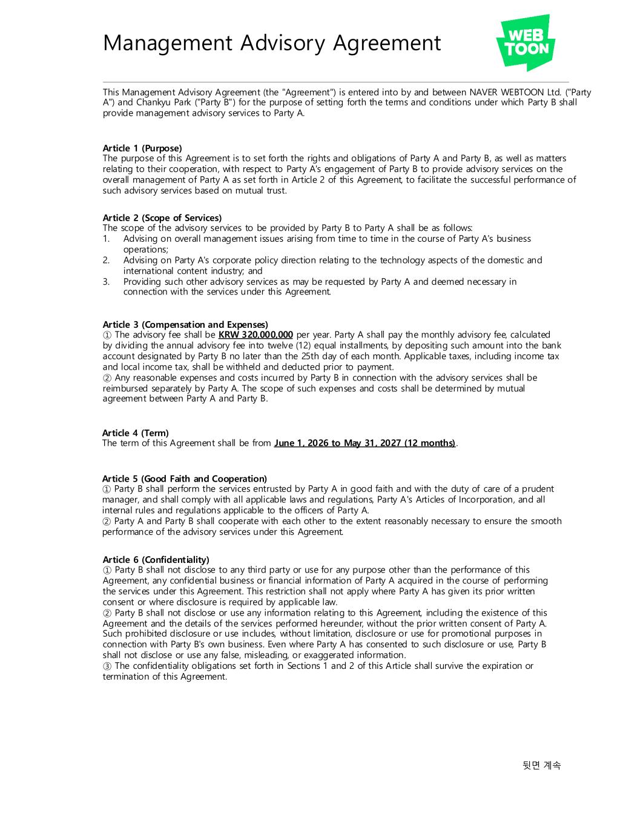
43
Management Advisory Agreement This Management Advisory Agreement (the "Agreement") is entered into by and between NAVER WEBTOON Ltd. ("Party A") and Chankyu Park ("Party B") for the purpose of setting forth the terms and conditions under which Party B shall provide management advisory services to Party A. Article 1 (Purpose) The purpose of this Agreement is to set forth the rights and obligations of Party A and Party B, as well as matters relating to their cooperation, with respect to Party A's engagement of Party B to provide advisory services on the overall management of Party A as set forth in Article 2 of this Agreement, to facilitate the successful performance of such advisory services based on mutual trust. Article 2 (Scope of Services) The scope of the advisory services to be provided by Party B to Party A shall be as follows: 1. Advising on overall management issues arising from time to time in the course of Party A's business operations; 2. Advising on Party A's corporate policy direction relating to the technology aspects of the domestic and international content industry; and 3. Providing such other advisory services as may be requested by Party A and deemed necessary in connection with the services under this Agreement. Article 3 (Compensation and Expenses) ① The advisory fee shall be KRW 320,000,000 per year. Party A shall pay the monthly advisory fee, calculated by dividing the annual advisory fee into twelve (12) equal installments, by depositing such amount into the bank account designated by Party B no later than the 25th day of each month. Applicable taxes, including income tax and local income tax, shall be withheld and deducted prior to payment. ② Any reasonable expenses and costs incurred by Party B in connection with the advisory services shall be reimbursed separately by Party A. The scope of such expenses and costs shall be determined by mutual agreement between Party A and Party B. Article 4 (Term) The term of this Agreement shall be from June 1, 2026 to May 31, 2027 (12 months) . Article 5 (Good Faith and Cooperation) ① Party B shall perform the services entrusted by Party A in good faith and with the duty of care of a prudent manager, and shall comply with all applicable laws and regulations, Party A's Articles of Incorporation, and all internal rules and regulations applicable to the officers of Party A. ② Party A and Party B shall cooperate with each other to the extent reasonably necessary to ensure the smooth performance of the advisory services under this Agreement. Article 6 (Confidentiality) ① Party B shall not disclose to any third party or use for any purpose other than the performance of this Agreement, any confidential business or financial information of Party A acquired in the course of performing the services under this Agreement. This restriction shall not apply where Party A has given its prior written consent or where disclosure is required by applicable law. ② Party B shall not disclose or use any information relating to this Agreement, including the existence of this Agreement and the details of the services performed hereunder, without the prior written consent of Party A. Such prohibited disclosure or use includes, without limitation, disclosure or use for promotional purposes in connection with Party B's own business. Even where Party A has consented to such disclosure or use, Party B shall not disclose or use any false, misleading, or exaggerated information. ③ The confidentiality obligations set forth in Sections 1 and 2 of this Article shall survive the expiration or termination of this Agreement. 뒷면 계속

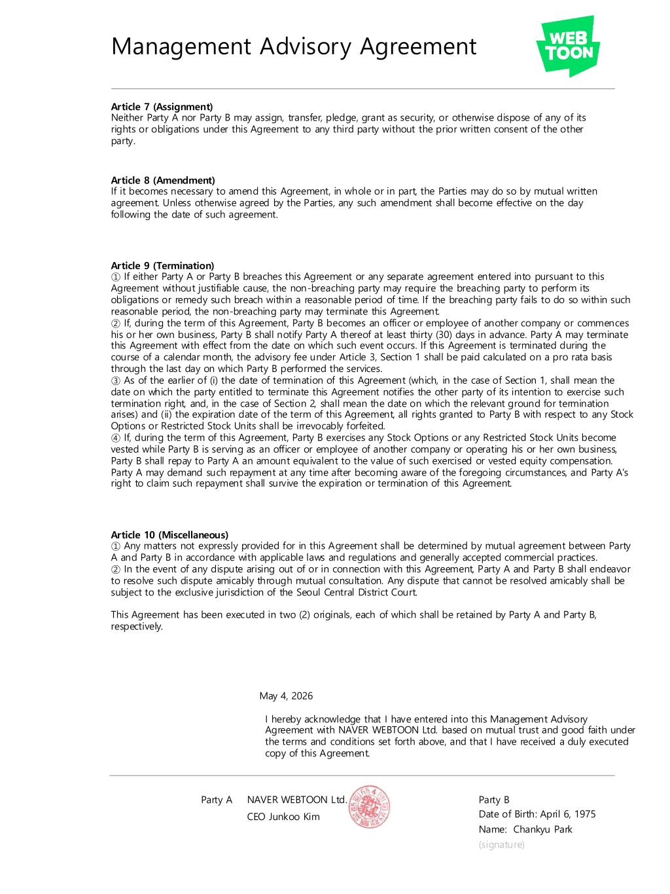
Management Advisory Agreement Article 9 (Termination) ① If either Party A or Party B breaches this Agreement or any separate agreement entered into pursuant to this Agreement without justifiable cause, the non-breaching party may require the breaching party to perform its obligations or remedy such breach within a reasonable period of time. If the breaching party fails to do so within such reasonable period, the non-breaching party may terminate this Agreement. ② If, during the term of this Agreement, Party B becomes an officer or employee of another company or commences his or her own business, Party B shall notify Party A thereof at least thirty (30) days in advance. Party A may terminate this Agreement with effect from the date on which such event occurs. If this Agreement is terminated during the course of a calendar month, the advisory fee under Article 3, Section 1 shall be paid calculated on a pro rata basis through the last day on which Party B performed the services. ③ As of the earlier of (i) the date of termination of this Agreement (which, in the case of Section 1, shall mean the date on which the party entitled to terminate this Agreement notifies the other party of its intention to exercise such termination right, and, in the case of Section 2, shall mean the date on which the relevant ground for termination arises) and (ii) the expiration date of the term of this Agreement, all rights granted to Party B with respect to any Stock Options or Restricted Stock Units shall be irrevocably forfeited. ④ If, during the term of this Agreement, Party B exercises any Stock Options or any Restricted Stock Units become vested while Party B is serving as an officer or employee of another company or operating his or her own business, Party B shall repay to Party A an amount equivalent to the value of such exercised or vested equity compensation. Party A may demand such repayment at any time after becoming aware of the foregoing circumstances, and Party A's right to claim such repayment shall survive the expiration or termination of this Agreement. Article 10 (Miscellaneous) ① Any matters not expressly provided for in this Agreement shall be determined by mutual agreement between Party A and Party B in accordance with applicable laws and regulations and generally accepted commercial practices. ② In the event of any dispute arising out of or in connection with this Agreement, Party A and Party B shall endeavor to resolve such dispute amicably through mutual consultation. Any dispute that cannot be resolved amicably shall be subject to the exclusive jurisdiction of the Seoul Central District Court. This Agreement has been executed in two (2) originals, each of which shall be retained by Party A and Party B, respectively. Party B Date of Birth: April 6, 1975 Name: Chankyu Park (signature) May 4, 2026 Party A I hereby acknowledge that I have entered into this Management Advisory Agreement with NAVER WEBTOON Ltd. based on mutual trust and good faith under the terms and conditions set forth above, and that I have received a duly executed copy of this Agreement. Article 8 (Amendment) If it becomes necessary to amend this Agreement, in whole or in part, the Parties may do so by mutual written agreement. Unless otherwise agreed by the Parties, any such amendment shall become effective on the day following the date of such agreement. Article 7 (Assignment) Neither Party A nor Party B may assign, transfer, pledge, grant as security, or otherwise dispose of any of its rights or obligations under this Agreement to any third party without the prior written consent of the other party. NAVER WEBTOON Ltd. CEO Junkoo Kim

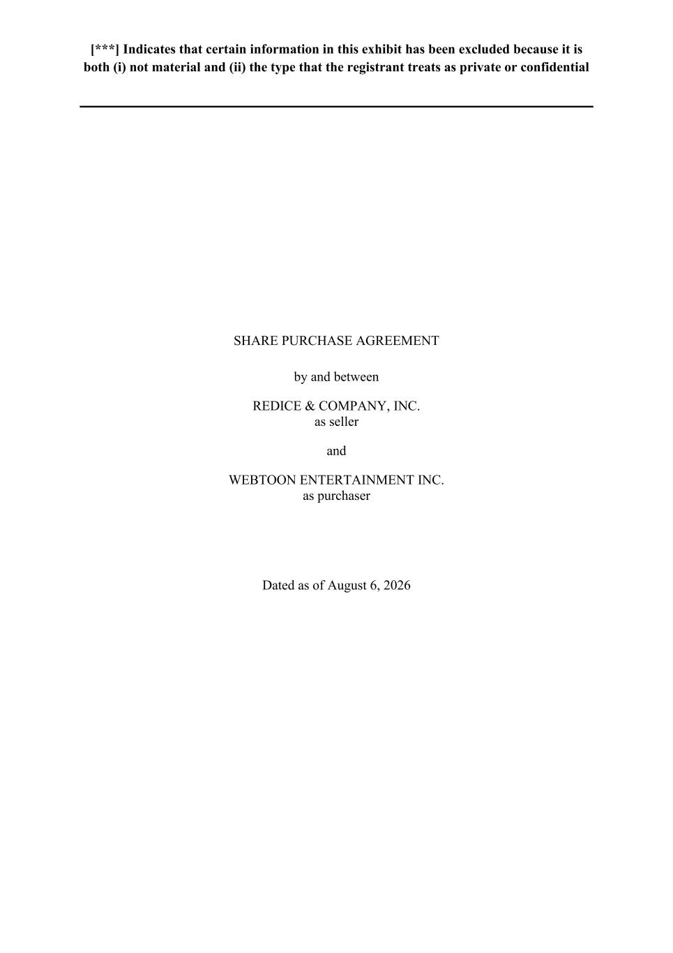
[***] Indicates that certain information in this exhibit has been excluded because it is both (i) not material and (ii) the type that the registrant treats as private or confidential SHARE PURCHASE AGREEMENT by and between REDICE & COMPANY, INC. as seller and WEBTOON ENTERTAINMENT INC. as purchaser Dated as of August 6, 2026

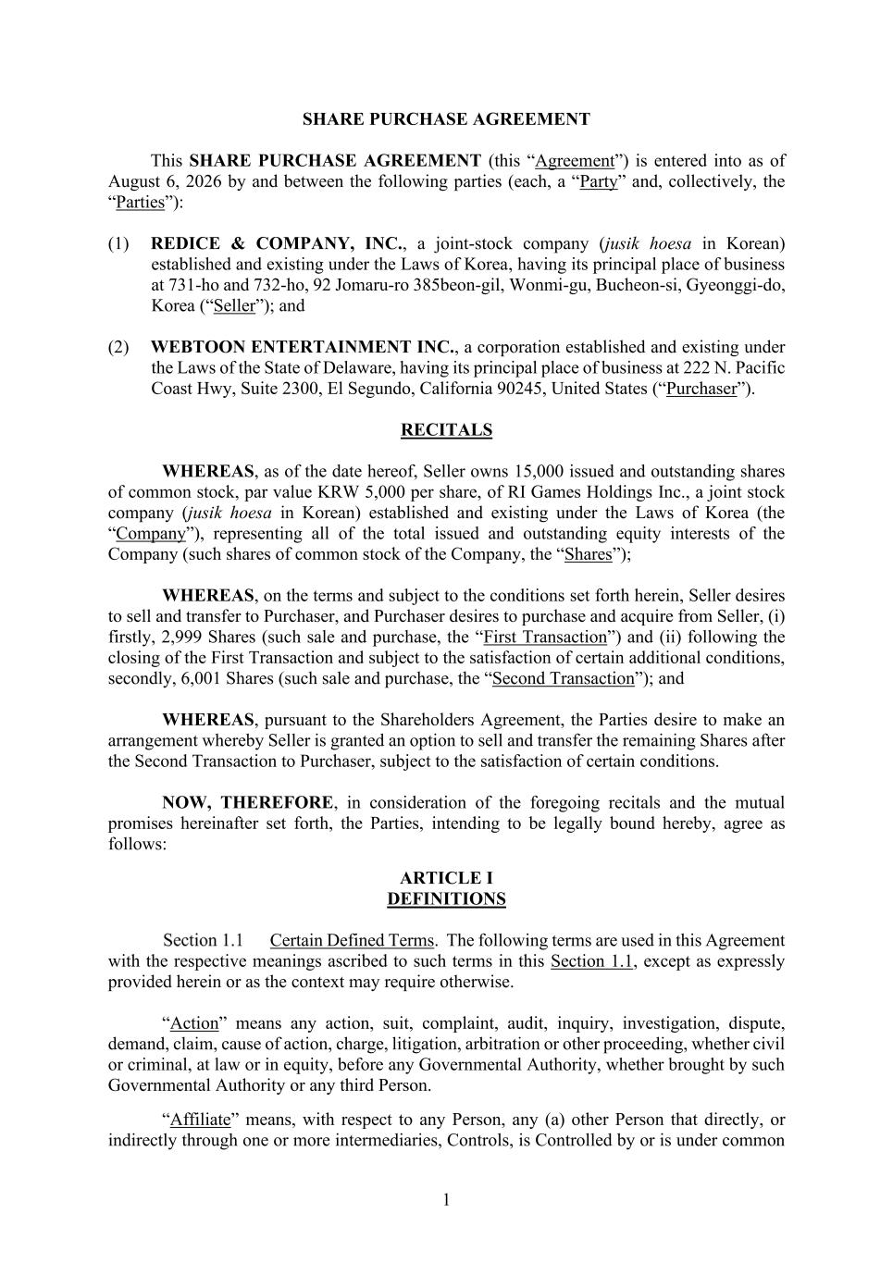
1 SHARE PURCHASE AGREEMENT This SHARE PURCHASE AGREEMENT (this “Agreement”) is entered into as of August 6, 2026 by and between the following parties (each, a “Party” and, collectively, the “Parties”): (1) REDICE & COMPANY, INC., a joint-stock company (jusik hoesa in Korean) established and existing under the Laws of Korea, having its principal place of business at 731-ho and 732-ho, 92 Jomaru-ro 385beon-gil, Wonmi-gu, Bucheon-si, Gyeonggi-do, Korea (“Seller”); and (2) WEBTOON ENTERTAINMENT INC., a corporation established and existing under the Laws of the State of Delaware, having its principal place of business at 222 N. Pacific Coast Hwy, Suite 2300, El Segundo, California 90245, United States (“Purchaser”). RECITALS WHEREAS, as of the date hereof, Seller owns 15,000 issued and outstanding shares of common stock, par value KRW 5,000 per share, of RI Games Holdings Inc., a joint stock company (jusik hoesa in Korean) established and existing under the Laws of Korea (the “Company”), representing all of the total issued and outstanding equity interests of the Company (such shares of common stock of the Company, the “Shares”); WHEREAS, on the terms and subject to the conditions set forth herein, Seller desires to sell and transfer to Purchaser, and Purchaser desires to purchase and acquire from Seller, (i) firstly, 2,999 Shares (such sale and purchase, the “First Transaction”) and (ii) following the closing of the First Transaction and subject to the satisfaction of certain additional conditions, secondly, 6,001 Shares (such sale and purchase, the “Second Transaction”); and WHEREAS, pursuant to the Shareholders Agreement, the Parties desire to make an arrangement whereby Seller is granted an option to sell and transfer the remaining Shares after the Second Transaction to Purchaser, subject to the satisfaction of certain conditions. NOW, THEREFORE, in consideration of the foregoing recitals and the mutual promises hereinafter set forth, the Parties, intending to be legally bound hereby, agree as follows: ARTICLE I DEFINITIONS Certain Defined Terms. The following terms are used in this Agreement with the respective meanings ascribed to such terms in this Section 1.1, except as expressly provided herein or as the context may require otherwise. “Action” means any action, suit, complaint, audit, inquiry, investigation, dispute, demand, claim, cause of action, charge, litigation, arbitration or other proceeding, whether civil or criminal, at law or in equity, before any Governmental Authority, whether brought by such Governmental Authority or any third Person. “Affiliate” means, with respect to any Person, any (a) other Person that directly, or indirectly through one or more intermediaries, Controls, is Controlled by or is under common

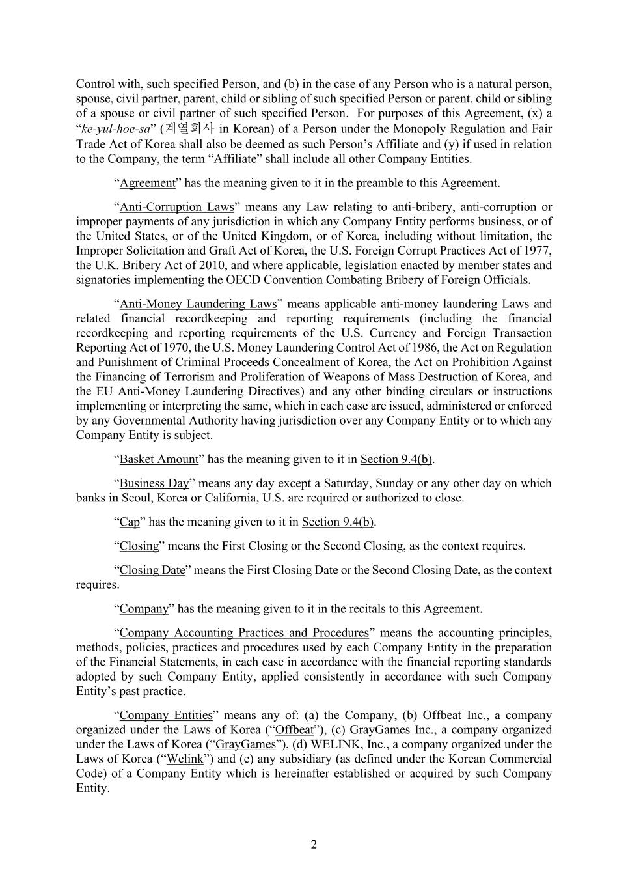
2 Control with, such specified Person, and (b) in the case of any Person who is a natural person, spouse, civil partner, parent, child or sibling of such specified Person or parent, child or sibling of a spouse or civil partner of such specified Person. For purposes of this Agreement, (x) a “ke-yul-hoe-sa” (계열회사 in Korean) of a Person under the Monopoly Regulation and Fair Trade Act of Korea shall also be deemed as such Person’s Affiliate and (y) if used in relation to the Company, the term “Affiliate” shall include all other Company Entities. “Agreement” has the meaning given to it in the preamble to this Agreement. “Anti-Corruption Laws” means any Law relating to anti-bribery, anti-corruption or improper payments of any jurisdiction in which any Company Entity performs business, or of the United States, or of the United Kingdom, or of Korea, including without limitation, the Improper Solicitation and Graft Act of Korea, the U.S. Foreign Corrupt Practices Act of 1977, the U.K. Bribery Act of 2010, and where applicable, legislation enacted by member states and signatories implementing the OECD Convention Combating Bribery of Foreign Officials. “Anti-Money Laundering Laws” means applicable anti-money laundering Laws and related financial recordkeeping and reporting requirements (including the financial recordkeeping and reporting requirements of the U.S. Currency and Foreign Transaction Reporting Act of 1970, the U.S. Money Laundering Control Act of 1986, the Act on Regulation and Punishment of Criminal Proceeds Concealment of Korea, the Act on Prohibition Against the Financing of Terrorism and Proliferation of Weapons of Mass Destruction of Korea, and the EU Anti-Money Laundering Directives) and any other binding circulars or instructions implementing or interpreting the same, which in each case are issued, administered or enforced by any Governmental Authority having jurisdiction over any Company Entity or to which any Company Entity is subject. “Basket Amount” has the meaning given to it in Section 9.4(b). “Business Day” means any day except a Saturday, Sunday or any other day on which banks in Seoul, Korea or California, U.S. are required or authorized to close. “Cap” has the meaning given to it in Section 9.4(b). “Closing” means the First Closing or the Second Closing, as the context requires. “Closing Date” means the First Closing Date or the Second Closing Date, as the context requires. “Company” has the meaning given to it in the recitals to this Agreement. “Company Accounting Practices and Procedures” means the accounting principles, methods, policies, practices and procedures used by each Company Entity in the preparation of the Financial Statements, in each case in accordance with the financial reporting standards adopted by such Company Entity, applied consistently in accordance with such Company Entity’s past practice. “Company Entities” means any of: (a) the Company, (b) Offbeat Inc., a company organized under the Laws of Korea (“Offbeat”), (c) GrayGames Inc., a company organized under the Laws of Korea (“GrayGames”), (d) WELINK, Inc., a company organized under the Laws of Korea (“Welink”) and (e) any subsidiary (as defined under the Korean Commercial Code) of a Company Entity which is hereinafter established or acquired by such Company Entity.

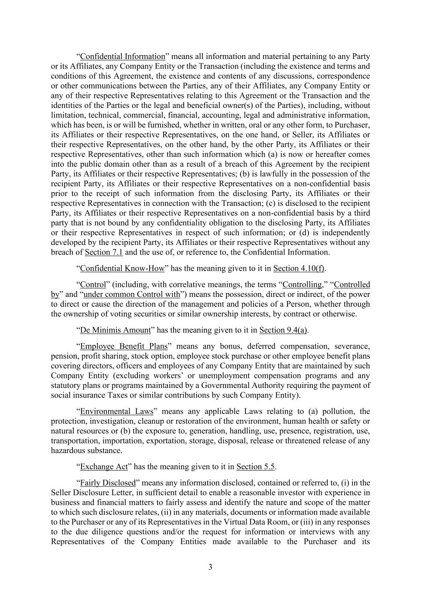
3 “Confidential Information” means all information and material pertaining to any Party or its Affiliates, any Company Entity or the Transaction (including the existence and terms and conditions of this Agreement, the existence and contents of any discussions, correspondence or other communications between the Parties, any of their Affiliates, any Company Entity or any of their respective Representatives relating to this Agreement or the Transaction and the identities of the Parties or the legal and beneficial owner(s) of the Parties), including, without limitation, technical, commercial, financial, accounting, legal and administrative information, which has been, is or will be furnished, whether in written, oral or any other form, to Purchaser, its Affiliates or their respective Representatives, on the one hand, or Seller, its Affiliates or their respective Representatives, on the other hand, by the other Party, its Affiliates or their respective Representatives, other than such information which (a) is now or hereafter comes into the public domain other than as a result of a breach of this Agreement by the recipient Party, its Affiliates or their respective Representatives; (b) is lawfully in the possession of the recipient Party, its Affiliates or their respective Representatives on a non-confidential basis prior to the receipt of such information from the disclosing Party, its Affiliates or their respective Representatives in connection with the Transaction; (c) is disclosed to the recipient Party, its Affiliates or their respective Representatives on a non-confidential basis by a third party that is not bound by any confidentiality obligation to the disclosing Party, its Affiliates or their respective Representatives in respect of such information; or (d) is independently developed by the recipient Party, its Affiliates or their respective Representatives without any breach of Section 7.1 and the use of, or reference to, the Confidential Information. “Confidential Know-How” has the meaning given to it in Section 4.10(f). “Control” (including, with correlative meanings, the terms “Controlling,” “Controlled by” and “under common Control with”) means the possession, direct or indirect, of the power to direct or cause the direction of the management and policies of a Person, whether through the ownership of voting securities or similar ownership interests, by contract or otherwise. “De Minimis Amount” has the meaning given to it in Section 9.4(a). “Employee Benefit Plans” means any bonus, deferred compensation, severance, pension, profit sharing, stock option, employee stock purchase or other employee benefit plans covering directors, officers and employees of any Company Entity that are maintained by such Company Entity (excluding workers’ or unemployment compensation programs and any statutory plans or programs maintained by a Governmental Authority requiring the payment of social insurance Taxes or similar contributions by such Company Entity). “Environmental Laws” means any applicable Laws relating to (a) pollution, the protection, investigation, cleanup or restoration of the environment, human health or safety or natural resources or (b) the exposure to, generation, handling, use, presence, registration, use, transportation, importation, exportation, storage, disposal, release or threatened release of any hazardous substance. “Exchange Act” has the meaning given to it in Section 5.5. “Fairly Disclosed” means any information disclosed, contained or referred to, (i) in the Seller Disclosure Letter, in sufficient detail to enable a reasonable investor with experience in business and financial matters to fairly assess and identify the nature and scope of the matter to which such disclosure relates, (ii) in any materials, documents or information made available to the Purchaser or any of its Representatives in the Virtual Data Room, or (iii) in any responses to the due diligence questions and/or the request for information or interviews with any Representatives of the Company Entities made available to the Purchaser and its

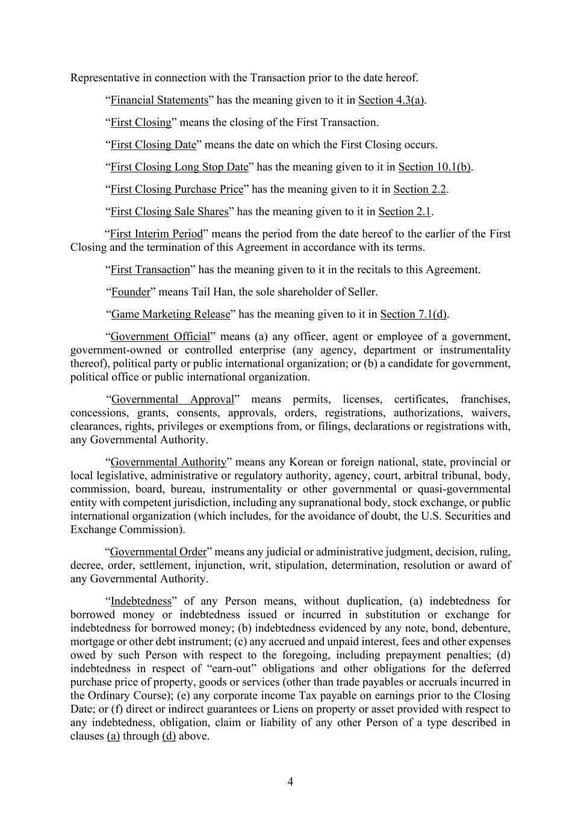
4 Representative in connection with the Transaction prior to the date hereof. “Financial Statements” has the meaning given to it in Section 4.3(a). “First Closing” means the closing of the First Transaction. “First Closing Date” means the date on which the First Closing occurs. “First Closing Long Stop Date” has the meaning given to it in Section 10.1(b). “First Closing Purchase Price” has the meaning given to it in Section 2.2. “First Closing Sale Shares” has the meaning given to it in Section 2.1. “First Interim Period” means the period from the date hereof to the earlier of the First Closing and the termination of this Agreement in accordance with its terms. “First Transaction” has the meaning given to it in the recitals to this Agreement. “Founder” means Tail Han, the sole shareholder of Seller. “Game Marketing Release” has the meaning given to it in Section 7.1(d). “Government Official” means (a) any officer, agent or employee of a government, government-owned or controlled enterprise (any agency, department or instrumentality thereof), political party or public international organization; or (b) a candidate for government, political office or public international organization. “Governmental Approval” means permits, licenses, certificates, franchises, concessions, grants, consents, approvals, orders, registrations, authorizations, waivers, clearances, rights, privileges or exemptions from, or filings, declarations or registrations with, any Governmental Authority. “Governmental Authority” means any Korean or foreign national, state, provincial or local legislative, administrative or regulatory authority, agency, court, arbitral tribunal, body, commission, board, bureau, instrumentality or other governmental or quasi-governmental entity with competent jurisdiction, including any supranational body, stock exchange, or public international organization (which includes, for the avoidance of doubt, the U.S. Securities and Exchange Commission). “Governmental Order” means any judicial or administrative judgment, decision, ruling, decree, order, settlement, injunction, writ, stipulation, determination, resolution or award of any Governmental Authority. “Indebtedness” of any Person means, without duplication, (a) indebtedness for borrowed money or indebtedness issued or incurred in substitution or exchange for indebtedness for borrowed money; (b) indebtedness evidenced by any note, bond, debenture, mortgage or other debt instrument; (c) any accrued and unpaid interest, fees and other expenses owed by such Person with respect to the foregoing, including prepayment penalties; (d) indebtedness in respect of “earn-out” obligations and other obligations for the deferred purchase price of property, goods or services (other than trade payables or accruals incurred in the Ordinary Course); (e) any corporate income Tax payable on earnings prior to the Closing Date; or (f) direct or indirect guarantees or Liens on property or asset provided with respect to any indebtedness, obligation, claim or liability of any other Person of a type described in clauses (a) through (d) above.

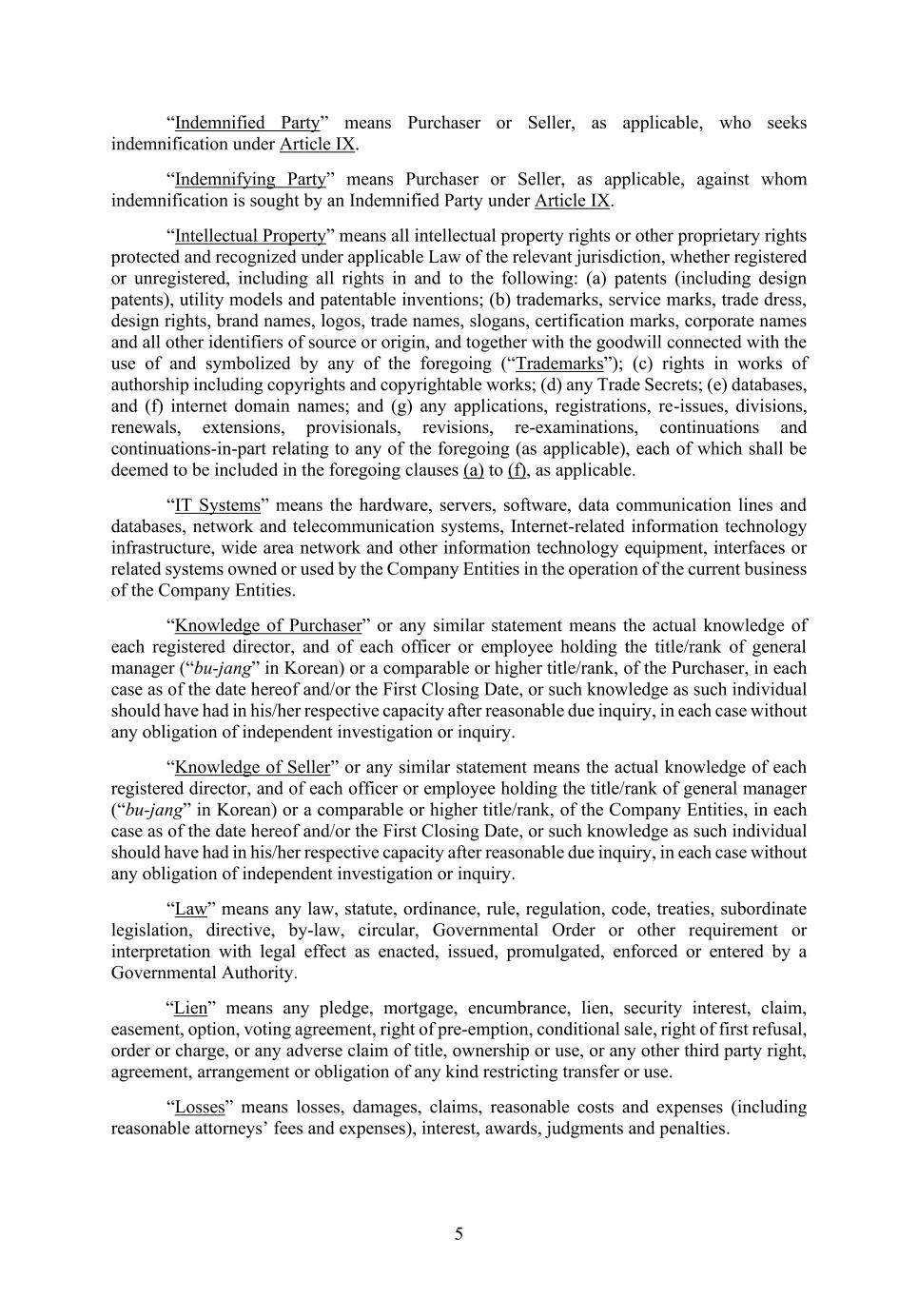
5 “Indemnified Party” means Purchaser or Seller, as applicable, who seeks indemnification under Article IX. “Indemnifying Party” means Purchaser or Seller, as applicable, against whom indemnification is sought by an Indemnified Party under Article IX. “Intellectual Property” means all intellectual property rights or other proprietary rights protected and recognized under applicable Law of the relevant jurisdiction, whether registered or unregistered, including all rights in and to the following: (a) patents (including design patents), utility models and patentable inventions; (b) trademarks, service marks, trade dress, design rights, brand names, logos, trade names, slogans, certification marks, corporate names and all other identifiers of source or origin, and together with the goodwill connected with the use of and symbolized by any of the foregoing (“Trademarks”); (c) rights in works of authorship including copyrights and copyrightable works; (d) any Trade Secrets; (e) databases, and (f) internet domain names; and (g) any applications, registrations, re-issues, divisions, renewals, extensions, provisionals, revisions, re-examinations, continuations and continuations-in-part relating to any of the foregoing (as applicable), each of which shall be deemed to be included in the foregoing clauses (a) to (f), as applicable. “IT Systems” means the hardware, servers, software, data communication lines and databases, network and telecommunication systems, Internet-related information technology infrastructure, wide area network and other information technology equipment, interfaces or related systems owned or used by the Company Entities in the operation of the current business of the Company Entities. “Knowledge of Purchaser” or any similar statement means the actual knowledge of each registered director, and of each officer or employee holding the title/rank of general manager (“bu-jang” in Korean) or a comparable or higher title/rank, of the Purchaser, in each case as of the date hereof and/or the First Closing Date, or such knowledge as such individual should have had in his/her respective capacity after reasonable due inquiry, in each case without any obligation of independent investigation or inquiry. “Knowledge of Seller” or any similar statement means the actual knowledge of each registered director, and of each officer or employee holding the title/rank of general manager (“bu-jang” in Korean) or a comparable or higher title/rank, of the Company Entities, in each case as of the date hereof and/or the First Closing Date, or such knowledge as such individual should have had in his/her respective capacity after reasonable due inquiry, in each case without any obligation of independent investigation or inquiry. “Law” means any law, statute, ordinance, rule, regulation, code, treaties, subordinate legislation, directive, by-law, circular, Governmental Order or other requirement or interpretation with legal effect as enacted, issued, promulgated, enforced or entered by a Governmental Authority. “Lien” means any pledge, mortgage, encumbrance, lien, security interest, claim, easement, option, voting agreement, right of pre-emption, conditional sale, right of first refusal, order or charge, or any adverse claim of title, ownership or use, or any other third party right, agreement, arrangement or obligation of any kind restricting transfer or use. “Losses” means losses, damages, claims, reasonable costs and expenses (including reasonable attorneys’ fees and expenses), interest, awards, judgments and penalties.

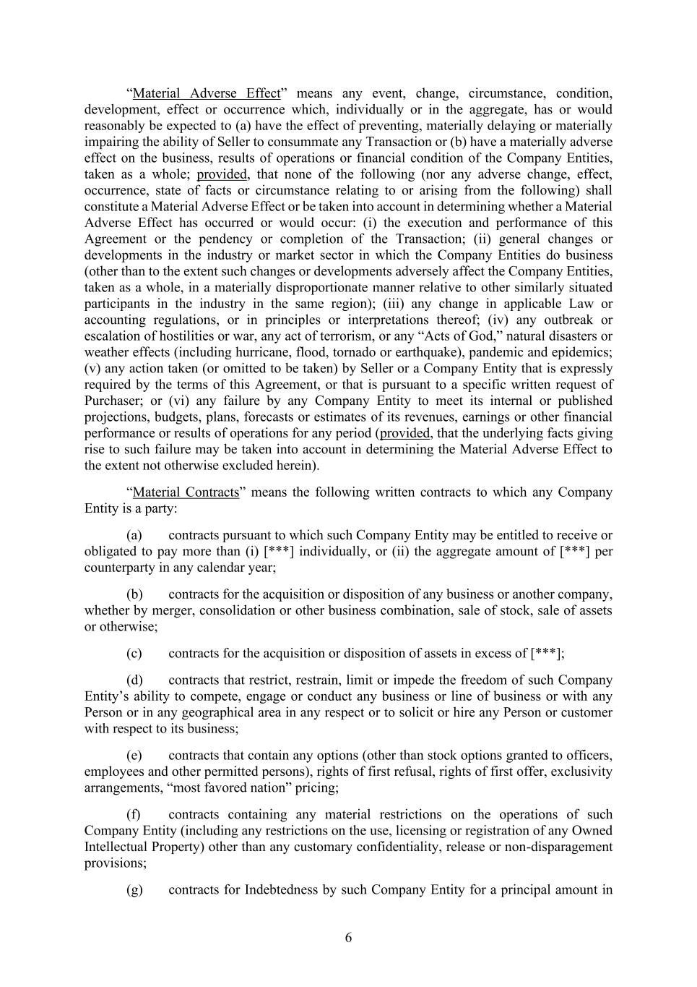
6 “Material Adverse Effect” means any event, change, circumstance, condition, development, effect or occurrence which, individually or in the aggregate, has or would reasonably be expected to (a) have the effect of preventing, materially delaying or materially impairing the ability of Seller to consummate any Transaction or (b) have a materially adverse effect on the business, results of operations or financial condition of the Company Entities, taken as a whole; provided, that none of the following (nor any adverse change, effect, occurrence, state of facts or circumstance relating to or arising from the following) shall constitute a Material Adverse Effect or be taken into account in determining whether a Material Adverse Effect has occurred or would occur: (i) the execution and performance of this Agreement or the pendency or completion of the Transaction; (ii) general changes or developments in the industry or market sector in which the Company Entities do business (other than to the extent such changes or developments adversely affect the Company Entities, taken as a whole, in a materially disproportionate manner relative to other similarly situated participants in the industry in the same region); (iii) any change in applicable Law or accounting regulations, or in principles or interpretations thereof; (iv) any outbreak or escalation of hostilities or war, any act of terrorism, or any “Acts of God,” natural disasters or weather effects (including hurricane, flood, tornado or earthquake), pandemic and epidemics; (v) any action taken (or omitted to be taken) by Seller or a Company Entity that is expressly required by the terms of this Agreement, or that is pursuant to a specific written request of Purchaser; or (vi) any failure by any Company Entity to meet its internal or published projections, budgets, plans, forecasts or estimates of its revenues, earnings or other financial performance or results of operations for any period (provided, that the underlying facts giving rise to such failure may be taken into account in determining the Material Adverse Effect to the extent not otherwise excluded herein). “Material Contracts” means the following written contracts to which any Company Entity is a party: (a) contracts pursuant to which such Company Entity may be entitled to receive or obligated to pay more than (i) [***] individually, or (ii) the aggregate amount of [***] per counterparty in any calendar year; (b) contracts for the acquisition or disposition of any business or another company, whether by merger, consolidation or other business combination, sale of stock, sale of assets or otherwise; (c) contracts for the acquisition or disposition of assets in excess of [***]; (d) contracts that restrict, restrain, limit or impede the freedom of such Company Entity’s ability to compete, engage or conduct any business or line of business or with any Person or in any geographical area in any respect or to solicit or hire any Person or customer with respect to its business; (e) contracts that contain any options (other than stock options granted to officers, employees and other permitted persons), rights of first refusal, rights of first offer, exclusivity arrangements, “most favored nation” pricing; (f) contracts containing any material restrictions on the operations of such Company Entity (including any restrictions on the use, licensing or registration of any Owned Intellectual Property) other than any customary confidentiality, release or non-disparagement provisions; (g) contracts for Indebtedness by such Company Entity for a principal amount in

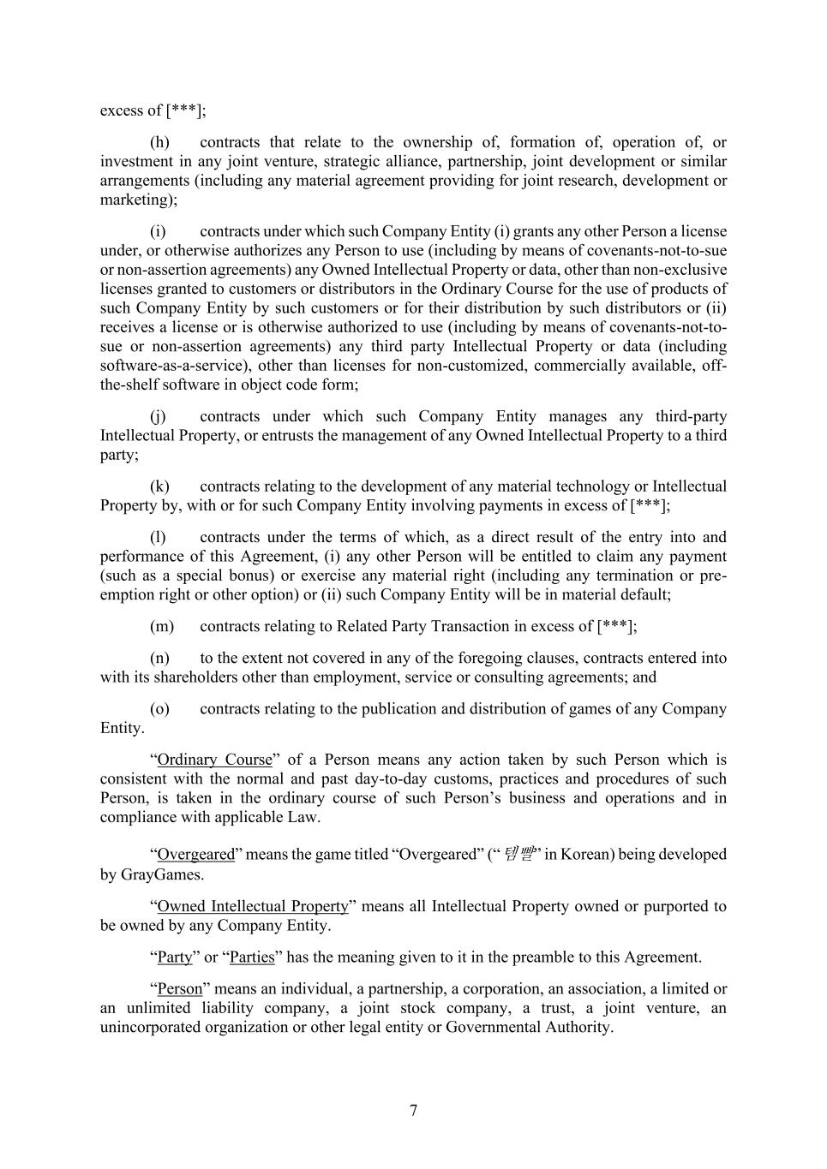
7 excess of [***]; (h) contracts that relate to the ownership of, formation of, operation of, or investment in any joint venture, strategic alliance, partnership, joint development or similar arrangements (including any material agreement providing for joint research, development or marketing); (i) contracts under which such Company Entity (i) grants any other Person a license under, or otherwise authorizes any Person to use (including by means of covenants-not-to-sue or non-assertion agreements) any Owned Intellectual Property or data, other than non-exclusive licenses granted to customers or distributors in the Ordinary Course for the use of products of such Company Entity by such customers or for their distribution by such distributors or (ii) receives a license or is otherwise authorized to use (including by means of covenants-not-to- sue or non-assertion agreements) any third party Intellectual Property or data (including software-as-a-service), other than licenses for non-customized, commercially available, off- the-shelf software in object code form; (j) contracts under which such Company Entity manages any third-party Intellectual Property, or entrusts the management of any Owned Intellectual Property to a third party; (k) contracts relating to the development of any material technology or Intellectual Property by, with or for such Company Entity involving payments in excess of [***]; (l) contracts under the terms of which, as a direct result of the entry into and performance of this Agreement, (i) any other Person will be entitled to claim any payment (such as a special bonus) or exercise any material right (including any termination or pre- emption right or other option) or (ii) such Company Entity will be in material default; (m) contracts relating to Related Party Transaction in excess of [***]; (n) to the extent not covered in any of the foregoing clauses, contracts entered into with its shareholders other than employment, service or consulting agreements; and (o) contracts relating to the publication and distribution of games of any Company Entity. “Ordinary Course” of a Person means any action taken by such Person which is consistent with the normal and past day-to-day customs, practices and procedures of such Person, is taken in the ordinary course of such Person’s business and operations and in compliance with applicable Law. “Overgeared” means the game titled “Overgeared” (“템빨” in Korean) being developed by GrayGames. “Owned Intellectual Property” means all Intellectual Property owned or purported to be owned by any Company Entity. “Party” or “Parties” has the meaning given to it in the preamble to this Agreement. “Person” means an individual, a partnership, a corporation, an association, a limited or an unlimited liability company, a joint stock company, a trust, a joint venture, an unincorporated organization or other legal entity or Governmental Authority.

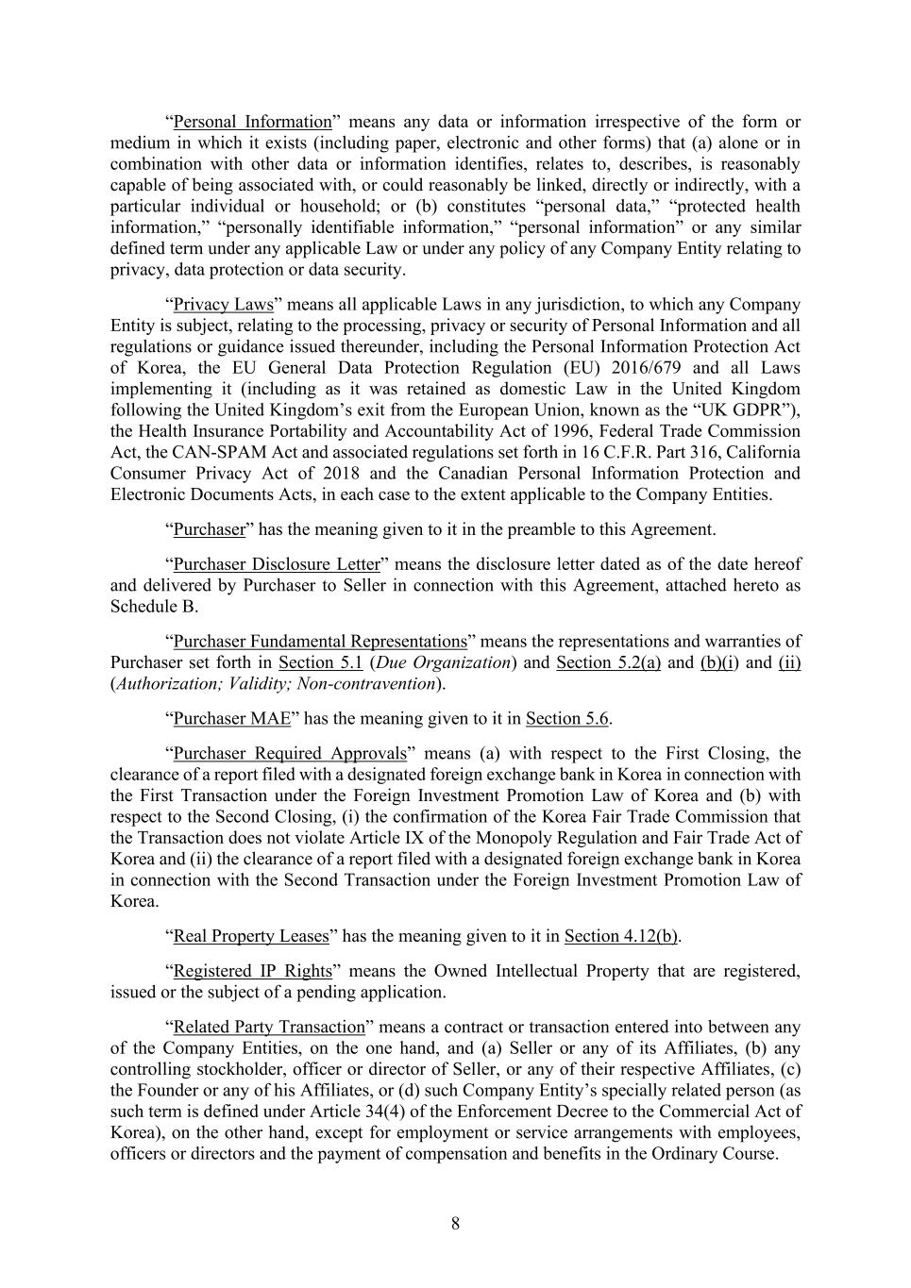
8 “Personal Information” means any data or information irrespective of the form or medium in which it exists (including paper, electronic and other forms) that (a) alone or in combination with other data or information identifies, relates to, describes, is reasonably capable of being associated with, or could reasonably be linked, directly or indirectly, with a particular individual or household; or (b) constitutes “personal data,” “protected health information,” “personally identifiable information,” “personal information” or any similar defined term under any applicable Law or under any policy of any Company Entity relating to privacy, data protection or data security. “Privacy Laws” means all applicable Laws in any jurisdiction, to which any Company Entity is subject, relating to the processing, privacy or security of Personal Information and all regulations or guidance issued thereunder, including the Personal Information Protection Act of Korea, the EU General Data Protection Regulation (EU) 2016/679 and all Laws implementing it (including as it was retained as domestic Law in the United Kingdom following the United Kingdom’s exit from the European Union, known as the “UK GDPR”), the Health Insurance Portability and Accountability Act of 1996, Federal Trade Commission Act, the CAN-SPAM Act and associated regulations set forth in 16 C.F.R. Part 316, California Consumer Privacy Act of 2018 and the Canadian Personal Information Protection and Electronic Documents Acts, in each case to the extent applicable to the Company Entities. “Purchaser” has the meaning given to it in the preamble to this Agreement. “Purchaser Disclosure Letter” means the disclosure letter dated as of the date hereof and delivered by Purchaser to Seller in connection with this Agreement, attached hereto as Schedule B. “Purchaser Fundamental Representations” means the representations and warranties of Purchaser set forth in Section 5.1 (Due Organization) and Section 5.2(a) and (b)(i) and (ii) (Authorization; Validity; Non-contravention). “Purchaser MAE” has the meaning given to it in Section 5.6. “Purchaser Required Approvals” means (a) with respect to the First Closing, the clearance of a report filed with a designated foreign exchange bank in Korea in connection with the First Transaction under the Foreign Investment Promotion Law of Korea and (b) with respect to the Second Closing, (i) the confirmation of the Korea Fair Trade Commission that the Transaction does not violate Article IX of the Monopoly Regulation and Fair Trade Act of Korea and (ii) the clearance of a report filed with a designated foreign exchange bank in Korea in connection with the Second Transaction under the Foreign Investment Promotion Law of Korea. “Real Property Leases” has the meaning given to it in Section 4.12(b). “Registered IP Rights” means the Owned Intellectual Property that are registered, issued or the subject of a pending application. “Related Party Transaction” means a contract or transaction entered into between any of the Company Entities, on the one hand, and (a) Seller or any of its Affiliates, (b) any controlling stockholder, officer or director of Seller, or any of their respective Affiliates, (c) the Founder or any of his Affiliates, or (d) such Company Entity’s specially related person (as such term is defined under Article 34(4) of the Enforcement Decree to the Commercial Act of Korea), on the other hand, except for employment or service arrangements with employees, officers or directors and the payment of compensation and benefits in the Ordinary Course.

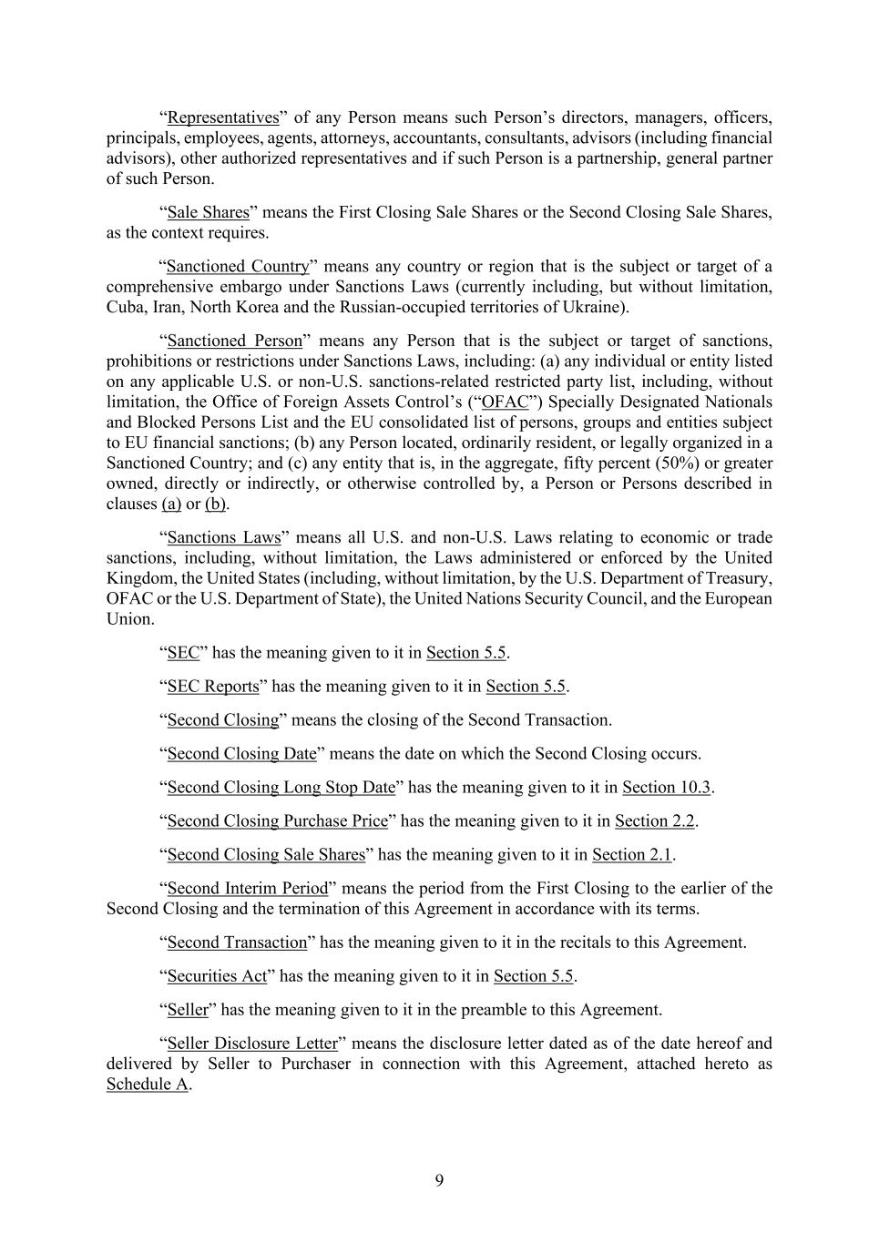
9 “Representatives” of any Person means such Person’s directors, managers, officers, principals, employees, agents, attorneys, accountants, consultants, advisors (including financial advisors), other authorized representatives and if such Person is a partnership, general partner of such Person. “Sale Shares” means the First Closing Sale Shares or the Second Closing Sale Shares, as the context requires. “Sanctioned Country” means any country or region that is the subject or target of a comprehensive embargo under Sanctions Laws (currently including, but without limitation, Cuba, Iran, North Korea and the Russian-occupied territories of Ukraine). “Sanctioned Person” means any Person that is the subject or target of sanctions, prohibitions or restrictions under Sanctions Laws, including: (a) any individual or entity listed on any applicable U.S. or non-U.S. sanctions-related restricted party list, including, without limitation, the Office of Foreign Assets Control’s (“OFAC”) Specially Designated Nationals and Blocked Persons List and the EU consolidated list of persons, groups and entities subject to EU financial sanctions; (b) any Person located, ordinarily resident, or legally organized in a Sanctioned Country; and (c) any entity that is, in the aggregate, fifty percent (50%) or greater owned, directly or indirectly, or otherwise controlled by, a Person or Persons described in clauses (a) or (b). “Sanctions Laws” means all U.S. and non-U.S. Laws relating to economic or trade sanctions, including, without limitation, the Laws administered or enforced by the United Kingdom, the United States (including, without limitation, by the U.S. Department of Treasury, OFAC or the U.S. Department of State), the United Nations Security Council, and the European Union. “SEC” has the meaning given to it in Section 5.5. “SEC Reports” has the meaning given to it in Section 5.5. “Second Closing” means the closing of the Second Transaction. “Second Closing Date” means the date on which the Second Closing occurs. “Second Closing Long Stop Date” has the meaning given to it in Section 10.3. “Second Closing Purchase Price” has the meaning given to it in Section 2.2. “Second Closing Sale Shares” has the meaning given to it in Section 2.1. “Second Interim Period” means the period from the First Closing to the earlier of the Second Closing and the termination of this Agreement in accordance with its terms. “Second Transaction” has the meaning given to it in the recitals to this Agreement. “Securities Act” has the meaning given to it in Section 5.5. “Seller” has the meaning given to it in the preamble to this Agreement. “Seller Disclosure Letter” means the disclosure letter dated as of the date hereof and delivered by Seller to Purchaser in connection with this Agreement, attached hereto as Schedule A.

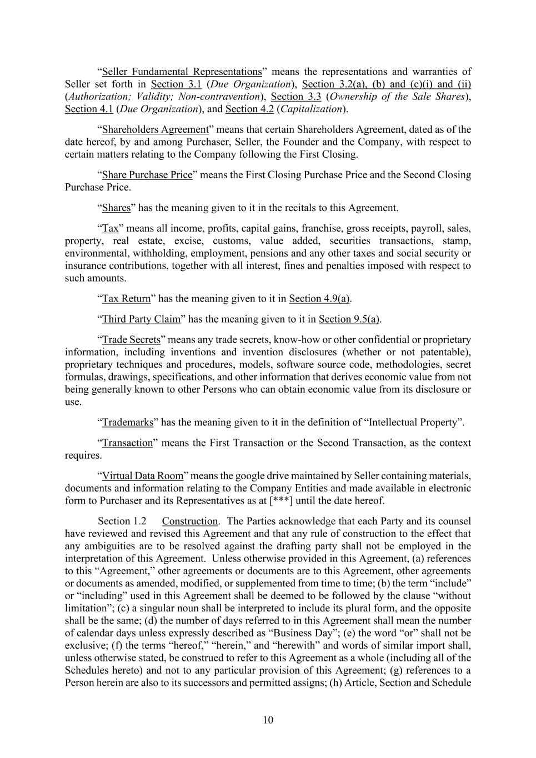
10 “Seller Fundamental Representations” means the representations and warranties of Seller set forth in Section 3.1 (Due Organization), Section 3.2(a), (b) and (c)(i) and (ii) (Authorization; Validity; Non-contravention), Section 3.3 (Ownership of the Sale Shares), Section 4.1 (Due Organization), and Section 4.2 (Capitalization). “Shareholders Agreement” means that certain Shareholders Agreement, dated as of the date hereof, by and among Purchaser, Seller, the Founder and the Company, with respect to certain matters relating to the Company following the First Closing. “Share Purchase Price” means the First Closing Purchase Price and the Second Closing Purchase Price. “Shares” has the meaning given to it in the recitals to this Agreement. “Tax” means all income, profits, capital gains, franchise, gross receipts, payroll, sales, property, real estate, excise, customs, value added, securities transactions, stamp, environmental, withholding, employment, pensions and any other taxes and social security or insurance contributions, together with all interest, fines and penalties imposed with respect to such amounts. “Tax Return” has the meaning given to it in Section 4.9(a). “Third Party Claim” has the meaning given to it in Section 9.5(a). “Trade Secrets” means any trade secrets, know-how or other confidential or proprietary information, including inventions and invention disclosures (whether or not patentable), proprietary techniques and procedures, models, software source code, methodologies, secret formulas, drawings, specifications, and other information that derives economic value from not being generally known to other Persons who can obtain economic value from its disclosure or use. “Trademarks” has the meaning given to it in the definition of “Intellectual Property”. “Transaction” means the First Transaction or the Second Transaction, as the context requires. “Virtual Data Room” means the google drive maintained by Seller containing materials, documents and information relating to the Company Entities and made available in electronic form to Purchaser and its Representatives as at [***] until the date hereof. Construction. The Parties acknowledge that each Party and its counsel have reviewed and revised this Agreement and that any rule of construction to the effect that any ambiguities are to be resolved against the drafting party shall not be employed in the interpretation of this Agreement. Unless otherwise provided in this Agreement, (a) references to this “Agreement,” other agreements or documents are to this Agreement, other agreements or documents as amended, modified, or supplemented from time to time; (b) the term “include” or “including” used in this Agreement shall be deemed to be followed by the clause “without limitation”; (c) a singular noun shall be interpreted to include its plural form, and the opposite shall be the same; (d) the number of days referred to in this Agreement shall mean the number of calendar days unless expressly described as “Business Day”; (e) the word “or” shall not be exclusive; (f) the terms “hereof,” “herein,” and “herewith” and words of similar import shall, unless otherwise stated, be construed to refer to this Agreement as a whole (including all of the Schedules hereto) and not to any particular provision of this Agreement; (g) references to a Person herein are also to its successors and permitted assigns; (h) Article, Section and Schedule

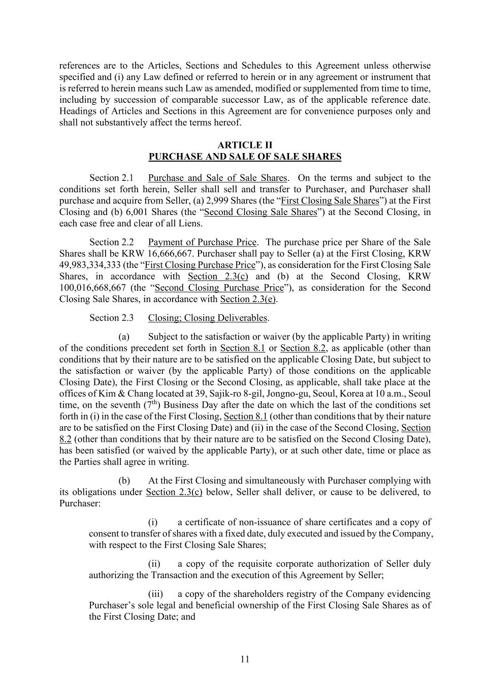
11 references are to the Articles, Sections and Schedules to this Agreement unless otherwise specified and (i) any Law defined or referred to herein or in any agreement or instrument that is referred to herein means such Law as amended, modified or supplemented from time to time, including by succession of comparable successor Law, as of the applicable reference date. Headings of Articles and Sections in this Agreement are for convenience purposes only and shall not substantively affect the terms hereof. ARTICLE II PURCHASE AND SALE OF SALE SHARES Purchase and Sale of Sale Shares. On the terms and subject to the conditions set forth herein, Seller shall sell and transfer to Purchaser, and Purchaser shall purchase and acquire from Seller, (a) 2,999 Shares (the “First Closing Sale Shares”) at the First Closing and (b) 6,001 Shares (the “Second Closing Sale Shares”) at the Second Closing, in each case free and clear of all Liens. Payment of Purchase Price. The purchase price per Share of the Sale Shares shall be KRW 16,666,667. Purchaser shall pay to Seller (a) at the First Closing, KRW 49,983,334,333 (the “First Closing Purchase Price”), as consideration for the First Closing Sale Shares, in accordance with Section 2.3(c) and (b) at the Second Closing, KRW 100,016,668,667 (the “Second Closing Purchase Price”), as consideration for the Second Closing Sale Shares, in accordance with Section 2.3(e). Closing; Closing Deliverables. (a) Subject to the satisfaction or waiver (by the applicable Party) in writing of the conditions precedent set forth in Section 8.1 or Section 8.2, as applicable (other than conditions that by their nature are to be satisfied on the applicable Closing Date, but subject to the satisfaction or waiver (by the applicable Party) of those conditions on the applicable Closing Date), the First Closing or the Second Closing, as applicable, shall take place at the offices of Kim & Chang located at 39, Sajik-ro 8-gil, Jongno-gu, Seoul, Korea at 10 a.m., Seoul time, on the seventh (7th) Business Day after the date on which the last of the conditions set forth in (i) in the case of the First Closing, Section 8.1 (other than conditions that by their nature are to be satisfied on the First Closing Date) and (ii) in the case of the Second Closing, Section 8.2 (other than conditions that by their nature are to be satisfied on the Second Closing Date), has been satisfied (or waived by the applicable Party), or at such other date, time or place as the Parties shall agree in writing. (b) At the First Closing and simultaneously with Purchaser complying with its obligations under Section 2.3(c) below, Seller shall deliver, or cause to be delivered, to Purchaser: (i) a certificate of non-issuance of share certificates and a copy of consent to transfer of shares with a fixed date, duly executed and issued by the Company, with respect to the First Closing Sale Shares; (ii) a copy of the requisite corporate authorization of Seller duly authorizing the Transaction and the execution of this Agreement by Seller; (iii) a copy of the shareholders registry of the Company evidencing Purchaser’s sole legal and beneficial ownership of the First Closing Sale Shares as of the First Closing Date; and

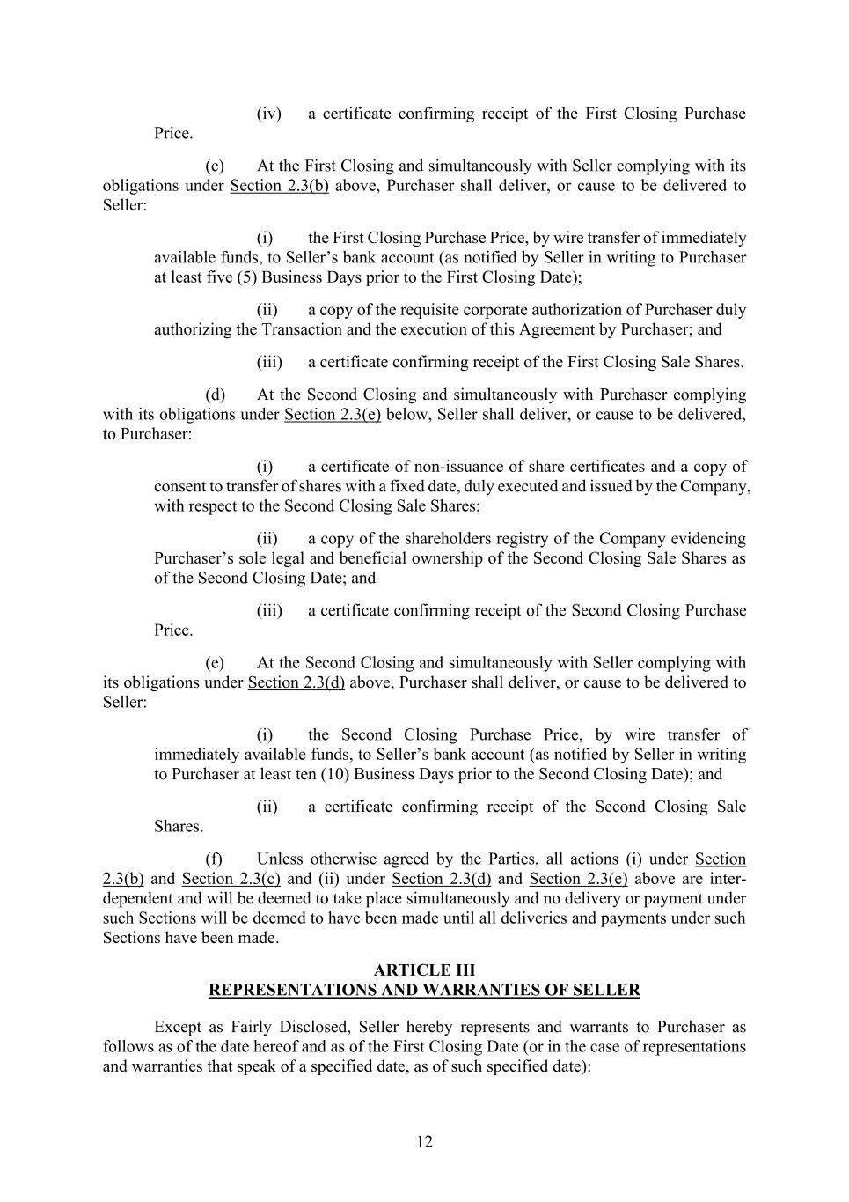
12 (iv) a certificate confirming receipt of the First Closing Purchase Price. (c) At the First Closing and simultaneously with Seller complying with its obligations under Section 2.3(b) above, Purchaser shall deliver, or cause to be delivered to Seller: (i) the First Closing Purchase Price, by wire transfer of immediately available funds, to Seller’s bank account (as notified by Seller in writing to Purchaser at least five (5) Business Days prior to the First Closing Date); (ii) a copy of the requisite corporate authorization of Purchaser duly authorizing the Transaction and the execution of this Agreement by Purchaser; and (iii) a certificate confirming receipt of the First Closing Sale Shares. (d) At the Second Closing and simultaneously with Purchaser complying with its obligations under Section 2.3(e) below, Seller shall deliver, or cause to be delivered, to Purchaser: (i) a certificate of non-issuance of share certificates and a copy of consent to transfer of shares with a fixed date, duly executed and issued by the Company, with respect to the Second Closing Sale Shares; (ii) a copy of the shareholders registry of the Company evidencing Purchaser’s sole legal and beneficial ownership of the Second Closing Sale Shares as of the Second Closing Date; and (iii) a certificate confirming receipt of the Second Closing Purchase Price. (e) At the Second Closing and simultaneously with Seller complying with its obligations under Section 2.3(d) above, Purchaser shall deliver, or cause to be delivered to Seller: (i) the Second Closing Purchase Price, by wire transfer of immediately available funds, to Seller’s bank account (as notified by Seller in writing to Purchaser at least ten (10) Business Days prior to the Second Closing Date); and (ii) a certificate confirming receipt of the Second Closing Sale Shares. (f) Unless otherwise agreed by the Parties, all actions (i) under Section 2.3(b) and Section 2.3(c) and (ii) under Section 2.3(d) and Section 2.3(e) above are inter- dependent and will be deemed to take place simultaneously and no delivery or payment under such Sections will be deemed to have been made until all deliveries and payments under such Sections have been made. ARTICLE III REPRESENTATIONS AND WARRANTIES OF SELLER Except as Fairly Disclosed, Seller hereby represents and warrants to Purchaser as follows as of the date hereof and as of the First Closing Date (or in the case of representations and warranties that speak of a specified date, as of such specified date):

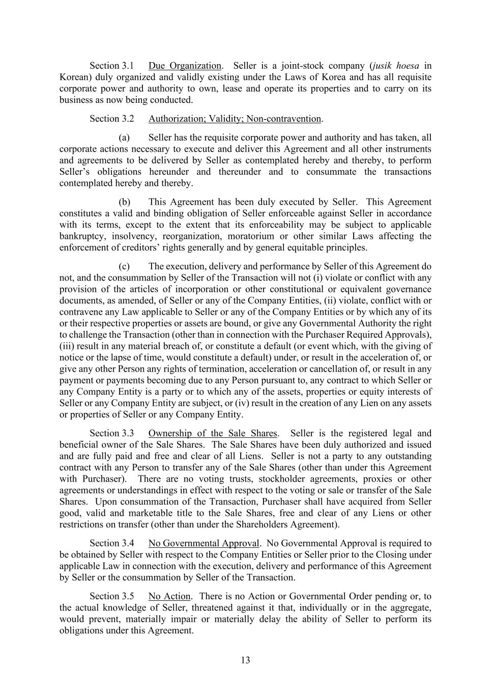
13 Due Organization. Seller is a joint-stock company (jusik hoesa in Korean) duly organized and validly existing under the Laws of Korea and has all requisite corporate power and authority to own, lease and operate its properties and to carry on its business as now being conducted. Authorization; Validity; Non-contravention. (a) Seller has the requisite corporate power and authority and has taken, all corporate actions necessary to execute and deliver this Agreement and all other instruments and agreements to be delivered by Seller as contemplated hereby and thereby, to perform Seller’s obligations hereunder and thereunder and to consummate the transactions contemplated hereby and thereby. (b) This Agreement has been duly executed by Seller. This Agreement constitutes a valid and binding obligation of Seller enforceable against Seller in accordance with its terms, except to the extent that its enforceability may be subject to applicable bankruptcy, insolvency, reorganization, moratorium or other similar Laws affecting the enforcement of creditors’ rights generally and by general equitable principles. (c) The execution, delivery and performance by Seller of this Agreement do not, and the consummation by Seller of the Transaction will not (i) violate or conflict with any provision of the articles of incorporation or other constitutional or equivalent governance documents, as amended, of Seller or any of the Company Entities, (ii) violate, conflict with or contravene any Law applicable to Seller or any of the Company Entities or by which any of its or their respective properties or assets are bound, or give any Governmental Authority the right to challenge the Transaction (other than in connection with the Purchaser Required Approvals), (iii) result in any material breach of, or constitute a default (or event which, with the giving of notice or the lapse of time, would constitute a default) under, or result in the acceleration of, or give any other Person any rights of termination, acceleration or cancellation of, or result in any payment or payments becoming due to any Person pursuant to, any contract to which Seller or any Company Entity is a party or to which any of the assets, properties or equity interests of Seller or any Company Entity are subject, or (iv) result in the creation of any Lien on any assets or properties of Seller or any Company Entity. Ownership of the Sale Shares. Seller is the registered legal and beneficial owner of the Sale Shares. The Sale Shares have been duly authorized and issued and are fully paid and free and clear of all Liens. Seller is not a party to any outstanding contract with any Person to transfer any of the Sale Shares (other than under this Agreement with Purchaser). There are no voting trusts, stockholder agreements, proxies or other agreements or understandings in effect with respect to the voting or sale or transfer of the Sale Shares. Upon consummation of the Transaction, Purchaser shall have acquired from Seller good, valid and marketable title to the Sale Shares, free and clear of any Liens or other restrictions on transfer (other than under the Shareholders Agreement). No Governmental Approval. No Governmental Approval is required to be obtained by Seller with respect to the Company Entities or Seller prior to the Closing under applicable Law in connection with the execution, delivery and performance of this Agreement by Seller or the consummation by Seller of the Transaction. No Action. There is no Action or Governmental Order pending or, to the actual knowledge of Seller, threatened against it that, individually or in the aggregate, would prevent, materially impair or materially delay the ability of Seller to perform its obligations under this Agreement.

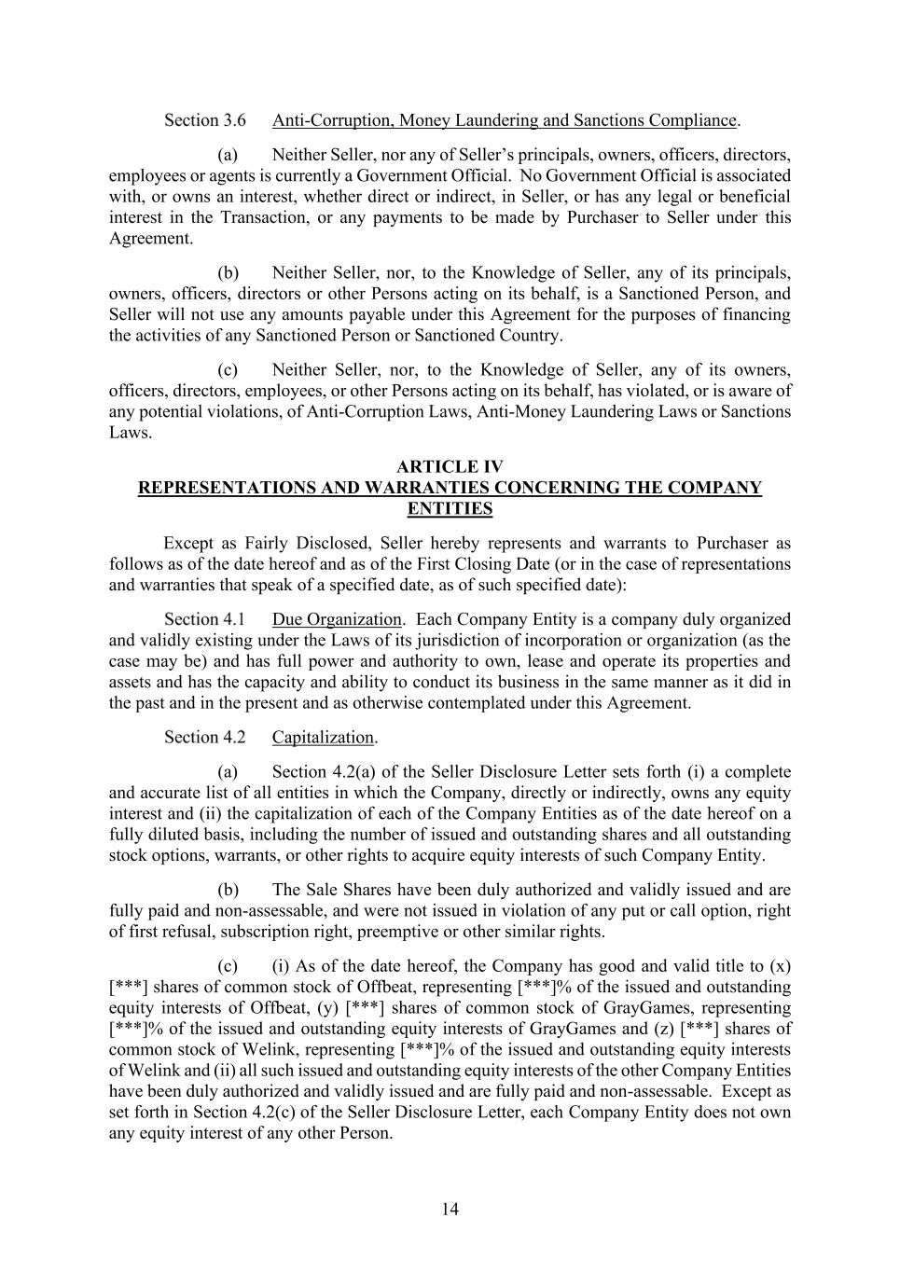
14 Anti-Corruption, Money Laundering and Sanctions Compliance. (a) Neither Seller, nor any of Seller’s principals, owners, officers, directors, employees or agents is currently a Government Official. No Government Official is associated with, or owns an interest, whether direct or indirect, in Seller, or has any legal or beneficial interest in the Transaction, or any payments to be made by Purchaser to Seller under this Agreement. (b) Neither Seller, nor, to the Knowledge of Seller, any of its principals, owners, officers, directors or other Persons acting on its behalf, is a Sanctioned Person, and Seller will not use any amounts payable under this Agreement for the purposes of financing the activities of any Sanctioned Person or Sanctioned Country. (c) Neither Seller, nor, to the Knowledge of Seller, any of its owners, officers, directors, employees, or other Persons acting on its behalf, has violated, or is aware of any potential violations, of Anti-Corruption Laws, Anti-Money Laundering Laws or Sanctions Laws. ARTICLE IV REPRESENTATIONS AND WARRANTIES CONCERNING THE COMPANY ENTITIES Except as Fairly Disclosed, Seller hereby represents and warrants to Purchaser as follows as of the date hereof and as of the First Closing Date (or in the case of representations and warranties that speak of a specified date, as of such specified date): Due Organization. Each Company Entity is a company duly organized and validly existing under the Laws of its jurisdiction of incorporation or organization (as the case may be) and has full power and authority to own, lease and operate its properties and assets and has the capacity and ability to conduct its business in the same manner as it did in the past and in the present and as otherwise contemplated under this Agreement. Capitalization. (a) Section 4.2(a) of the Seller Disclosure Letter sets forth (i) a complete and accurate list of all entities in which the Company, directly or indirectly, owns any equity interest and (ii) the capitalization of each of the Company Entities as of the date hereof on a fully diluted basis, including the number of issued and outstanding shares and all outstanding stock options, warrants, or other rights to acquire equity interests of such Company Entity. (b) The Sale Shares have been duly authorized and validly issued and are fully paid and non-assessable, and were not issued in violation of any put or call option, right of first refusal, subscription right, preemptive or other similar rights. (c) (i) As of the date hereof, the Company has good and valid title to (x) [***] shares of common stock of Offbeat, representing [***]% of the issued and outstanding equity interests of Offbeat, (y) [***] shares of common stock of GrayGames, representing [***]% of the issued and outstanding equity interests of GrayGames and (z) [***] shares of common stock of Welink, representing [***]% of the issued and outstanding equity interests of Welink and (ii) all such issued and outstanding equity interests of the other Company Entities have been duly authorized and validly issued and are fully paid and non-assessable. Except as set forth in Section 4.2(c) of the Seller Disclosure Letter, each Company Entity does not own any equity interest of any other Person.

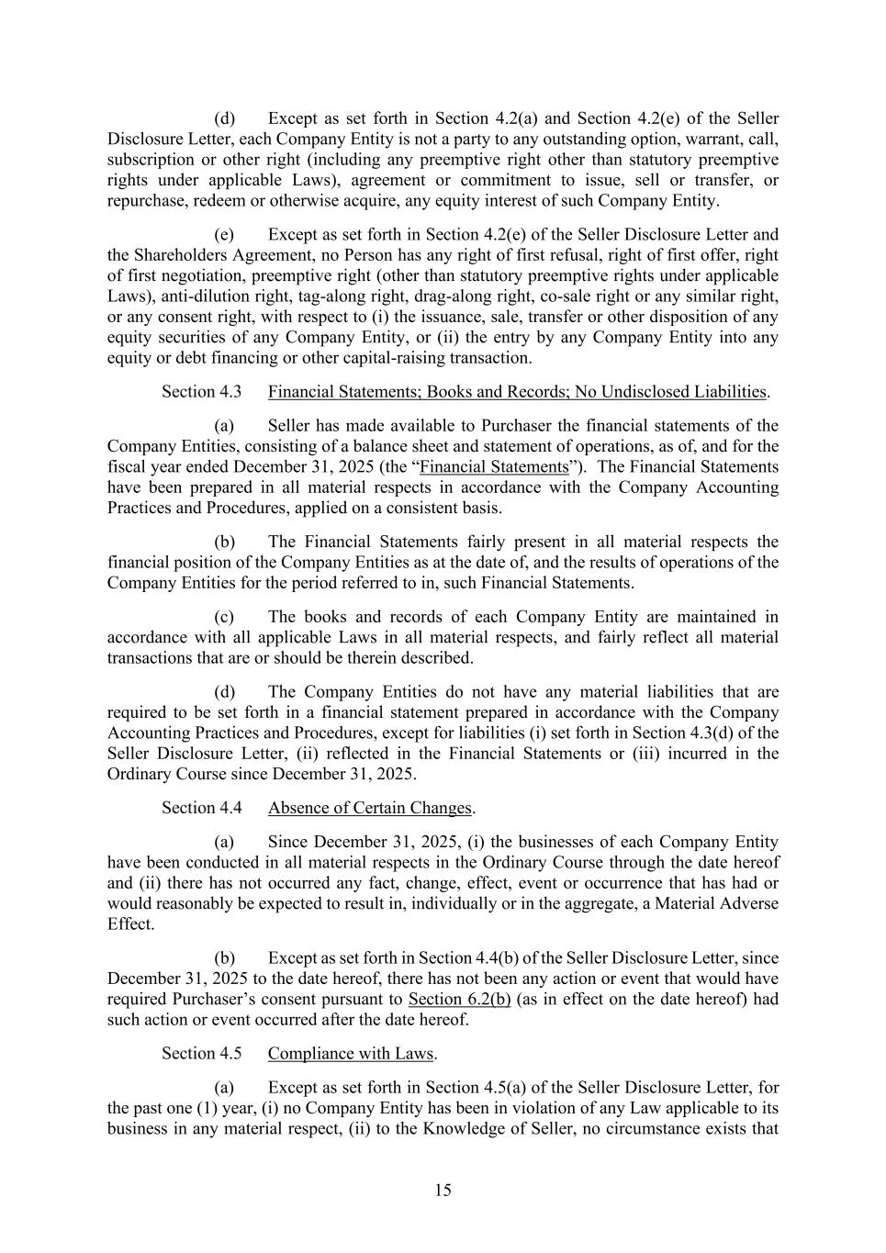
15 (d) Except as set forth in Section 4.2(a) and Section 4.2(e) of the Seller Disclosure Letter, each Company Entity is not a party to any outstanding option, warrant, call, subscription or other right (including any preemptive right other than statutory preemptive rights under applicable Laws), agreement or commitment to issue, sell or transfer, or repurchase, redeem or otherwise acquire, any equity interest of such Company Entity. (e) Except as set forth in Section 4.2(e) of the Seller Disclosure Letter and the Shareholders Agreement, no Person has any right of first refusal, right of first offer, right of first negotiation, preemptive right (other than statutory preemptive rights under applicable Laws), anti-dilution right, tag-along right, drag-along right, co-sale right or any similar right, or any consent right, with respect to (i) the issuance, sale, transfer or other disposition of any equity securities of any Company Entity, or (ii) the entry by any Company Entity into any equity or debt financing or other capital-raising transaction. Financial Statements; Books and Records; No Undisclosed Liabilities. (a) Seller has made available to Purchaser the financial statements of the Company Entities, consisting of a balance sheet and statement of operations, as of, and for the fiscal year ended December 31, 2025 (the “Financial Statements”). The Financial Statements have been prepared in all material respects in accordance with the Company Accounting Practices and Procedures, applied on a consistent basis. (b) The Financial Statements fairly present in all material respects the financial position of the Company Entities as at the date of, and the results of operations of the Company Entities for the period referred to in, such Financial Statements. (c) The books and records of each Company Entity are maintained in accordance with all applicable Laws in all material respects, and fairly reflect all material transactions that are or should be therein described. (d) The Company Entities do not have any material liabilities that are required to be set forth in a financial statement prepared in accordance with the Company Accounting Practices and Procedures, except for liabilities (i) set forth in Section 4.3(d) of the Seller Disclosure Letter, (ii) reflected in the Financial Statements or (iii) incurred in the Ordinary Course since December 31, 2025. Absence of Certain Changes. (a) Since December 31, 2025, (i) the businesses of each Company Entity have been conducted in all material respects in the Ordinary Course through the date hereof and (ii) there has not occurred any fact, change, effect, event or occurrence that has had or would reasonably be expected to result in, individually or in the aggregate, a Material Adverse Effect. (b) Except as set forth in Section 4.4(b) of the Seller Disclosure Letter, since December 31, 2025 to the date hereof, there has not been any action or event that would have required Purchaser’s consent pursuant to Section 6.2(b) (as in effect on the date hereof) had such action or event occurred after the date hereof. Compliance with Laws. (a) Except as set forth in Section 4.5(a) of the Seller Disclosure Letter, for the past one (1) year, (i) no Company Entity has been in violation of any Law applicable to its business in any material respect, (ii) to the Knowledge of Seller, no circumstance exists that

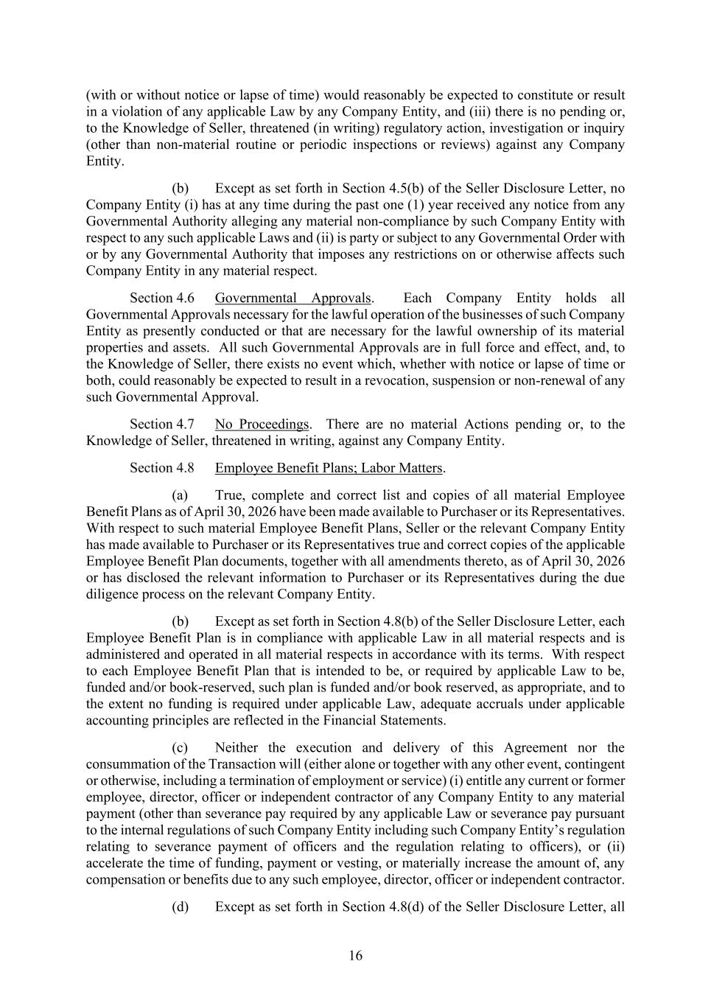
16 (with or without notice or lapse of time) would reasonably be expected to constitute or result in a violation of any applicable Law by any Company Entity, and (iii) there is no pending or, to the Knowledge of Seller, threatened (in writing) regulatory action, investigation or inquiry (other than non-material routine or periodic inspections or reviews) against any Company Entity. (b) Except as set forth in Section 4.5(b) of the Seller Disclosure Letter, no Company Entity (i) has at any time during the past one (1) year received any notice from any Governmental Authority alleging any material non-compliance by such Company Entity with respect to any such applicable Laws and (ii) is party or subject to any Governmental Order with or by any Governmental Authority that imposes any restrictions on or otherwise affects such Company Entity in any material respect. Governmental Approvals. Each Company Entity holds all Governmental Approvals necessary for the lawful operation of the businesses of such Company Entity as presently conducted or that are necessary for the lawful ownership of its material properties and assets. All such Governmental Approvals are in full force and effect, and, to the Knowledge of Seller, there exists no event which, whether with notice or lapse of time or both, could reasonably be expected to result in a revocation, suspension or non-renewal of any such Governmental Approval. No Proceedings. There are no material Actions pending or, to the Knowledge of Seller, threatened in writing, against any Company Entity. Employee Benefit Plans; Labor Matters. (a) True, complete and correct list and copies of all material Employee Benefit Plans as of April 30, 2026 have been made available to Purchaser or its Representatives. With respect to such material Employee Benefit Plans, Seller or the relevant Company Entity has made available to Purchaser or its Representatives true and correct copies of the applicable Employee Benefit Plan documents, together with all amendments thereto, as of April 30, 2026 or has disclosed the relevant information to Purchaser or its Representatives during the due diligence process on the relevant Company Entity. (b) Except as set forth in Section 4.8(b) of the Seller Disclosure Letter, each Employee Benefit Plan is in compliance with applicable Law in all material respects and is administered and operated in all material respects in accordance with its terms. With respect to each Employee Benefit Plan that is intended to be, or required by applicable Law to be, funded and/or book-reserved, such plan is funded and/or book reserved, as appropriate, and to the extent no funding is required under applicable Law, adequate accruals under applicable accounting principles are reflected in the Financial Statements. (c) Neither the execution and delivery of this Agreement nor the consummation of the Transaction will (either alone or together with any other event, contingent or otherwise, including a termination of employment or service) (i) entitle any current or former employee, director, officer or independent contractor of any Company Entity to any material payment (other than severance pay required by any applicable Law or severance pay pursuant to the internal regulations of such Company Entity including such Company Entity’s regulation relating to severance payment of officers and the regulation relating to officers), or (ii) accelerate the time of funding, payment or vesting, or materially increase the amount of, any compensation or benefits due to any such employee, director, officer or independent contractor. (d) Except as set forth in Section 4.8(d) of the Seller Disclosure Letter, all

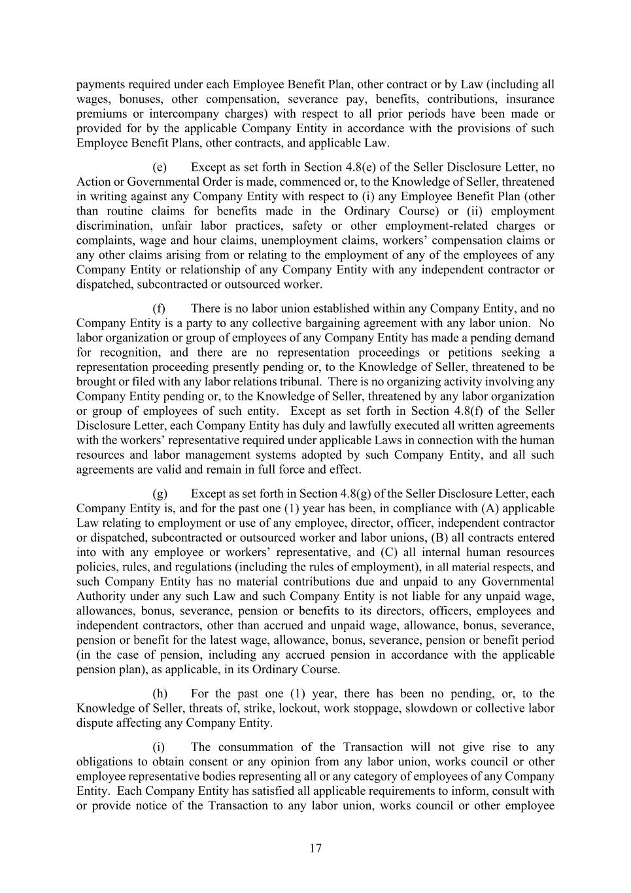
17 payments required under each Employee Benefit Plan, other contract or by Law (including all wages, bonuses, other compensation, severance pay, benefits, contributions, insurance premiums or intercompany charges) with respect to all prior periods have been made or provided for by the applicable Company Entity in accordance with the provisions of such Employee Benefit Plans, other contracts, and applicable Law. (e) Except as set forth in Section 4.8(e) of the Seller Disclosure Letter, no Action or Governmental Order is made, commenced or, to the Knowledge of Seller, threatened in writing against any Company Entity with respect to (i) any Employee Benefit Plan (other than routine claims for benefits made in the Ordinary Course) or (ii) employment discrimination, unfair labor practices, safety or other employment-related charges or complaints, wage and hour claims, unemployment claims, workers’ compensation claims or any other claims arising from or relating to the employment of any of the employees of any Company Entity or relationship of any Company Entity with any independent contractor or dispatched, subcontracted or outsourced worker. (f) There is no labor union established within any Company Entity, and no Company Entity is a party to any collective bargaining agreement with any labor union. No labor organization or group of employees of any Company Entity has made a pending demand for recognition, and there are no representation proceedings or petitions seeking a representation proceeding presently pending or, to the Knowledge of Seller, threatened to be brought or filed with any labor relations tribunal. There is no organizing activity involving any Company Entity pending or, to the Knowledge of Seller, threatened by any labor organization or group of employees of such entity. Except as set forth in Section 4.8(f) of the Seller Disclosure Letter, each Company Entity has duly and lawfully executed all written agreements with the workers’ representative required under applicable Laws in connection with the human resources and labor management systems adopted by such Company Entity, and all such agreements are valid and remain in full force and effect. (g) Except as set forth in Section 4.8(g) of the Seller Disclosure Letter, each Company Entity is, and for the past one (1) year has been, in compliance with (A) applicable Law relating to employment or use of any employee, director, officer, independent contractor or dispatched, subcontracted or outsourced worker and labor unions, (B) all contracts entered into with any employee or workers’ representative, and (C) all internal human resources policies, rules, and regulations (including the rules of employment), in all material respects, and such Company Entity has no material contributions due and unpaid to any Governmental Authority under any such Law and such Company Entity is not liable for any unpaid wage, allowances, bonus, severance, pension or benefits to its directors, officers, employees and independent contractors, other than accrued and unpaid wage, allowance, bonus, severance, pension or benefit for the latest wage, allowance, bonus, severance, pension or benefit period (in the case of pension, including any accrued pension in accordance with the applicable pension plan), as applicable, in its Ordinary Course. (h) For the past one (1) year, there has been no pending, or, to the Knowledge of Seller, threats of, strike, lockout, work stoppage, slowdown or collective labor dispute affecting any Company Entity. (i) The consummation of the Transaction will not give rise to any obligations to obtain consent or any opinion from any labor union, works council or other employee representative bodies representing all or any category of employees of any Company Entity. Each Company Entity has satisfied all applicable requirements to inform, consult with or provide notice of the Transaction to any labor union, works council or other employee

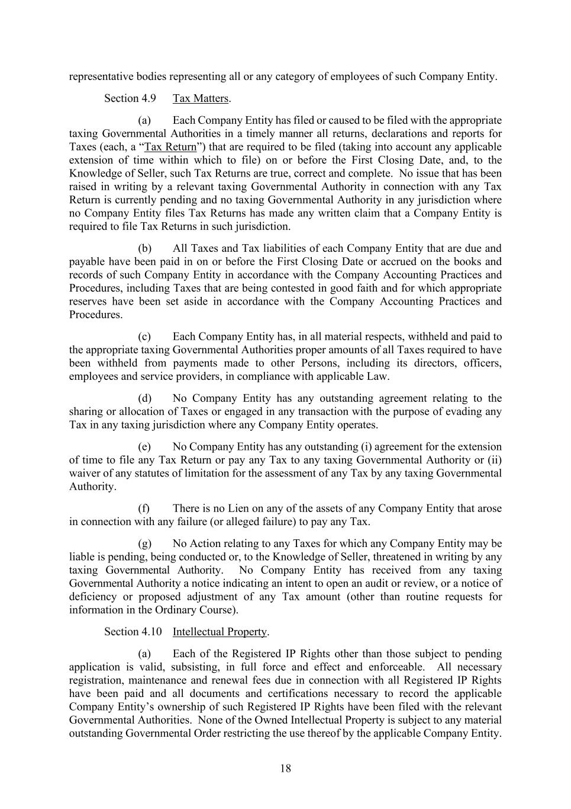
18 representative bodies representing all or any category of employees of such Company Entity. Tax Matters. (a) Each Company Entity has filed or caused to be filed with the appropriate taxing Governmental Authorities in a timely manner all returns, declarations and reports for Taxes (each, a “Tax Return”) that are required to be filed (taking into account any applicable extension of time within which to file) on or before the First Closing Date, and, to the Knowledge of Seller, such Tax Returns are true, correct and complete. No issue that has been raised in writing by a relevant taxing Governmental Authority in connection with any Tax Return is currently pending and no taxing Governmental Authority in any jurisdiction where no Company Entity files Tax Returns has made any written claim that a Company Entity is required to file Tax Returns in such jurisdiction. (b) All Taxes and Tax liabilities of each Company Entity that are due and payable have been paid in on or before the First Closing Date or accrued on the books and records of such Company Entity in accordance with the Company Accounting Practices and Procedures, including Taxes that are being contested in good faith and for which appropriate reserves have been set aside in accordance with the Company Accounting Practices and Procedures. (c) Each Company Entity has, in all material respects, withheld and paid to the appropriate taxing Governmental Authorities proper amounts of all Taxes required to have been withheld from payments made to other Persons, including its directors, officers, employees and service providers, in compliance with applicable Law. (d) No Company Entity has any outstanding agreement relating to the sharing or allocation of Taxes or engaged in any transaction with the purpose of evading any Tax in any taxing jurisdiction where any Company Entity operates. (e) No Company Entity has any outstanding (i) agreement for the extension of time to file any Tax Return or pay any Tax to any taxing Governmental Authority or (ii) waiver of any statutes of limitation for the assessment of any Tax by any taxing Governmental Authority. (f) There is no Lien on any of the assets of any Company Entity that arose in connection with any failure (or alleged failure) to pay any Tax. (g) No Action relating to any Taxes for which any Company Entity may be liable is pending, being conducted or, to the Knowledge of Seller, threatened in writing by any taxing Governmental Authority. No Company Entity has received from any taxing Governmental Authority a notice indicating an intent to open an audit or review, or a notice of deficiency or proposed adjustment of any Tax amount (other than routine requests for information in the Ordinary Course). Intellectual Property. (a) Each of the Registered IP Rights other than those subject to pending application is valid, subsisting, in full force and effect and enforceable. All necessary registration, maintenance and renewal fees due in connection with all Registered IP Rights have been paid and all documents and certifications necessary to record the applicable Company Entity’s ownership of such Registered IP Rights have been filed with the relevant Governmental Authorities. None of the Owned Intellectual Property is subject to any material outstanding Governmental Order restricting the use thereof by the applicable Company Entity.

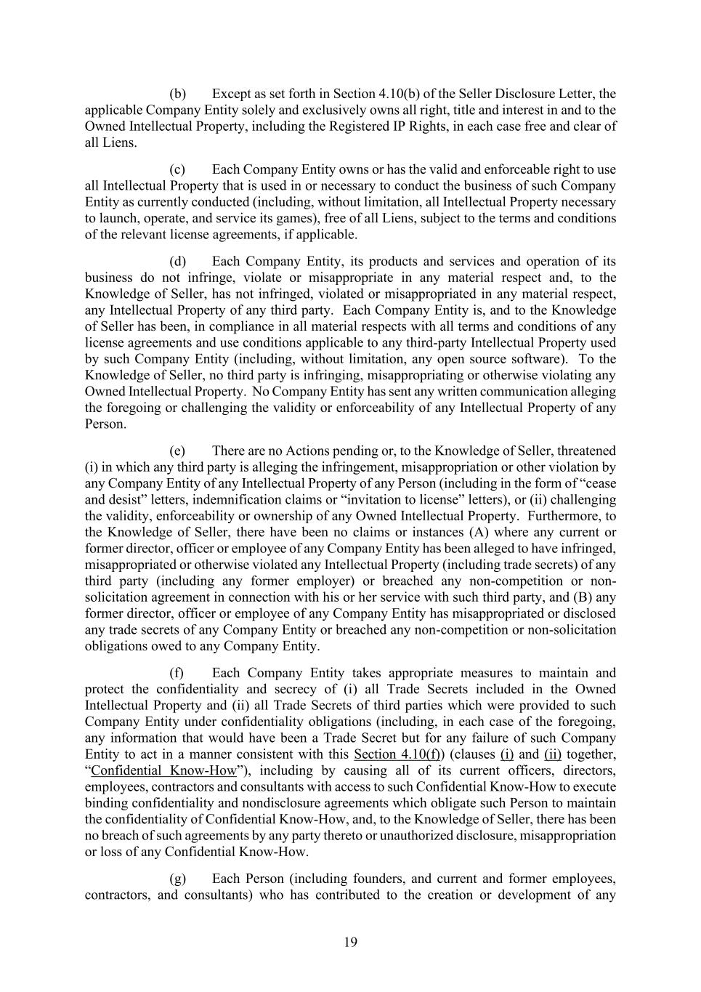
19 (b) Except as set forth in Section 4.10(b) of the Seller Disclosure Letter, the applicable Company Entity solely and exclusively owns all right, title and interest in and to the Owned Intellectual Property, including the Registered IP Rights, in each case free and clear of all Liens. (c) Each Company Entity owns or has the valid and enforceable right to use all Intellectual Property that is used in or necessary to conduct the business of such Company Entity as currently conducted (including, without limitation, all Intellectual Property necessary to launch, operate, and service its games), free of all Liens, subject to the terms and conditions of the relevant license agreements, if applicable. (d) Each Company Entity, its products and services and operation of its business do not infringe, violate or misappropriate in any material respect and, to the Knowledge of Seller, has not infringed, violated or misappropriated in any material respect, any Intellectual Property of any third party. Each Company Entity is, and to the Knowledge of Seller has been, in compliance in all material respects with all terms and conditions of any license agreements and use conditions applicable to any third-party Intellectual Property used by such Company Entity (including, without limitation, any open source software). To the Knowledge of Seller, no third party is infringing, misappropriating or otherwise violating any Owned Intellectual Property. No Company Entity has sent any written communication alleging the foregoing or challenging the validity or enforceability of any Intellectual Property of any Person. (e) There are no Actions pending or, to the Knowledge of Seller, threatened (i) in which any third party is alleging the infringement, misappropriation or other violation by any Company Entity of any Intellectual Property of any Person (including in the form of “cease and desist” letters, indemnification claims or “invitation to license” letters), or (ii) challenging the validity, enforceability or ownership of any Owned Intellectual Property. Furthermore, to the Knowledge of Seller, there have been no claims or instances (A) where any current or former director, officer or employee of any Company Entity has been alleged to have infringed, misappropriated or otherwise violated any Intellectual Property (including trade secrets) of any third party (including any former employer) or breached any non-competition or non- solicitation agreement in connection with his or her service with such third party, and (B) any former director, officer or employee of any Company Entity has misappropriated or disclosed any trade secrets of any Company Entity or breached any non-competition or non-solicitation obligations owed to any Company Entity. (f) Each Company Entity takes appropriate measures to maintain and protect the confidentiality and secrecy of (i) all Trade Secrets included in the Owned Intellectual Property and (ii) all Trade Secrets of third parties which were provided to such Company Entity under confidentiality obligations (including, in each case of the foregoing, any information that would have been a Trade Secret but for any failure of such Company Entity to act in a manner consistent with this Section 4.10(f)) (clauses (i) and (ii) together, “Confidential Know-How”), including by causing all of its current officers, directors, employees, contractors and consultants with access to such Confidential Know-How to execute binding confidentiality and nondisclosure agreements which obligate such Person to maintain the confidentiality of Confidential Know-How, and, to the Knowledge of Seller, there has been no breach of such agreements by any party thereto or unauthorized disclosure, misappropriation or loss of any Confidential Know-How. (g) Each Person (including founders, and current and former employees, contractors, and consultants) who has contributed to the creation or development of any

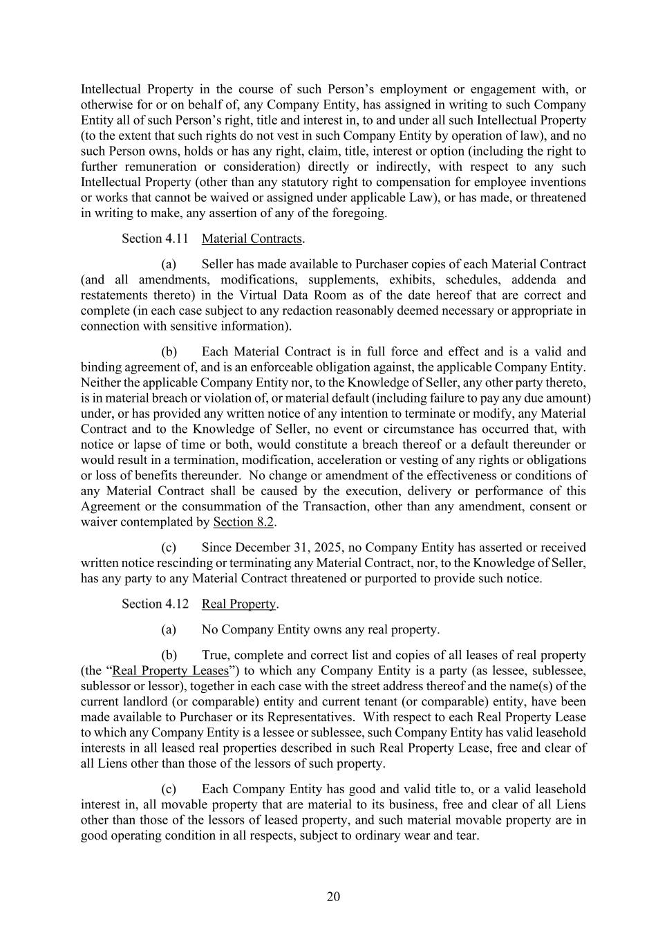
20 Intellectual Property in the course of such Person’s employment or engagement with, or otherwise for or on behalf of, any Company Entity, has assigned in writing to such Company Entity all of such Person’s right, title and interest in, to and under all such Intellectual Property (to the extent that such rights do not vest in such Company Entity by operation of law), and no such Person owns, holds or has any right, claim, title, interest or option (including the right to further remuneration or consideration) directly or indirectly, with respect to any such Intellectual Property (other than any statutory right to compensation for employee inventions or works that cannot be waived or assigned under applicable Law), or has made, or threatened in writing to make, any assertion of any of the foregoing. Material Contracts. (a) Seller has made available to Purchaser copies of each Material Contract (and all amendments, modifications, supplements, exhibits, schedules, addenda and restatements thereto) in the Virtual Data Room as of the date hereof that are correct and complete (in each case subject to any redaction reasonably deemed necessary or appropriate in connection with sensitive information). (b) Each Material Contract is in full force and effect and is a valid and binding agreement of, and is an enforceable obligation against, the applicable Company Entity. Neither the applicable Company Entity nor, to the Knowledge of Seller, any other party thereto, is in material breach or violation of, or material default (including failure to pay any due amount) under, or has provided any written notice of any intention to terminate or modify, any Material Contract and to the Knowledge of Seller, no event or circumstance has occurred that, with notice or lapse of time or both, would constitute a breach thereof or a default thereunder or would result in a termination, modification, acceleration or vesting of any rights or obligations or loss of benefits thereunder. No change or amendment of the effectiveness or conditions of any Material Contract shall be caused by the execution, delivery or performance of this Agreement or the consummation of the Transaction, other than any amendment, consent or waiver contemplated by Section 8.2. (c) Since December 31, 2025, no Company Entity has asserted or received written notice rescinding or terminating any Material Contract, nor, to the Knowledge of Seller, has any party to any Material Contract threatened or purported to provide such notice. Real Property. (a) No Company Entity owns any real property. (b) True, complete and correct list and copies of all leases of real property (the “Real Property Leases”) to which any Company Entity is a party (as lessee, sublessee, sublessor or lessor), together in each case with the street address thereof and the name(s) of the current landlord (or comparable) entity and current tenant (or comparable) entity, have been made available to Purchaser or its Representatives. With respect to each Real Property Lease to which any Company Entity is a lessee or sublessee, such Company Entity has valid leasehold interests in all leased real properties described in such Real Property Lease, free and clear of all Liens other than those of the lessors of such property. (c) Each Company Entity has good and valid title to, or a valid leasehold interest in, all movable property that are material to its business, free and clear of all Liens other than those of the lessors of leased property, and such material movable property are in good operating condition in all respects, subject to ordinary wear and tear.

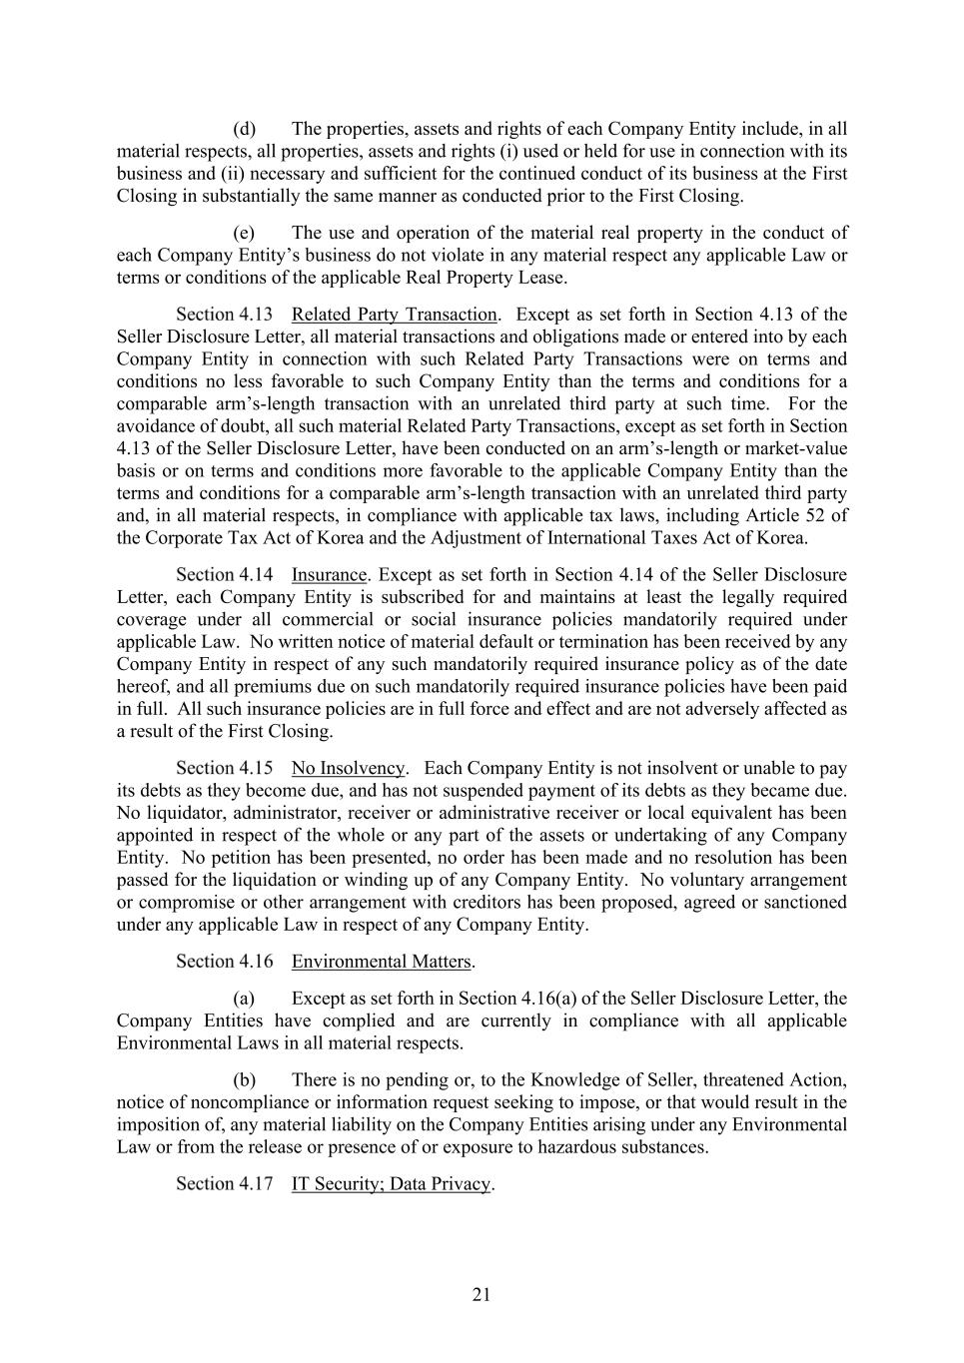
21 (d) The properties, assets and rights of each Company Entity include, in all material respects, all properties, assets and rights (i) used or held for use in connection with its business and (ii) necessary and sufficient for the continued conduct of its business at the First Closing in substantially the same manner as conducted prior to the First Closing. (e) The use and operation of the material real property in the conduct of each Company Entity’s business do not violate in any material respect any applicable Law or terms or conditions of the applicable Real Property Lease. Related Party Transaction. Except as set forth in Section 4.13 of the Seller Disclosure Letter, all material transactions and obligations made or entered into by each Company Entity in connection with such Related Party Transactions were on terms and conditions no less favorable to such Company Entity than the terms and conditions for a comparable arm’s-length transaction with an unrelated third party at such time. For the avoidance of doubt, all such material Related Party Transactions, except as set forth in Section 4.13 of the Seller Disclosure Letter, have been conducted on an arm’s-length or market-value basis or on terms and conditions more favorable to the applicable Company Entity than the terms and conditions for a comparable arm’s-length transaction with an unrelated third party and, in all material respects, in compliance with applicable tax laws, including Article 52 of the Corporate Tax Act of Korea and the Adjustment of International Taxes Act of Korea. Insurance. Except as set forth in Section 4.14 of the Seller Disclosure Letter, each Company Entity is subscribed for and maintains at least the legally required coverage under all commercial or social insurance policies mandatorily required under applicable Law. No written notice of material default or termination has been received by any Company Entity in respect of any such mandatorily required insurance policy as of the date hereof, and all premiums due on such mandatorily required insurance policies have been paid in full. All such insurance policies are in full force and effect and are not adversely affected as a result of the First Closing. No Insolvency. Each Company Entity is not insolvent or unable to pay its debts as they become due, and has not suspended payment of its debts as they became due. No liquidator, administrator, receiver or administrative receiver or local equivalent has been appointed in respect of the whole or any part of the assets or undertaking of any Company Entity. No petition has been presented, no order has been made and no resolution has been passed for the liquidation or winding up of any Company Entity. No voluntary arrangement or compromise or other arrangement with creditors has been proposed, agreed or sanctioned under any applicable Law in respect of any Company Entity. Environmental Matters. (a) Except as set forth in Section 4.16(a) of the Seller Disclosure Letter, the Company Entities have complied and are currently in compliance with all applicable Environmental Laws in all material respects. (b) There is no pending or, to the Knowledge of Seller, threatened Action, notice of noncompliance or information request seeking to impose, or that would result in the imposition of, any material liability on the Company Entities arising under any Environmental Law or from the release or presence of or exposure to hazardous substances. IT Security; Data Privacy.

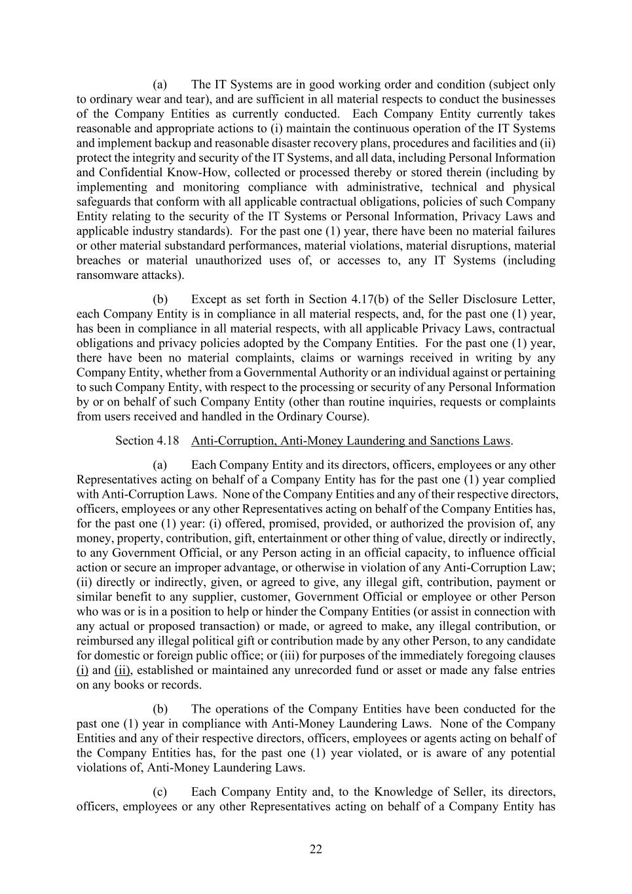
22 (a) The IT Systems are in good working order and condition (subject only to ordinary wear and tear), and are sufficient in all material respects to conduct the businesses of the Company Entities as currently conducted. Each Company Entity currently takes reasonable and appropriate actions to (i) maintain the continuous operation of the IT Systems and implement backup and reasonable disaster recovery plans, procedures and facilities and (ii) protect the integrity and security of the IT Systems, and all data, including Personal Information and Confidential Know-How, collected or processed thereby or stored therein (including by implementing and monitoring compliance with administrative, technical and physical safeguards that conform with all applicable contractual obligations, policies of such Company Entity relating to the security of the IT Systems or Personal Information, Privacy Laws and applicable industry standards). For the past one (1) year, there have been no material failures or other material substandard performances, material violations, material disruptions, material breaches or material unauthorized uses of, or accesses to, any IT Systems (including ransomware attacks). (b) Except as set forth in Section 4.17(b) of the Seller Disclosure Letter, each Company Entity is in compliance in all material respects, and, for the past one (1) year, has been in compliance in all material respects, with all applicable Privacy Laws, contractual obligations and privacy policies adopted by the Company Entities. For the past one (1) year, there have been no material complaints, claims or warnings received in writing by any Company Entity, whether from a Governmental Authority or an individual against or pertaining to such Company Entity, with respect to the processing or security of any Personal Information by or on behalf of such Company Entity (other than routine inquiries, requests or complaints from users received and handled in the Ordinary Course). Anti-Corruption, Anti-Money Laundering and Sanctions Laws. (a) Each Company Entity and its directors, officers, employees or any other Representatives acting on behalf of a Company Entity has for the past one (1) year complied with Anti-Corruption Laws. None of the Company Entities and any of their respective directors, officers, employees or any other Representatives acting on behalf of the Company Entities has, for the past one (1) year: (i) offered, promised, provided, or authorized the provision of, any money, property, contribution, gift, entertainment or other thing of value, directly or indirectly, to any Government Official, or any Person acting in an official capacity, to influence official action or secure an improper advantage, or otherwise in violation of any Anti-Corruption Law; (ii) directly or indirectly, given, or agreed to give, any illegal gift, contribution, payment or similar benefit to any supplier, customer, Government Official or employee or other Person who was or is in a position to help or hinder the Company Entities (or assist in connection with any actual or proposed transaction) or made, or agreed to make, any illegal contribution, or reimbursed any illegal political gift or contribution made by any other Person, to any candidate for domestic or foreign public office; or (iii) for purposes of the immediately foregoing clauses (i) and (ii), established or maintained any unrecorded fund or asset or made any false entries on any books or records. (b) The operations of the Company Entities have been conducted for the past one (1) year in compliance with Anti-Money Laundering Laws. None of the Company Entities and any of their respective directors, officers, employees or agents acting on behalf of the Company Entities has, for the past one (1) year violated, or is aware of any potential violations of, Anti-Money Laundering Laws. (c) Each Company Entity and, to the Knowledge of Seller, its directors, officers, employees or any other Representatives acting on behalf of a Company Entity has

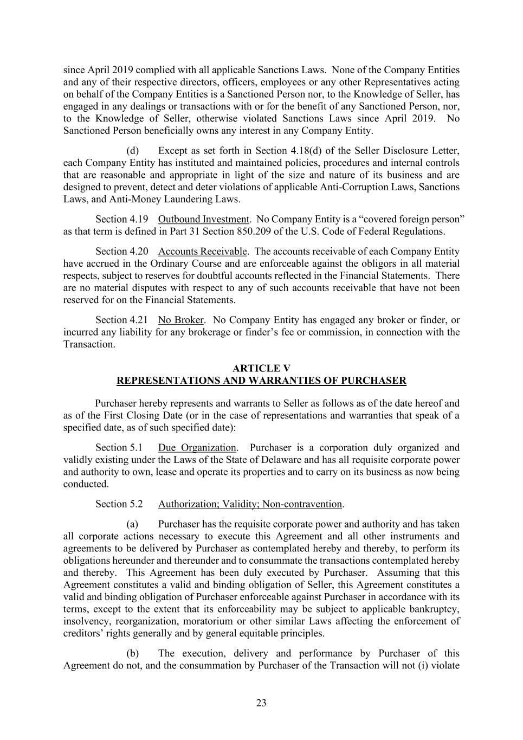
23 since April 2019 complied with all applicable Sanctions Laws. None of the Company Entities and any of their respective directors, officers, employees or any other Representatives acting on behalf of the Company Entities is a Sanctioned Person nor, to the Knowledge of Seller, has engaged in any dealings or transactions with or for the benefit of any Sanctioned Person, nor, to the Knowledge of Seller, otherwise violated Sanctions Laws since April 2019. No Sanctioned Person beneficially owns any interest in any Company Entity. (d) Except as set forth in Section 4.18(d) of the Seller Disclosure Letter, each Company Entity has instituted and maintained policies, procedures and internal controls that are reasonable and appropriate in light of the size and nature of its business and are designed to prevent, detect and deter violations of applicable Anti-Corruption Laws, Sanctions Laws, and Anti-Money Laundering Laws. Outbound Investment. No Company Entity is a “covered foreign person” as that term is defined in Part 31 Section 850.209 of the U.S. Code of Federal Regulations. Accounts Receivable. The accounts receivable of each Company Entity have accrued in the Ordinary Course and are enforceable against the obligors in all material respects, subject to reserves for doubtful accounts reflected in the Financial Statements. There are no material disputes with respect to any of such accounts receivable that have not been reserved for on the Financial Statements. No Broker. No Company Entity has engaged any broker or finder, or incurred any liability for any brokerage or finder’s fee or commission, in connection with the Transaction. ARTICLE V REPRESENTATIONS AND WARRANTIES OF PURCHASER Purchaser hereby represents and warrants to Seller as follows as of the date hereof and as of the First Closing Date (or in the case of representations and warranties that speak of a specified date, as of such specified date): Due Organization. Purchaser is a corporation duly organized and validly existing under the Laws of the State of Delaware and has all requisite corporate power and authority to own, lease and operate its properties and to carry on its business as now being conducted. Authorization; Validity; Non-contravention. (a) Purchaser has the requisite corporate power and authority and has taken all corporate actions necessary to execute this Agreement and all other instruments and agreements to be delivered by Purchaser as contemplated hereby and thereby, to perform its obligations hereunder and thereunder and to consummate the transactions contemplated hereby and thereby. This Agreement has been duly executed by Purchaser. Assuming that this Agreement constitutes a valid and binding obligation of Seller, this Agreement constitutes a valid and binding obligation of Purchaser enforceable against Purchaser in accordance with its terms, except to the extent that its enforceability may be subject to applicable bankruptcy, insolvency, reorganization, moratorium or other similar Laws affecting the enforcement of creditors’ rights generally and by general equitable principles. (b) The execution, delivery and performance by Purchaser of this Agreement do not, and the consummation by Purchaser of the Transaction will not (i) violate

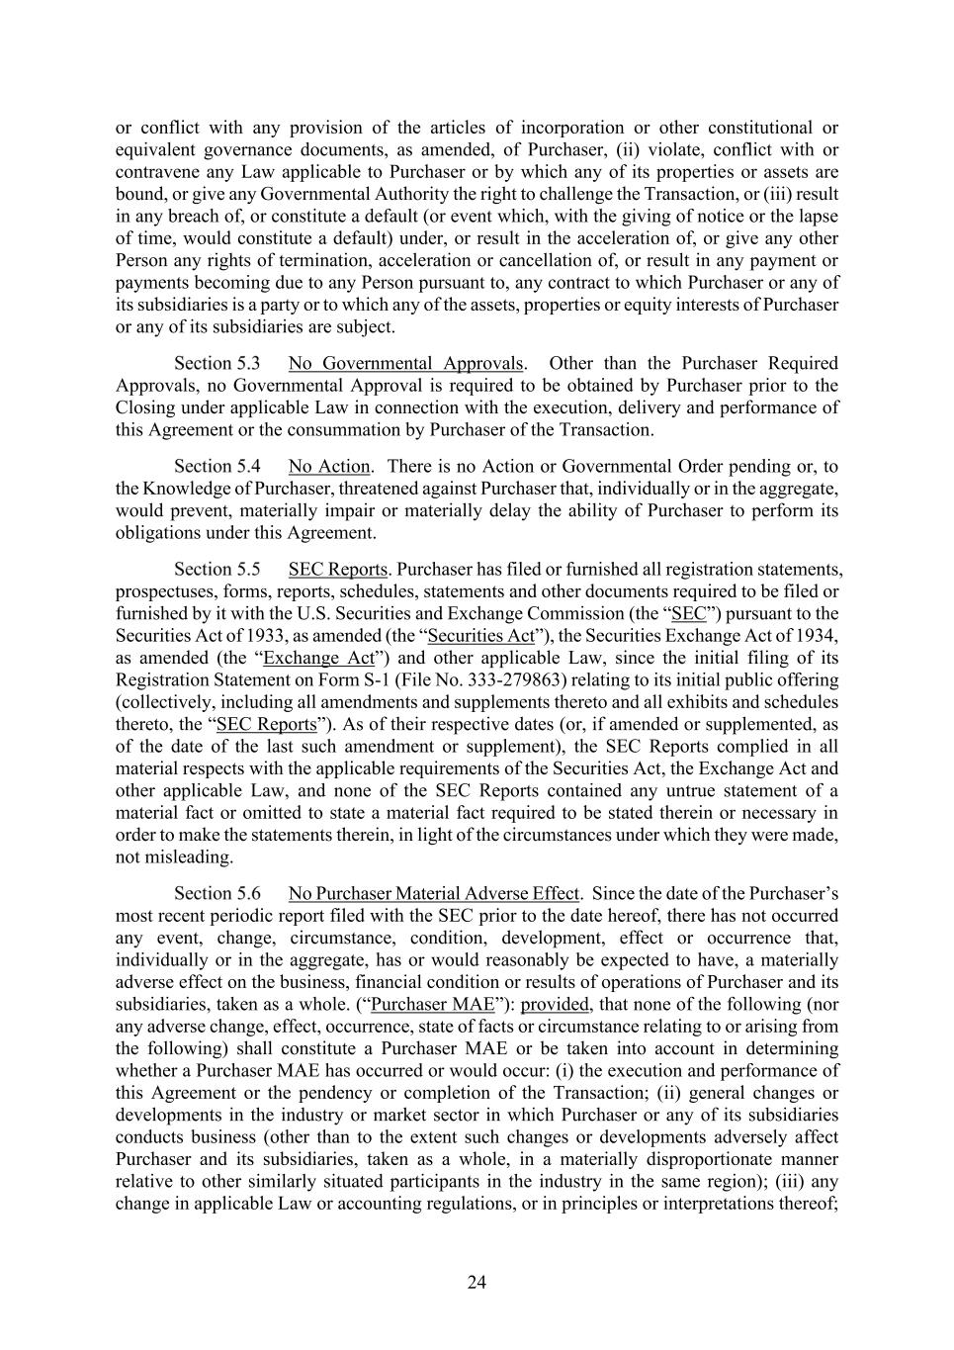
24 or conflict with any provision of the articles of incorporation or other constitutional or equivalent governance documents, as amended, of Purchaser, (ii) violate, conflict with or contravene any Law applicable to Purchaser or by which any of its properties or assets are bound, or give any Governmental Authority the right to challenge the Transaction, or (iii) result in any breach of, or constitute a default (or event which, with the giving of notice or the lapse of time, would constitute a default) under, or result in the acceleration of, or give any other Person any rights of termination, acceleration or cancellation of, or result in any payment or payments becoming due to any Person pursuant to, any contract to which Purchaser or any of its subsidiaries is a party or to which any of the assets, properties or equity interests of Purchaser or any of its subsidiaries are subject. No Governmental Approvals. Other than the Purchaser Required Approvals, no Governmental Approval is required to be obtained by Purchaser prior to the Closing under applicable Law in connection with the execution, delivery and performance of this Agreement or the consummation by Purchaser of the Transaction. No Action. There is no Action or Governmental Order pending or, to the Knowledge of Purchaser, threatened against Purchaser that, individually or in the aggregate, would prevent, materially impair or materially delay the ability of Purchaser to perform its obligations under this Agreement. SEC Reports. Purchaser has filed or furnished all registration statements, prospectuses, forms, reports, schedules, statements and other documents required to be filed or furnished by it with the U.S. Securities and Exchange Commission (the “SEC”) pursuant to the Securities Act of 1933, as amended (the “Securities Act”), the Securities Exchange Act of 1934, as amended (the “Exchange Act”) and other applicable Law, since the initial filing of its Registration Statement on Form S-1 (File No. 333-279863) relating to its initial public offering (collectively, including all amendments and supplements thereto and all exhibits and schedules thereto, the “SEC Reports”). As of their respective dates (or, if amended or supplemented, as of the date of the last such amendment or supplement), the SEC Reports complied in all material respects with the applicable requirements of the Securities Act, the Exchange Act and other applicable Law, and none of the SEC Reports contained any untrue statement of a material fact or omitted to state a material fact required to be stated therein or necessary in order to make the statements therein, in light of the circumstances under which they were made, not misleading. No Purchaser Material Adverse Effect. Since the date of the Purchaser’s most recent periodic report filed with the SEC prior to the date hereof, there has not occurred any event, change, circumstance, condition, development, effect or occurrence that, individually or in the aggregate, has or would reasonably be expected to have, a materially adverse effect on the business, financial condition or results of operations of Purchaser and its subsidiaries, taken as a whole. (“Purchaser MAE”): provided, that none of the following (nor any adverse change, effect, occurrence, state of facts or circumstance relating to or arising from the following) shall constitute a Purchaser MAE or be taken into account in determining whether a Purchaser MAE has occurred or would occur: (i) the execution and performance of this Agreement or the pendency or completion of the Transaction; (ii) general changes or developments in the industry or market sector in which Purchaser or any of its subsidiaries conducts business (other than to the extent such changes or developments adversely affect Purchaser and its subsidiaries, taken as a whole, in a materially disproportionate manner relative to other similarly situated participants in the industry in the same region); (iii) any change in applicable Law or accounting regulations, or in principles or interpretations thereof;

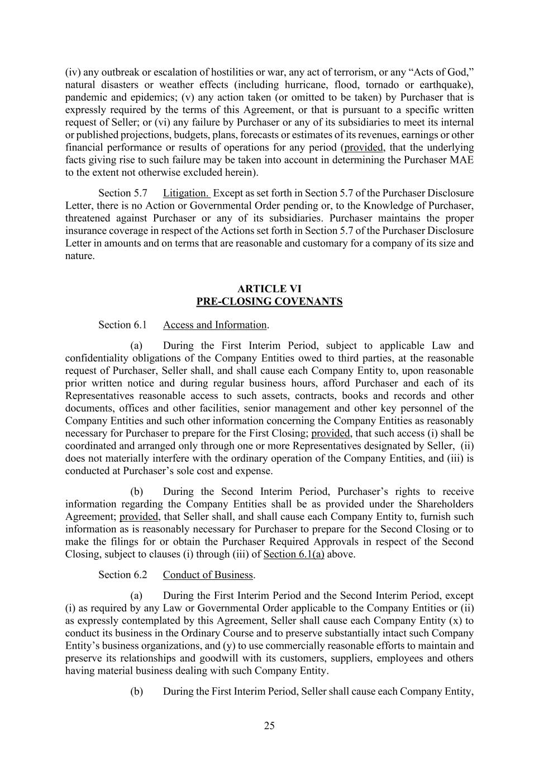
25 (iv) any outbreak or escalation of hostilities or war, any act of terrorism, or any “Acts of God,” natural disasters or weather effects (including hurricane, flood, tornado or earthquake), pandemic and epidemics; (v) any action taken (or omitted to be taken) by Purchaser that is expressly required by the terms of this Agreement, or that is pursuant to a specific written request of Seller; or (vi) any failure by Purchaser or any of its subsidiaries to meet its internal or published projections, budgets, plans, forecasts or estimates of its revenues, earnings or other financial performance or results of operations for any period (provided, that the underlying facts giving rise to such failure may be taken into account in determining the Purchaser MAE to the extent not otherwise excluded herein). Litigation. Except as set forth in Section 5.7 of the Purchaser Disclosure Letter, there is no Action or Governmental Order pending or, to the Knowledge of Purchaser, threatened against Purchaser or any of its subsidiaries. Purchaser maintains the proper insurance coverage in respect of the Actions set forth in Section 5.7 of the Purchaser Disclosure Letter in amounts and on terms that are reasonable and customary for a company of its size and nature. ARTICLE VI PRE-CLOSING COVENANTS Access and Information. (a) During the First Interim Period, subject to applicable Law and confidentiality obligations of the Company Entities owed to third parties, at the reasonable request of Purchaser, Seller shall, and shall cause each Company Entity to, upon reasonable prior written notice and during regular business hours, afford Purchaser and each of its Representatives reasonable access to such assets, contracts, books and records and other documents, offices and other facilities, senior management and other key personnel of the Company Entities and such other information concerning the Company Entities as reasonably necessary for Purchaser to prepare for the First Closing; provided, that such access (i) shall be coordinated and arranged only through one or more Representatives designated by Seller, (ii) does not materially interfere with the ordinary operation of the Company Entities, and (iii) is conducted at Purchaser’s sole cost and expense. (b) During the Second Interim Period, Purchaser’s rights to receive information regarding the Company Entities shall be as provided under the Shareholders Agreement; provided, that Seller shall, and shall cause each Company Entity to, furnish such information as is reasonably necessary for Purchaser to prepare for the Second Closing or to make the filings for or obtain the Purchaser Required Approvals in respect of the Second Closing, subject to clauses (i) through (iii) of Section 6.1(a) above. Conduct of Business. (a) During the First Interim Period and the Second Interim Period, except (i) as required by any Law or Governmental Order applicable to the Company Entities or (ii) as expressly contemplated by this Agreement, Seller shall cause each Company Entity (x) to conduct its business in the Ordinary Course and to preserve substantially intact such Company Entity’s business organizations, and (y) to use commercially reasonable efforts to maintain and preserve its relationships and goodwill with its customers, suppliers, employees and others having material business dealing with such Company Entity. (b) During the First Interim Period, Seller shall cause each Company Entity,

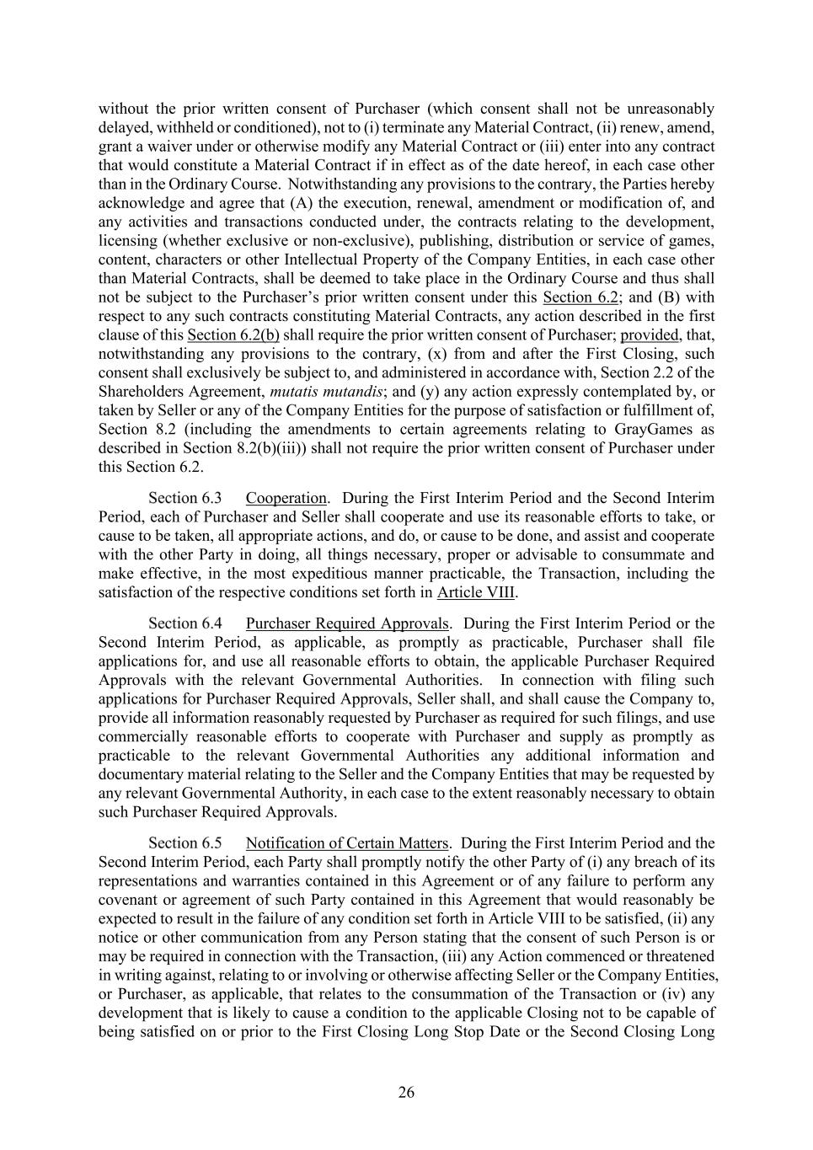
26 without the prior written consent of Purchaser (which consent shall not be unreasonably delayed, withheld or conditioned), not to (i) terminate any Material Contract, (ii) renew, amend, grant a waiver under or otherwise modify any Material Contract or (iii) enter into any contract that would constitute a Material Contract if in effect as of the date hereof, in each case other than in the Ordinary Course. Notwithstanding any provisions to the contrary, the Parties hereby acknowledge and agree that (A) the execution, renewal, amendment or modification of, and any activities and transactions conducted under, the contracts relating to the development, licensing (whether exclusive or non-exclusive), publishing, distribution or service of games, content, characters or other Intellectual Property of the Company Entities, in each case other than Material Contracts, shall be deemed to take place in the Ordinary Course and thus shall not be subject to the Purchaser’s prior written consent under this Section 6.2; and (B) with respect to any such contracts constituting Material Contracts, any action described in the first clause of this Section 6.2(b) shall require the prior written consent of Purchaser; provided, that, notwithstanding any provisions to the contrary, (x) from and after the First Closing, such consent shall exclusively be subject to, and administered in accordance with, Section 2.2 of the Shareholders Agreement, mutatis mutandis; and (y) any action expressly contemplated by, or taken by Seller or any of the Company Entities for the purpose of satisfaction or fulfillment of, Section 8.2 (including the amendments to certain agreements relating to GrayGames as described in Section 8.2(b)(iii)) shall not require the prior written consent of Purchaser under this Section 6.2. Cooperation. During the First Interim Period and the Second Interim Period, each of Purchaser and Seller shall cooperate and use its reasonable efforts to take, or cause to be taken, all appropriate actions, and do, or cause to be done, and assist and cooperate with the other Party in doing, all things necessary, proper or advisable to consummate and make effective, in the most expeditious manner practicable, the Transaction, including the satisfaction of the respective conditions set forth in Article VIII. Purchaser Required Approvals. During the First Interim Period or the Second Interim Period, as applicable, as promptly as practicable, Purchaser shall file applications for, and use all reasonable efforts to obtain, the applicable Purchaser Required Approvals with the relevant Governmental Authorities. In connection with filing such applications for Purchaser Required Approvals, Seller shall, and shall cause the Company to, provide all information reasonably requested by Purchaser as required for such filings, and use commercially reasonable efforts to cooperate with Purchaser and supply as promptly as practicable to the relevant Governmental Authorities any additional information and documentary material relating to the Seller and the Company Entities that may be requested by any relevant Governmental Authority, in each case to the extent reasonably necessary to obtain such Purchaser Required Approvals. Notification of Certain Matters. During the First Interim Period and the Second Interim Period, each Party shall promptly notify the other Party of (i) any breach of its representations and warranties contained in this Agreement or of any failure to perform any covenant or agreement of such Party contained in this Agreement that would reasonably be expected to result in the failure of any condition set forth in Article VIII to be satisfied, (ii) any notice or other communication from any Person stating that the consent of such Person is or may be required in connection with the Transaction, (iii) any Action commenced or threatened in writing against, relating to or involving or otherwise affecting Seller or the Company Entities, or Purchaser, as applicable, that relates to the consummation of the Transaction or (iv) any development that is likely to cause a condition to the applicable Closing not to be capable of being satisfied on or prior to the First Closing Long Stop Date or the Second Closing Long

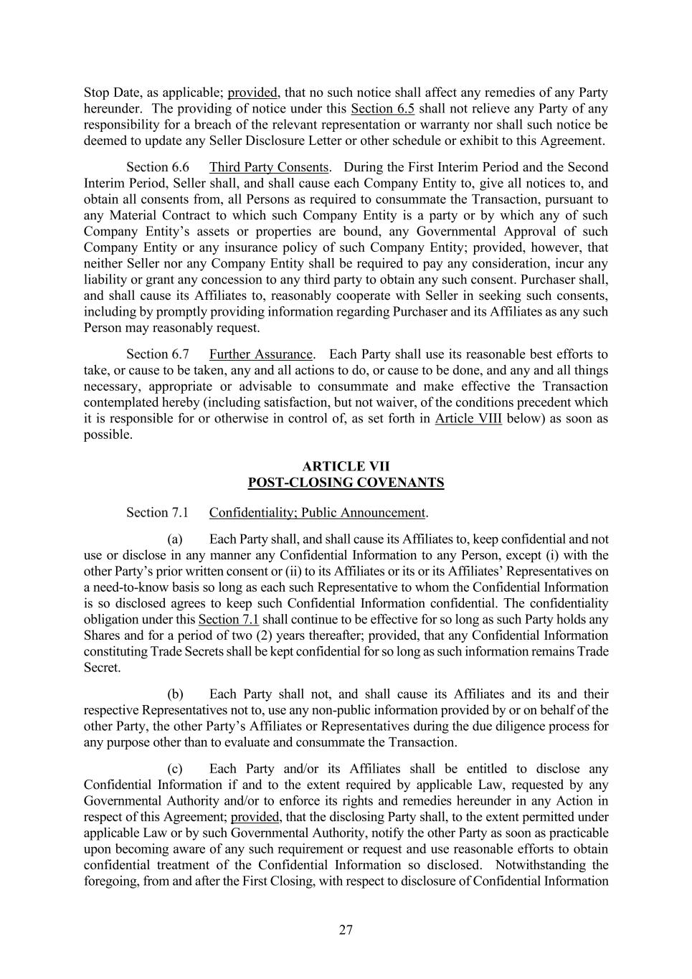
27 Stop Date, as applicable; provided, that no such notice shall affect any remedies of any Party hereunder. The providing of notice under this Section 6.5 shall not relieve any Party of any responsibility for a breach of the relevant representation or warranty nor shall such notice be deemed to update any Seller Disclosure Letter or other schedule or exhibit to this Agreement. Third Party Consents. During the First Interim Period and the Second Interim Period, Seller shall, and shall cause each Company Entity to, give all notices to, and obtain all consents from, all Persons as required to consummate the Transaction, pursuant to any Material Contract to which such Company Entity is a party or by which any of such Company Entity’s assets or properties are bound, any Governmental Approval of such Company Entity or any insurance policy of such Company Entity; provided, however, that neither Seller nor any Company Entity shall be required to pay any consideration, incur any liability or grant any concession to any third party to obtain any such consent. Purchaser shall, and shall cause its Affiliates to, reasonably cooperate with Seller in seeking such consents, including by promptly providing information regarding Purchaser and its Affiliates as any such Person may reasonably request. Further Assurance. Each Party shall use its reasonable best efforts to take, or cause to be taken, any and all actions to do, or cause to be done, and any and all things necessary, appropriate or advisable to consummate and make effective the Transaction contemplated hereby (including satisfaction, but not waiver, of the conditions precedent which it is responsible for or otherwise in control of, as set forth in Article VIII below) as soon as possible. ARTICLE VII POST-CLOSING COVENANTS Confidentiality; Public Announcement. (a) Each Party shall, and shall cause its Affiliates to, keep confidential and not use or disclose in any manner any Confidential Information to any Person, except (i) with the other Party’s prior written consent or (ii) to its Affiliates or its or its Affiliates’ Representatives on a need-to-know basis so long as each such Representative to whom the Confidential Information is so disclosed agrees to keep such Confidential Information confidential. The confidentiality obligation under this Section 7.1 shall continue to be effective for so long as such Party holds any Shares and for a period of two (2) years thereafter; provided, that any Confidential Information constituting Trade Secrets shall be kept confidential for so long as such information remains Trade Secret. (b) Each Party shall not, and shall cause its Affiliates and its and their respective Representatives not to, use any non-public information provided by or on behalf of the other Party, the other Party’s Affiliates or Representatives during the due diligence process for any purpose other than to evaluate and consummate the Transaction. (c) Each Party and/or its Affiliates shall be entitled to disclose any Confidential Information if and to the extent required by applicable Law, requested by any Governmental Authority and/or to enforce its rights and remedies hereunder in any Action in respect of this Agreement; provided, that the disclosing Party shall, to the extent permitted under applicable Law or by such Governmental Authority, notify the other Party as soon as practicable upon becoming aware of any such requirement or request and use reasonable efforts to obtain confidential treatment of the Confidential Information so disclosed. Notwithstanding the foregoing, from and after the First Closing, with respect to disclosure of Confidential Information

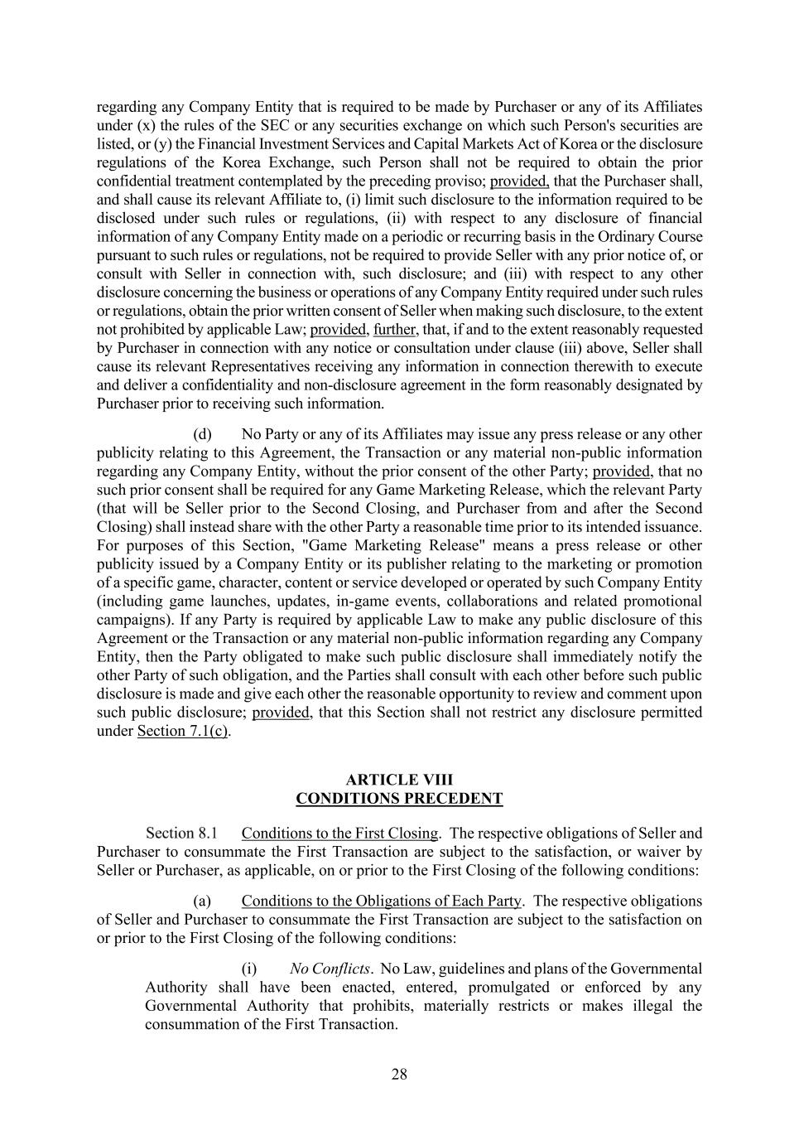
28 regarding any Company Entity that is required to be made by Purchaser or any of its Affiliates under (x) the rules of the SEC or any securities exchange on which such Person's securities are listed, or (y) the Financial Investment Services and Capital Markets Act of Korea or the disclosure regulations of the Korea Exchange, such Person shall not be required to obtain the prior confidential treatment contemplated by the preceding proviso; provided, that the Purchaser shall, and shall cause its relevant Affiliate to, (i) limit such disclosure to the information required to be disclosed under such rules or regulations, (ii) with respect to any disclosure of financial information of any Company Entity made on a periodic or recurring basis in the Ordinary Course pursuant to such rules or regulations, not be required to provide Seller with any prior notice of, or consult with Seller in connection with, such disclosure; and (iii) with respect to any other disclosure concerning the business or operations of any Company Entity required under such rules or regulations, obtain the prior written consent of Seller when making such disclosure, to the extent not prohibited by applicable Law; provided, further, that, if and to the extent reasonably requested by Purchaser in connection with any notice or consultation under clause (iii) above, Seller shall cause its relevant Representatives receiving any information in connection therewith to execute and deliver a confidentiality and non-disclosure agreement in the form reasonably designated by Purchaser prior to receiving such information. (d) No Party or any of its Affiliates may issue any press release or any other publicity relating to this Agreement, the Transaction or any material non-public information regarding any Company Entity, without the prior consent of the other Party; provided, that no such prior consent shall be required for any Game Marketing Release, which the relevant Party (that will be Seller prior to the Second Closing, and Purchaser from and after the Second Closing) shall instead share with the other Party a reasonable time prior to its intended issuance. For purposes of this Section, "Game Marketing Release" means a press release or other publicity issued by a Company Entity or its publisher relating to the marketing or promotion of a specific game, character, content or service developed or operated by such Company Entity (including game launches, updates, in-game events, collaborations and related promotional campaigns). If any Party is required by applicable Law to make any public disclosure of this Agreement or the Transaction or any material non-public information regarding any Company Entity, then the Party obligated to make such public disclosure shall immediately notify the other Party of such obligation, and the Parties shall consult with each other before such public disclosure is made and give each other the reasonable opportunity to review and comment upon such public disclosure; provided, that this Section shall not restrict any disclosure permitted under Section 7.1(c). ARTICLE VIII CONDITIONS PRECEDENT Conditions to the First Closing. The respective obligations of Seller and Purchaser to consummate the First Transaction are subject to the satisfaction, or waiver by Seller or Purchaser, as applicable, on or prior to the First Closing of the following conditions: (a) Conditions to the Obligations of Each Party. The respective obligations of Seller and Purchaser to consummate the First Transaction are subject to the satisfaction on or prior to the First Closing of the following conditions: (i) No Conflicts. No Law, guidelines and plans of the Governmental Authority shall have been enacted, entered, promulgated or enforced by any Governmental Authority that prohibits, materially restricts or makes illegal the consummation of the First Transaction.

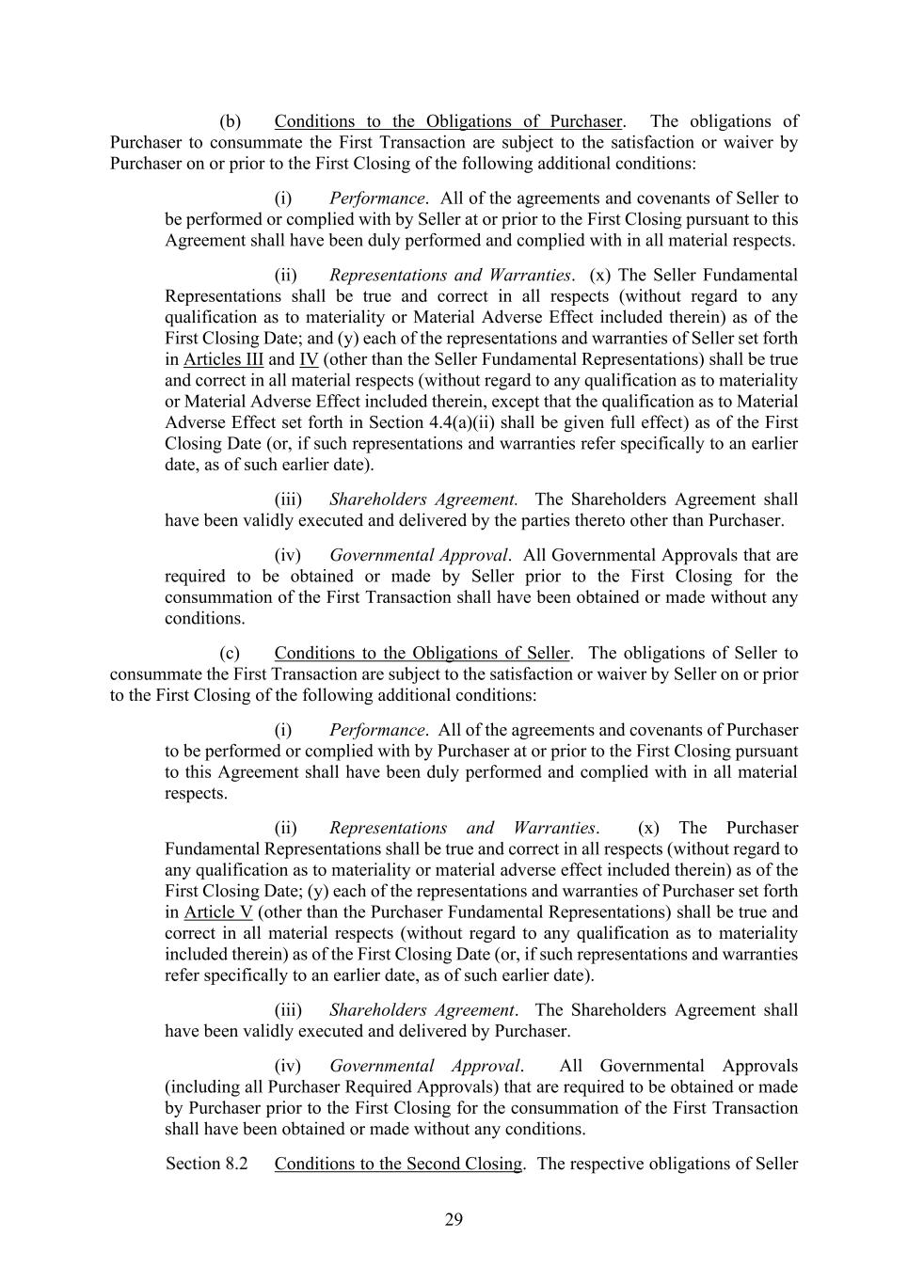
29 (b) Conditions to the Obligations of Purchaser. The obligations of Purchaser to consummate the First Transaction are subject to the satisfaction or waiver by Purchaser on or prior to the First Closing of the following additional conditions: (i) Performance. All of the agreements and covenants of Seller to be performed or complied with by Seller at or prior to the First Closing pursuant to this Agreement shall have been duly performed and complied with in all material respects. (ii) Representations and Warranties. (x) The Seller Fundamental Representations shall be true and correct in all respects (without regard to any qualification as to materiality or Material Adverse Effect included therein) as of the First Closing Date; and (y) each of the representations and warranties of Seller set forth in Articles III and IV (other than the Seller Fundamental Representations) shall be true and correct in all material respects (without regard to any qualification as to materiality or Material Adverse Effect included therein, except that the qualification as to Material Adverse Effect set forth in Section 4.4(a)(ii) shall be given full effect) as of the First Closing Date (or, if such representations and warranties refer specifically to an earlier date, as of such earlier date). (iii) Shareholders Agreement. The Shareholders Agreement shall have been validly executed and delivered by the parties thereto other than Purchaser. (iv) Governmental Approval. All Governmental Approvals that are required to be obtained or made by Seller prior to the First Closing for the consummation of the First Transaction shall have been obtained or made without any conditions. (c) Conditions to the Obligations of Seller. The obligations of Seller to consummate the First Transaction are subject to the satisfaction or waiver by Seller on or prior to the First Closing of the following additional conditions: (i) Performance. All of the agreements and covenants of Purchaser to be performed or complied with by Purchaser at or prior to the First Closing pursuant to this Agreement shall have been duly performed and complied with in all material respects. (ii) Representations and Warranties. (x) The Purchaser Fundamental Representations shall be true and correct in all respects (without regard to any qualification as to materiality or material adverse effect included therein) as of the First Closing Date; (y) each of the representations and warranties of Purchaser set forth in Article V (other than the Purchaser Fundamental Representations) shall be true and correct in all material respects (without regard to any qualification as to materiality included therein) as of the First Closing Date (or, if such representations and warranties refer specifically to an earlier date, as of such earlier date). (iii) Shareholders Agreement. The Shareholders Agreement shall have been validly executed and delivered by Purchaser. (iv) Governmental Approval. All Governmental Approvals (including all Purchaser Required Approvals) that are required to be obtained or made by Purchaser prior to the First Closing for the consummation of the First Transaction shall have been obtained or made without any conditions. Conditions to the Second Closing. The respective obligations of Seller

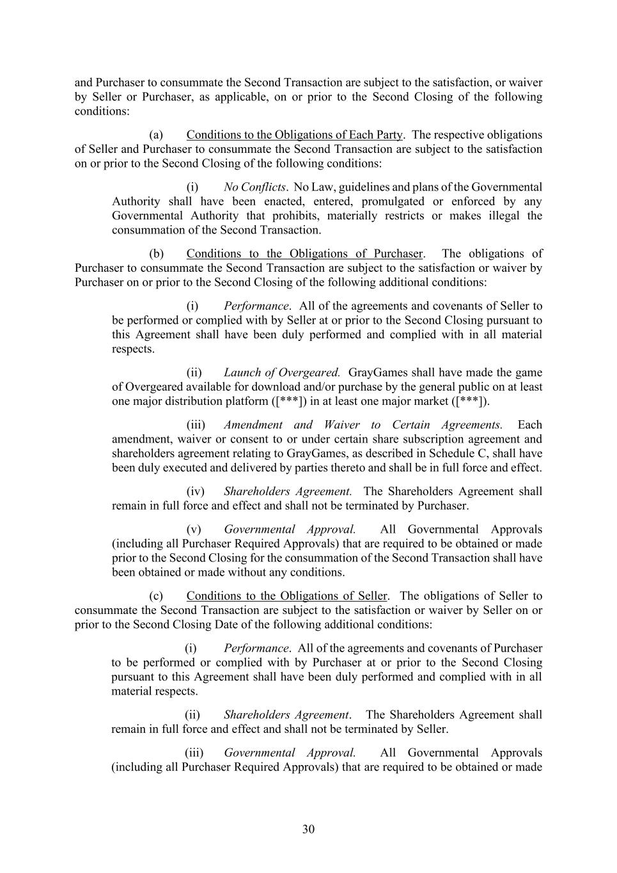
30 and Purchaser to consummate the Second Transaction are subject to the satisfaction, or waiver by Seller or Purchaser, as applicable, on or prior to the Second Closing of the following conditions: (a) Conditions to the Obligations of Each Party. The respective obligations of Seller and Purchaser to consummate the Second Transaction are subject to the satisfaction on or prior to the Second Closing of the following conditions: (i) No Conflicts. No Law, guidelines and plans of the Governmental Authority shall have been enacted, entered, promulgated or enforced by any Governmental Authority that prohibits, materially restricts or makes illegal the consummation of the Second Transaction. (b) Conditions to the Obligations of Purchaser. The obligations of Purchaser to consummate the Second Transaction are subject to the satisfaction or waiver by Purchaser on or prior to the Second Closing of the following additional conditions: (i) Performance. All of the agreements and covenants of Seller to be performed or complied with by Seller at or prior to the Second Closing pursuant to this Agreement shall have been duly performed and complied with in all material respects. (ii) Launch of Overgeared. GrayGames shall have made the game of Overgeared available for download and/or purchase by the general public on at least one major distribution platform ([***]) in at least one major market ([***]). (iii) Amendment and Waiver to Certain Agreements. Each amendment, waiver or consent to or under certain share subscription agreement and shareholders agreement relating to GrayGames, as described in Schedule C, shall have been duly executed and delivered by parties thereto and shall be in full force and effect. (iv) Shareholders Agreement. The Shareholders Agreement shall remain in full force and effect and shall not be terminated by Purchaser. (v) Governmental Approval. All Governmental Approvals (including all Purchaser Required Approvals) that are required to be obtained or made prior to the Second Closing for the consummation of the Second Transaction shall have been obtained or made without any conditions. (c) Conditions to the Obligations of Seller. The obligations of Seller to consummate the Second Transaction are subject to the satisfaction or waiver by Seller on or prior to the Second Closing Date of the following additional conditions: (i) Performance. All of the agreements and covenants of Purchaser to be performed or complied with by Purchaser at or prior to the Second Closing pursuant to this Agreement shall have been duly performed and complied with in all material respects. (ii) Shareholders Agreement. The Shareholders Agreement shall remain in full force and effect and shall not be terminated by Seller. (iii) Governmental Approval. All Governmental Approvals (including all Purchaser Required Approvals) that are required to be obtained or made

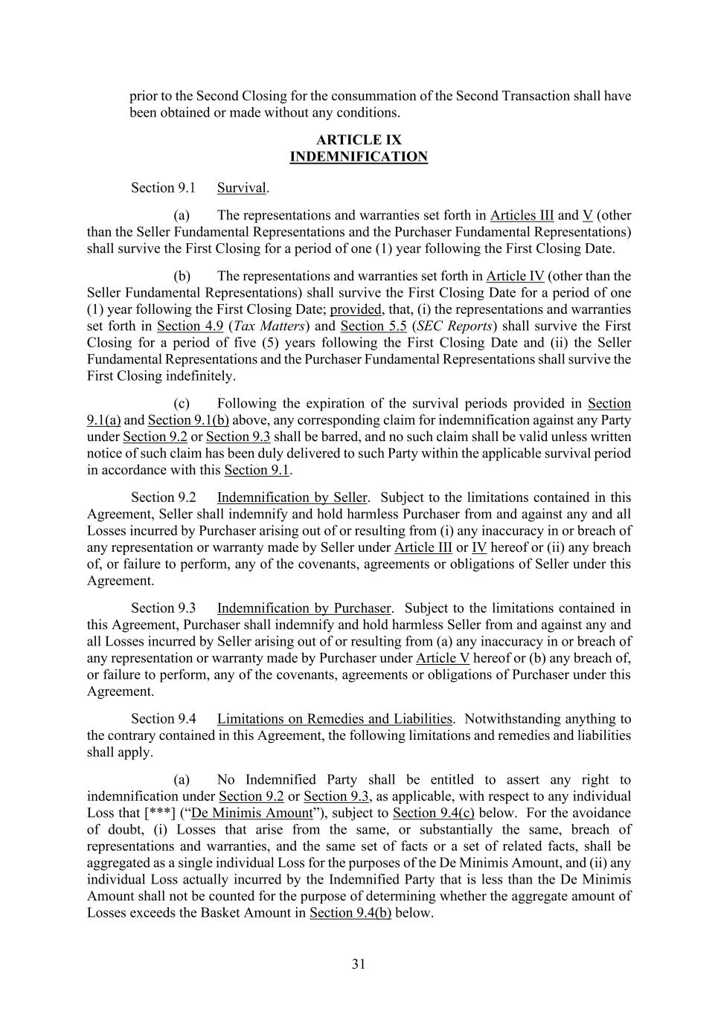
31 prior to the Second Closing for the consummation of the Second Transaction shall have been obtained or made without any conditions. ARTICLE IX INDEMNIFICATION Survival. (a) The representations and warranties set forth in Articles III and V (other than the Seller Fundamental Representations and the Purchaser Fundamental Representations) shall survive the First Closing for a period of one (1) year following the First Closing Date. (b) The representations and warranties set forth in Article IV (other than the Seller Fundamental Representations) shall survive the First Closing Date for a period of one (1) year following the First Closing Date; provided, that, (i) the representations and warranties set forth in Section 4.9 (Tax Matters) and Section 5.5 (SEC Reports) shall survive the First Closing for a period of five (5) years following the First Closing Date and (ii) the Seller Fundamental Representations and the Purchaser Fundamental Representations shall survive the First Closing indefinitely. (c) Following the expiration of the survival periods provided in Section 9.1(a) and Section 9.1(b) above, any corresponding claim for indemnification against any Party under Section 9.2 or Section 9.3 shall be barred, and no such claim shall be valid unless written notice of such claim has been duly delivered to such Party within the applicable survival period in accordance with this Section 9.1. Indemnification by Seller. Subject to the limitations contained in this Agreement, Seller shall indemnify and hold harmless Purchaser from and against any and all Losses incurred by Purchaser arising out of or resulting from (i) any inaccuracy in or breach of any representation or warranty made by Seller under Article III or IV hereof or (ii) any breach of, or failure to perform, any of the covenants, agreements or obligations of Seller under this Agreement. Indemnification by Purchaser. Subject to the limitations contained in this Agreement, Purchaser shall indemnify and hold harmless Seller from and against any and all Losses incurred by Seller arising out of or resulting from (a) any inaccuracy in or breach of any representation or warranty made by Purchaser under Article V hereof or (b) any breach of, or failure to perform, any of the covenants, agreements or obligations of Purchaser under this Agreement. Limitations on Remedies and Liabilities. Notwithstanding anything to the contrary contained in this Agreement, the following limitations and remedies and liabilities shall apply. (a) No Indemnified Party shall be entitled to assert any right to indemnification under Section 9.2 or Section 9.3, as applicable, with respect to any individual Loss that [***] (“De Minimis Amount”), subject to Section 9.4(c) below. For the avoidance of doubt, (i) Losses that arise from the same, or substantially the same, breach of representations and warranties, and the same set of facts or a set of related facts, shall be aggregated as a single individual Loss for the purposes of the De Minimis Amount, and (ii) any individual Loss actually incurred by the Indemnified Party that is less than the De Minimis Amount shall not be counted for the purpose of determining whether the aggregate amount of Losses exceeds the Basket Amount in Section 9.4(b) below.

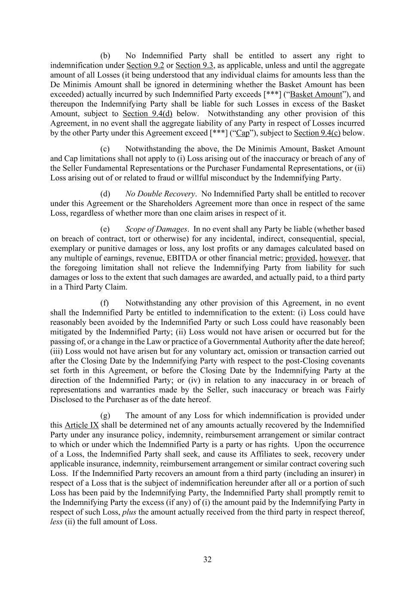
32 (b) No Indemnified Party shall be entitled to assert any right to indemnification under Section 9.2 or Section 9.3, as applicable, unless and until the aggregate amount of all Losses (it being understood that any individual claims for amounts less than the De Minimis Amount shall be ignored in determining whether the Basket Amount has been exceeded) actually incurred by such Indemnified Party exceeds [***] (“Basket Amount”), and thereupon the Indemnifying Party shall be liable for such Losses in excess of the Basket Amount, subject to Section 9.4(d) below. Notwithstanding any other provision of this Agreement, in no event shall the aggregate liability of any Party in respect of Losses incurred by the other Party under this Agreement exceed [***] (“Cap”), subject to Section 9.4(c) below. (c) Notwithstanding the above, the De Minimis Amount, Basket Amount and Cap limitations shall not apply to (i) Loss arising out of the inaccuracy or breach of any of the Seller Fundamental Representations or the Purchaser Fundamental Representations, or (ii) Loss arising out of or related to fraud or willful misconduct by the Indemnifying Party. (d) No Double Recovery. No Indemnified Party shall be entitled to recover under this Agreement or the Shareholders Agreement more than once in respect of the same Loss, regardless of whether more than one claim arises in respect of it. (e) Scope of Damages. In no event shall any Party be liable (whether based on breach of contract, tort or otherwise) for any incidental, indirect, consequential, special, exemplary or punitive damages or loss, any lost profits or any damages calculated based on any multiple of earnings, revenue, EBITDA or other financial metric; provided, however, that the foregoing limitation shall not relieve the Indemnifying Party from liability for such damages or loss to the extent that such damages are awarded, and actually paid, to a third party in a Third Party Claim. (f) Notwithstanding any other provision of this Agreement, in no event shall the Indemnified Party be entitled to indemnification to the extent: (i) Loss could have reasonably been avoided by the Indemnified Party or such Loss could have reasonably been mitigated by the Indemnified Party; (ii) Loss would not have arisen or occurred but for the passing of, or a change in the Law or practice of a Governmental Authority after the date hereof; (iii) Loss would not have arisen but for any voluntary act, omission or transaction carried out after the Closing Date by the Indemnifying Party with respect to the post-Closing covenants set forth in this Agreement, or before the Closing Date by the Indemnifying Party at the direction of the Indemnified Party; or (iv) in relation to any inaccuracy in or breach of representations and warranties made by the Seller, such inaccuracy or breach was Fairly Disclosed to the Purchaser as of the date hereof. (g) The amount of any Loss for which indemnification is provided under this Article IX shall be determined net of any amounts actually recovered by the Indemnified Party under any insurance policy, indemnity, reimbursement arrangement or similar contract to which or under which the Indemnified Party is a party or has rights. Upon the occurrence of a Loss, the Indemnified Party shall seek, and cause its Affiliates to seek, recovery under applicable insurance, indemnity, reimbursement arrangement or similar contract covering such Loss. If the Indemnified Party recovers an amount from a third party (including an insurer) in respect of a Loss that is the subject of indemnification hereunder after all or a portion of such Loss has been paid by the Indemnifying Party, the Indemnified Party shall promptly remit to the Indemnifying Party the excess (if any) of (i) the amount paid by the Indemnifying Party in respect of such Loss, plus the amount actually received from the third party in respect thereof, less (ii) the full amount of Loss.

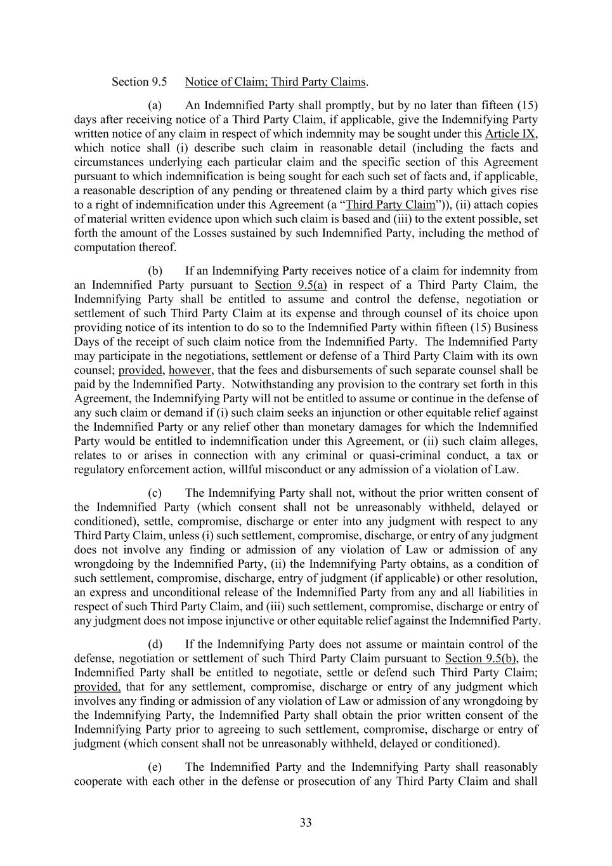
33 Notice of Claim; Third Party Claims. (a) An Indemnified Party shall promptly, but by no later than fifteen (15) days after receiving notice of a Third Party Claim, if applicable, give the Indemnifying Party written notice of any claim in respect of which indemnity may be sought under this Article IX, which notice shall (i) describe such claim in reasonable detail (including the facts and circumstances underlying each particular claim and the specific section of this Agreement pursuant to which indemnification is being sought for each such set of facts and, if applicable, a reasonable description of any pending or threatened claim by a third party which gives rise to a right of indemnification under this Agreement (a “Third Party Claim”)), (ii) attach copies of material written evidence upon which such claim is based and (iii) to the extent possible, set forth the amount of the Losses sustained by such Indemnified Party, including the method of computation thereof. (b) If an Indemnifying Party receives notice of a claim for indemnity from an Indemnified Party pursuant to Section 9.5(a) in respect of a Third Party Claim, the Indemnifying Party shall be entitled to assume and control the defense, negotiation or settlement of such Third Party Claim at its expense and through counsel of its choice upon providing notice of its intention to do so to the Indemnified Party within fifteen (15) Business Days of the receipt of such claim notice from the Indemnified Party. The Indemnified Party may participate in the negotiations, settlement or defense of a Third Party Claim with its own counsel; provided, however, that the fees and disbursements of such separate counsel shall be paid by the Indemnified Party. Notwithstanding any provision to the contrary set forth in this Agreement, the Indemnifying Party will not be entitled to assume or continue in the defense of any such claim or demand if (i) such claim seeks an injunction or other equitable relief against the Indemnified Party or any relief other than monetary damages for which the Indemnified Party would be entitled to indemnification under this Agreement, or (ii) such claim alleges, relates to or arises in connection with any criminal or quasi-criminal conduct, a tax or regulatory enforcement action, willful misconduct or any admission of a violation of Law. (c) The Indemnifying Party shall not, without the prior written consent of the Indemnified Party (which consent shall not be unreasonably withheld, delayed or conditioned), settle, compromise, discharge or enter into any judgment with respect to any Third Party Claim, unless (i) such settlement, compromise, discharge, or entry of any judgment does not involve any finding or admission of any violation of Law or admission of any wrongdoing by the Indemnified Party, (ii) the Indemnifying Party obtains, as a condition of such settlement, compromise, discharge, entry of judgment (if applicable) or other resolution, an express and unconditional release of the Indemnified Party from any and all liabilities in respect of such Third Party Claim, and (iii) such settlement, compromise, discharge or entry of any judgment does not impose injunctive or other equitable relief against the Indemnified Party. (d) If the Indemnifying Party does not assume or maintain control of the defense, negotiation or settlement of such Third Party Claim pursuant to Section 9.5(b), the Indemnified Party shall be entitled to negotiate, settle or defend such Third Party Claim; provided, that for any settlement, compromise, discharge or entry of any judgment which involves any finding or admission of any violation of Law or admission of any wrongdoing by the Indemnifying Party, the Indemnified Party shall obtain the prior written consent of the Indemnifying Party prior to agreeing to such settlement, compromise, discharge or entry of judgment (which consent shall not be unreasonably withheld, delayed or conditioned). (e) The Indemnified Party and the Indemnifying Party shall reasonably cooperate with each other in the defense or prosecution of any Third Party Claim and shall

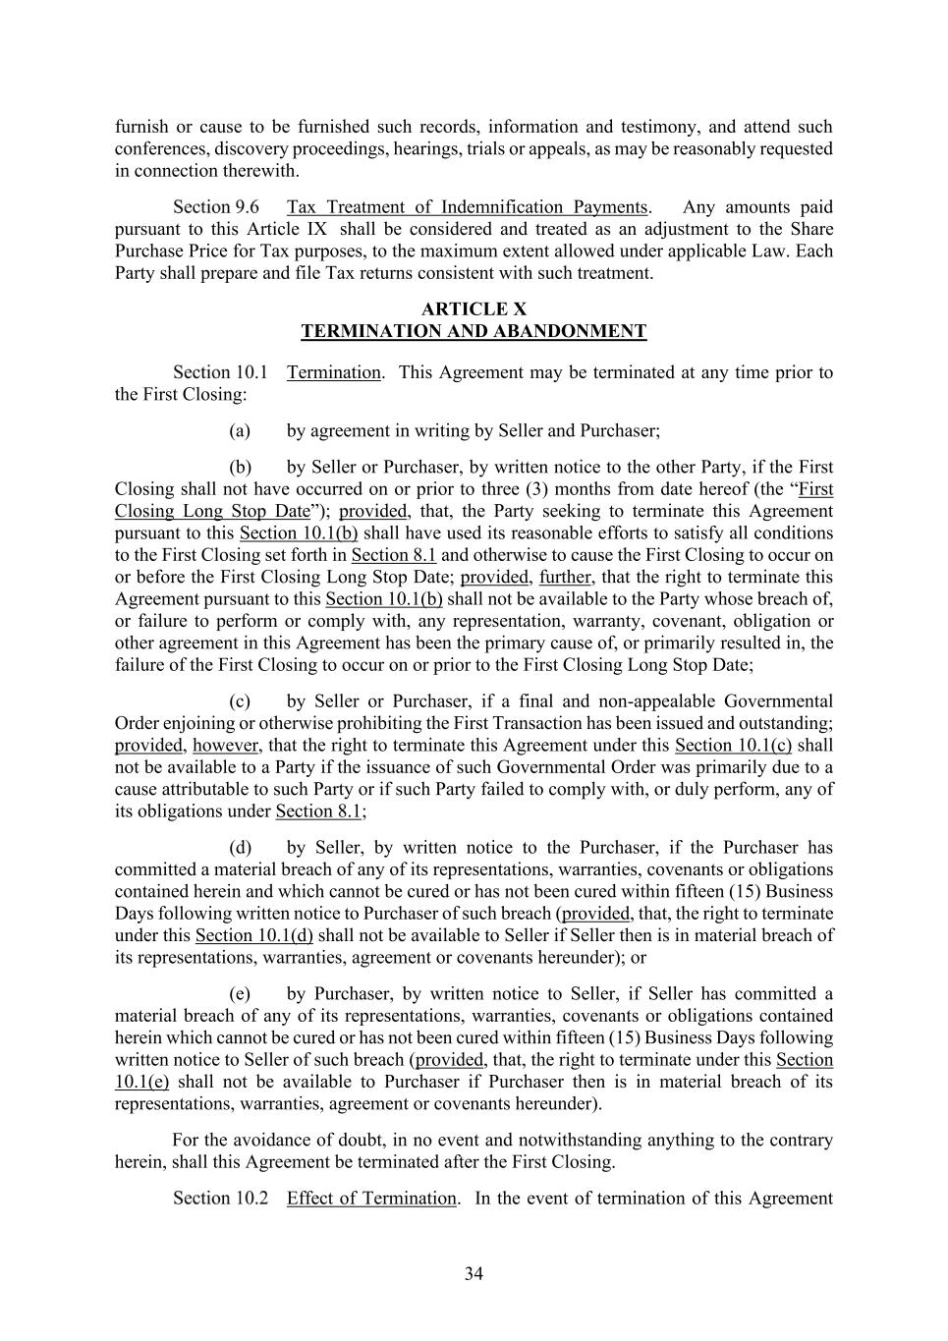
34 furnish or cause to be furnished such records, information and testimony, and attend such conferences, discovery proceedings, hearings, trials or appeals, as may be reasonably requested in connection therewith. Tax Treatment of Indemnification Payments. Any amounts paid pursuant to this Article IX shall be considered and treated as an adjustment to the Share Purchase Price for Tax purposes, to the maximum extent allowed under applicable Law. Each Party shall prepare and file Tax returns consistent with such treatment. ARTICLE X TERMINATION AND ABANDONMENT Termination. This Agreement may be terminated at any time prior to the First Closing: (a) by agreement in writing by Seller and Purchaser; (b) by Seller or Purchaser, by written notice to the other Party, if the First Closing shall not have occurred on or prior to three (3) months from date hereof (the “First Closing Long Stop Date”); provided, that, the Party seeking to terminate this Agreement pursuant to this Section 10.1(b) shall have used its reasonable efforts to satisfy all conditions to the First Closing set forth in Section 8.1 and otherwise to cause the First Closing to occur on or before the First Closing Long Stop Date; provided, further, that the right to terminate this Agreement pursuant to this Section 10.1(b) shall not be available to the Party whose breach of, or failure to perform or comply with, any representation, warranty, covenant, obligation or other agreement in this Agreement has been the primary cause of, or primarily resulted in, the failure of the First Closing to occur on or prior to the First Closing Long Stop Date; (c) by Seller or Purchaser, if a final and non-appealable Governmental Order enjoining or otherwise prohibiting the First Transaction has been issued and outstanding; provided, however, that the right to terminate this Agreement under this Section 10.1(c) shall not be available to a Party if the issuance of such Governmental Order was primarily due to a cause attributable to such Party or if such Party failed to comply with, or duly perform, any of its obligations under Section 8.1; (d) by Seller, by written notice to the Purchaser, if the Purchaser has committed a material breach of any of its representations, warranties, covenants or obligations contained herein and which cannot be cured or has not been cured within fifteen (15) Business Days following written notice to Purchaser of such breach (provided, that, the right to terminate under this Section 10.1(d) shall not be available to Seller if Seller then is in material breach of its representations, warranties, agreement or covenants hereunder); or (e) by Purchaser, by written notice to Seller, if Seller has committed a material breach of any of its representations, warranties, covenants or obligations contained herein which cannot be cured or has not been cured within fifteen (15) Business Days following written notice to Seller of such breach (provided, that, the right to terminate under this Section 10.1(e) shall not be available to Purchaser if Purchaser then is in material breach of its representations, warranties, agreement or covenants hereunder). For the avoidance of doubt, in no event and notwithstanding anything to the contrary herein, shall this Agreement be terminated after the First Closing. Effect of Termination. In the event of termination of this Agreement

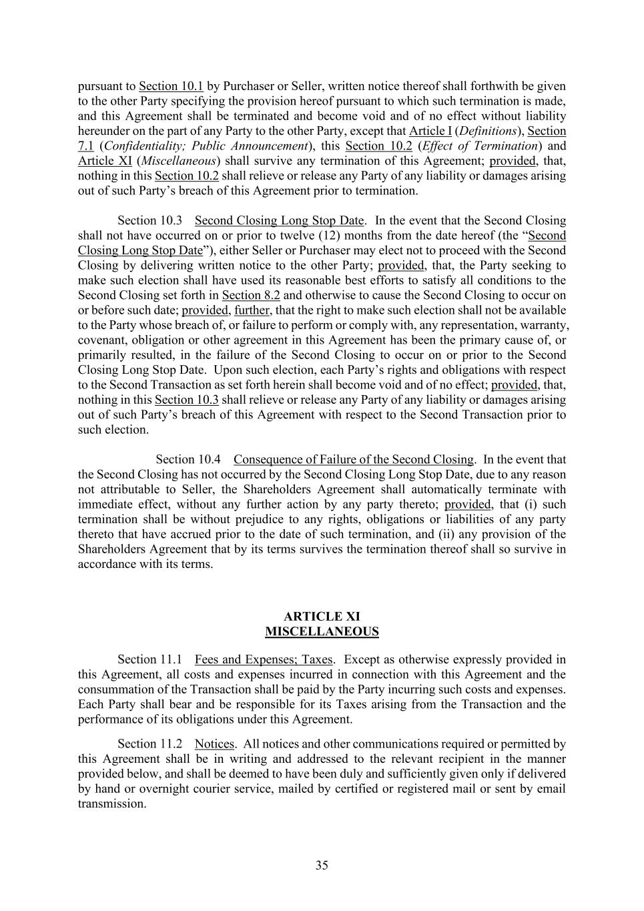
35 pursuant to Section 10.1 by Purchaser or Seller, written notice thereof shall forthwith be given to the other Party specifying the provision hereof pursuant to which such termination is made, and this Agreement shall be terminated and become void and of no effect without liability hereunder on the part of any Party to the other Party, except that Article I (Definitions), Section 7.1 (Confidentiality; Public Announcement), this Section 10.2 (Effect of Termination) and Article XI (Miscellaneous) shall survive any termination of this Agreement; provided, that, nothing in this Section 10.2 shall relieve or release any Party of any liability or damages arising out of such Party’s breach of this Agreement prior to termination. Second Closing Long Stop Date. In the event that the Second Closing shall not have occurred on or prior to twelve (12) months from the date hereof (the “Second Closing Long Stop Date”), either Seller or Purchaser may elect not to proceed with the Second Closing by delivering written notice to the other Party; provided, that, the Party seeking to make such election shall have used its reasonable best efforts to satisfy all conditions to the Second Closing set forth in Section 8.2 and otherwise to cause the Second Closing to occur on or before such date; provided, further, that the right to make such election shall not be available to the Party whose breach of, or failure to perform or comply with, any representation, warranty, covenant, obligation or other agreement in this Agreement has been the primary cause of, or primarily resulted, in the failure of the Second Closing to occur on or prior to the Second Closing Long Stop Date. Upon such election, each Party’s rights and obligations with respect to the Second Transaction as set forth herein shall become void and of no effect; provided, that, nothing in this Section 10.3 shall relieve or release any Party of any liability or damages arising out of such Party’s breach of this Agreement with respect to the Second Transaction prior to such election. Consequence of Failure of the Second Closing. In the event that the Second Closing has not occurred by the Second Closing Long Stop Date, due to any reason not attributable to Seller, the Shareholders Agreement shall automatically terminate with immediate effect, without any further action by any party thereto; provided, that (i) such termination shall be without prejudice to any rights, obligations or liabilities of any party thereto that have accrued prior to the date of such termination, and (ii) any provision of the Shareholders Agreement that by its terms survives the termination thereof shall so survive in accordance with its terms. ARTICLE XI MISCELLANEOUS Fees and Expenses; Taxes. Except as otherwise expressly provided in this Agreement, all costs and expenses incurred in connection with this Agreement and the consummation of the Transaction shall be paid by the Party incurring such costs and expenses. Each Party shall bear and be responsible for its Taxes arising from the Transaction and the performance of its obligations under this Agreement. Notices. All notices and other communications required or permitted by this Agreement shall be in writing and addressed to the relevant recipient in the manner provided below, and shall be deemed to have been duly and sufficiently given only if delivered by hand or overnight courier service, mailed by certified or registered mail or sent by email transmission.

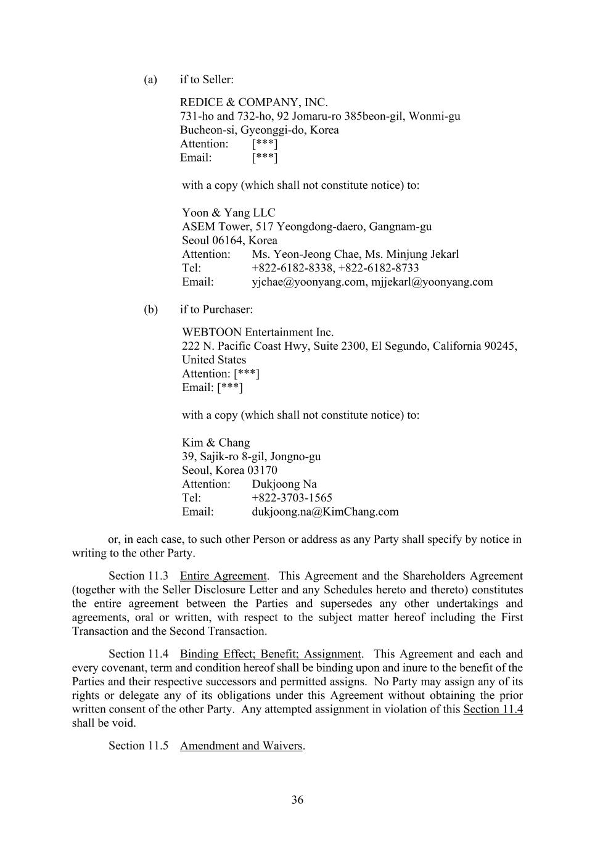
36 (a) if to Seller: REDICE & COMPANY, INC. 731-ho and 732-ho, 92 Jomaru-ro 385beon-gil, Wonmi-gu Bucheon-si, Gyeonggi-do, Korea Attention: [***] Email: [***] with a copy (which shall not constitute notice) to: Yoon & Yang LLC ASEM Tower, 517 Yeongdong-daero, Gangnam-gu Seoul 06164, Korea Attention: Ms. Yeon-Jeong Chae, Ms. Minjung Jekarl Tel: +822-6182-8338, +822-6182-8733 Email: yjchae@yoonyang.com, mjjekarl@yoonyang.com (b) if to Purchaser: WEBTOON Entertainment Inc. 222 N. Pacific Coast Hwy, Suite 2300, El Segundo, California 90245, United States Attention: [***] Email: [***] with a copy (which shall not constitute notice) to: Kim & Chang 39, Sajik-ro 8-gil, Jongno-gu Seoul, Korea 03170 Attention: Dukjoong Na Tel: +822-3703-1565 Email: dukjoong.na@KimChang.com or, in each case, to such other Person or address as any Party shall specify by notice in writing to the other Party. Entire Agreement. This Agreement and the Shareholders Agreement (together with the Seller Disclosure Letter and any Schedules hereto and thereto) constitutes the entire agreement between the Parties and supersedes any other undertakings and agreements, oral or written, with respect to the subject matter hereof including the First Transaction and the Second Transaction. Binding Effect; Benefit; Assignment. This Agreement and each and every covenant, term and condition hereof shall be binding upon and inure to the benefit of the Parties and their respective successors and permitted assigns. No Party may assign any of its rights or delegate any of its obligations under this Agreement without obtaining the prior written consent of the other Party. Any attempted assignment in violation of this Section 11.4 shall be void. Amendment and Waivers.

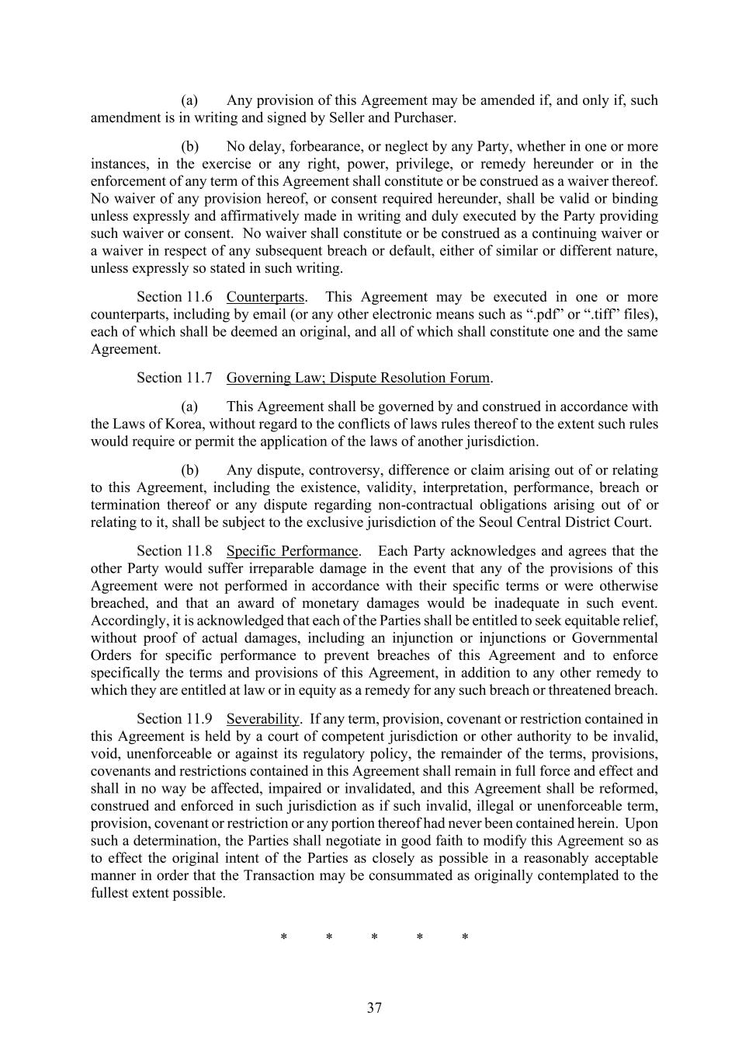
37 (a) Any provision of this Agreement may be amended if, and only if, such amendment is in writing and signed by Seller and Purchaser. (b) No delay, forbearance, or neglect by any Party, whether in one or more instances, in the exercise or any right, power, privilege, or remedy hereunder or in the enforcement of any term of this Agreement shall constitute or be construed as a waiver thereof. No waiver of any provision hereof, or consent required hereunder, shall be valid or binding unless expressly and affirmatively made in writing and duly executed by the Party providing such waiver or consent. No waiver shall constitute or be construed as a continuing waiver or a waiver in respect of any subsequent breach or default, either of similar or different nature, unless expressly so stated in such writing. Counterparts. This Agreement may be executed in one or more counterparts, including by email (or any other electronic means such as “.pdf” or “.tiff” files), each of which shall be deemed an original, and all of which shall constitute one and the same Agreement. Governing Law; Dispute Resolution Forum. (a) This Agreement shall be governed by and construed in accordance with the Laws of Korea, without regard to the conflicts of laws rules thereof to the extent such rules would require or permit the application of the laws of another jurisdiction. (b) Any dispute, controversy, difference or claim arising out of or relating to this Agreement, including the existence, validity, interpretation, performance, breach or termination thereof or any dispute regarding non-contractual obligations arising out of or relating to it, shall be subject to the exclusive jurisdiction of the Seoul Central District Court. Specific Performance. Each Party acknowledges and agrees that the other Party would suffer irreparable damage in the event that any of the provisions of this Agreement were not performed in accordance with their specific terms or were otherwise breached, and that an award of monetary damages would be inadequate in such event. Accordingly, it is acknowledged that each of the Parties shall be entitled to seek equitable relief, without proof of actual damages, including an injunction or injunctions or Governmental Orders for specific performance to prevent breaches of this Agreement and to enforce specifically the terms and provisions of this Agreement, in addition to any other remedy to which they are entitled at law or in equity as a remedy for any such breach or threatened breach. Severability. If any term, provision, covenant or restriction contained in this Agreement is held by a court of competent jurisdiction or other authority to be invalid, void, unenforceable or against its regulatory policy, the remainder of the terms, provisions, covenants and restrictions contained in this Agreement shall remain in full force and effect and shall in no way be affected, impaired or invalidated, and this Agreement shall be reformed, construed and enforced in such jurisdiction as if such invalid, illegal or unenforceable term, provision, covenant or restriction or any portion thereof had never been contained herein. Upon such a determination, the Parties shall negotiate in good faith to modify this Agreement so as to effect the original intent of the Parties as closely as possible in a reasonably acceptable manner in order that the Transaction may be consummated as originally contemplated to the fullest extent possible. * * * * *

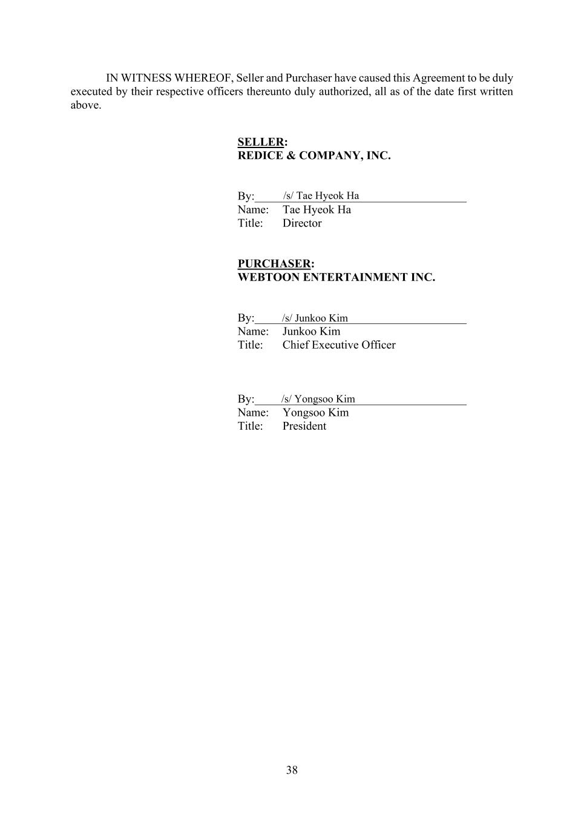
38 IN WITNESS WHEREOF, Seller and Purchaser have caused this Agreement to be duly executed by their respective officers thereunto duly authorized, all as of the date first written above. SELLER: REDICE & COMPANY, INC. By:____________________________________ Name: Tae Hyeok Ha Title: Director PURCHASER: WEBTOON ENTERTAINMENT INC. By:____________________________________ Name: Junkoo Kim Title: Chief Executive Officer By:____________________________________ Name: Yongsoo Kim Title: President /s/ Tae Hyeok Ha /s/ Junkoo Kim /s/ Yongsoo Kim

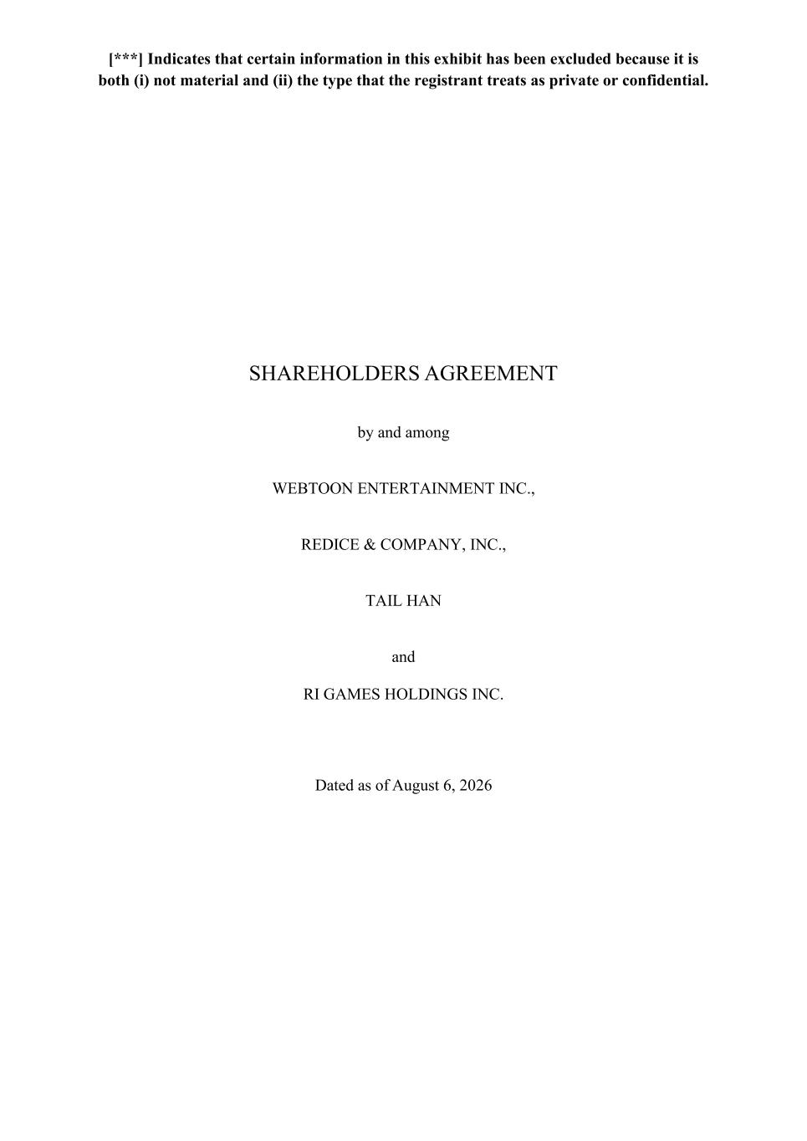
[***] Indicates that certain information in this exhibit has been excluded because it is both (i) not material and (ii) the type that the registrant treats as private or confidential. SHAREHOLDERS AGREEMENT by and among WEBTOON ENTERTAINMENT INC., REDICE & COMPANY, INC., TAIL HAN and RI GAMES HOLDINGS INC. Dated as of August 6, 2026

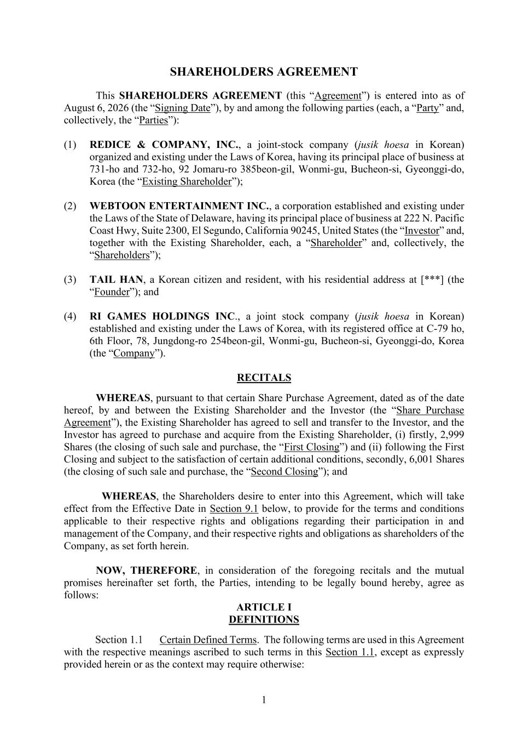
1 SHAREHOLDERS AGREEMENT This SHAREHOLDERS AGREEMENT (this “Agreement”) is entered into as of August 6, 2026 (the “Signing Date”), by and among the following parties (each, a “Party” and, collectively, the “Parties”): (1) REDICE & COMPANY, INC., a joint-stock company (jusik hoesa in Korean) organized and existing under the Laws of Korea, having its principal place of business at 731-ho and 732-ho, 92 Jomaru-ro 385beon-gil, Wonmi-gu, Bucheon-si, Gyeonggi-do, Korea (the “Existing Shareholder”); (2) WEBTOON ENTERTAINMENT INC., a corporation established and existing under the Laws of the State of Delaware, having its principal place of business at 222 N. Pacific Coast Hwy, Suite 2300, El Segundo, California 90245, United States (the “Investor” and, together with the Existing Shareholder, each, a “Shareholder” and, collectively, the “Shareholders”); (3) TAIL HAN, a Korean citizen and resident, with his residential address at [***] (the “Founder”); and (4) RI GAMES HOLDINGS INC., a joint stock company (jusik hoesa in Korean) established and existing under the Laws of Korea, with its registered office at C-79 ho, 6th Floor, 78, Jungdong-ro 254beon-gil, Wonmi-gu, Bucheon-si, Gyeonggi-do, Korea (the “Company”). RECITALS WHEREAS, pursuant to that certain Share Purchase Agreement, dated as of the date hereof, by and between the Existing Shareholder and the Investor (the “Share Purchase Agreement”), the Existing Shareholder has agreed to sell and transfer to the Investor, and the Investor has agreed to purchase and acquire from the Existing Shareholder, (i) firstly, 2,999 Shares (the closing of such sale and purchase, the “First Closing”) and (ii) following the First Closing and subject to the satisfaction of certain additional conditions, secondly, 6,001 Shares (the closing of such sale and purchase, the “Second Closing”); and WHEREAS, the Shareholders desire to enter into this Agreement, which will take effect from the Effective Date in Section 9.1 below, to provide for the terms and conditions applicable to their respective rights and obligations regarding their participation in and management of the Company, and their respective rights and obligations as shareholders of the Company, as set forth herein. NOW, THEREFORE, in consideration of the foregoing recitals and the mutual promises hereinafter set forth, the Parties, intending to be legally bound hereby, agree as follows: ARTICLE I DEFINITIONS Certain Defined Terms. The following terms are used in this Agreement with the respective meanings ascribed to such terms in this Section 1.1, except as expressly provided herein or as the context may require otherwise:

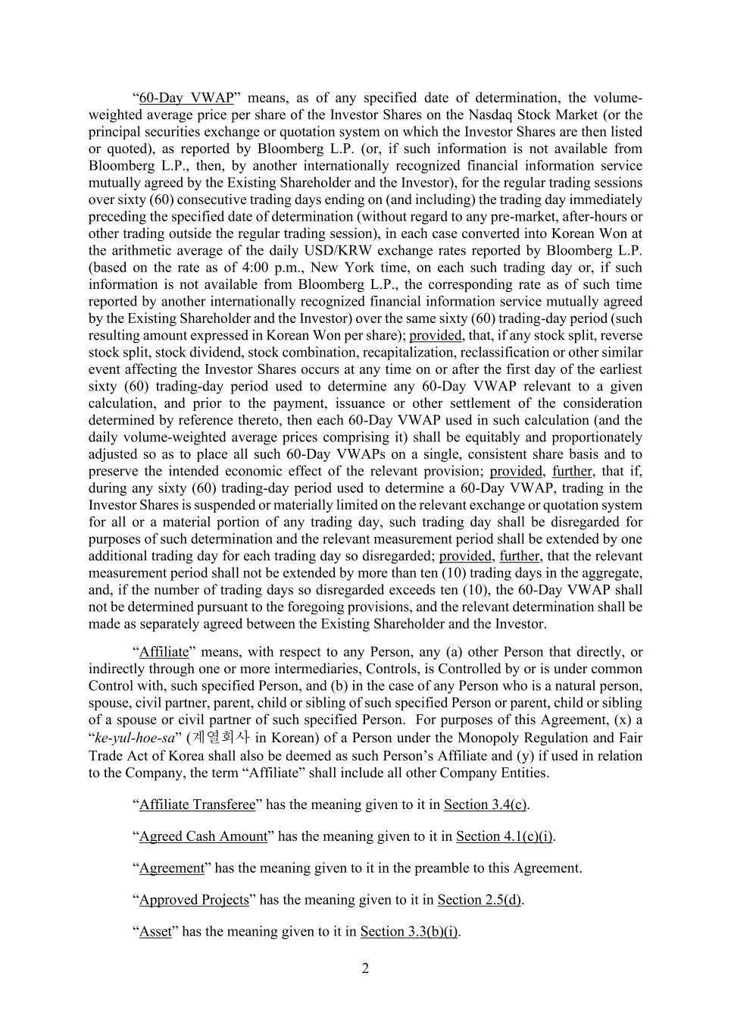
2 “60-Day VWAP” means, as of any specified date of determination, the volume- weighted average price per share of the Investor Shares on the Nasdaq Stock Market (or the principal securities exchange or quotation system on which the Investor Shares are then listed or quoted), as reported by Bloomberg L.P. (or, if such information is not available from Bloomberg L.P., then, by another internationally recognized financial information service mutually agreed by the Existing Shareholder and the Investor), for the regular trading sessions over sixty (60) consecutive trading days ending on (and including) the trading day immediately preceding the specified date of determination (without regard to any pre-market, after-hours or other trading outside the regular trading session), in each case converted into Korean Won at the arithmetic average of the daily USD/KRW exchange rates reported by Bloomberg L.P. (based on the rate as of 4:00 p.m., New York time, on each such trading day or, if such information is not available from Bloomberg L.P., the corresponding rate as of such time reported by another internationally recognized financial information service mutually agreed by the Existing Shareholder and the Investor) over the same sixty (60) trading-day period (such resulting amount expressed in Korean Won per share); provided, that, if any stock split, reverse stock split, stock dividend, stock combination, recapitalization, reclassification or other similar event affecting the Investor Shares occurs at any time on or after the first day of the earliest sixty (60) trading-day period used to determine any 60-Day VWAP relevant to a given calculation, and prior to the payment, issuance or other settlement of the consideration determined by reference thereto, then each 60-Day VWAP used in such calculation (and the daily volume-weighted average prices comprising it) shall be equitably and proportionately adjusted so as to place all such 60-Day VWAPs on a single, consistent share basis and to preserve the intended economic effect of the relevant provision; provided, further, that if, during any sixty (60) trading-day period used to determine a 60-Day VWAP, trading in the Investor Shares is suspended or materially limited on the relevant exchange or quotation system for all or a material portion of any trading day, such trading day shall be disregarded for purposes of such determination and the relevant measurement period shall be extended by one additional trading day for each trading day so disregarded; provided, further, that the relevant measurement period shall not be extended by more than ten (10) trading days in the aggregate, and, if the number of trading days so disregarded exceeds ten (10), the 60-Day VWAP shall not be determined pursuant to the foregoing provisions, and the relevant determination shall be made as separately agreed between the Existing Shareholder and the Investor. “Affiliate” means, with respect to any Person, any (a) other Person that directly, or indirectly through one or more intermediaries, Controls, is Controlled by or is under common Control with, such specified Person, and (b) in the case of any Person who is a natural person, spouse, civil partner, parent, child or sibling of such specified Person or parent, child or sibling of a spouse or civil partner of such specified Person. For purposes of this Agreement, (x) a “ke-yul-hoe-sa” (계열회사 in Korean) of a Person under the Monopoly Regulation and Fair Trade Act of Korea shall also be deemed as such Person’s Affiliate and (y) if used in relation to the Company, the term “Affiliate” shall include all other Company Entities. “Affiliate Transferee” has the meaning given to it in Section 3.4(c). “Agreed Cash Amount” has the meaning given to it in Section 4.1(c)(i). “Agreement” has the meaning given to it in the preamble to this Agreement. “Approved Projects” has the meaning given to it in Section 2.5(d). “Asset” has the meaning given to it in Section 3.3(b)(i).

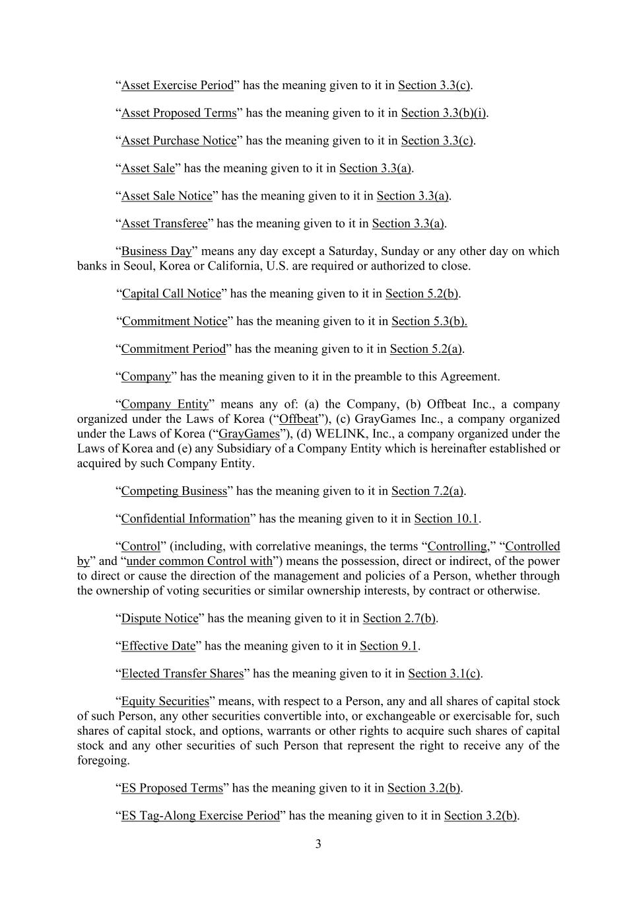
3 “Asset Exercise Period” has the meaning given to it in Section 3.3(c). “Asset Proposed Terms” has the meaning given to it in Section 3.3(b)(i). “Asset Purchase Notice” has the meaning given to it in Section 3.3(c). “Asset Sale” has the meaning given to it in Section 3.3(a). “Asset Sale Notice” has the meaning given to it in Section 3.3(a). “Asset Transferee” has the meaning given to it in Section 3.3(a). “Business Day” means any day except a Saturday, Sunday or any other day on which banks in Seoul, Korea or California, U.S. are required or authorized to close. “Capital Call Notice” has the meaning given to it in Section 5.2(b). “Commitment Notice” has the meaning given to it in Section 5.3(b). “Commitment Period” has the meaning given to it in Section 5.2(a). “Company” has the meaning given to it in the preamble to this Agreement. “Company Entity” means any of: (a) the Company, (b) Offbeat Inc., a company organized under the Laws of Korea (“Offbeat”), (c) GrayGames Inc., a company organized under the Laws of Korea (“GrayGames”), (d) WELINK, Inc., a company organized under the Laws of Korea and (e) any Subsidiary of a Company Entity which is hereinafter established or acquired by such Company Entity. “Competing Business” has the meaning given to it in Section 7.2(a). “Confidential Information” has the meaning given to it in Section 10.1. “Control” (including, with correlative meanings, the terms “Controlling,” “Controlled by” and “under common Control with”) means the possession, direct or indirect, of the power to direct or cause the direction of the management and policies of a Person, whether through the ownership of voting securities or similar ownership interests, by contract or otherwise. “Dispute Notice” has the meaning given to it in Section 2.7(b). “Effective Date” has the meaning given to it in Section 9.1. “Elected Transfer Shares” has the meaning given to it in Section 3.1(c). “Equity Securities” means, with respect to a Person, any and all shares of capital stock of such Person, any other securities convertible into, or exchangeable or exercisable for, such shares of capital stock, and options, warrants or other rights to acquire such shares of capital stock and any other securities of such Person that represent the right to receive any of the foregoing. “ES Proposed Terms” has the meaning given to it in Section 3.2(b). “ES Tag-Along Exercise Period” has the meaning given to it in Section 3.2(b).

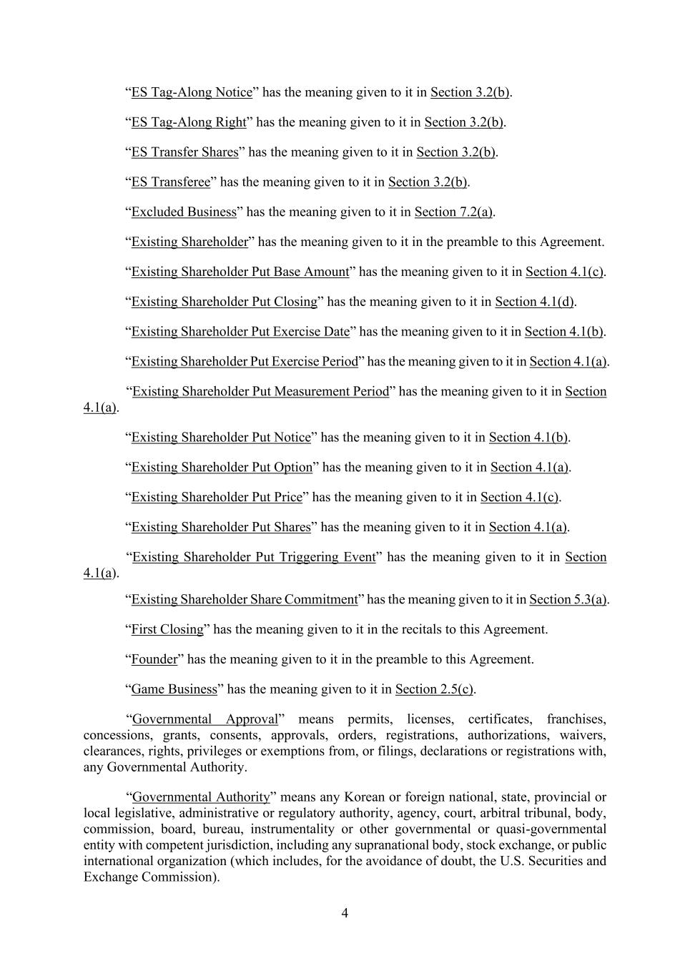
4 “ES Tag-Along Notice” has the meaning given to it in Section 3.2(b). “ES Tag-Along Right” has the meaning given to it in Section 3.2(b). “ES Transfer Shares” has the meaning given to it in Section 3.2(b). “ES Transferee” has the meaning given to it in Section 3.2(b). “Excluded Business” has the meaning given to it in Section 7.2(a). “Existing Shareholder” has the meaning given to it in the preamble to this Agreement. “Existing Shareholder Put Base Amount” has the meaning given to it in Section 4.1(c). “Existing Shareholder Put Closing” has the meaning given to it in Section 4.1(d). “Existing Shareholder Put Exercise Date” has the meaning given to it in Section 4.1(b). “Existing Shareholder Put Exercise Period” has the meaning given to it in Section 4.1(a). “Existing Shareholder Put Measurement Period” has the meaning given to it in Section 4.1(a). “Existing Shareholder Put Notice” has the meaning given to it in Section 4.1(b). “Existing Shareholder Put Option” has the meaning given to it in Section 4.1(a). “Existing Shareholder Put Price” has the meaning given to it in Section 4.1(c). “Existing Shareholder Put Shares” has the meaning given to it in Section 4.1(a). “Existing Shareholder Put Triggering Event” has the meaning given to it in Section 4.1(a). “Existing Shareholder Share Commitment” has the meaning given to it in Section 5.3(a). “First Closing” has the meaning given to it in the recitals to this Agreement. “Founder” has the meaning given to it in the preamble to this Agreement. “Game Business” has the meaning given to it in Section 2.5(c). “Governmental Approval” means permits, licenses, certificates, franchises, concessions, grants, consents, approvals, orders, registrations, authorizations, waivers, clearances, rights, privileges or exemptions from, or filings, declarations or registrations with, any Governmental Authority. “Governmental Authority” means any Korean or foreign national, state, provincial or local legislative, administrative or regulatory authority, agency, court, arbitral tribunal, body, commission, board, bureau, instrumentality or other governmental or quasi-governmental entity with competent jurisdiction, including any supranational body, stock exchange, or public international organization (which includes, for the avoidance of doubt, the U.S. Securities and Exchange Commission).

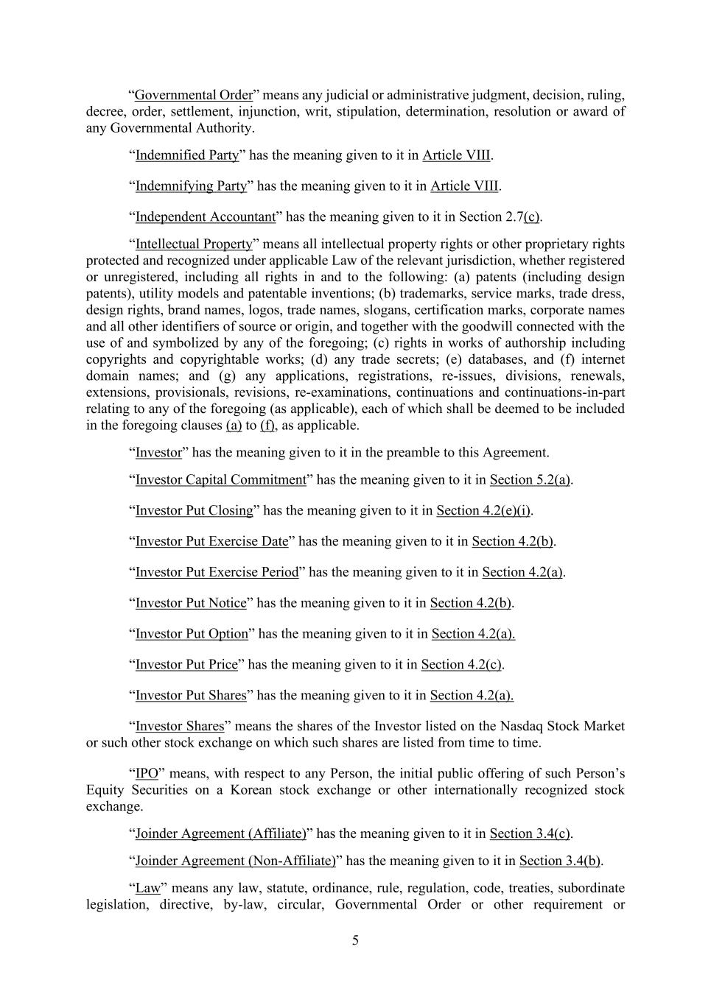
5 “Governmental Order” means any judicial or administrative judgment, decision, ruling, decree, order, settlement, injunction, writ, stipulation, determination, resolution or award of any Governmental Authority. “Indemnified Party” has the meaning given to it in Article VIII. “Indemnifying Party” has the meaning given to it in Article VIII. “Independent Accountant” has the meaning given to it in Section 2.7(c). “Intellectual Property” means all intellectual property rights or other proprietary rights protected and recognized under applicable Law of the relevant jurisdiction, whether registered or unregistered, including all rights in and to the following: (a) patents (including design patents), utility models and patentable inventions; (b) trademarks, service marks, trade dress, design rights, brand names, logos, trade names, slogans, certification marks, corporate names and all other identifiers of source or origin, and together with the goodwill connected with the use of and symbolized by any of the foregoing; (c) rights in works of authorship including copyrights and copyrightable works; (d) any trade secrets; (e) databases, and (f) internet domain names; and (g) any applications, registrations, re-issues, divisions, renewals, extensions, provisionals, revisions, re-examinations, continuations and continuations-in-part relating to any of the foregoing (as applicable), each of which shall be deemed to be included in the foregoing clauses (a) to (f), as applicable. “Investor” has the meaning given to it in the preamble to this Agreement. “Investor Capital Commitment” has the meaning given to it in Section 5.2(a). “Investor Put Closing” has the meaning given to it in Section 4.2(e)(i). “Investor Put Exercise Date” has the meaning given to it in Section 4.2(b). “Investor Put Exercise Period” has the meaning given to it in Section 4.2(a). “Investor Put Notice” has the meaning given to it in Section 4.2(b). “Investor Put Option” has the meaning given to it in Section 4.2(a). “Investor Put Price” has the meaning given to it in Section 4.2(c). “Investor Put Shares” has the meaning given to it in Section 4.2(a). “Investor Shares” means the shares of the Investor listed on the Nasdaq Stock Market or such other stock exchange on which such shares are listed from time to time. “IPO” means, with respect to any Person, the initial public offering of such Person’s Equity Securities on a Korean stock exchange or other internationally recognized stock exchange. “Joinder Agreement (Affiliate)” has the meaning given to it in Section 3.4(c). “Joinder Agreement (Non-Affiliate)” has the meaning given to it in Section 3.4(b). “Law” means any law, statute, ordinance, rule, regulation, code, treaties, subordinate legislation, directive, by-law, circular, Governmental Order or other requirement or

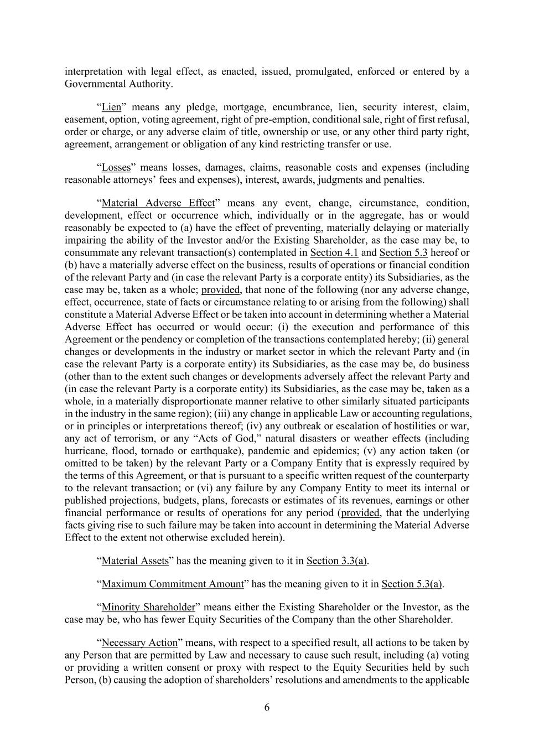
6 interpretation with legal effect, as enacted, issued, promulgated, enforced or entered by a Governmental Authority. “Lien” means any pledge, mortgage, encumbrance, lien, security interest, claim, easement, option, voting agreement, right of pre-emption, conditional sale, right of first refusal, order or charge, or any adverse claim of title, ownership or use, or any other third party right, agreement, arrangement or obligation of any kind restricting transfer or use. “Losses” means losses, damages, claims, reasonable costs and expenses (including reasonable attorneys’ fees and expenses), interest, awards, judgments and penalties. “Material Adverse Effect” means any event, change, circumstance, condition, development, effect or occurrence which, individually or in the aggregate, has or would reasonably be expected to (a) have the effect of preventing, materially delaying or materially impairing the ability of the Investor and/or the Existing Shareholder, as the case may be, to consummate any relevant transaction(s) contemplated in Section 4.1 and Section 5.3 hereof or (b) have a materially adverse effect on the business, results of operations or financial condition of the relevant Party and (in case the relevant Party is a corporate entity) its Subsidiaries, as the case may be, taken as a whole; provided, that none of the following (nor any adverse change, effect, occurrence, state of facts or circumstance relating to or arising from the following) shall constitute a Material Adverse Effect or be taken into account in determining whether a Material Adverse Effect has occurred or would occur: (i) the execution and performance of this Agreement or the pendency or completion of the transactions contemplated hereby; (ii) general changes or developments in the industry or market sector in which the relevant Party and (in case the relevant Party is a corporate entity) its Subsidiaries, as the case may be, do business (other than to the extent such changes or developments adversely affect the relevant Party and (in case the relevant Party is a corporate entity) its Subsidiaries, as the case may be, taken as a whole, in a materially disproportionate manner relative to other similarly situated participants in the industry in the same region); (iii) any change in applicable Law or accounting regulations, or in principles or interpretations thereof; (iv) any outbreak or escalation of hostilities or war, any act of terrorism, or any “Acts of God,” natural disasters or weather effects (including hurricane, flood, tornado or earthquake), pandemic and epidemics; (v) any action taken (or omitted to be taken) by the relevant Party or a Company Entity that is expressly required by the terms of this Agreement, or that is pursuant to a specific written request of the counterparty to the relevant transaction; or (vi) any failure by any Company Entity to meet its internal or published projections, budgets, plans, forecasts or estimates of its revenues, earnings or other financial performance or results of operations for any period (provided, that the underlying facts giving rise to such failure may be taken into account in determining the Material Adverse Effect to the extent not otherwise excluded herein). “Material Assets” has the meaning given to it in Section 3.3(a). “Maximum Commitment Amount” has the meaning given to it in Section 5.3(a). “Minority Shareholder” means either the Existing Shareholder or the Investor, as the case may be, who has fewer Equity Securities of the Company than the other Shareholder. “Necessary Action” means, with respect to a specified result, all actions to be taken by any Person that are permitted by Law and necessary to cause such result, including (a) voting or providing a written consent or proxy with respect to the Equity Securities held by such Person, (b) causing the adoption of shareholders’ resolutions and amendments to the applicable

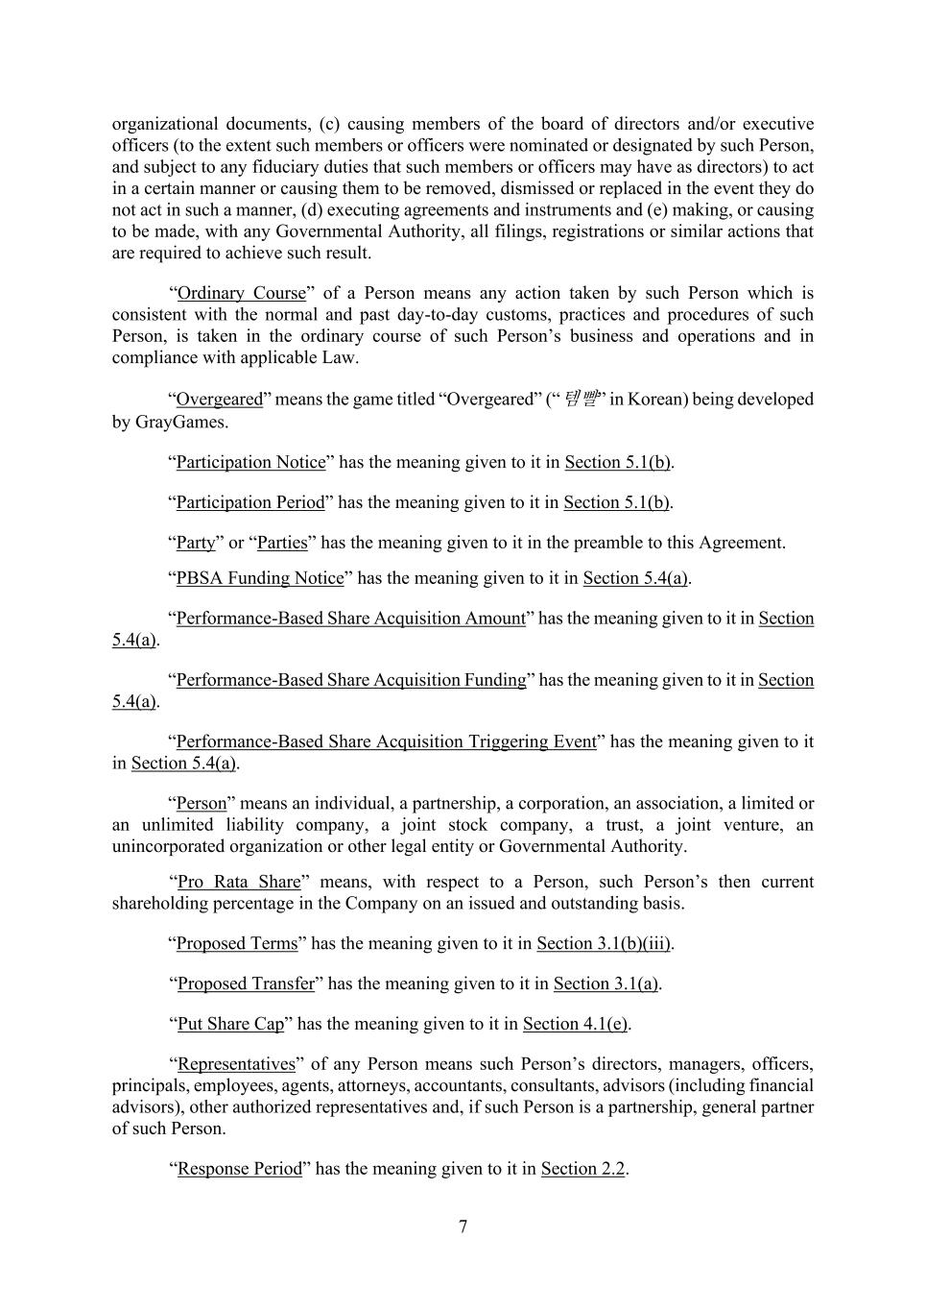
7 organizational documents, (c) causing members of the board of directors and/or executive officers (to the extent such members or officers were nominated or designated by such Person, and subject to any fiduciary duties that such members or officers may have as directors) to act in a certain manner or causing them to be removed, dismissed or replaced in the event they do not act in such a manner, (d) executing agreements and instruments and (e) making, or causing to be made, with any Governmental Authority, all filings, registrations or similar actions that are required to achieve such result. “Ordinary Course” of a Person means any action taken by such Person which is consistent with the normal and past day-to-day customs, practices and procedures of such Person, is taken in the ordinary course of such Person’s business and operations and in compliance with applicable Law. “Overgeared” means the game titled “Overgeared” (“템빨” in Korean) being developed by GrayGames. “Participation Notice” has the meaning given to it in Section 5.1(b). “Participation Period” has the meaning given to it in Section 5.1(b). “Party” or “Parties” has the meaning given to it in the preamble to this Agreement. “PBSA Funding Notice” has the meaning given to it in Section 5.4(a). “Performance-Based Share Acquisition Amount” has the meaning given to it in Section 5.4(a). “Performance-Based Share Acquisition Funding” has the meaning given to it in Section 5.4(a). “Performance-Based Share Acquisition Triggering Event” has the meaning given to it in Section 5.4(a). “Person” means an individual, a partnership, a corporation, an association, a limited or an unlimited liability company, a joint stock company, a trust, a joint venture, an unincorporated organization or other legal entity or Governmental Authority. “Pro Rata Share” means, with respect to a Person, such Person’s then current shareholding percentage in the Company on an issued and outstanding basis. “Proposed Terms” has the meaning given to it in Section 3.1(b)(iii). “Proposed Transfer” has the meaning given to it in Section 3.1(a). “Put Share Cap” has the meaning given to it in Section 4.1(e). “Representatives” of any Person means such Person’s directors, managers, officers, principals, employees, agents, attorneys, accountants, consultants, advisors (including financial advisors), other authorized representatives and, if such Person is a partnership, general partner of such Person. “Response Period” has the meaning given to it in Section 2.2.

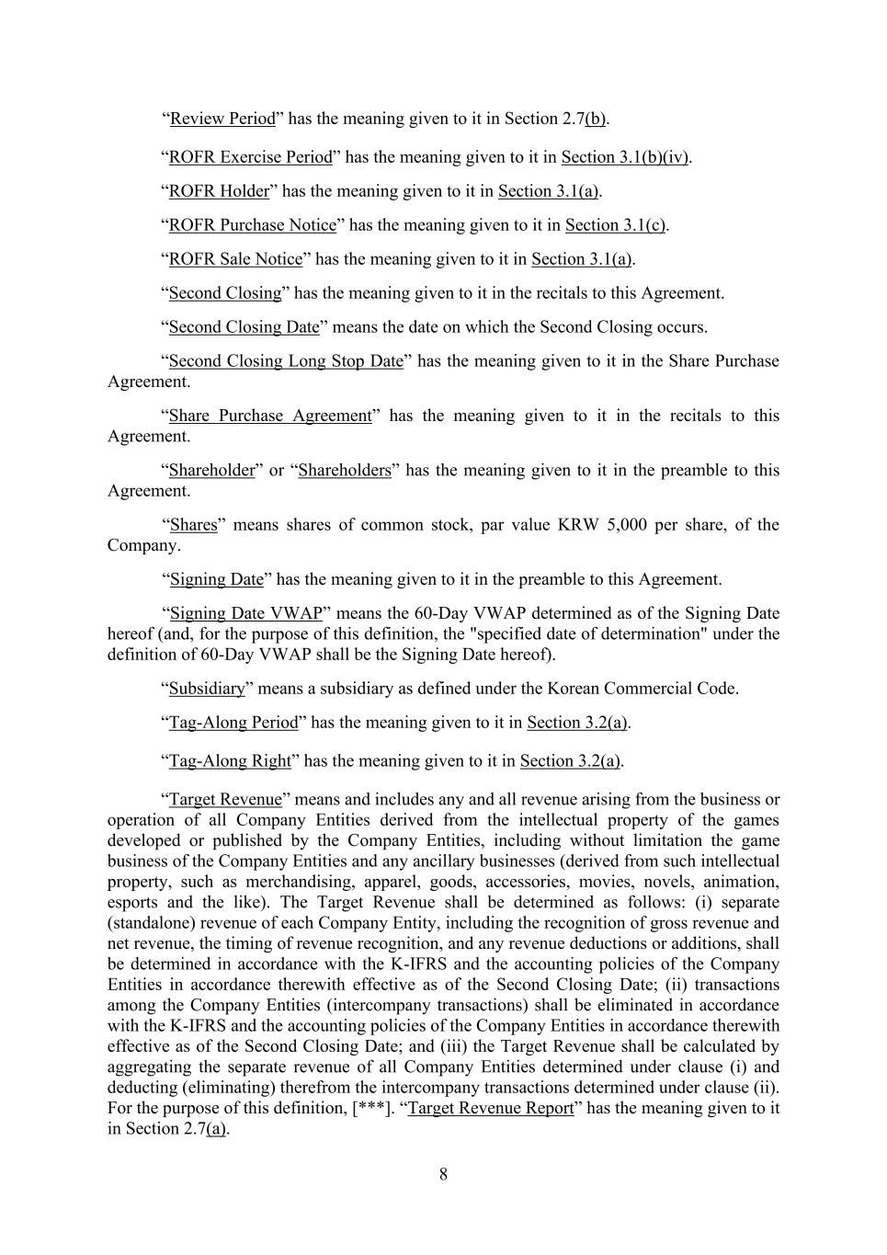
8 “Review Period” has the meaning given to it in Section 2.7(b). “ROFR Exercise Period” has the meaning given to it in Section 3.1(b)(iv). “ROFR Holder” has the meaning given to it in Section 3.1(a). “ROFR Purchase Notice” has the meaning given to it in Section 3.1(c). “ROFR Sale Notice” has the meaning given to it in Section 3.1(a). “Second Closing” has the meaning given to it in the recitals to this Agreement. “Second Closing Date” means the date on which the Second Closing occurs. “Second Closing Long Stop Date” has the meaning given to it in the Share Purchase Agreement. “Share Purchase Agreement” has the meaning given to it in the recitals to this Agreement. “Shareholder” or “Shareholders” has the meaning given to it in the preamble to this Agreement. “Shares” means shares of common stock, par value KRW 5,000 per share, of the Company. “Signing Date” has the meaning given to it in the preamble to this Agreement. “Signing Date VWAP” means the 60-Day VWAP determined as of the Signing Date hereof (and, for the purpose of this definition, the "specified date of determination" under the definition of 60-Day VWAP shall be the Signing Date hereof). “Subsidiary” means a subsidiary as defined under the Korean Commercial Code. “Tag-Along Period” has the meaning given to it in Section 3.2(a). “Tag-Along Right” has the meaning given to it in Section 3.2(a). “Target Revenue” means and includes any and all revenue arising from the business or operation of all Company Entities derived from the intellectual property of the games developed or published by the Company Entities, including without limitation the game business of the Company Entities and any ancillary businesses (derived from such intellectual property, such as merchandising, apparel, goods, accessories, movies, novels, animation, esports and the like). The Target Revenue shall be determined as follows: (i) separate (standalone) revenue of each Company Entity, including the recognition of gross revenue and net revenue, the timing of revenue recognition, and any revenue deductions or additions, shall be determined in accordance with the K-IFRS and the accounting policies of the Company Entities in accordance therewith effective as of the Second Closing Date; (ii) transactions among the Company Entities (intercompany transactions) shall be eliminated in accordance with the K-IFRS and the accounting policies of the Company Entities in accordance therewith effective as of the Second Closing Date; and (iii) the Target Revenue shall be calculated by aggregating the separate revenue of all Company Entities determined under clause (i) and deducting (eliminating) therefrom the intercompany transactions determined under clause (ii). For the purpose of this definition, [***]. “Target Revenue Report” has the meaning given to it in Section 2.7(a).

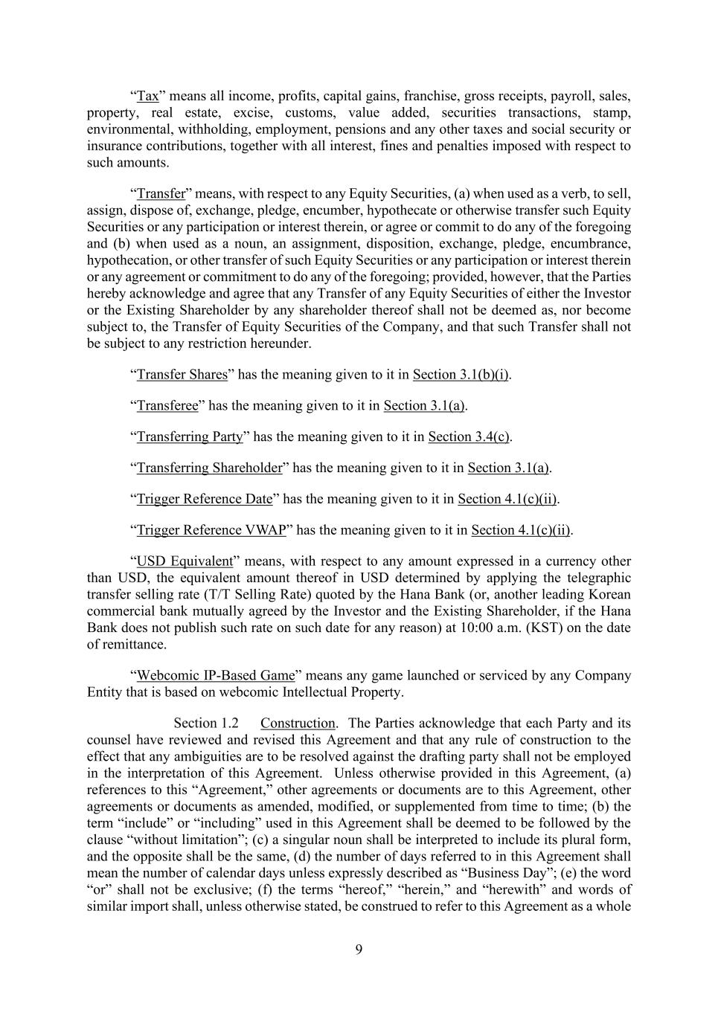
9 “Tax” means all income, profits, capital gains, franchise, gross receipts, payroll, sales, property, real estate, excise, customs, value added, securities transactions, stamp, environmental, withholding, employment, pensions and any other taxes and social security or insurance contributions, together with all interest, fines and penalties imposed with respect to such amounts. “Transfer” means, with respect to any Equity Securities, (a) when used as a verb, to sell, assign, dispose of, exchange, pledge, encumber, hypothecate or otherwise transfer such Equity Securities or any participation or interest therein, or agree or commit to do any of the foregoing and (b) when used as a noun, an assignment, disposition, exchange, pledge, encumbrance, hypothecation, or other transfer of such Equity Securities or any participation or interest therein or any agreement or commitment to do any of the foregoing; provided, however, that the Parties hereby acknowledge and agree that any Transfer of any Equity Securities of either the Investor or the Existing Shareholder by any shareholder thereof shall not be deemed as, nor become subject to, the Transfer of Equity Securities of the Company, and that such Transfer shall not be subject to any restriction hereunder. “Transfer Shares” has the meaning given to it in Section 3.1(b)(i). “Transferee” has the meaning given to it in Section 3.1(a). “Transferring Party” has the meaning given to it in Section 3.4(c). “Transferring Shareholder” has the meaning given to it in Section 3.1(a). “Trigger Reference Date” has the meaning given to it in Section 4.1(c)(ii). “Trigger Reference VWAP” has the meaning given to it in Section 4.1(c)(ii). “USD Equivalent” means, with respect to any amount expressed in a currency other than USD, the equivalent amount thereof in USD determined by applying the telegraphic transfer selling rate (T/T Selling Rate) quoted by the Hana Bank (or, another leading Korean commercial bank mutually agreed by the Investor and the Existing Shareholder, if the Hana Bank does not publish such rate on such date for any reason) at 10:00 a.m. (KST) on the date of remittance. “Webcomic IP-Based Game” means any game launched or serviced by any Company Entity that is based on webcomic Intellectual Property. Construction. The Parties acknowledge that each Party and its counsel have reviewed and revised this Agreement and that any rule of construction to the effect that any ambiguities are to be resolved against the drafting party shall not be employed in the interpretation of this Agreement. Unless otherwise provided in this Agreement, (a) references to this “Agreement,” other agreements or documents are to this Agreement, other agreements or documents as amended, modified, or supplemented from time to time; (b) the term “include” or “including” used in this Agreement shall be deemed to be followed by the clause “without limitation”; (c) a singular noun shall be interpreted to include its plural form, and the opposite shall be the same, (d) the number of days referred to in this Agreement shall mean the number of calendar days unless expressly described as “Business Day”; (e) the word “or” shall not be exclusive; (f) the terms “hereof,” “herein,” and “herewith” and words of similar import shall, unless otherwise stated, be construed to refer to this Agreement as a whole

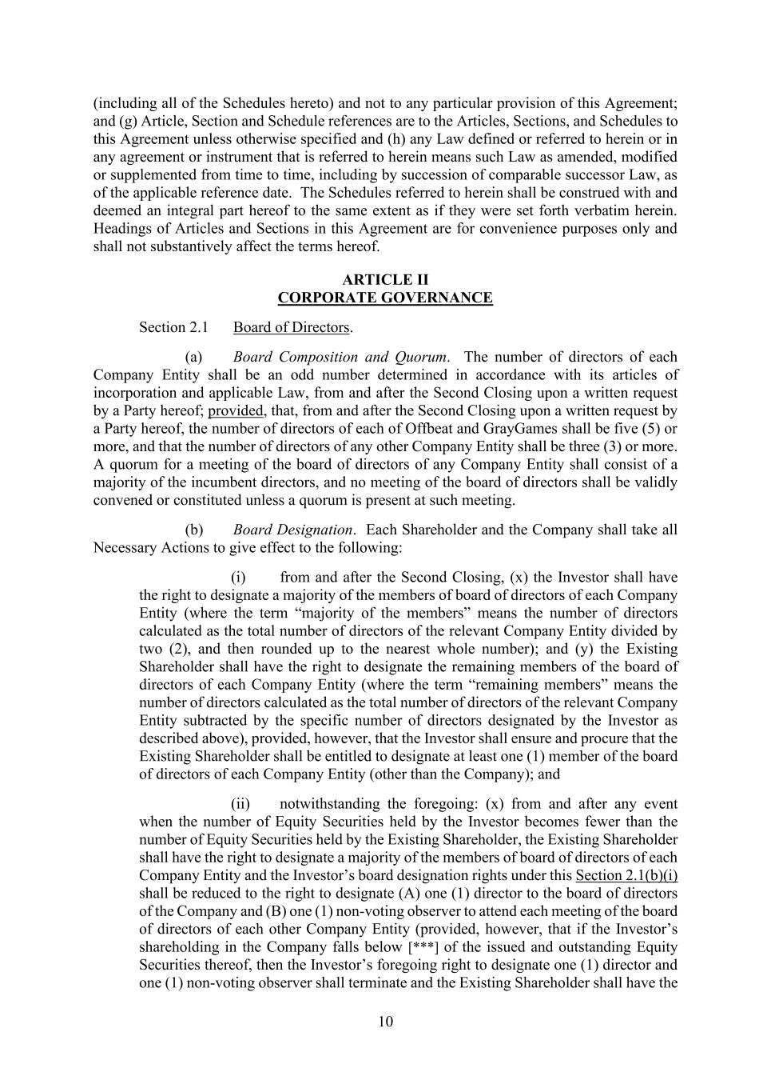
10 (including all of the Schedules hereto) and not to any particular provision of this Agreement; and (g) Article, Section and Schedule references are to the Articles, Sections, and Schedules to this Agreement unless otherwise specified and (h) any Law defined or referred to herein or in any agreement or instrument that is referred to herein means such Law as amended, modified or supplemented from time to time, including by succession of comparable successor Law, as of the applicable reference date. The Schedules referred to herein shall be construed with and deemed an integral part hereof to the same extent as if they were set forth verbatim herein. Headings of Articles and Sections in this Agreement are for convenience purposes only and shall not substantively affect the terms hereof. ARTICLE II CORPORATE GOVERNANCE Section 2.1 Board of Directors. (a) Board Composition and Quorum. The number of directors of each Company Entity shall be an odd number determined in accordance with its articles of incorporation and applicable Law, from and after the Second Closing upon a written request by a Party hereof; provided, that, from and after the Second Closing upon a written request by a Party hereof, the number of directors of each of Offbeat and GrayGames shall be five (5) or more, and that the number of directors of any other Company Entity shall be three (3) or more. A quorum for a meeting of the board of directors of any Company Entity shall consist of a majority of the incumbent directors, and no meeting of the board of directors shall be validly convened or constituted unless a quorum is present at such meeting. (b) Board Designation. Each Shareholder and the Company shall take all Necessary Actions to give effect to the following: (i) from and after the Second Closing, (x) the Investor shall have the right to designate a majority of the members of board of directors of each Company Entity (where the term “majority of the members” means the number of directors calculated as the total number of directors of the relevant Company Entity divided by two (2), and then rounded up to the nearest whole number); and (y) the Existing Shareholder shall have the right to designate the remaining members of the board of directors of each Company Entity (where the term “remaining members” means the number of directors calculated as the total number of directors of the relevant Company Entity subtracted by the specific number of directors designated by the Investor as described above), provided, however, that the Investor shall ensure and procure that the Existing Shareholder shall be entitled to designate at least one (1) member of the board of directors of each Company Entity (other than the Company); and (ii) notwithstanding the foregoing: (x) from and after any event when the number of Equity Securities held by the Investor becomes fewer than the number of Equity Securities held by the Existing Shareholder, the Existing Shareholder shall have the right to designate a majority of the members of board of directors of each Company Entity and the Investor’s board designation rights under this Section 2.1(b)(i) shall be reduced to the right to designate (A) one (1) director to the board of directors of the Company and (B) one (1) non-voting observer to attend each meeting of the board of directors of each other Company Entity (provided, however, that if the Investor’s shareholding in the Company falls below [***] of the issued and outstanding Equity Securities thereof, then the Investor’s foregoing right to designate one (1) director and one (1) non-voting observer shall terminate and the Existing Shareholder shall have the

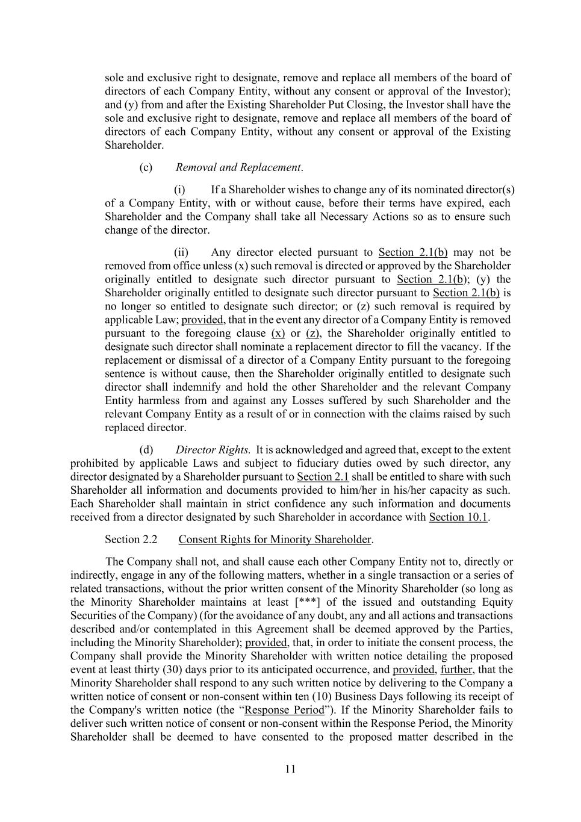
11 sole and exclusive right to designate, remove and replace all members of the board of directors of each Company Entity, without any consent or approval of the Investor); and (y) from and after the Existing Shareholder Put Closing, the Investor shall have the sole and exclusive right to designate, remove and replace all members of the board of directors of each Company Entity, without any consent or approval of the Existing Shareholder. (c) Removal and Replacement. (i) If a Shareholder wishes to change any of its nominated director(s) of a Company Entity, with or without cause, before their terms have expired, each Shareholder and the Company shall take all Necessary Actions so as to ensure such change of the director. (ii) Any director elected pursuant to Section 2.1(b) may not be removed from office unless (x) such removal is directed or approved by the Shareholder originally entitled to designate such director pursuant to Section 2.1(b); (y) the Shareholder originally entitled to designate such director pursuant to Section 2.1(b) is no longer so entitled to designate such director; or (z) such removal is required by applicable Law; provided, that in the event any director of a Company Entity is removed pursuant to the foregoing clause (x) or (z), the Shareholder originally entitled to designate such director shall nominate a replacement director to fill the vacancy. If the replacement or dismissal of a director of a Company Entity pursuant to the foregoing sentence is without cause, then the Shareholder originally entitled to designate such director shall indemnify and hold the other Shareholder and the relevant Company Entity harmless from and against any Losses suffered by such Shareholder and the relevant Company Entity as a result of or in connection with the claims raised by such replaced director. (d) Director Rights. It is acknowledged and agreed that, except to the extent prohibited by applicable Laws and subject to fiduciary duties owed by such director, any director designated by a Shareholder pursuant to Section 2.1 shall be entitled to share with such Shareholder all information and documents provided to him/her in his/her capacity as such. Each Shareholder shall maintain in strict confidence any such information and documents received from a director designated by such Shareholder in accordance with Section 10.1. Section 2.2 Consent Rights for Minority Shareholder. The Company shall not, and shall cause each other Company Entity not to, directly or indirectly, engage in any of the following matters, whether in a single transaction or a series of related transactions, without the prior written consent of the Minority Shareholder (so long as the Minority Shareholder maintains at least [***] of the issued and outstanding Equity Securities of the Company) (for the avoidance of any doubt, any and all actions and transactions described and/or contemplated in this Agreement shall be deemed approved by the Parties, including the Minority Shareholder); provided, that, in order to initiate the consent process, the Company shall provide the Minority Shareholder with written notice detailing the proposed event at least thirty (30) days prior to its anticipated occurrence, and provided, further, that the Minority Shareholder shall respond to any such written notice by delivering to the Company a written notice of consent or non-consent within ten (10) Business Days following its receipt of the Company's written notice (the “Response Period”). If the Minority Shareholder fails to deliver such written notice of consent or non-consent within the Response Period, the Minority Shareholder shall be deemed to have consented to the proposed matter described in the

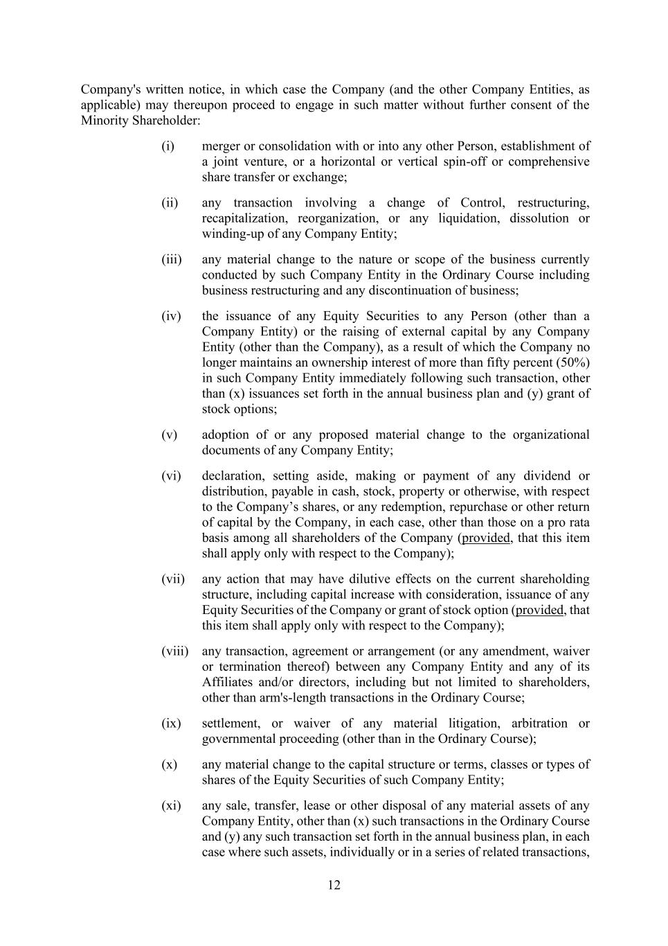
12 Company's written notice, in which case the Company (and the other Company Entities, as applicable) may thereupon proceed to engage in such matter without further consent of the Minority Shareholder: (i) merger or consolidation with or into any other Person, establishment of a joint venture, or a horizontal or vertical spin-off or comprehensive share transfer or exchange; (ii) any transaction involving a change of Control, restructuring, recapitalization, reorganization, or any liquidation, dissolution or winding-up of any Company Entity; (iii) any material change to the nature or scope of the business currently conducted by such Company Entity in the Ordinary Course including business restructuring and any discontinuation of business; (iv) the issuance of any Equity Securities to any Person (other than a Company Entity) or the raising of external capital by any Company Entity (other than the Company), as a result of which the Company no longer maintains an ownership interest of more than fifty percent (50%) in such Company Entity immediately following such transaction, other than (x) issuances set forth in the annual business plan and (y) grant of stock options; (v) adoption of or any proposed material change to the organizational documents of any Company Entity; (vi) declaration, setting aside, making or payment of any dividend or distribution, payable in cash, stock, property or otherwise, with respect to the Company’s shares, or any redemption, repurchase or other return of capital by the Company, in each case, other than those on a pro rata basis among all shareholders of the Company (provided, that this item shall apply only with respect to the Company); (vii) any action that may have dilutive effects on the current shareholding structure, including capital increase with consideration, issuance of any Equity Securities of the Company or grant of stock option (provided, that this item shall apply only with respect to the Company); (viii) any transaction, agreement or arrangement (or any amendment, waiver or termination thereof) between any Company Entity and any of its Affiliates and/or directors, including but not limited to shareholders, other than arm's-length transactions in the Ordinary Course; (ix) settlement, or waiver of any material litigation, arbitration or governmental proceeding (other than in the Ordinary Course); (x) any material change to the capital structure or terms, classes or types of shares of the Equity Securities of such Company Entity; (xi) any sale, transfer, lease or other disposal of any material assets of any Company Entity, other than (x) such transactions in the Ordinary Course and (y) any such transaction set forth in the annual business plan, in each case where such assets, individually or in a series of related transactions,

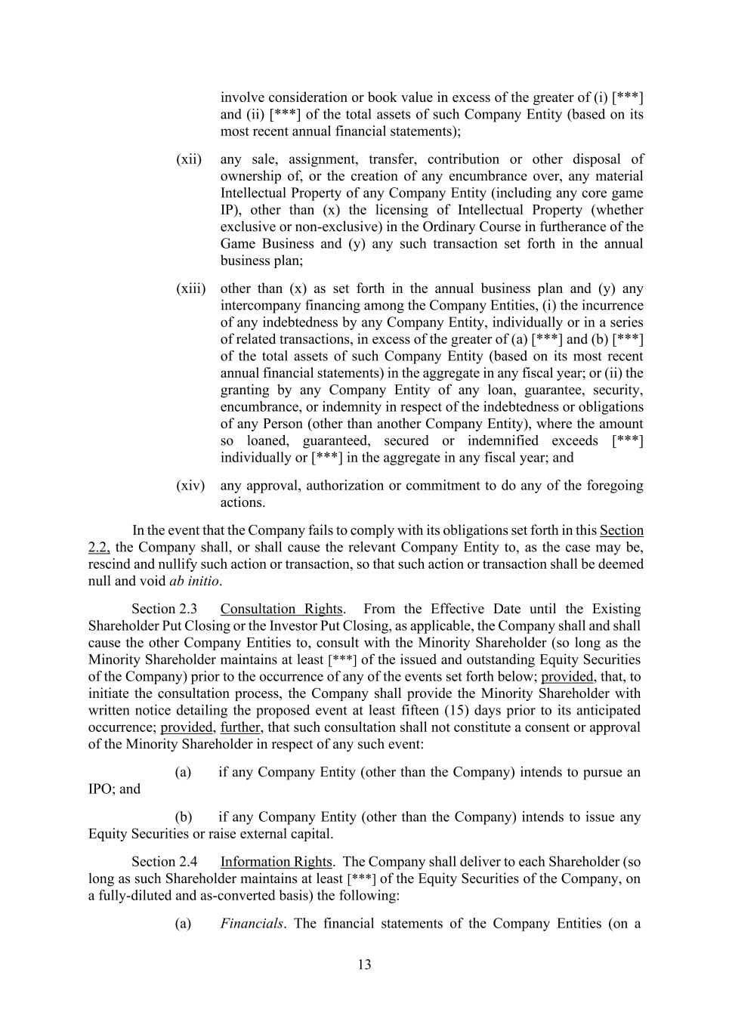
13 involve consideration or book value in excess of the greater of (i) [***] and (ii) [***] of the total assets of such Company Entity (based on its most recent annual financial statements); (xii) any sale, assignment, transfer, contribution or other disposal of ownership of, or the creation of any encumbrance over, any material Intellectual Property of any Company Entity (including any core game IP), other than (x) the licensing of Intellectual Property (whether exclusive or non-exclusive) in the Ordinary Course in furtherance of the Game Business and (y) any such transaction set forth in the annual business plan; (xiii) other than (x) as set forth in the annual business plan and (y) any intercompany financing among the Company Entities, (i) the incurrence of any indebtedness by any Company Entity, individually or in a series of related transactions, in excess of the greater of (a) [***] and (b) [***] of the total assets of such Company Entity (based on its most recent annual financial statements) in the aggregate in any fiscal year; or (ii) the granting by any Company Entity of any loan, guarantee, security, encumbrance, or indemnity in respect of the indebtedness or obligations of any Person (other than another Company Entity), where the amount so loaned, guaranteed, secured or indemnified exceeds [***] individually or [***] in the aggregate in any fiscal year; and (xiv) any approval, authorization or commitment to do any of the foregoing actions. In the event that the Company fails to comply with its obligations set forth in this Section 2.2, the Company shall, or shall cause the relevant Company Entity to, as the case may be, rescind and nullify such action or transaction, so that such action or transaction shall be deemed null and void ab initio. Section 2.3 Consultation Rights. From the Effective Date until the Existing Shareholder Put Closing or the Investor Put Closing, as applicable, the Company shall and shall cause the other Company Entities to, consult with the Minority Shareholder (so long as the Minority Shareholder maintains at least [***] of the issued and outstanding Equity Securities of the Company) prior to the occurrence of any of the events set forth below; provided, that, to initiate the consultation process, the Company shall provide the Minority Shareholder with written notice detailing the proposed event at least fifteen (15) days prior to its anticipated occurrence; provided, further, that such consultation shall not constitute a consent or approval of the Minority Shareholder in respect of any such event: (a) if any Company Entity (other than the Company) intends to pursue an IPO; and (b) if any Company Entity (other than the Company) intends to issue any Equity Securities or raise external capital. Section 2.4 Information Rights. The Company shall deliver to each Shareholder (so long as such Shareholder maintains at least [***] of the Equity Securities of the Company, on a fully-diluted and as-converted basis) the following: (a) Financials. The financial statements of the Company Entities (on a

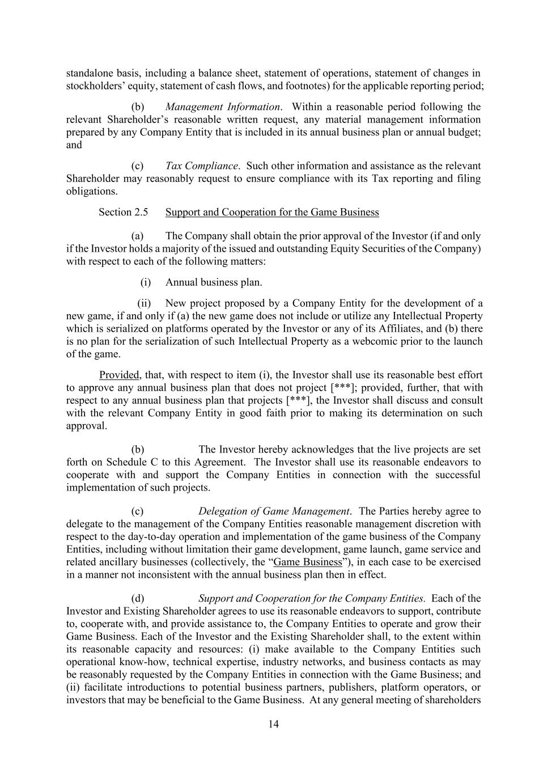
14 standalone basis, including a balance sheet, statement of operations, statement of changes in stockholders’ equity, statement of cash flows, and footnotes) for the applicable reporting period; (b) Management Information. Within a reasonable period following the relevant Shareholder’s reasonable written request, any material management information prepared by any Company Entity that is included in its annual business plan or annual budget; and (c) Tax Compliance. Such other information and assistance as the relevant Shareholder may reasonably request to ensure compliance with its Tax reporting and filing obligations. Section 2.5 Support and Cooperation for the Game Business (a) The Company shall obtain the prior approval of the Investor (if and only if the Investor holds a majority of the issued and outstanding Equity Securities of the Company) with respect to each of the following matters: (i) Annual business plan. (ii) New project proposed by a Company Entity for the development of a new game, if and only if (a) the new game does not include or utilize any Intellectual Property which is serialized on platforms operated by the Investor or any of its Affiliates, and (b) there is no plan for the serialization of such Intellectual Property as a webcomic prior to the launch of the game. Provided, that, with respect to item (i), the Investor shall use its reasonable best effort to approve any annual business plan that does not project [***]; provided, further, that with respect to any annual business plan that projects [***], the Investor shall discuss and consult with the relevant Company Entity in good faith prior to making its determination on such approval. (b) The Investor hereby acknowledges that the live projects are set forth on Schedule C to this Agreement. The Investor shall use its reasonable endeavors to cooperate with and support the Company Entities in connection with the successful implementation of such projects. (c) Delegation of Game Management. The Parties hereby agree to delegate to the management of the Company Entities reasonable management discretion with respect to the day-to-day operation and implementation of the game business of the Company Entities, including without limitation their game development, game launch, game service and related ancillary businesses (collectively, the “Game Business”), in each case to be exercised in a manner not inconsistent with the annual business plan then in effect. (d) Support and Cooperation for the Company Entities. Each of the Investor and Existing Shareholder agrees to use its reasonable endeavors to support, contribute to, cooperate with, and provide assistance to, the Company Entities to operate and grow their Game Business. Each of the Investor and the Existing Shareholder shall, to the extent within its reasonable capacity and resources: (i) make available to the Company Entities such operational know-how, technical expertise, industry networks, and business contacts as may be reasonably requested by the Company Entities in connection with the Game Business; and (ii) facilitate introductions to potential business partners, publishers, platform operators, or investors that may be beneficial to the Game Business. At any general meeting of shareholders

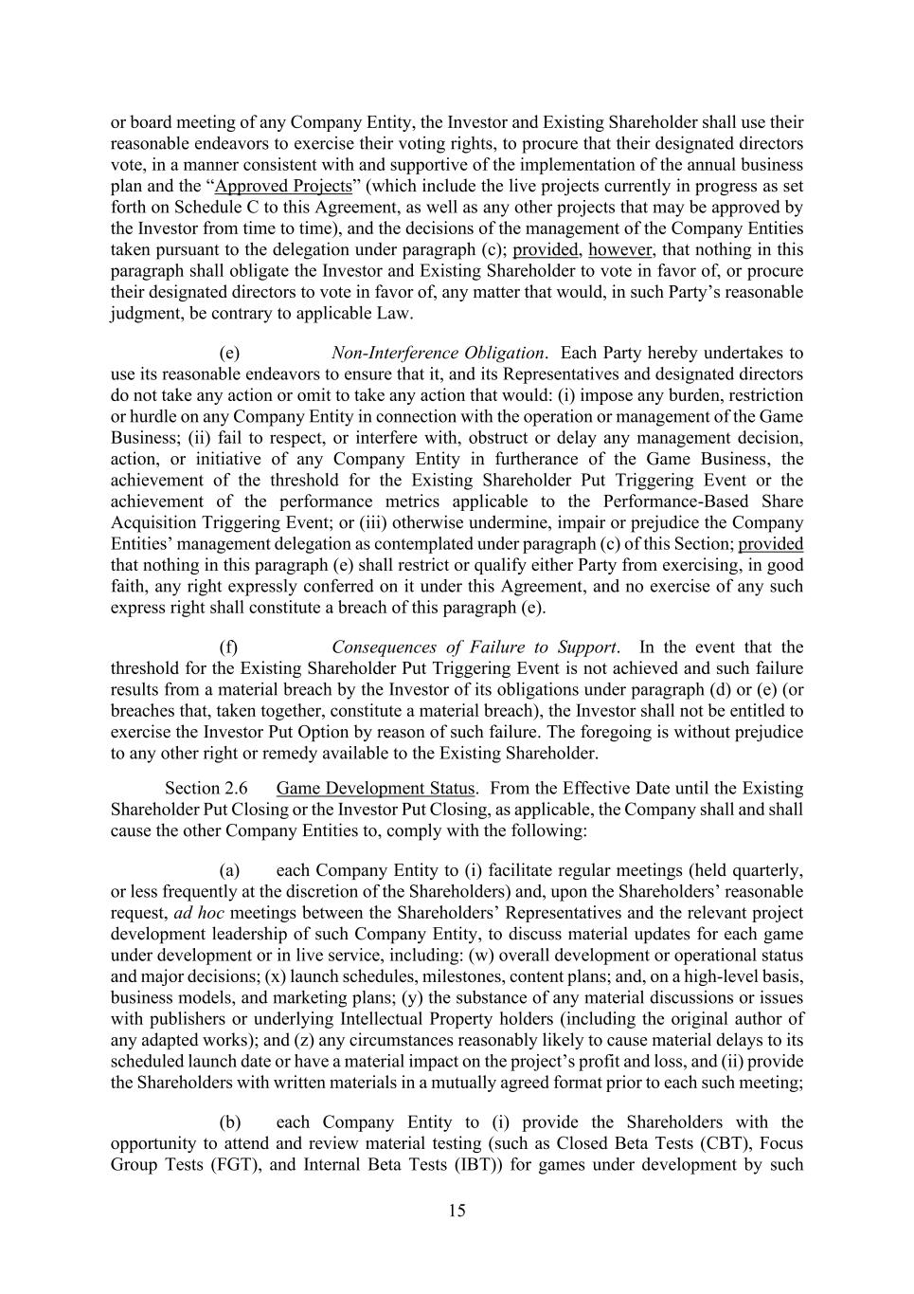
15 or board meeting of any Company Entity, the Investor and Existing Shareholder shall use their reasonable endeavors to exercise their voting rights, to procure that their designated directors vote, in a manner consistent with and supportive of the implementation of the annual business plan and the “Approved Projects” (which include the live projects currently in progress as set forth on Schedule C to this Agreement, as well as any other projects that may be approved by the Investor from time to time), and the decisions of the management of the Company Entities taken pursuant to the delegation under paragraph (c); provided, however, that nothing in this paragraph shall obligate the Investor and Existing Shareholder to vote in favor of, or procure their designated directors to vote in favor of, any matter that would, in such Party’s reasonable judgment, be contrary to applicable Law. (e) Non-Interference Obligation. Each Party hereby undertakes to use its reasonable endeavors to ensure that it, and its Representatives and designated directors do not take any action or omit to take any action that would: (i) impose any burden, restriction or hurdle on any Company Entity in connection with the operation or management of the Game Business; (ii) fail to respect, or interfere with, obstruct or delay any management decision, action, or initiative of any Company Entity in furtherance of the Game Business, the achievement of the threshold for the Existing Shareholder Put Triggering Event or the achievement of the performance metrics applicable to the Performance-Based Share Acquisition Triggering Event; or (iii) otherwise undermine, impair or prejudice the Company Entities’ management delegation as contemplated under paragraph (c) of this Section; provided that nothing in this paragraph (e) shall restrict or qualify either Party from exercising, in good faith, any right expressly conferred on it under this Agreement, and no exercise of any such express right shall constitute a breach of this paragraph (e). (f) Consequences of Failure to Support. In the event that the threshold for the Existing Shareholder Put Triggering Event is not achieved and such failure results from a material breach by the Investor of its obligations under paragraph (d) or (e) (or breaches that, taken together, constitute a material breach), the Investor shall not be entitled to exercise the Investor Put Option by reason of such failure. The foregoing is without prejudice to any other right or remedy available to the Existing Shareholder. Section 2.6 Game Development Status. From the Effective Date until the Existing Shareholder Put Closing or the Investor Put Closing, as applicable, the Company shall and shall cause the other Company Entities to, comply with the following: (a) each Company Entity to (i) facilitate regular meetings (held quarterly, or less frequently at the discretion of the Shareholders) and, upon the Shareholders’ reasonable request, ad hoc meetings between the Shareholders’ Representatives and the relevant project development leadership of such Company Entity, to discuss material updates for each game under development or in live service, including: (w) overall development or operational status and major decisions; (x) launch schedules, milestones, content plans; and, on a high-level basis, business models, and marketing plans; (y) the substance of any material discussions or issues with publishers or underlying Intellectual Property holders (including the original author of any adapted works); and (z) any circumstances reasonably likely to cause material delays to its scheduled launch date or have a material impact on the project’s profit and loss, and (ii) provide the Shareholders with written materials in a mutually agreed format prior to each such meeting; (b) each Company Entity to (i) provide the Shareholders with the opportunity to attend and review material testing (such as Closed Beta Tests (CBT), Focus Group Tests (FGT), and Internal Beta Tests (IBT)) for games under development by such

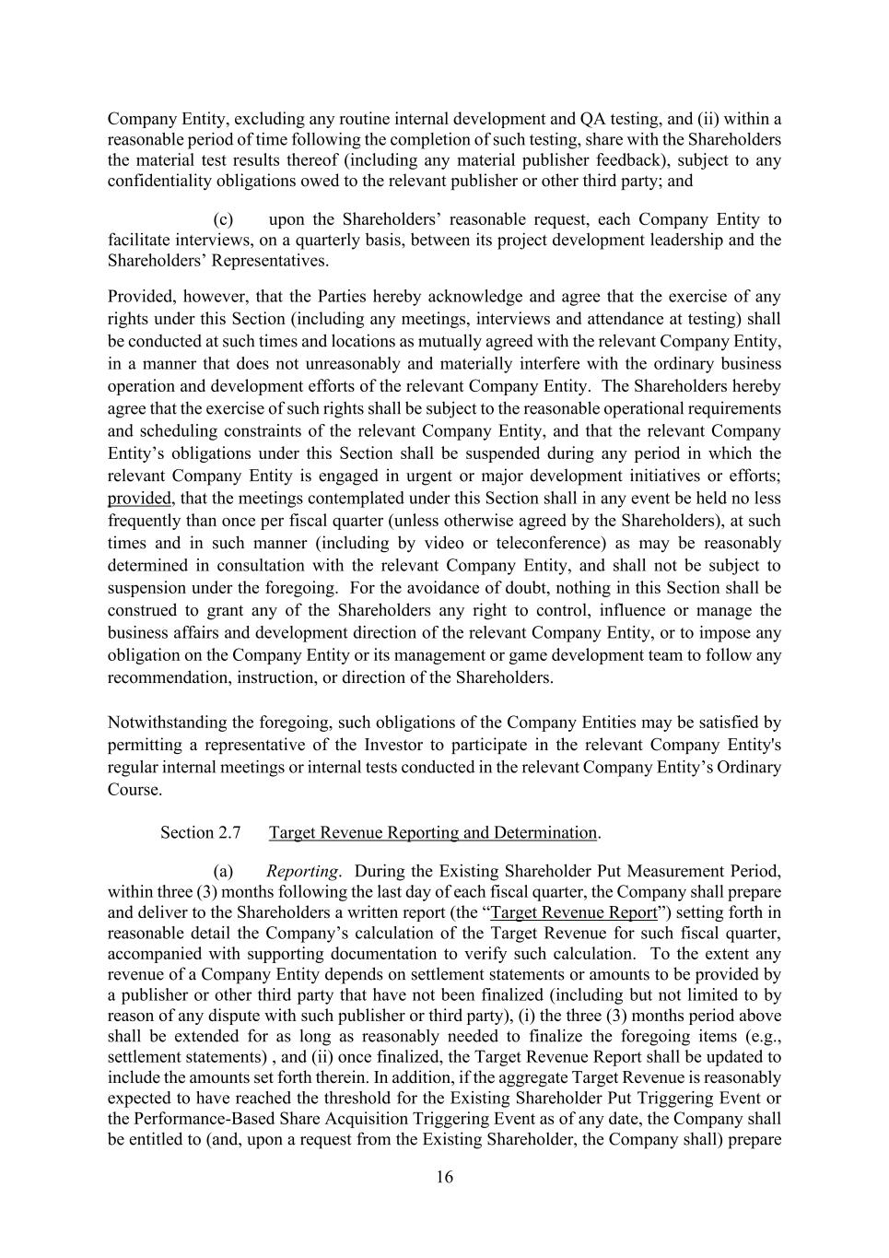
16 Company Entity, excluding any routine internal development and QA testing, and (ii) within a reasonable period of time following the completion of such testing, share with the Shareholders the material test results thereof (including any material publisher feedback), subject to any confidentiality obligations owed to the relevant publisher or other third party; and (c) upon the Shareholders’ reasonable request, each Company Entity to facilitate interviews, on a quarterly basis, between its project development leadership and the Shareholders’ Representatives. Provided, however, that the Parties hereby acknowledge and agree that the exercise of any rights under this Section (including any meetings, interviews and attendance at testing) shall be conducted at such times and locations as mutually agreed with the relevant Company Entity, in a manner that does not unreasonably and materially interfere with the ordinary business operation and development efforts of the relevant Company Entity. The Shareholders hereby agree that the exercise of such rights shall be subject to the reasonable operational requirements and scheduling constraints of the relevant Company Entity, and that the relevant Company Entity’s obligations under this Section shall be suspended during any period in which the relevant Company Entity is engaged in urgent or major development initiatives or efforts; provided, that the meetings contemplated under this Section shall in any event be held no less frequently than once per fiscal quarter (unless otherwise agreed by the Shareholders), at such times and in such manner (including by video or teleconference) as may be reasonably determined in consultation with the relevant Company Entity, and shall not be subject to suspension under the foregoing. For the avoidance of doubt, nothing in this Section shall be construed to grant any of the Shareholders any right to control, influence or manage the business affairs and development direction of the relevant Company Entity, or to impose any obligation on the Company Entity or its management or game development team to follow any recommendation, instruction, or direction of the Shareholders. Notwithstanding the foregoing, such obligations of the Company Entities may be satisfied by permitting a representative of the Investor to participate in the relevant Company Entity's regular internal meetings or internal tests conducted in the relevant Company Entity’s Ordinary Course. Section 2.7 Target Revenue Reporting and Determination. (a) Reporting. During the Existing Shareholder Put Measurement Period, within three (3) months following the last day of each fiscal quarter, the Company shall prepare and deliver to the Shareholders a written report (the “Target Revenue Report”) setting forth in reasonable detail the Company’s calculation of the Target Revenue for such fiscal quarter, accompanied with supporting documentation to verify such calculation. To the extent any revenue of a Company Entity depends on settlement statements or amounts to be provided by a publisher or other third party that have not been finalized (including but not limited to by reason of any dispute with such publisher or third party), (i) the three (3) months period above shall be extended for as long as reasonably needed to finalize the foregoing items (e.g., settlement statements) , and (ii) once finalized, the Target Revenue Report shall be updated to include the amounts set forth therein. In addition, if the aggregate Target Revenue is reasonably expected to have reached the threshold for the Existing Shareholder Put Triggering Event or the Performance-Based Share Acquisition Triggering Event as of any date, the Company shall be entitled to (and, upon a request from the Existing Shareholder, the Company shall) prepare

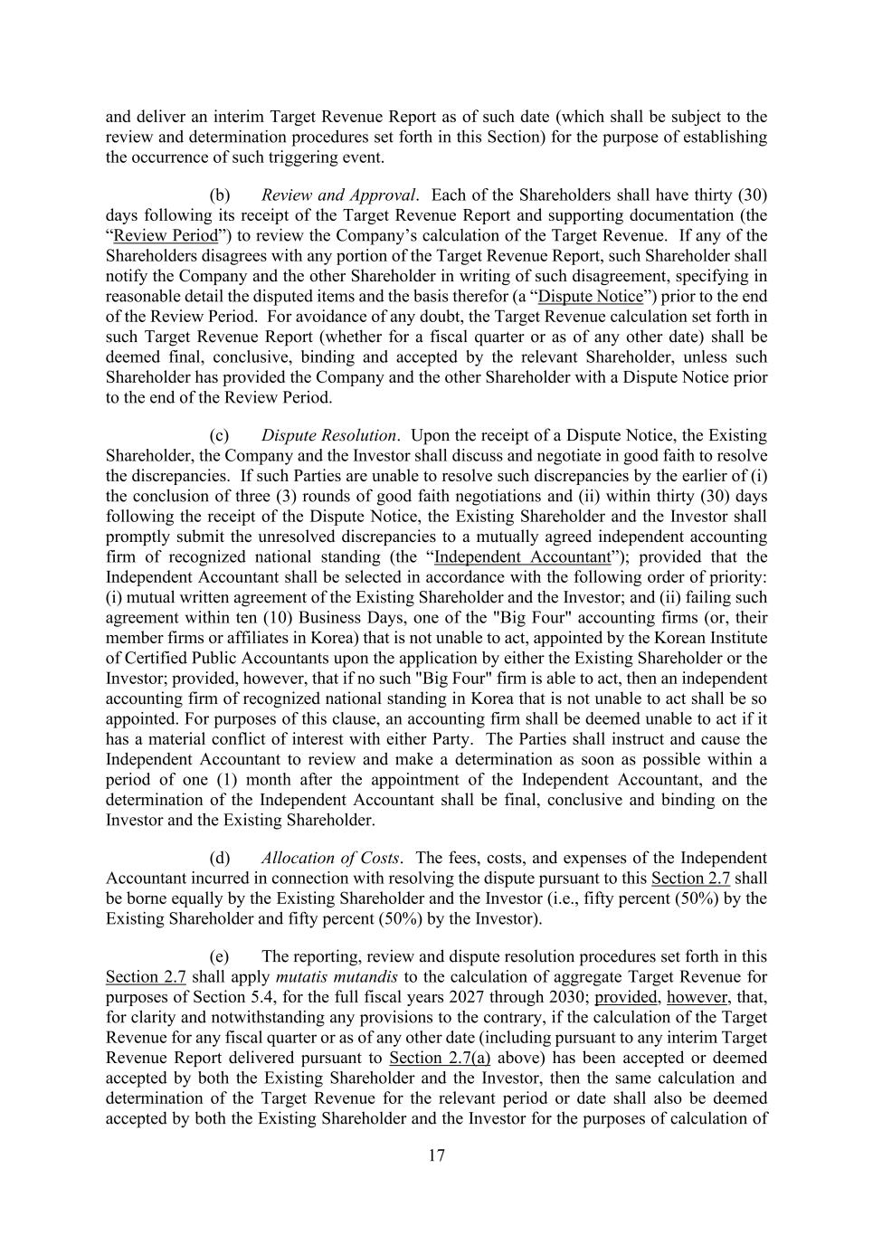
17 and deliver an interim Target Revenue Report as of such date (which shall be subject to the review and determination procedures set forth in this Section) for the purpose of establishing the occurrence of such triggering event. (b) Review and Approval. Each of the Shareholders shall have thirty (30) days following its receipt of the Target Revenue Report and supporting documentation (the “Review Period”) to review the Company’s calculation of the Target Revenue. If any of the Shareholders disagrees with any portion of the Target Revenue Report, such Shareholder shall notify the Company and the other Shareholder in writing of such disagreement, specifying in reasonable detail the disputed items and the basis therefor (a “Dispute Notice”) prior to the end of the Review Period. For avoidance of any doubt, the Target Revenue calculation set forth in such Target Revenue Report (whether for a fiscal quarter or as of any other date) shall be deemed final, conclusive, binding and accepted by the relevant Shareholder, unless such Shareholder has provided the Company and the other Shareholder with a Dispute Notice prior to the end of the Review Period. (c) Dispute Resolution. Upon the receipt of a Dispute Notice, the Existing Shareholder, the Company and the Investor shall discuss and negotiate in good faith to resolve the discrepancies. If such Parties are unable to resolve such discrepancies by the earlier of (i) the conclusion of three (3) rounds of good faith negotiations and (ii) within thirty (30) days following the receipt of the Dispute Notice, the Existing Shareholder and the Investor shall promptly submit the unresolved discrepancies to a mutually agreed independent accounting firm of recognized national standing (the “Independent Accountant”); provided that the Independent Accountant shall be selected in accordance with the following order of priority: (i) mutual written agreement of the Existing Shareholder and the Investor; and (ii) failing such agreement within ten (10) Business Days, one of the "Big Four" accounting firms (or, their member firms or affiliates in Korea) that is not unable to act, appointed by the Korean Institute of Certified Public Accountants upon the application by either the Existing Shareholder or the Investor; provided, however, that if no such "Big Four" firm is able to act, then an independent accounting firm of recognized national standing in Korea that is not unable to act shall be so appointed. For purposes of this clause, an accounting firm shall be deemed unable to act if it has a material conflict of interest with either Party. The Parties shall instruct and cause the Independent Accountant to review and make a determination as soon as possible within a period of one (1) month after the appointment of the Independent Accountant, and the determination of the Independent Accountant shall be final, conclusive and binding on the Investor and the Existing Shareholder. (d) Allocation of Costs. The fees, costs, and expenses of the Independent Accountant incurred in connection with resolving the dispute pursuant to this Section 2.7 shall be borne equally by the Existing Shareholder and the Investor (i.e., fifty percent (50%) by the Existing Shareholder and fifty percent (50%) by the Investor). (e) The reporting, review and dispute resolution procedures set forth in this Section 2.7 shall apply mutatis mutandis to the calculation of aggregate Target Revenue for purposes of Section 5.4, for the full fiscal years 2027 through 2030; provided, however, that, for clarity and notwithstanding any provisions to the contrary, if the calculation of the Target Revenue for any fiscal quarter or as of any other date (including pursuant to any interim Target Revenue Report delivered pursuant to Section 2.7(a) above) has been accepted or deemed accepted by both the Existing Shareholder and the Investor, then the same calculation and determination of the Target Revenue for the relevant period or date shall also be deemed accepted by both the Existing Shareholder and the Investor for the purposes of calculation of

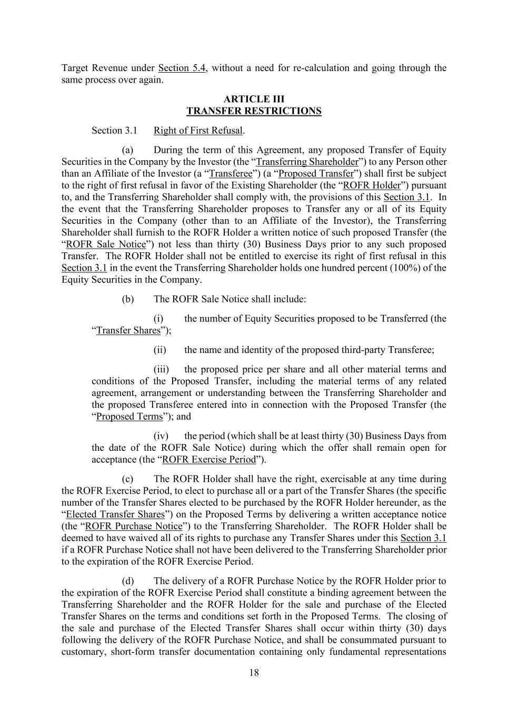
18 Target Revenue under Section 5.4, without a need for re-calculation and going through the same process over again. ARTICLE III TRANSFER RESTRICTIONS Section 3.1 Right of First Refusal. (a) During the term of this Agreement, any proposed Transfer of Equity Securities in the Company by the Investor (the “Transferring Shareholder”) to any Person other than an Affiliate of the Investor (a “Transferee”) (a “Proposed Transfer”) shall first be subject to the right of first refusal in favor of the Existing Shareholder (the “ROFR Holder”) pursuant to, and the Transferring Shareholder shall comply with, the provisions of this Section 3.1. In the event that the Transferring Shareholder proposes to Transfer any or all of its Equity Securities in the Company (other than to an Affiliate of the Investor), the Transferring Shareholder shall furnish to the ROFR Holder a written notice of such proposed Transfer (the “ROFR Sale Notice”) not less than thirty (30) Business Days prior to any such proposed Transfer. The ROFR Holder shall not be entitled to exercise its right of first refusal in this Section 3.1 in the event the Transferring Shareholder holds one hundred percent (100%) of the Equity Securities in the Company. (b) The ROFR Sale Notice shall include: (i) the number of Equity Securities proposed to be Transferred (the “Transfer Shares”); (ii) the name and identity of the proposed third-party Transferee; (iii) the proposed price per share and all other material terms and conditions of the Proposed Transfer, including the material terms of any related agreement, arrangement or understanding between the Transferring Shareholder and the proposed Transferee entered into in connection with the Proposed Transfer (the “Proposed Terms”); and (iv) the period (which shall be at least thirty (30) Business Days from the date of the ROFR Sale Notice) during which the offer shall remain open for acceptance (the “ROFR Exercise Period”). (c) The ROFR Holder shall have the right, exercisable at any time during the ROFR Exercise Period, to elect to purchase all or a part of the Transfer Shares (the specific number of the Transfer Shares elected to be purchased by the ROFR Holder hereunder, as the “Elected Transfer Shares”) on the Proposed Terms by delivering a written acceptance notice (the “ROFR Purchase Notice”) to the Transferring Shareholder. The ROFR Holder shall be deemed to have waived all of its rights to purchase any Transfer Shares under this Section 3.1 if a ROFR Purchase Notice shall not have been delivered to the Transferring Shareholder prior to the expiration of the ROFR Exercise Period. (d) The delivery of a ROFR Purchase Notice by the ROFR Holder prior to the expiration of the ROFR Exercise Period shall constitute a binding agreement between the Transferring Shareholder and the ROFR Holder for the sale and purchase of the Elected Transfer Shares on the terms and conditions set forth in the Proposed Terms. The closing of the sale and purchase of the Elected Transfer Shares shall occur within thirty (30) days following the delivery of the ROFR Purchase Notice, and shall be consummated pursuant to customary, short-form transfer documentation containing only fundamental representations

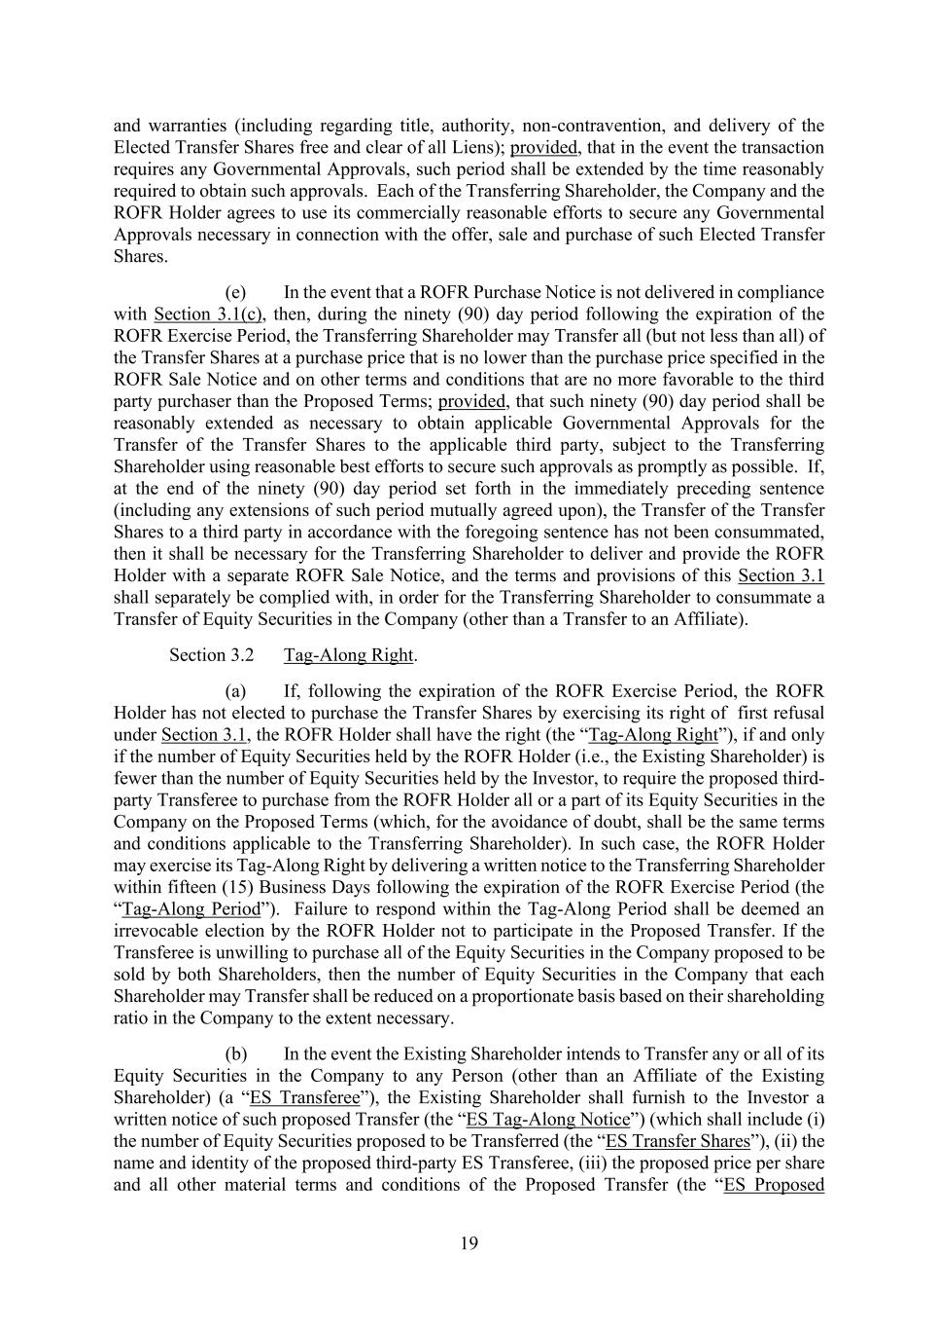
19 and warranties (including regarding title, authority, non-contravention, and delivery of the Elected Transfer Shares free and clear of all Liens); provided, that in the event the transaction requires any Governmental Approvals, such period shall be extended by the time reasonably required to obtain such approvals. Each of the Transferring Shareholder, the Company and the ROFR Holder agrees to use its commercially reasonable efforts to secure any Governmental Approvals necessary in connection with the offer, sale and purchase of such Elected Transfer Shares. (e) In the event that a ROFR Purchase Notice is not delivered in compliance with Section 3.1(c), then, during the ninety (90) day period following the expiration of the ROFR Exercise Period, the Transferring Shareholder may Transfer all (but not less than all) of the Transfer Shares at a purchase price that is no lower than the purchase price specified in the ROFR Sale Notice and on other terms and conditions that are no more favorable to the third party purchaser than the Proposed Terms; provided, that such ninety (90) day period shall be reasonably extended as necessary to obtain applicable Governmental Approvals for the Transfer of the Transfer Shares to the applicable third party, subject to the Transferring Shareholder using reasonable best efforts to secure such approvals as promptly as possible. If, at the end of the ninety (90) day period set forth in the immediately preceding sentence (including any extensions of such period mutually agreed upon), the Transfer of the Transfer Shares to a third party in accordance with the foregoing sentence has not been consummated, then it shall be necessary for the Transferring Shareholder to deliver and provide the ROFR Holder with a separate ROFR Sale Notice, and the terms and provisions of this Section 3.1 shall separately be complied with, in order for the Transferring Shareholder to consummate a Transfer of Equity Securities in the Company (other than a Transfer to an Affiliate). Section 3.2 Tag-Along Right. (a) If, following the expiration of the ROFR Exercise Period, the ROFR Holder has not elected to purchase the Transfer Shares by exercising its right of first refusal under Section 3.1, the ROFR Holder shall have the right (the “Tag-Along Right”), if and only if the number of Equity Securities held by the ROFR Holder (i.e., the Existing Shareholder) is fewer than the number of Equity Securities held by the Investor, to require the proposed third- party Transferee to purchase from the ROFR Holder all or a part of its Equity Securities in the Company on the Proposed Terms (which, for the avoidance of doubt, shall be the same terms and conditions applicable to the Transferring Shareholder). In such case, the ROFR Holder may exercise its Tag-Along Right by delivering a written notice to the Transferring Shareholder within fifteen (15) Business Days following the expiration of the ROFR Exercise Period (the “Tag-Along Period”). Failure to respond within the Tag-Along Period shall be deemed an irrevocable election by the ROFR Holder not to participate in the Proposed Transfer. If the Transferee is unwilling to purchase all of the Equity Securities in the Company proposed to be sold by both Shareholders, then the number of Equity Securities in the Company that each Shareholder may Transfer shall be reduced on a proportionate basis based on their shareholding ratio in the Company to the extent necessary. (b) In the event the Existing Shareholder intends to Transfer any or all of its Equity Securities in the Company to any Person (other than an Affiliate of the Existing Shareholder) (a “ES Transferee”), the Existing Shareholder shall furnish to the Investor a written notice of such proposed Transfer (the “ES Tag-Along Notice”) (which shall include (i) the number of Equity Securities proposed to be Transferred (the “ES Transfer Shares”), (ii) the name and identity of the proposed third-party ES Transferee, (iii) the proposed price per share and all other material terms and conditions of the Proposed Transfer (the “ES Proposed

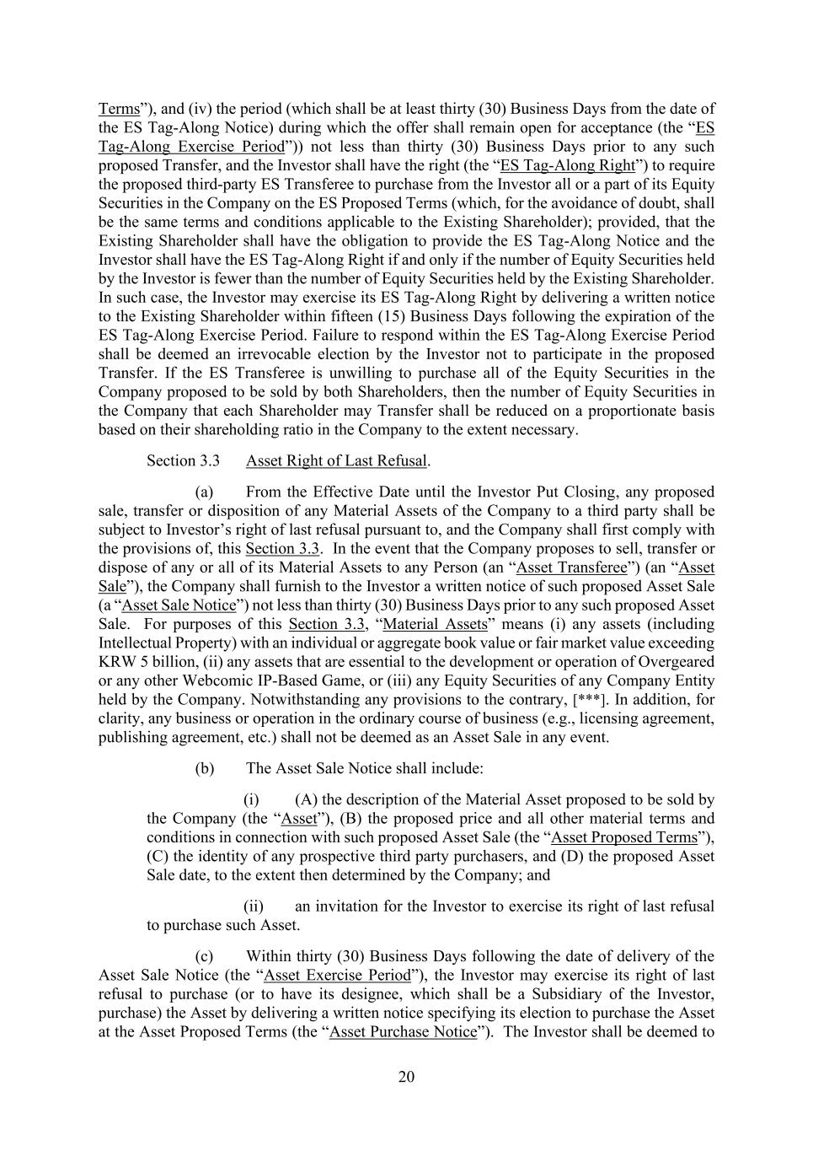
20 Terms”), and (iv) the period (which shall be at least thirty (30) Business Days from the date of the ES Tag-Along Notice) during which the offer shall remain open for acceptance (the “ES Tag-Along Exercise Period”)) not less than thirty (30) Business Days prior to any such proposed Transfer, and the Investor shall have the right (the “ES Tag-Along Right”) to require the proposed third-party ES Transferee to purchase from the Investor all or a part of its Equity Securities in the Company on the ES Proposed Terms (which, for the avoidance of doubt, shall be the same terms and conditions applicable to the Existing Shareholder); provided, that the Existing Shareholder shall have the obligation to provide the ES Tag-Along Notice and the Investor shall have the ES Tag-Along Right if and only if the number of Equity Securities held by the Investor is fewer than the number of Equity Securities held by the Existing Shareholder. In such case, the Investor may exercise its ES Tag-Along Right by delivering a written notice to the Existing Shareholder within fifteen (15) Business Days following the expiration of the ES Tag-Along Exercise Period. Failure to respond within the ES Tag-Along Exercise Period shall be deemed an irrevocable election by the Investor not to participate in the proposed Transfer. If the ES Transferee is unwilling to purchase all of the Equity Securities in the Company proposed to be sold by both Shareholders, then the number of Equity Securities in the Company that each Shareholder may Transfer shall be reduced on a proportionate basis based on their shareholding ratio in the Company to the extent necessary. Section 3.3 Asset Right of Last Refusal. (a) From the Effective Date until the Investor Put Closing, any proposed sale, transfer or disposition of any Material Assets of the Company to a third party shall be subject to Investor’s right of last refusal pursuant to, and the Company shall first comply with the provisions of, this Section 3.3. In the event that the Company proposes to sell, transfer or dispose of any or all of its Material Assets to any Person (an “Asset Transferee”) (an “Asset Sale”), the Company shall furnish to the Investor a written notice of such proposed Asset Sale (a “Asset Sale Notice”) not less than thirty (30) Business Days prior to any such proposed Asset Sale. For purposes of this Section 3.3, “Material Assets” means (i) any assets (including Intellectual Property) with an individual or aggregate book value or fair market value exceeding KRW 5 billion, (ii) any assets that are essential to the development or operation of Overgeared or any other Webcomic IP-Based Game, or (iii) any Equity Securities of any Company Entity held by the Company. Notwithstanding any provisions to the contrary, [***]. In addition, for clarity, any business or operation in the ordinary course of business (e.g., licensing agreement, publishing agreement, etc.) shall not be deemed as an Asset Sale in any event. (b) The Asset Sale Notice shall include: (i) (A) the description of the Material Asset proposed to be sold by the Company (the “Asset”), (B) the proposed price and all other material terms and conditions in connection with such proposed Asset Sale (the “Asset Proposed Terms”), (C) the identity of any prospective third party purchasers, and (D) the proposed Asset Sale date, to the extent then determined by the Company; and (ii) an invitation for the Investor to exercise its right of last refusal to purchase such Asset. (c) Within thirty (30) Business Days following the date of delivery of the Asset Sale Notice (the “Asset Exercise Period”), the Investor may exercise its right of last refusal to purchase (or to have its designee, which shall be a Subsidiary of the Investor, purchase) the Asset by delivering a written notice specifying its election to purchase the Asset at the Asset Proposed Terms (the “Asset Purchase Notice”). The Investor shall be deemed to

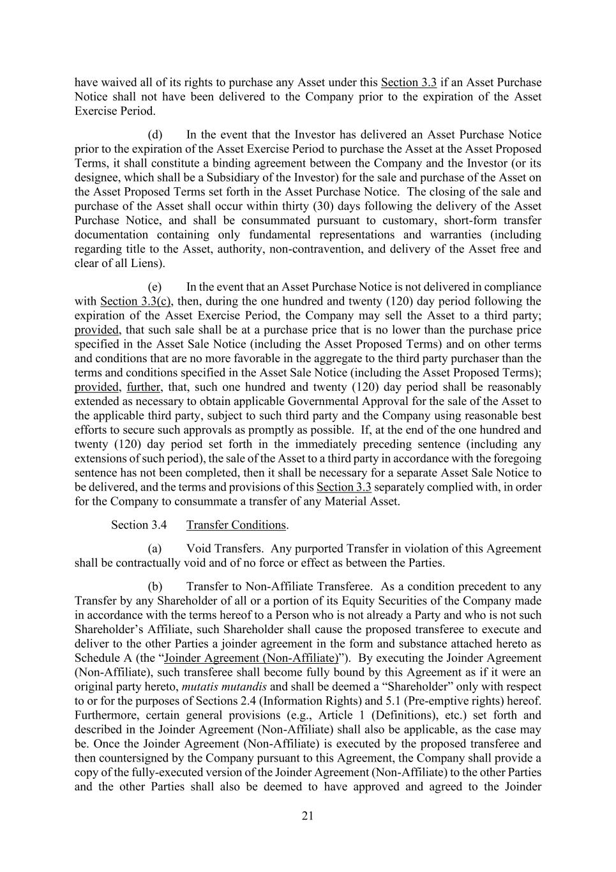
21 have waived all of its rights to purchase any Asset under this Section 3.3 if an Asset Purchase Notice shall not have been delivered to the Company prior to the expiration of the Asset Exercise Period. (d) In the event that the Investor has delivered an Asset Purchase Notice prior to the expiration of the Asset Exercise Period to purchase the Asset at the Asset Proposed Terms, it shall constitute a binding agreement between the Company and the Investor (or its designee, which shall be a Subsidiary of the Investor) for the sale and purchase of the Asset on the Asset Proposed Terms set forth in the Asset Purchase Notice. The closing of the sale and purchase of the Asset shall occur within thirty (30) days following the delivery of the Asset Purchase Notice, and shall be consummated pursuant to customary, short-form transfer documentation containing only fundamental representations and warranties (including regarding title to the Asset, authority, non-contravention, and delivery of the Asset free and clear of all Liens). (e) In the event that an Asset Purchase Notice is not delivered in compliance with Section 3.3(c), then, during the one hundred and twenty (120) day period following the expiration of the Asset Exercise Period, the Company may sell the Asset to a third party; provided, that such sale shall be at a purchase price that is no lower than the purchase price specified in the Asset Sale Notice (including the Asset Proposed Terms) and on other terms and conditions that are no more favorable in the aggregate to the third party purchaser than the terms and conditions specified in the Asset Sale Notice (including the Asset Proposed Terms); provided, further, that, such one hundred and twenty (120) day period shall be reasonably extended as necessary to obtain applicable Governmental Approval for the sale of the Asset to the applicable third party, subject to such third party and the Company using reasonable best efforts to secure such approvals as promptly as possible. If, at the end of the one hundred and twenty (120) day period set forth in the immediately preceding sentence (including any extensions of such period), the sale of the Asset to a third party in accordance with the foregoing sentence has not been completed, then it shall be necessary for a separate Asset Sale Notice to be delivered, and the terms and provisions of this Section 3.3 separately complied with, in order for the Company to consummate a transfer of any Material Asset. Section 3.4 Transfer Conditions. (a) Void Transfers. Any purported Transfer in violation of this Agreement shall be contractually void and of no force or effect as between the Parties. (b) Transfer to Non-Affiliate Transferee. As a condition precedent to any Transfer by any Shareholder of all or a portion of its Equity Securities of the Company made in accordance with the terms hereof to a Person who is not already a Party and who is not such Shareholder’s Affiliate, such Shareholder shall cause the proposed transferee to execute and deliver to the other Parties a joinder agreement in the form and substance attached hereto as Schedule A (the “Joinder Agreement (Non-Affiliate)”). By executing the Joinder Agreement (Non-Affiliate), such transferee shall become fully bound by this Agreement as if it were an original party hereto, mutatis mutandis and shall be deemed a “Shareholder” only with respect to or for the purposes of Sections 2.4 (Information Rights) and 5.1 (Pre-emptive rights) hereof. Furthermore, certain general provisions (e.g., Article 1 (Definitions), etc.) set forth and described in the Joinder Agreement (Non-Affiliate) shall also be applicable, as the case may be. Once the Joinder Agreement (Non-Affiliate) is executed by the proposed transferee and then countersigned by the Company pursuant to this Agreement, the Company shall provide a copy of the fully-executed version of the Joinder Agreement (Non-Affiliate) to the other Parties and the other Parties shall also be deemed to have approved and agreed to the Joinder

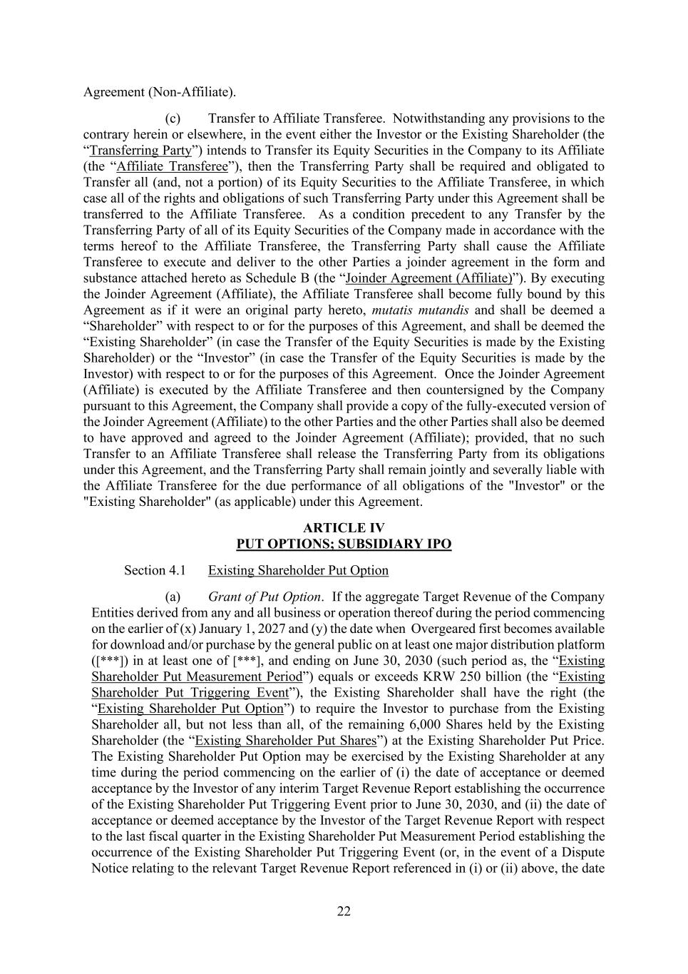
22 Agreement (Non-Affiliate). (c) Transfer to Affiliate Transferee. Notwithstanding any provisions to the contrary herein or elsewhere, in the event either the Investor or the Existing Shareholder (the “Transferring Party”) intends to Transfer its Equity Securities in the Company to its Affiliate (the “Affiliate Transferee”), then the Transferring Party shall be required and obligated to Transfer all (and, not a portion) of its Equity Securities to the Affiliate Transferee, in which case all of the rights and obligations of such Transferring Party under this Agreement shall be transferred to the Affiliate Transferee. As a condition precedent to any Transfer by the Transferring Party of all of its Equity Securities of the Company made in accordance with the terms hereof to the Affiliate Transferee, the Transferring Party shall cause the Affiliate Transferee to execute and deliver to the other Parties a joinder agreement in the form and substance attached hereto as Schedule B (the “Joinder Agreement (Affiliate)”). By executing the Joinder Agreement (Affiliate), the Affiliate Transferee shall become fully bound by this Agreement as if it were an original party hereto, mutatis mutandis and shall be deemed a “Shareholder” with respect to or for the purposes of this Agreement, and shall be deemed the “Existing Shareholder” (in case the Transfer of the Equity Securities is made by the Existing Shareholder) or the “Investor” (in case the Transfer of the Equity Securities is made by the Investor) with respect to or for the purposes of this Agreement. Once the Joinder Agreement (Affiliate) is executed by the Affiliate Transferee and then countersigned by the Company pursuant to this Agreement, the Company shall provide a copy of the fully-executed version of the Joinder Agreement (Affiliate) to the other Parties and the other Parties shall also be deemed to have approved and agreed to the Joinder Agreement (Affiliate); provided, that no such Transfer to an Affiliate Transferee shall release the Transferring Party from its obligations under this Agreement, and the Transferring Party shall remain jointly and severally liable with the Affiliate Transferee for the due performance of all obligations of the "Investor" or the "Existing Shareholder" (as applicable) under this Agreement. ARTICLE IV PUT OPTIONS; SUBSIDIARY IPO Section 4.1 Existing Shareholder Put Option (a) Grant of Put Option. If the aggregate Target Revenue of the Company Entities derived from any and all business or operation thereof during the period commencing on the earlier of (x) January 1, 2027 and (y) the date when Overgeared first becomes available for download and/or purchase by the general public on at least one major distribution platform ([***]) in at least one of [***], and ending on June 30, 2030 (such period as, the “Existing Shareholder Put Measurement Period”) equals or exceeds KRW 250 billion (the “Existing Shareholder Put Triggering Event”), the Existing Shareholder shall have the right (the “Existing Shareholder Put Option”) to require the Investor to purchase from the Existing Shareholder all, but not less than all, of the remaining 6,000 Shares held by the Existing Shareholder (the “Existing Shareholder Put Shares”) at the Existing Shareholder Put Price. The Existing Shareholder Put Option may be exercised by the Existing Shareholder at any time during the period commencing on the earlier of (i) the date of acceptance or deemed acceptance by the Investor of any interim Target Revenue Report establishing the occurrence of the Existing Shareholder Put Triggering Event prior to June 30, 2030, and (ii) the date of acceptance or deemed acceptance by the Investor of the Target Revenue Report with respect to the last fiscal quarter in the Existing Shareholder Put Measurement Period establishing the occurrence of the Existing Shareholder Put Triggering Event (or, in the event of a Dispute Notice relating to the relevant Target Revenue Report referenced in (i) or (ii) above, the date

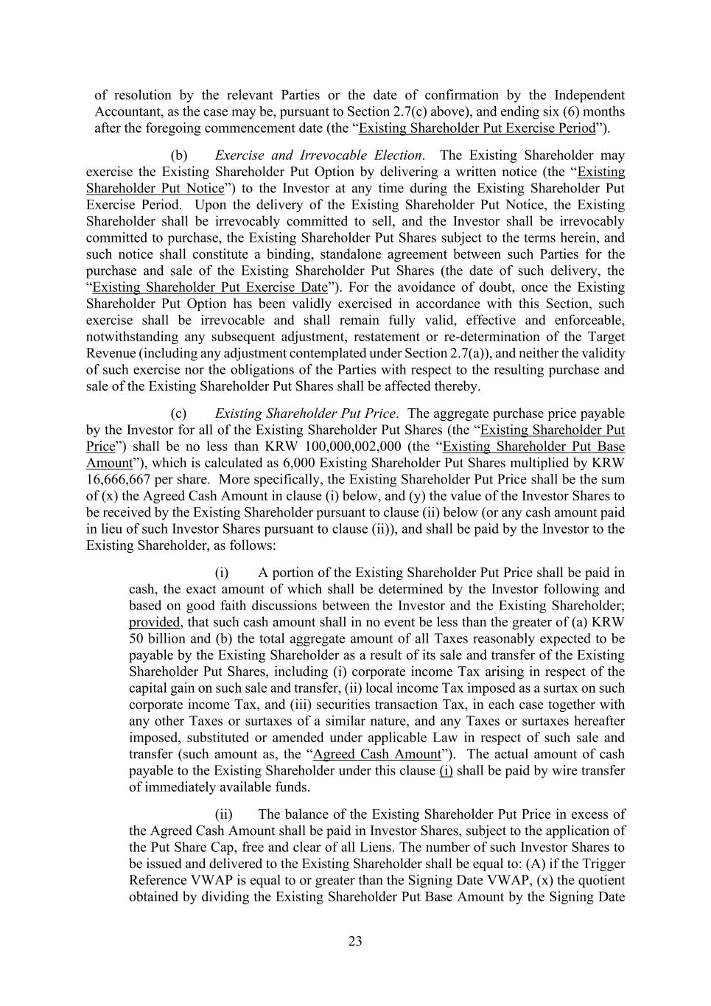
23 of resolution by the relevant Parties or the date of confirmation by the Independent Accountant, as the case may be, pursuant to Section 2.7(c) above), and ending six (6) months after the foregoing commencement date (the “Existing Shareholder Put Exercise Period”). (b) Exercise and Irrevocable Election. The Existing Shareholder may exercise the Existing Shareholder Put Option by delivering a written notice (the “Existing Shareholder Put Notice”) to the Investor at any time during the Existing Shareholder Put Exercise Period. Upon the delivery of the Existing Shareholder Put Notice, the Existing Shareholder shall be irrevocably committed to sell, and the Investor shall be irrevocably committed to purchase, the Existing Shareholder Put Shares subject to the terms herein, and such notice shall constitute a binding, standalone agreement between such Parties for the purchase and sale of the Existing Shareholder Put Shares (the date of such delivery, the “Existing Shareholder Put Exercise Date”). For the avoidance of doubt, once the Existing Shareholder Put Option has been validly exercised in accordance with this Section, such exercise shall be irrevocable and shall remain fully valid, effective and enforceable, notwithstanding any subsequent adjustment, restatement or re-determination of the Target Revenue (including any adjustment contemplated under Section 2.7(a)), and neither the validity of such exercise nor the obligations of the Parties with respect to the resulting purchase and sale of the Existing Shareholder Put Shares shall be affected thereby. (c) Existing Shareholder Put Price. The aggregate purchase price payable by the Investor for all of the Existing Shareholder Put Shares (the “Existing Shareholder Put Price”) shall be no less than KRW 100,000,002,000 (the “Existing Shareholder Put Base Amount”), which is calculated as 6,000 Existing Shareholder Put Shares multiplied by KRW 16,666,667 per share. More specifically, the Existing Shareholder Put Price shall be the sum of (x) the Agreed Cash Amount in clause (i) below, and (y) the value of the Investor Shares to be received by the Existing Shareholder pursuant to clause (ii) below (or any cash amount paid in lieu of such Investor Shares pursuant to clause (ii)), and shall be paid by the Investor to the Existing Shareholder, as follows: (i) A portion of the Existing Shareholder Put Price shall be paid in cash, the exact amount of which shall be determined by the Investor following and based on good faith discussions between the Investor and the Existing Shareholder; provided, that such cash amount shall in no event be less than the greater of (a) KRW 50 billion and (b) the total aggregate amount of all Taxes reasonably expected to be payable by the Existing Shareholder as a result of its sale and transfer of the Existing Shareholder Put Shares, including (i) corporate income Tax arising in respect of the capital gain on such sale and transfer, (ii) local income Tax imposed as a surtax on such corporate income Tax, and (iii) securities transaction Tax, in each case together with any other Taxes or surtaxes of a similar nature, and any Taxes or surtaxes hereafter imposed, substituted or amended under applicable Law in respect of such sale and transfer (such amount as, the “Agreed Cash Amount”). The actual amount of cash payable to the Existing Shareholder under this clause (i) shall be paid by wire transfer of immediately available funds. (ii) The balance of the Existing Shareholder Put Price in excess of the Agreed Cash Amount shall be paid in Investor Shares, subject to the application of the Put Share Cap, free and clear of all Liens. The number of such Investor Shares to be issued and delivered to the Existing Shareholder shall be equal to: (A) if the Trigger Reference VWAP is equal to or greater than the Signing Date VWAP, (x) the quotient obtained by dividing the Existing Shareholder Put Base Amount by the Signing Date

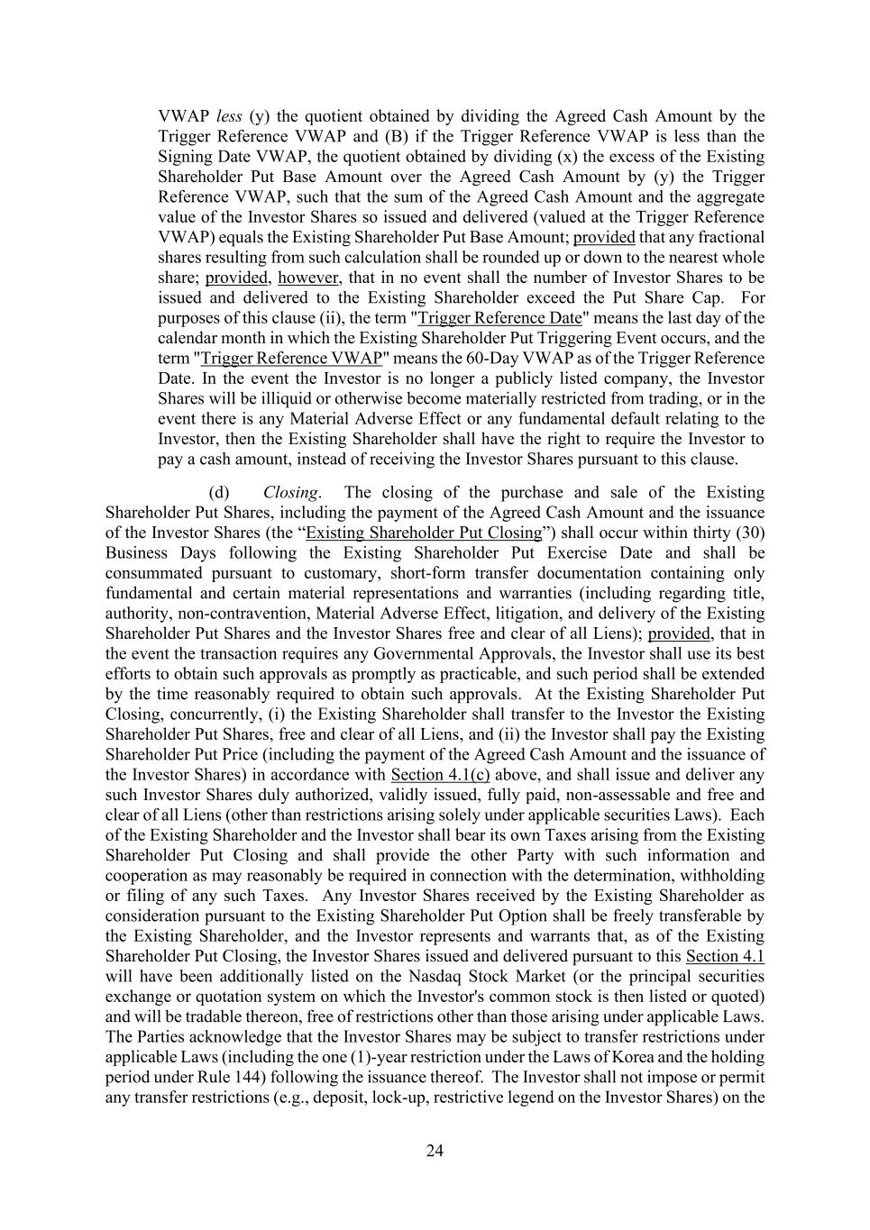
24 VWAP less (y) the quotient obtained by dividing the Agreed Cash Amount by the Trigger Reference VWAP and (B) if the Trigger Reference VWAP is less than the Signing Date VWAP, the quotient obtained by dividing (x) the excess of the Existing Shareholder Put Base Amount over the Agreed Cash Amount by (y) the Trigger Reference VWAP, such that the sum of the Agreed Cash Amount and the aggregate value of the Investor Shares so issued and delivered (valued at the Trigger Reference VWAP) equals the Existing Shareholder Put Base Amount; provided that any fractional shares resulting from such calculation shall be rounded up or down to the nearest whole share; provided, however, that in no event shall the number of Investor Shares to be issued and delivered to the Existing Shareholder exceed the Put Share Cap. For purposes of this clause (ii), the term "Trigger Reference Date" means the last day of the calendar month in which the Existing Shareholder Put Triggering Event occurs, and the term "Trigger Reference VWAP" means the 60-Day VWAP as of the Trigger Reference Date. In the event the Investor is no longer a publicly listed company, the Investor Shares will be illiquid or otherwise become materially restricted from trading, or in the event there is any Material Adverse Effect or any fundamental default relating to the Investor, then the Existing Shareholder shall have the right to require the Investor to pay a cash amount, instead of receiving the Investor Shares pursuant to this clause. (d) Closing. The closing of the purchase and sale of the Existing Shareholder Put Shares, including the payment of the Agreed Cash Amount and the issuance of the Investor Shares (the “Existing Shareholder Put Closing”) shall occur within thirty (30) Business Days following the Existing Shareholder Put Exercise Date and shall be consummated pursuant to customary, short-form transfer documentation containing only fundamental and certain material representations and warranties (including regarding title, authority, non-contravention, Material Adverse Effect, litigation, and delivery of the Existing Shareholder Put Shares and the Investor Shares free and clear of all Liens); provided, that in the event the transaction requires any Governmental Approvals, the Investor shall use its best efforts to obtain such approvals as promptly as practicable, and such period shall be extended by the time reasonably required to obtain such approvals. At the Existing Shareholder Put Closing, concurrently, (i) the Existing Shareholder shall transfer to the Investor the Existing Shareholder Put Shares, free and clear of all Liens, and (ii) the Investor shall pay the Existing Shareholder Put Price (including the payment of the Agreed Cash Amount and the issuance of the Investor Shares) in accordance with Section 4.1(c) above, and shall issue and deliver any such Investor Shares duly authorized, validly issued, fully paid, non-assessable and free and clear of all Liens (other than restrictions arising solely under applicable securities Laws). Each of the Existing Shareholder and the Investor shall bear its own Taxes arising from the Existing Shareholder Put Closing and shall provide the other Party with such information and cooperation as may reasonably be required in connection with the determination, withholding or filing of any such Taxes. Any Investor Shares received by the Existing Shareholder as consideration pursuant to the Existing Shareholder Put Option shall be freely transferable by the Existing Shareholder, and the Investor represents and warrants that, as of the Existing Shareholder Put Closing, the Investor Shares issued and delivered pursuant to this Section 4.1 will have been additionally listed on the Nasdaq Stock Market (or the principal securities exchange or quotation system on which the Investor's common stock is then listed or quoted) and will be tradable thereon, free of restrictions other than those arising under applicable Laws. The Parties acknowledge that the Investor Shares may be subject to transfer restrictions under applicable Laws (including the one (1)-year restriction under the Laws of Korea and the holding period under Rule 144) following the issuance thereof. The Investor shall not impose or permit any transfer restrictions (e.g., deposit, lock-up, restrictive legend on the Investor Shares) on the

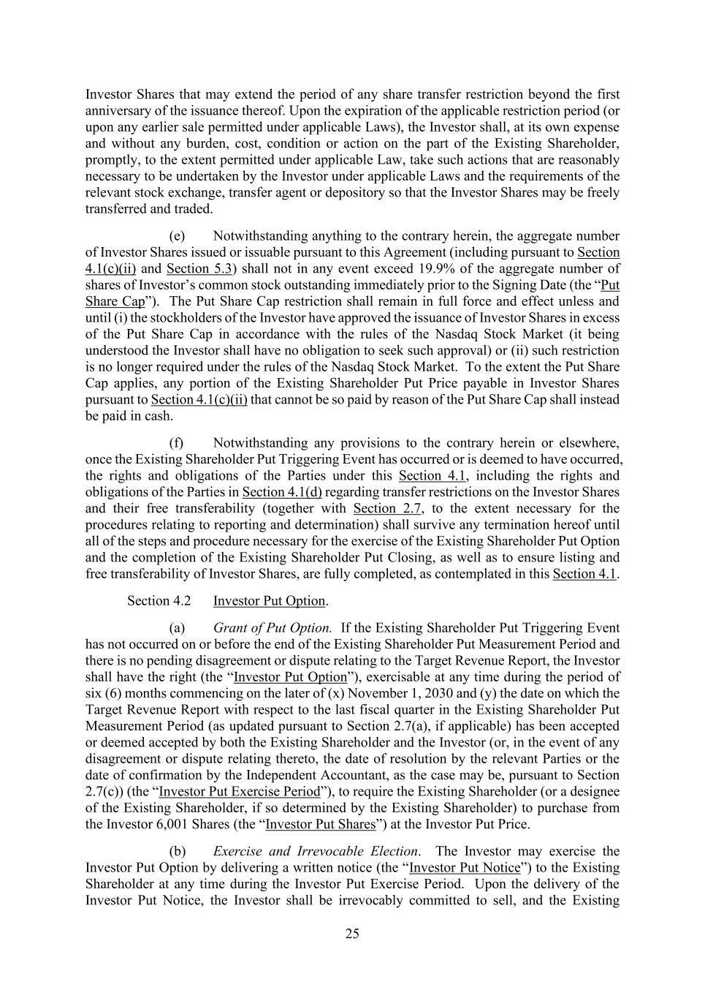
25 Investor Shares that may extend the period of any share transfer restriction beyond the first anniversary of the issuance thereof. Upon the expiration of the applicable restriction period (or upon any earlier sale permitted under applicable Laws), the Investor shall, at its own expense and without any burden, cost, condition or action on the part of the Existing Shareholder, promptly, to the extent permitted under applicable Law, take such actions that are reasonably necessary to be undertaken by the Investor under applicable Laws and the requirements of the relevant stock exchange, transfer agent or depository so that the Investor Shares may be freely transferred and traded. (e) Notwithstanding anything to the contrary herein, the aggregate number of Investor Shares issued or issuable pursuant to this Agreement (including pursuant to Section 4.1(c)(ii) and Section 5.3) shall not in any event exceed 19.9% of the aggregate number of shares of Investor’s common stock outstanding immediately prior to the Signing Date (the “Put Share Cap”). The Put Share Cap restriction shall remain in full force and effect unless and until (i) the stockholders of the Investor have approved the issuance of Investor Shares in excess of the Put Share Cap in accordance with the rules of the Nasdaq Stock Market (it being understood the Investor shall have no obligation to seek such approval) or (ii) such restriction is no longer required under the rules of the Nasdaq Stock Market. To the extent the Put Share Cap applies, any portion of the Existing Shareholder Put Price payable in Investor Shares pursuant to Section 4.1(c)(ii) that cannot be so paid by reason of the Put Share Cap shall instead be paid in cash. (f) Notwithstanding any provisions to the contrary herein or elsewhere, once the Existing Shareholder Put Triggering Event has occurred or is deemed to have occurred, the rights and obligations of the Parties under this Section 4.1, including the rights and obligations of the Parties in Section 4.1(d) regarding transfer restrictions on the Investor Shares and their free transferability (together with Section 2.7, to the extent necessary for the procedures relating to reporting and determination) shall survive any termination hereof until all of the steps and procedure necessary for the exercise of the Existing Shareholder Put Option and the completion of the Existing Shareholder Put Closing, as well as to ensure listing and free transferability of Investor Shares, are fully completed, as contemplated in this Section 4.1. Section 4.2 Investor Put Option. (a) Grant of Put Option. If the Existing Shareholder Put Triggering Event has not occurred on or before the end of the Existing Shareholder Put Measurement Period and there is no pending disagreement or dispute relating to the Target Revenue Report, the Investor shall have the right (the “Investor Put Option”), exercisable at any time during the period of six (6) months commencing on the later of (x) November 1, 2030 and (y) the date on which the Target Revenue Report with respect to the last fiscal quarter in the Existing Shareholder Put Measurement Period (as updated pursuant to Section 2.7(a), if applicable) has been accepted or deemed accepted by both the Existing Shareholder and the Investor (or, in the event of any disagreement or dispute relating thereto, the date of resolution by the relevant Parties or the date of confirmation by the Independent Accountant, as the case may be, pursuant to Section 2.7(c)) (the “Investor Put Exercise Period”), to require the Existing Shareholder (or a designee of the Existing Shareholder, if so determined by the Existing Shareholder) to purchase from the Investor 6,001 Shares (the “Investor Put Shares”) at the Investor Put Price. (b) Exercise and Irrevocable Election. The Investor may exercise the Investor Put Option by delivering a written notice (the “Investor Put Notice”) to the Existing Shareholder at any time during the Investor Put Exercise Period. Upon the delivery of the Investor Put Notice, the Investor shall be irrevocably committed to sell, and the Existing

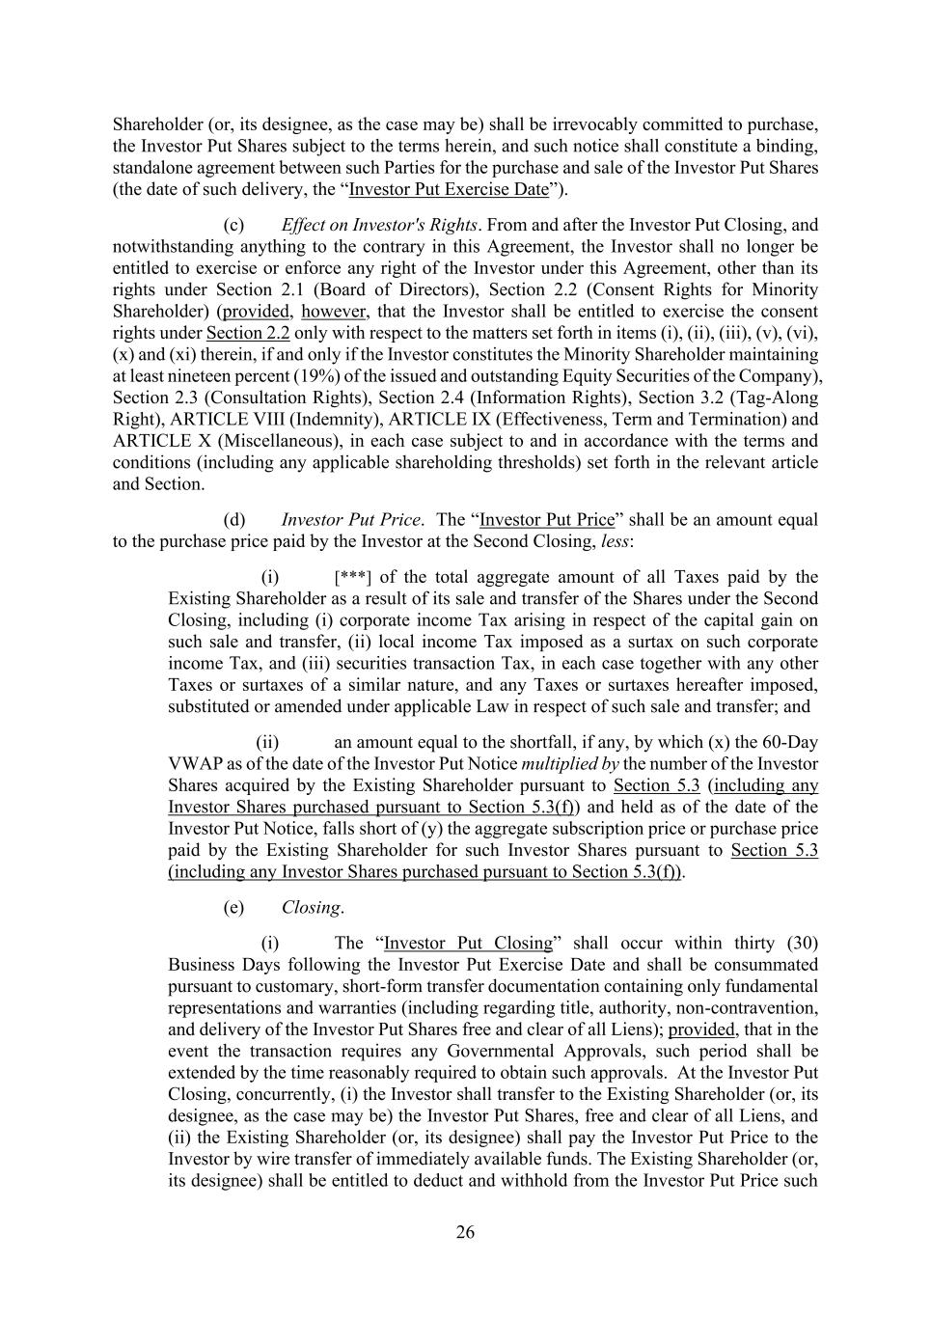
26 Shareholder (or, its designee, as the case may be) shall be irrevocably committed to purchase, the Investor Put Shares subject to the terms herein, and such notice shall constitute a binding, standalone agreement between such Parties for the purchase and sale of the Investor Put Shares (the date of such delivery, the “Investor Put Exercise Date”). (c) Effect on Investor's Rights. From and after the Investor Put Closing, and notwithstanding anything to the contrary in this Agreement, the Investor shall no longer be entitled to exercise or enforce any right of the Investor under this Agreement, other than its rights under Section 2.1 (Board of Directors), Section 2.2 (Consent Rights for Minority Shareholder) (provided, however, that the Investor shall be entitled to exercise the consent rights under Section 2.2 only with respect to the matters set forth in items (i), (ii), (iii), (v), (vi), (x) and (xi) therein, if and only if the Investor constitutes the Minority Shareholder maintaining at least nineteen percent (19%) of the issued and outstanding Equity Securities of the Company), Section 2.3 (Consultation Rights), Section 2.4 (Information Rights), Section 3.2 (Tag-Along Right), ARTICLE VIII (Indemnity), ARTICLE IX (Effectiveness, Term and Termination) and ARTICLE X (Miscellaneous), in each case subject to and in accordance with the terms and conditions (including any applicable shareholding thresholds) set forth in the relevant article and Section. (d) Investor Put Price. The “Investor Put Price” shall be an amount equal to the purchase price paid by the Investor at the Second Closing, less: (i) [***] of the total aggregate amount of all Taxes paid by the Existing Shareholder as a result of its sale and transfer of the Shares under the Second Closing, including (i) corporate income Tax arising in respect of the capital gain on such sale and transfer, (ii) local income Tax imposed as a surtax on such corporate income Tax, and (iii) securities transaction Tax, in each case together with any other Taxes or surtaxes of a similar nature, and any Taxes or surtaxes hereafter imposed, substituted or amended under applicable Law in respect of such sale and transfer; and (ii) an amount equal to the shortfall, if any, by which (x) the 60-Day VWAP as of the date of the Investor Put Notice multiplied by the number of the Investor Shares acquired by the Existing Shareholder pursuant to Section 5.3 (including any Investor Shares purchased pursuant to Section 5.3(f)) and held as of the date of the Investor Put Notice, falls short of (y) the aggregate subscription price or purchase price paid by the Existing Shareholder for such Investor Shares pursuant to Section 5.3 (including any Investor Shares purchased pursuant to Section 5.3(f)). (e) Closing. (i) The “Investor Put Closing” shall occur within thirty (30) Business Days following the Investor Put Exercise Date and shall be consummated pursuant to customary, short-form transfer documentation containing only fundamental representations and warranties (including regarding title, authority, non-contravention, and delivery of the Investor Put Shares free and clear of all Liens); provided, that in the event the transaction requires any Governmental Approvals, such period shall be extended by the time reasonably required to obtain such approvals. At the Investor Put Closing, concurrently, (i) the Investor shall transfer to the Existing Shareholder (or, its designee, as the case may be) the Investor Put Shares, free and clear of all Liens, and (ii) the Existing Shareholder (or, its designee) shall pay the Investor Put Price to the Investor by wire transfer of immediately available funds. The Existing Shareholder (or, its designee) shall be entitled to deduct and withhold from the Investor Put Price such

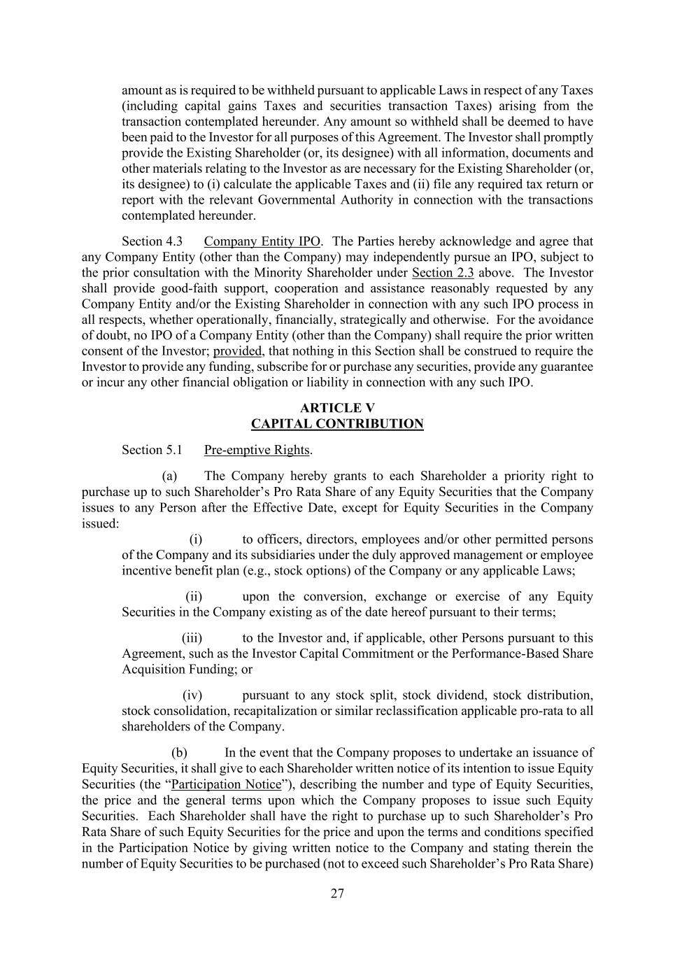
27 amount as is required to be withheld pursuant to applicable Laws in respect of any Taxes (including capital gains Taxes and securities transaction Taxes) arising from the transaction contemplated hereunder. Any amount so withheld shall be deemed to have been paid to the Investor for all purposes of this Agreement. The Investor shall promptly provide the Existing Shareholder (or, its designee) with all information, documents and other materials relating to the Investor as are necessary for the Existing Shareholder (or, its designee) to (i) calculate the applicable Taxes and (ii) file any required tax return or report with the relevant Governmental Authority in connection with the transactions contemplated hereunder. Section 4.3 Company Entity IPO. The Parties hereby acknowledge and agree that any Company Entity (other than the Company) may independently pursue an IPO, subject to the prior consultation with the Minority Shareholder under Section 2.3 above. The Investor shall provide good-faith support, cooperation and assistance reasonably requested by any Company Entity and/or the Existing Shareholder in connection with any such IPO process in all respects, whether operationally, financially, strategically and otherwise. For the avoidance of doubt, no IPO of a Company Entity (other than the Company) shall require the prior written consent of the Investor; provided, that nothing in this Section shall be construed to require the Investor to provide any funding, subscribe for or purchase any securities, provide any guarantee or incur any other financial obligation or liability in connection with any such IPO. ARTICLE V CAPITAL CONTRIBUTION Section 5.1 Pre-emptive Rights. (a) The Company hereby grants to each Shareholder a priority right to purchase up to such Shareholder’s Pro Rata Share of any Equity Securities that the Company issues to any Person after the Effective Date, except for Equity Securities in the Company issued: (i) to officers, directors, employees and/or other permitted persons of the Company and its subsidiaries under the duly approved management or employee incentive benefit plan (e.g., stock options) of the Company or any applicable Laws; (ii) upon the conversion, exchange or exercise of any Equity Securities in the Company existing as of the date hereof pursuant to their terms; (iii) to the Investor and, if applicable, other Persons pursuant to this Agreement, such as the Investor Capital Commitment or the Performance-Based Share Acquisition Funding; or (iv) pursuant to any stock split, stock dividend, stock distribution, stock consolidation, recapitalization or similar reclassification applicable pro-rata to all shareholders of the Company. (b) In the event that the Company proposes to undertake an issuance of Equity Securities, it shall give to each Shareholder written notice of its intention to issue Equity Securities (the “Participation Notice”), describing the number and type of Equity Securities, the price and the general terms upon which the Company proposes to issue such Equity Securities. Each Shareholder shall have the right to purchase up to such Shareholder’s Pro Rata Share of such Equity Securities for the price and upon the terms and conditions specified in the Participation Notice by giving written notice to the Company and stating therein the number of Equity Securities to be purchased (not to exceed such Shareholder’s Pro Rata Share)

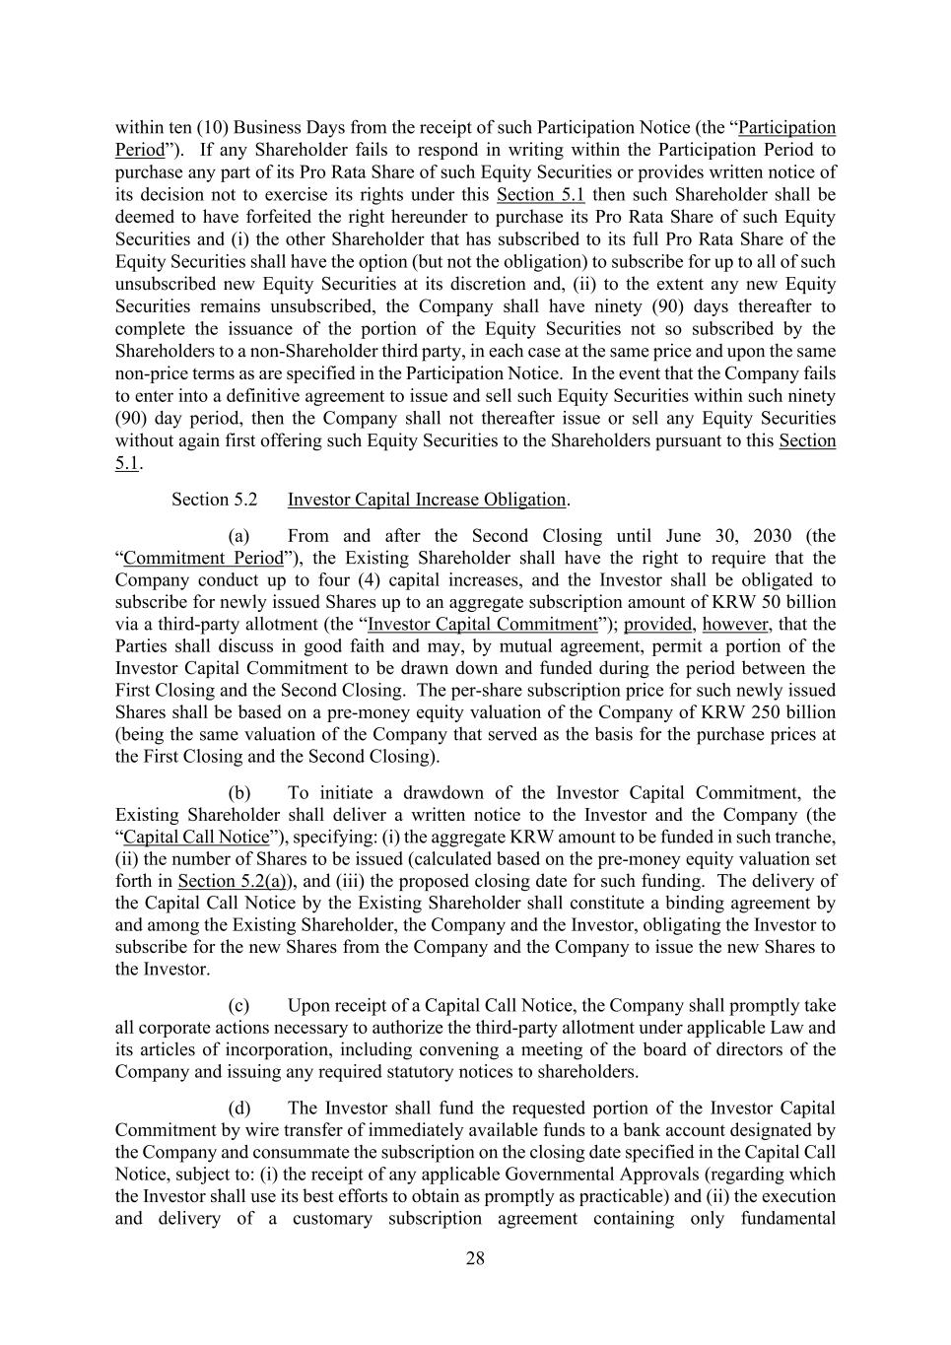
28 within ten (10) Business Days from the receipt of such Participation Notice (the “Participation Period”). If any Shareholder fails to respond in writing within the Participation Period to purchase any part of its Pro Rata Share of such Equity Securities or provides written notice of its decision not to exercise its rights under this Section 5.1 then such Shareholder shall be deemed to have forfeited the right hereunder to purchase its Pro Rata Share of such Equity Securities and (i) the other Shareholder that has subscribed to its full Pro Rata Share of the Equity Securities shall have the option (but not the obligation) to subscribe for up to all of such unsubscribed new Equity Securities at its discretion and, (ii) to the extent any new Equity Securities remains unsubscribed, the Company shall have ninety (90) days thereafter to complete the issuance of the portion of the Equity Securities not so subscribed by the Shareholders to a non-Shareholder third party, in each case at the same price and upon the same non-price terms as are specified in the Participation Notice. In the event that the Company fails to enter into a definitive agreement to issue and sell such Equity Securities within such ninety (90) day period, then the Company shall not thereafter issue or sell any Equity Securities without again first offering such Equity Securities to the Shareholders pursuant to this Section 5.1. Section 5.2 Investor Capital Increase Obligation. (a) From and after the Second Closing until June 30, 2030 (the “Commitment Period”), the Existing Shareholder shall have the right to require that the Company conduct up to four (4) capital increases, and the Investor shall be obligated to subscribe for newly issued Shares up to an aggregate subscription amount of KRW 50 billion via a third-party allotment (the “Investor Capital Commitment”); provided, however, that the Parties shall discuss in good faith and may, by mutual agreement, permit a portion of the Investor Capital Commitment to be drawn down and funded during the period between the First Closing and the Second Closing. The per-share subscription price for such newly issued Shares shall be based on a pre-money equity valuation of the Company of KRW 250 billion (being the same valuation of the Company that served as the basis for the purchase prices at the First Closing and the Second Closing). (b) To initiate a drawdown of the Investor Capital Commitment, the Existing Shareholder shall deliver a written notice to the Investor and the Company (the “Capital Call Notice”), specifying: (i) the aggregate KRW amount to be funded in such tranche, (ii) the number of Shares to be issued (calculated based on the pre-money equity valuation set forth in Section 5.2(a)), and (iii) the proposed closing date for such funding. The delivery of the Capital Call Notice by the Existing Shareholder shall constitute a binding agreement by and among the Existing Shareholder, the Company and the Investor, obligating the Investor to subscribe for the new Shares from the Company and the Company to issue the new Shares to the Investor. (c) Upon receipt of a Capital Call Notice, the Company shall promptly take all corporate actions necessary to authorize the third-party allotment under applicable Law and its articles of incorporation, including convening a meeting of the board of directors of the Company and issuing any required statutory notices to shareholders. (d) The Investor shall fund the requested portion of the Investor Capital Commitment by wire transfer of immediately available funds to a bank account designated by the Company and consummate the subscription on the closing date specified in the Capital Call Notice, subject to: (i) the receipt of any applicable Governmental Approvals (regarding which the Investor shall use its best efforts to obtain as promptly as practicable) and (ii) the execution and delivery of a customary subscription agreement containing only fundamental

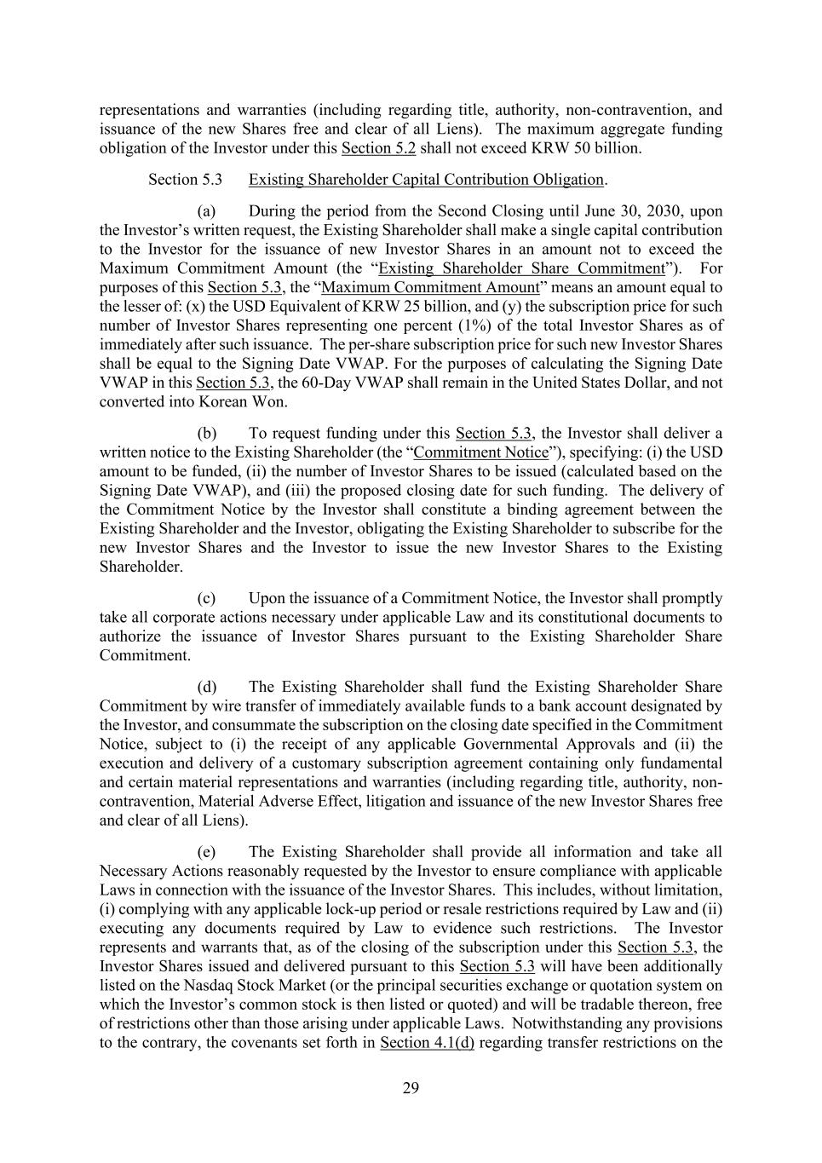
29 representations and warranties (including regarding title, authority, non-contravention, and issuance of the new Shares free and clear of all Liens). The maximum aggregate funding obligation of the Investor under this Section 5.2 shall not exceed KRW 50 billion. Section 5.3 Existing Shareholder Capital Contribution Obligation. (a) During the period from the Second Closing until June 30, 2030, upon the Investor’s written request, the Existing Shareholder shall make a single capital contribution to the Investor for the issuance of new Investor Shares in an amount not to exceed the Maximum Commitment Amount (the “Existing Shareholder Share Commitment”). For purposes of this Section 5.3, the “Maximum Commitment Amount” means an amount equal to the lesser of: (x) the USD Equivalent of KRW 25 billion, and (y) the subscription price for such number of Investor Shares representing one percent (1%) of the total Investor Shares as of immediately after such issuance. The per-share subscription price for such new Investor Shares shall be equal to the Signing Date VWAP. For the purposes of calculating the Signing Date VWAP in this Section 5.3, the 60-Day VWAP shall remain in the United States Dollar, and not converted into Korean Won. (b) To request funding under this Section 5.3, the Investor shall deliver a written notice to the Existing Shareholder (the “Commitment Notice”), specifying: (i) the USD amount to be funded, (ii) the number of Investor Shares to be issued (calculated based on the Signing Date VWAP), and (iii) the proposed closing date for such funding. The delivery of the Commitment Notice by the Investor shall constitute a binding agreement between the Existing Shareholder and the Investor, obligating the Existing Shareholder to subscribe for the new Investor Shares and the Investor to issue the new Investor Shares to the Existing Shareholder. (c) Upon the issuance of a Commitment Notice, the Investor shall promptly take all corporate actions necessary under applicable Law and its constitutional documents to authorize the issuance of Investor Shares pursuant to the Existing Shareholder Share Commitment. (d) The Existing Shareholder shall fund the Existing Shareholder Share Commitment by wire transfer of immediately available funds to a bank account designated by the Investor, and consummate the subscription on the closing date specified in the Commitment Notice, subject to (i) the receipt of any applicable Governmental Approvals and (ii) the execution and delivery of a customary subscription agreement containing only fundamental and certain material representations and warranties (including regarding title, authority, non- contravention, Material Adverse Effect, litigation and issuance of the new Investor Shares free and clear of all Liens). (e) The Existing Shareholder shall provide all information and take all Necessary Actions reasonably requested by the Investor to ensure compliance with applicable Laws in connection with the issuance of the Investor Shares. This includes, without limitation, (i) complying with any applicable lock-up period or resale restrictions required by Law and (ii) executing any documents required by Law to evidence such restrictions. The Investor represents and warrants that, as of the closing of the subscription under this Section 5.3, the Investor Shares issued and delivered pursuant to this Section 5.3 will have been additionally listed on the Nasdaq Stock Market (or the principal securities exchange or quotation system on which the Investor’s common stock is then listed or quoted) and will be tradable thereon, free of restrictions other than those arising under applicable Laws. Notwithstanding any provisions to the contrary, the covenants set forth in Section 4.1(d) regarding transfer restrictions on the

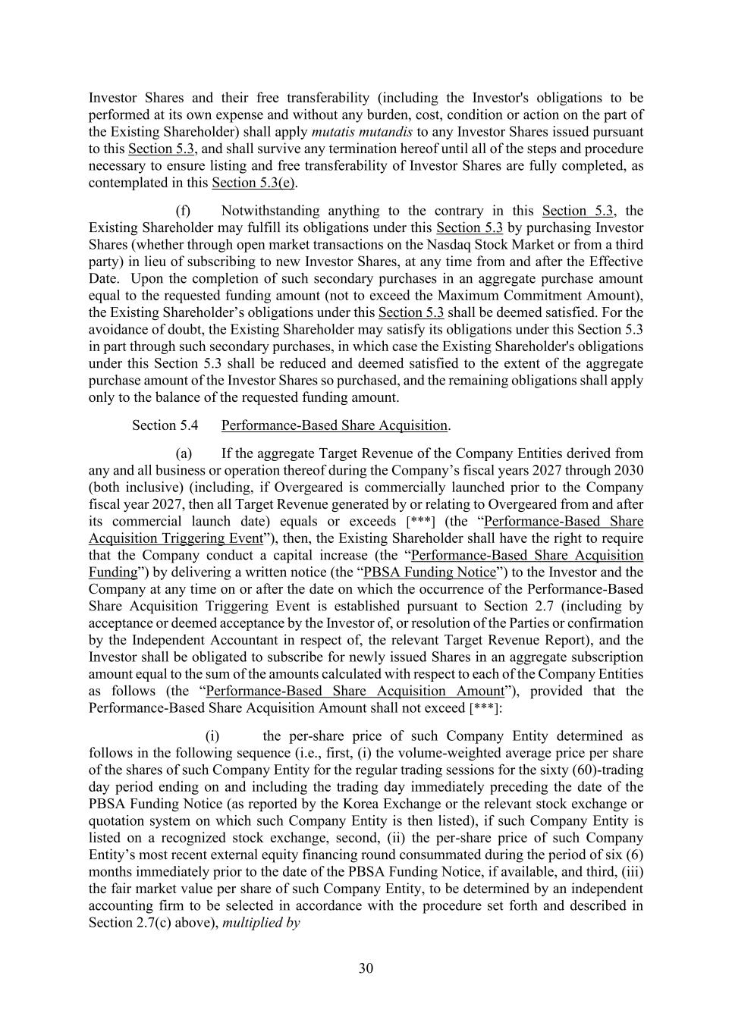
30 Investor Shares and their free transferability (including the Investor's obligations to be performed at its own expense and without any burden, cost, condition or action on the part of the Existing Shareholder) shall apply mutatis mutandis to any Investor Shares issued pursuant to this Section 5.3, and shall survive any termination hereof until all of the steps and procedure necessary to ensure listing and free transferability of Investor Shares are fully completed, as contemplated in this Section 5.3(e). (f) Notwithstanding anything to the contrary in this Section 5.3, the Existing Shareholder may fulfill its obligations under this Section 5.3 by purchasing Investor Shares (whether through open market transactions on the Nasdaq Stock Market or from a third party) in lieu of subscribing to new Investor Shares, at any time from and after the Effective Date. Upon the completion of such secondary purchases in an aggregate purchase amount equal to the requested funding amount (not to exceed the Maximum Commitment Amount), the Existing Shareholder’s obligations under this Section 5.3 shall be deemed satisfied. For the avoidance of doubt, the Existing Shareholder may satisfy its obligations under this Section 5.3 in part through such secondary purchases, in which case the Existing Shareholder's obligations under this Section 5.3 shall be reduced and deemed satisfied to the extent of the aggregate purchase amount of the Investor Shares so purchased, and the remaining obligations shall apply only to the balance of the requested funding amount. Section 5.4 Performance-Based Share Acquisition. (a) If the aggregate Target Revenue of the Company Entities derived from any and all business or operation thereof during the Company’s fiscal years 2027 through 2030 (both inclusive) (including, if Overgeared is commercially launched prior to the Company fiscal year 2027, then all Target Revenue generated by or relating to Overgeared from and after its commercial launch date) equals or exceeds [***] (the “Performance-Based Share Acquisition Triggering Event”), then, the Existing Shareholder shall have the right to require that the Company conduct a capital increase (the “Performance-Based Share Acquisition Funding”) by delivering a written notice (the “PBSA Funding Notice”) to the Investor and the Company at any time on or after the date on which the occurrence of the Performance-Based Share Acquisition Triggering Event is established pursuant to Section 2.7 (including by acceptance or deemed acceptance by the Investor of, or resolution of the Parties or confirmation by the Independent Accountant in respect of, the relevant Target Revenue Report), and the Investor shall be obligated to subscribe for newly issued Shares in an aggregate subscription amount equal to the sum of the amounts calculated with respect to each of the Company Entities as follows (the “Performance-Based Share Acquisition Amount”), provided that the Performance-Based Share Acquisition Amount shall not exceed [***]: (i) the per-share price of such Company Entity determined as follows in the following sequence (i.e., first, (i) the volume-weighted average price per share of the shares of such Company Entity for the regular trading sessions for the sixty (60)-trading day period ending on and including the trading day immediately preceding the date of the PBSA Funding Notice (as reported by the Korea Exchange or the relevant stock exchange or quotation system on which such Company Entity is then listed), if such Company Entity is listed on a recognized stock exchange, second, (ii) the per-share price of such Company Entity’s most recent external equity financing round consummated during the period of six (6) months immediately prior to the date of the PBSA Funding Notice, if available, and third, (iii) the fair market value per share of such Company Entity, to be determined by an independent accounting firm to be selected in accordance with the procedure set forth and described in Section 2.7(c) above), multiplied by

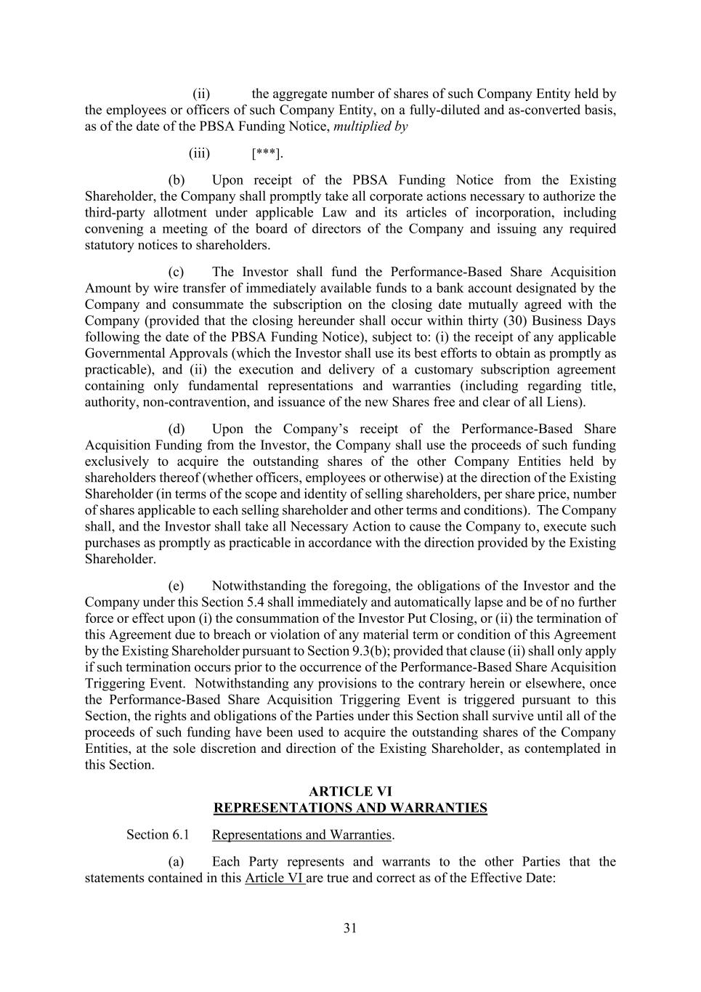
31 (ii) the aggregate number of shares of such Company Entity held by the employees or officers of such Company Entity, on a fully-diluted and as-converted basis, as of the date of the PBSA Funding Notice, multiplied by (iii) [***]. (b) Upon receipt of the PBSA Funding Notice from the Existing Shareholder, the Company shall promptly take all corporate actions necessary to authorize the third-party allotment under applicable Law and its articles of incorporation, including convening a meeting of the board of directors of the Company and issuing any required statutory notices to shareholders. (c) The Investor shall fund the Performance-Based Share Acquisition Amount by wire transfer of immediately available funds to a bank account designated by the Company and consummate the subscription on the closing date mutually agreed with the Company (provided that the closing hereunder shall occur within thirty (30) Business Days following the date of the PBSA Funding Notice), subject to: (i) the receipt of any applicable Governmental Approvals (which the Investor shall use its best efforts to obtain as promptly as practicable), and (ii) the execution and delivery of a customary subscription agreement containing only fundamental representations and warranties (including regarding title, authority, non-contravention, and issuance of the new Shares free and clear of all Liens). (d) Upon the Company’s receipt of the Performance-Based Share Acquisition Funding from the Investor, the Company shall use the proceeds of such funding exclusively to acquire the outstanding shares of the other Company Entities held by shareholders thereof (whether officers, employees or otherwise) at the direction of the Existing Shareholder (in terms of the scope and identity of selling shareholders, per share price, number of shares applicable to each selling shareholder and other terms and conditions). The Company shall, and the Investor shall take all Necessary Action to cause the Company to, execute such purchases as promptly as practicable in accordance with the direction provided by the Existing Shareholder. (e) Notwithstanding the foregoing, the obligations of the Investor and the Company under this Section 5.4 shall immediately and automatically lapse and be of no further force or effect upon (i) the consummation of the Investor Put Closing, or (ii) the termination of this Agreement due to breach or violation of any material term or condition of this Agreement by the Existing Shareholder pursuant to Section 9.3(b); provided that clause (ii) shall only apply if such termination occurs prior to the occurrence of the Performance-Based Share Acquisition Triggering Event. Notwithstanding any provisions to the contrary herein or elsewhere, once the Performance-Based Share Acquisition Triggering Event is triggered pursuant to this Section, the rights and obligations of the Parties under this Section shall survive until all of the proceeds of such funding have been used to acquire the outstanding shares of the Company Entities, at the sole discretion and direction of the Existing Shareholder, as contemplated in this Section. ARTICLE VI REPRESENTATIONS AND WARRANTIES Representations and Warranties. (a) Each Party represents and warrants to the other Parties that the statements contained in this Article VI are true and correct as of the Effective Date:

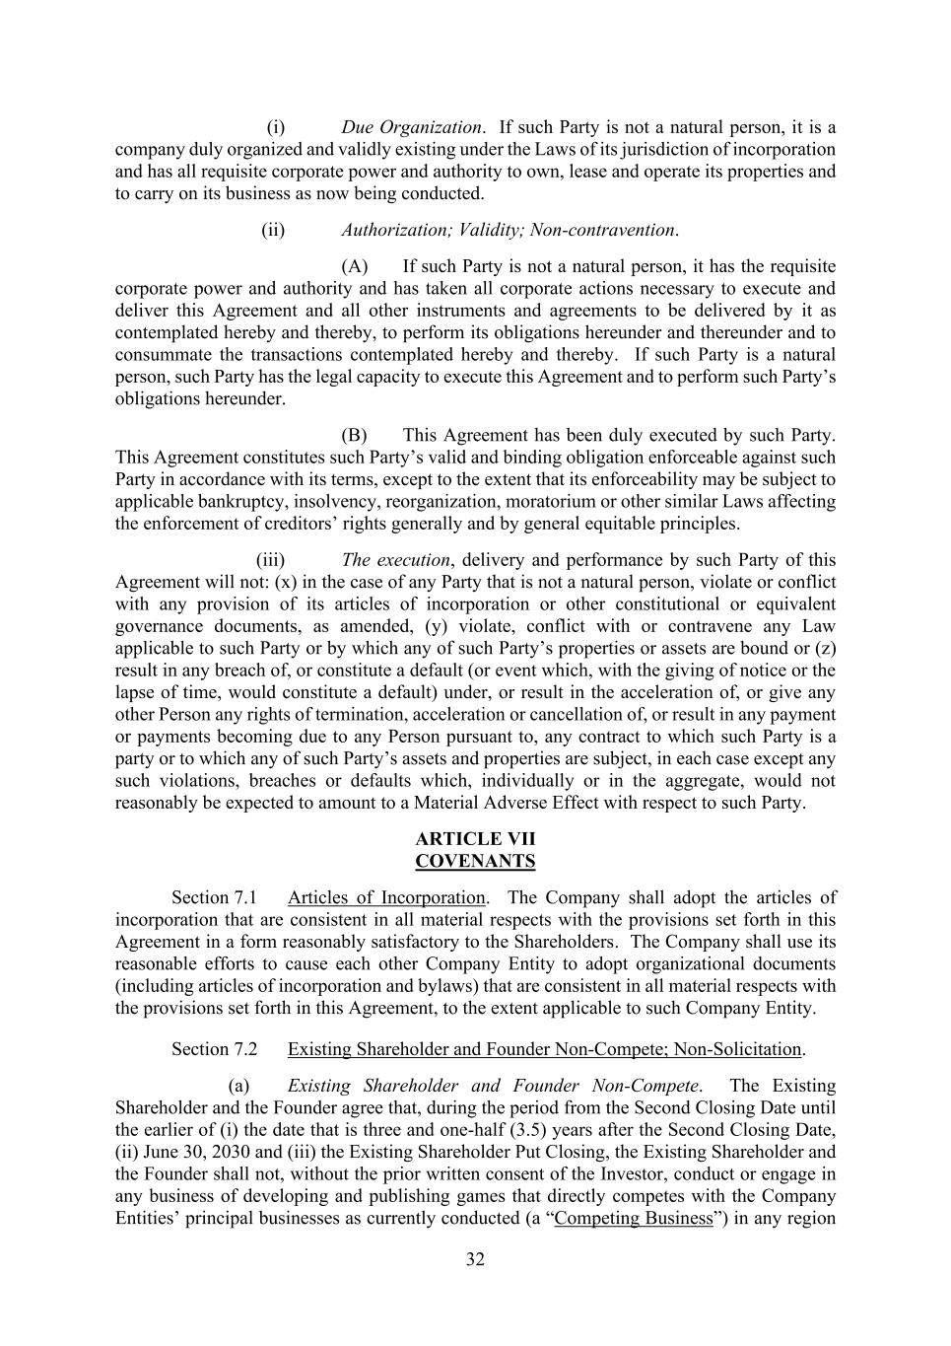
32 (i) Due Organization. If such Party is not a natural person, it is a company duly organized and validly existing under the Laws of its jurisdiction of incorporation and has all requisite corporate power and authority to own, lease and operate its properties and to carry on its business as now being conducted. (ii) Authorization; Validity; Non-contravention. (A) If such Party is not a natural person, it has the requisite corporate power and authority and has taken all corporate actions necessary to execute and deliver this Agreement and all other instruments and agreements to be delivered by it as contemplated hereby and thereby, to perform its obligations hereunder and thereunder and to consummate the transactions contemplated hereby and thereby. If such Party is a natural person, such Party has the legal capacity to execute this Agreement and to perform such Party’s obligations hereunder. (B) This Agreement has been duly executed by such Party. This Agreement constitutes such Party’s valid and binding obligation enforceable against such Party in accordance with its terms, except to the extent that its enforceability may be subject to applicable bankruptcy, insolvency, reorganization, moratorium or other similar Laws affecting the enforcement of creditors’ rights generally and by general equitable principles. (iii) The execution, delivery and performance by such Party of this Agreement will not: (x) in the case of any Party that is not a natural person, violate or conflict with any provision of its articles of incorporation or other constitutional or equivalent governance documents, as amended, (y) violate, conflict with or contravene any Law applicable to such Party or by which any of such Party’s properties or assets are bound or (z) result in any breach of, or constitute a default (or event which, with the giving of notice or the lapse of time, would constitute a default) under, or result in the acceleration of, or give any other Person any rights of termination, acceleration or cancellation of, or result in any payment or payments becoming due to any Person pursuant to, any contract to which such Party is a party or to which any of such Party’s assets and properties are subject, in each case except any such violations, breaches or defaults which, individually or in the aggregate, would not reasonably be expected to amount to a Material Adverse Effect with respect to such Party. ARTICLE VII COVENANTS Section 7.1 Articles of Incorporation. The Company shall adopt the articles of incorporation that are consistent in all material respects with the provisions set forth in this Agreement in a form reasonably satisfactory to the Shareholders. The Company shall use its reasonable efforts to cause each other Company Entity to adopt organizational documents (including articles of incorporation and bylaws) that are consistent in all material respects with the provisions set forth in this Agreement, to the extent applicable to such Company Entity. Section 7.2 Existing Shareholder and Founder Non-Compete; Non-Solicitation. (a) Existing Shareholder and Founder Non-Compete. The Existing Shareholder and the Founder agree that, during the period from the Second Closing Date until the earlier of (i) the date that is three and one-half (3.5) years after the Second Closing Date, (ii) June 30, 2030 and (iii) the Existing Shareholder Put Closing, the Existing Shareholder and the Founder shall not, without the prior written consent of the Investor, conduct or engage in any business of developing and publishing games that directly competes with the Company Entities’ principal businesses as currently conducted (a “Competing Business”) in any region

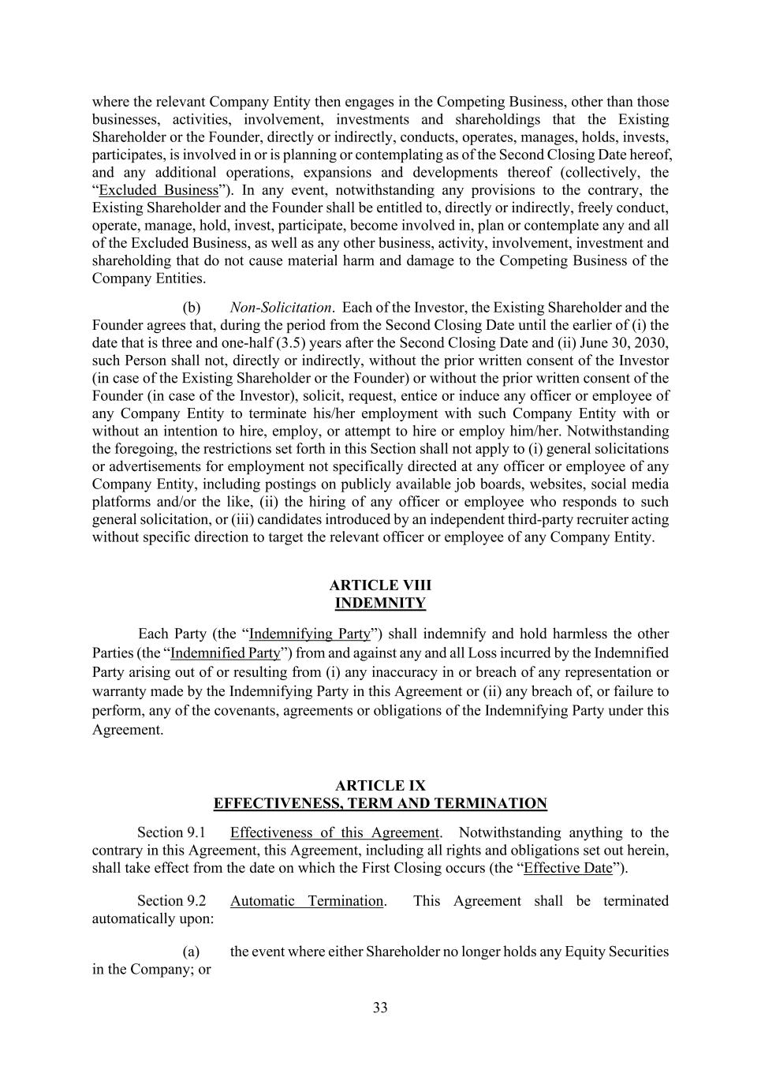
33 where the relevant Company Entity then engages in the Competing Business, other than those businesses, activities, involvement, investments and shareholdings that the Existing Shareholder or the Founder, directly or indirectly, conducts, operates, manages, holds, invests, participates, is involved in or is planning or contemplating as of the Second Closing Date hereof, and any additional operations, expansions and developments thereof (collectively, the “Excluded Business”). In any event, notwithstanding any provisions to the contrary, the Existing Shareholder and the Founder shall be entitled to, directly or indirectly, freely conduct, operate, manage, hold, invest, participate, become involved in, plan or contemplate any and all of the Excluded Business, as well as any other business, activity, involvement, investment and shareholding that do not cause material harm and damage to the Competing Business of the Company Entities. (b) Non-Solicitation. Each of the Investor, the Existing Shareholder and the Founder agrees that, during the period from the Second Closing Date until the earlier of (i) the date that is three and one-half (3.5) years after the Second Closing Date and (ii) June 30, 2030, such Person shall not, directly or indirectly, without the prior written consent of the Investor (in case of the Existing Shareholder or the Founder) or without the prior written consent of the Founder (in case of the Investor), solicit, request, entice or induce any officer or employee of any Company Entity to terminate his/her employment with such Company Entity with or without an intention to hire, employ, or attempt to hire or employ him/her. Notwithstanding the foregoing, the restrictions set forth in this Section shall not apply to (i) general solicitations or advertisements for employment not specifically directed at any officer or employee of any Company Entity, including postings on publicly available job boards, websites, social media platforms and/or the like, (ii) the hiring of any officer or employee who responds to such general solicitation, or (iii) candidates introduced by an independent third-party recruiter acting without specific direction to target the relevant officer or employee of any Company Entity. ARTICLE VIII INDEMNITY Each Party (the “Indemnifying Party”) shall indemnify and hold harmless the other Parties (the “Indemnified Party”) from and against any and all Loss incurred by the Indemnified Party arising out of or resulting from (i) any inaccuracy in or breach of any representation or warranty made by the Indemnifying Party in this Agreement or (ii) any breach of, or failure to perform, any of the covenants, agreements or obligations of the Indemnifying Party under this Agreement. ARTICLE IX EFFECTIVENESS, TERM AND TERMINATION Effectiveness of this Agreement. Notwithstanding anything to the contrary in this Agreement, this Agreement, including all rights and obligations set out herein, shall take effect from the date on which the First Closing occurs (the “Effective Date”). Automatic Termination. This Agreement shall be terminated automatically upon: (a) the event where either Shareholder no longer holds any Equity Securities in the Company; or

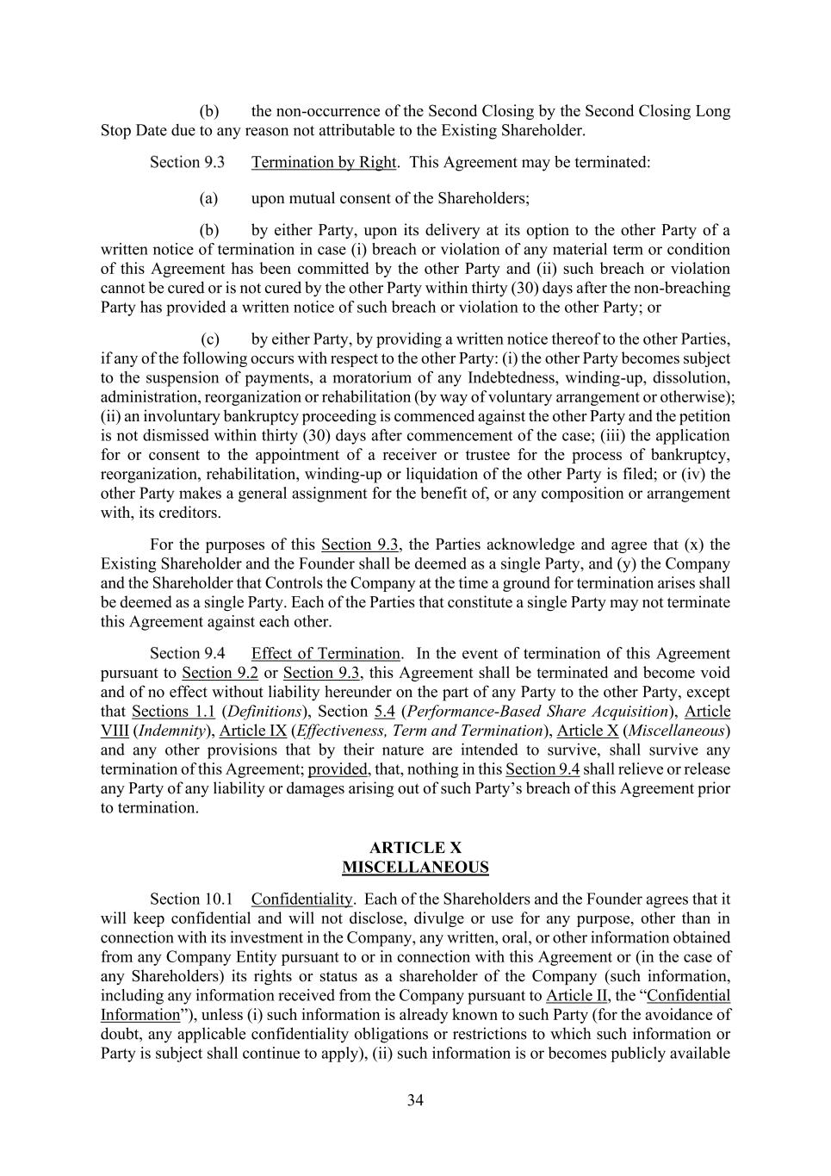
34 (b) the non-occurrence of the Second Closing by the Second Closing Long Stop Date due to any reason not attributable to the Existing Shareholder. Termination by Right. This Agreement may be terminated: (a) upon mutual consent of the Shareholders; (b) by either Party, upon its delivery at its option to the other Party of a written notice of termination in case (i) breach or violation of any material term or condition of this Agreement has been committed by the other Party and (ii) such breach or violation cannot be cured or is not cured by the other Party within thirty (30) days after the non-breaching Party has provided a written notice of such breach or violation to the other Party; or (c) by either Party, by providing a written notice thereof to the other Parties, if any of the following occurs with respect to the other Party: (i) the other Party becomes subject to the suspension of payments, a moratorium of any Indebtedness, winding-up, dissolution, administration, reorganization or rehabilitation (by way of voluntary arrangement or otherwise); (ii) an involuntary bankruptcy proceeding is commenced against the other Party and the petition is not dismissed within thirty (30) days after commencement of the case; (iii) the application for or consent to the appointment of a receiver or trustee for the process of bankruptcy, reorganization, rehabilitation, winding-up or liquidation of the other Party is filed; or (iv) the other Party makes a general assignment for the benefit of, or any composition or arrangement with, its creditors. For the purposes of this Section 9.3, the Parties acknowledge and agree that (x) the Existing Shareholder and the Founder shall be deemed as a single Party, and (y) the Company and the Shareholder that Controls the Company at the time a ground for termination arises shall be deemed as a single Party. Each of the Parties that constitute a single Party may not terminate this Agreement against each other. Effect of Termination. In the event of termination of this Agreement pursuant to Section 9.2 or Section 9.3, this Agreement shall be terminated and become void and of no effect without liability hereunder on the part of any Party to the other Party, except that Sections 1.1 (Definitions), Section 5.4 (Performance-Based Share Acquisition), Article VIII (Indemnity), Article IX (Effectiveness, Term and Termination), Article X (Miscellaneous) and any other provisions that by their nature are intended to survive, shall survive any termination of this Agreement; provided, that, nothing in this Section 9.4 shall relieve or release any Party of any liability or damages arising out of such Party’s breach of this Agreement prior to termination. ARTICLE X MISCELLANEOUS Section 10.1 Confidentiality. Each of the Shareholders and the Founder agrees that it will keep confidential and will not disclose, divulge or use for any purpose, other than in connection with its investment in the Company, any written, oral, or other information obtained from any Company Entity pursuant to or in connection with this Agreement or (in the case of any Shareholders) its rights or status as a shareholder of the Company (such information, including any information received from the Company pursuant to Article II, the “Confidential Information”), unless (i) such information is already known to such Party (for the avoidance of doubt, any applicable confidentiality obligations or restrictions to which such information or Party is subject shall continue to apply), (ii) such information is or becomes publicly available

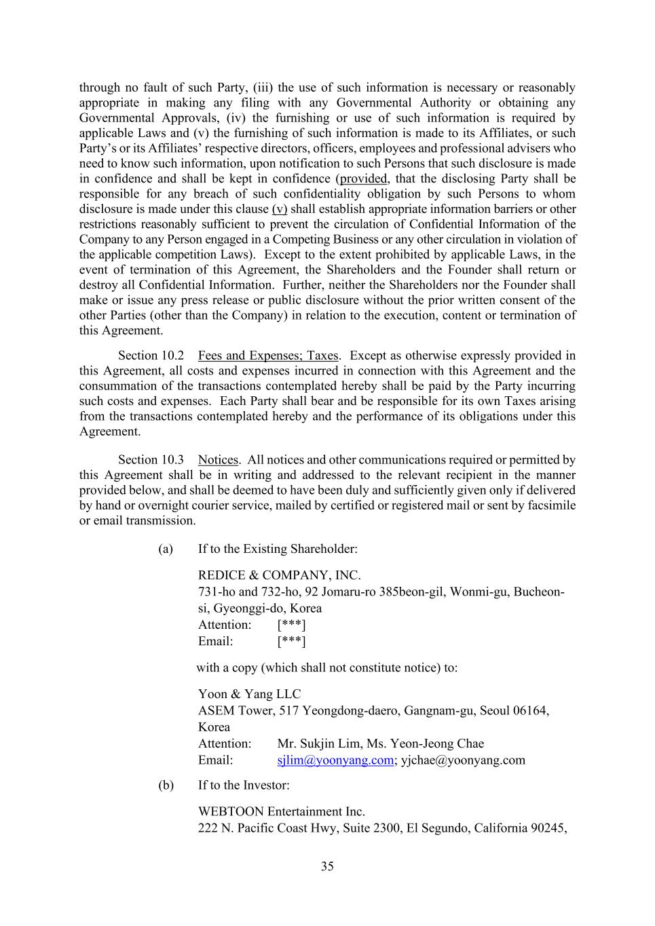
35 through no fault of such Party, (iii) the use of such information is necessary or reasonably appropriate in making any filing with any Governmental Authority or obtaining any Governmental Approvals, (iv) the furnishing or use of such information is required by applicable Laws and (v) the furnishing of such information is made to its Affiliates, or such Party’s or its Affiliates’ respective directors, officers, employees and professional advisers who need to know such information, upon notification to such Persons that such disclosure is made in confidence and shall be kept in confidence (provided, that the disclosing Party shall be responsible for any breach of such confidentiality obligation by such Persons to whom disclosure is made under this clause (v) shall establish appropriate information barriers or other restrictions reasonably sufficient to prevent the circulation of Confidential Information of the Company to any Person engaged in a Competing Business or any other circulation in violation of the applicable competition Laws). Except to the extent prohibited by applicable Laws, in the event of termination of this Agreement, the Shareholders and the Founder shall return or destroy all Confidential Information. Further, neither the Shareholders nor the Founder shall make or issue any press release or public disclosure without the prior written consent of the other Parties (other than the Company) in relation to the execution, content or termination of this Agreement. Section 10.2 Fees and Expenses; Taxes. Except as otherwise expressly provided in this Agreement, all costs and expenses incurred in connection with this Agreement and the consummation of the transactions contemplated hereby shall be paid by the Party incurring such costs and expenses. Each Party shall bear and be responsible for its own Taxes arising from the transactions contemplated hereby and the performance of its obligations under this Agreement. Section 10.3 Notices. All notices and other communications required or permitted by this Agreement shall be in writing and addressed to the relevant recipient in the manner provided below, and shall be deemed to have been duly and sufficiently given only if delivered by hand or overnight courier service, mailed by certified or registered mail or sent by facsimile or email transmission. (a) If to the Existing Shareholder: REDICE & COMPANY, INC. 731-ho and 732-ho, 92 Jomaru-ro 385beon-gil, Wonmi-gu, Bucheon- si, Gyeonggi-do, Korea Attention: [***] Email: [***] with a copy (which shall not constitute notice) to: Yoon & Yang LLC ASEM Tower, 517 Yeongdong-daero, Gangnam-gu, Seoul 06164, Korea Attention: Mr. Sukjin Lim, Ms. Yeon-Jeong Chae Email: sjlim@yoonyang.com; yjchae@yoonyang.com (b) If to the Investor: WEBTOON Entertainment Inc. 222 N. Pacific Coast Hwy, Suite 2300, El Segundo, California 90245,

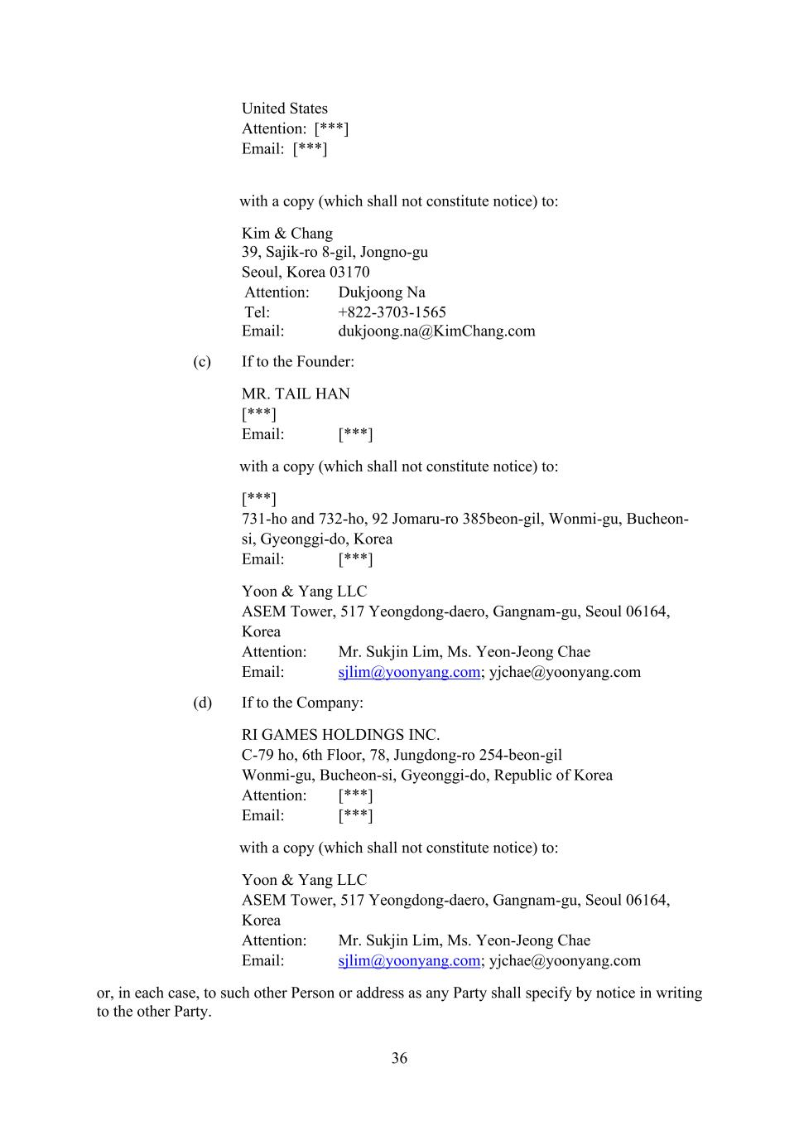
36 United States Attention: [***] Email: [***] with a copy (which shall not constitute notice) to: Kim & Chang 39, Sajik-ro 8-gil, Jongno-gu Seoul, Korea 03170 Attention: Dukjoong Na Tel: +822-3703-1565 Email: dukjoong.na@KimChang.com (c) If to the Founder: MR. TAIL HAN [***] Email: [***] with a copy (which shall not constitute notice) to: [***] 731-ho and 732-ho, 92 Jomaru-ro 385beon-gil, Wonmi-gu, Bucheon- si, Gyeonggi-do, Korea Email: [***] Yoon & Yang LLC ASEM Tower, 517 Yeongdong-daero, Gangnam-gu, Seoul 06164, Korea Attention: Mr. Sukjin Lim, Ms. Yeon-Jeong Chae Email: sjlim@yoonyang.com; yjchae@yoonyang.com (d) If to the Company: RI GAMES HOLDINGS INC. C-79 ho, 6th Floor, 78, Jungdong-ro 254-beon-gil Wonmi-gu, Bucheon-si, Gyeonggi-do, Republic of Korea Attention: [***] Email: [***] with a copy (which shall not constitute notice) to: Yoon & Yang LLC ASEM Tower, 517 Yeongdong-daero, Gangnam-gu, Seoul 06164, Korea Attention: Mr. Sukjin Lim, Ms. Yeon-Jeong Chae Email: sjlim@yoonyang.com; yjchae@yoonyang.com or, in each case, to such other Person or address as any Party shall specify by notice in writing to the other Party.

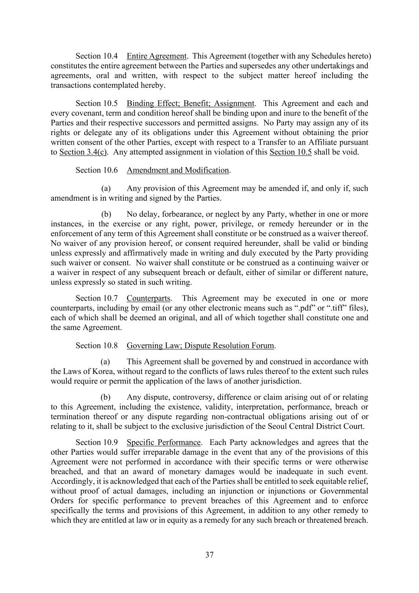
37 Section 10.4 Entire Agreement. This Agreement (together with any Schedules hereto) constitutes the entire agreement between the Parties and supersedes any other undertakings and agreements, oral and written, with respect to the subject matter hereof including the transactions contemplated hereby. Section 10.5 Binding Effect; Benefit; Assignment. This Agreement and each and every covenant, term and condition hereof shall be binding upon and inure to the benefit of the Parties and their respective successors and permitted assigns. No Party may assign any of its rights or delegate any of its obligations under this Agreement without obtaining the prior written consent of the other Parties, except with respect to a Transfer to an Affiliate pursuant to Section 3.4(c). Any attempted assignment in violation of this Section 10.5 shall be void. Section 10.6 Amendment and Modification. (a) Any provision of this Agreement may be amended if, and only if, such amendment is in writing and signed by the Parties. (b) No delay, forbearance, or neglect by any Party, whether in one or more instances, in the exercise or any right, power, privilege, or remedy hereunder or in the enforcement of any term of this Agreement shall constitute or be construed as a waiver thereof. No waiver of any provision hereof, or consent required hereunder, shall be valid or binding unless expressly and affirmatively made in writing and duly executed by the Party providing such waiver or consent. No waiver shall constitute or be construed as a continuing waiver or a waiver in respect of any subsequent breach or default, either of similar or different nature, unless expressly so stated in such writing. Section 10.7 Counterparts. This Agreement may be executed in one or more counterparts, including by email (or any other electronic means such as “.pdf” or “.tiff” files), each of which shall be deemed an original, and all of which together shall constitute one and the same Agreement. Section 10.8 Governing Law; Dispute Resolution Forum. (a) This Agreement shall be governed by and construed in accordance with the Laws of Korea, without regard to the conflicts of laws rules thereof to the extent such rules would require or permit the application of the laws of another jurisdiction. (b) Any dispute, controversy, difference or claim arising out of or relating to this Agreement, including the existence, validity, interpretation, performance, breach or termination thereof or any dispute regarding non-contractual obligations arising out of or relating to it, shall be subject to the exclusive jurisdiction of the Seoul Central District Court. Section 10.9 Specific Performance. Each Party acknowledges and agrees that the other Parties would suffer irreparable damage in the event that any of the provisions of this Agreement were not performed in accordance with their specific terms or were otherwise breached, and that an award of monetary damages would be inadequate in such event. Accordingly, it is acknowledged that each of the Parties shall be entitled to seek equitable relief, without proof of actual damages, including an injunction or injunctions or Governmental Orders for specific performance to prevent breaches of this Agreement and to enforce specifically the terms and provisions of this Agreement, in addition to any other remedy to which they are entitled at law or in equity as a remedy for any such breach or threatened breach.

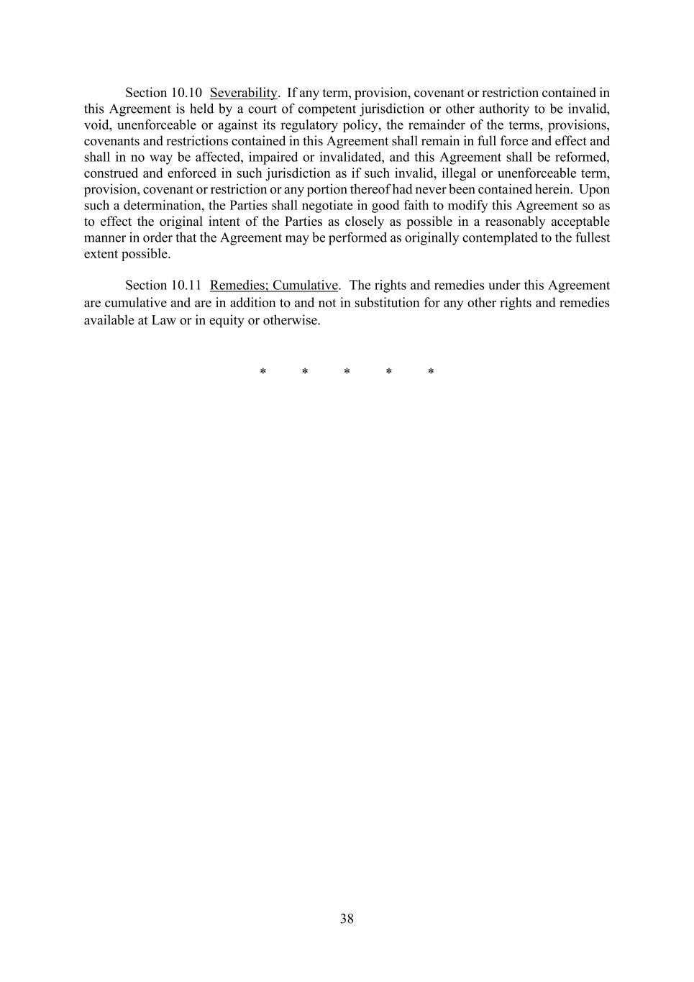
38 Section 10.10 Severability. If any term, provision, covenant or restriction contained in this Agreement is held by a court of competent jurisdiction or other authority to be invalid, void, unenforceable or against its regulatory policy, the remainder of the terms, provisions, covenants and restrictions contained in this Agreement shall remain in full force and effect and shall in no way be affected, impaired or invalidated, and this Agreement shall be reformed, construed and enforced in such jurisdiction as if such invalid, illegal or unenforceable term, provision, covenant or restriction or any portion thereof had never been contained herein. Upon such a determination, the Parties shall negotiate in good faith to modify this Agreement so as to effect the original intent of the Parties as closely as possible in a reasonably acceptable manner in order that the Agreement may be performed as originally contemplated to the fullest extent possible. Section 10.11 Remedies; Cumulative. The rights and remedies under this Agreement are cumulative and are in addition to and not in substitution for any other rights and remedies available at Law or in equity or otherwise. * * * * *


[Signature Page to Shareholders Agreement] IN WITNESS WHEREOF, the Parties have executed or caused this Agreement to be executed as of the date first written above. EXISTING SHAREHOLDER: REDICE & COMPANY, INC. By ___________________________ Name: Tae Hyeok Ha Title: Director /s/ Tae Hyeok Ha

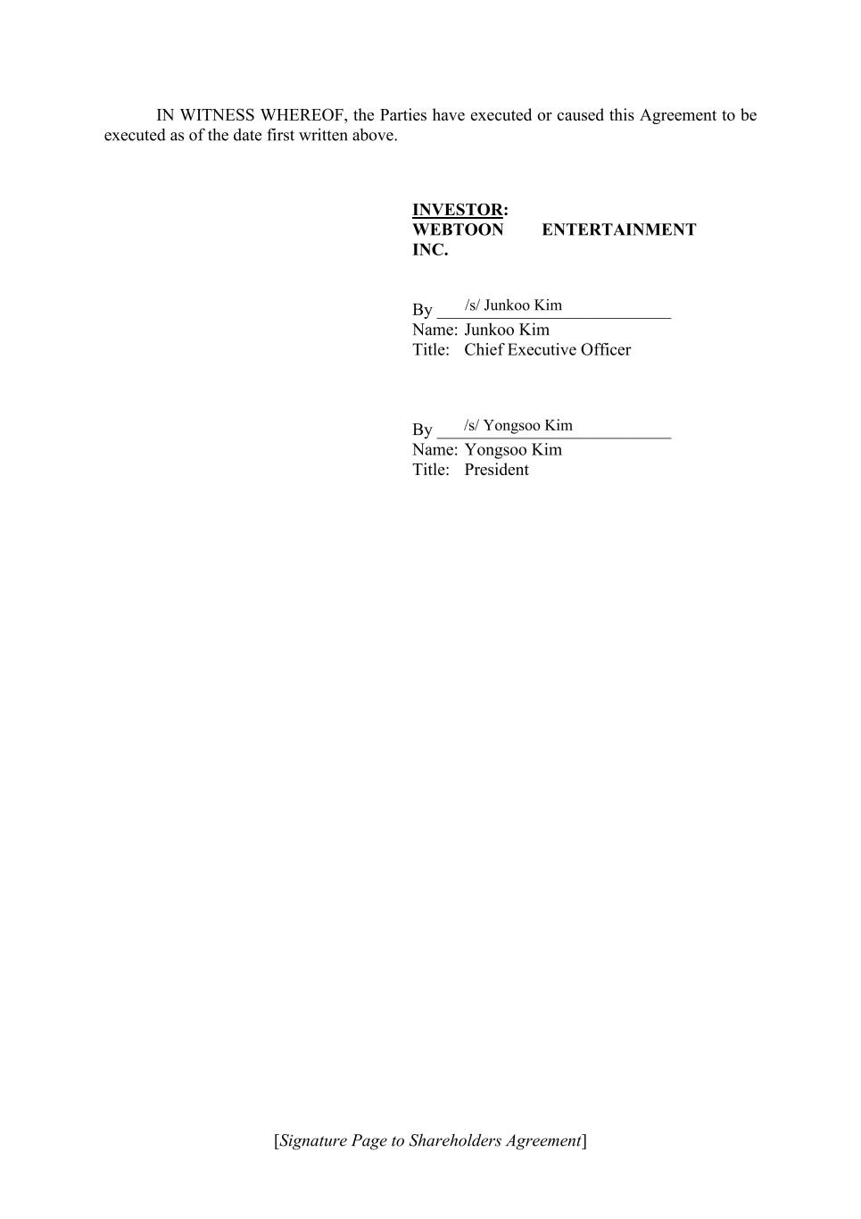
[Signature Page to Shareholders Agreement] IN WITNESS WHEREOF, the Parties have executed or caused this Agreement to be executed as of the date first written above. INVESTOR: WEBTOON ENTERTAINMENT INC. By ___________________________ Name: Junkoo Kim Title: Chief Executive Officer By ___________________________ Name: Yongsoo Kim Title: President /s/ Junkoo Kim /s/ Yongsoo Kim


[Signature Page to Shareholders Agreement] IN WITNESS WHEREOF, the Parties have executed or caused this Agreement to be executed as of the date first written above. FOUNDER: TAIL HAN ___________________________ Date of Birth: [***] /s/ Tail Han

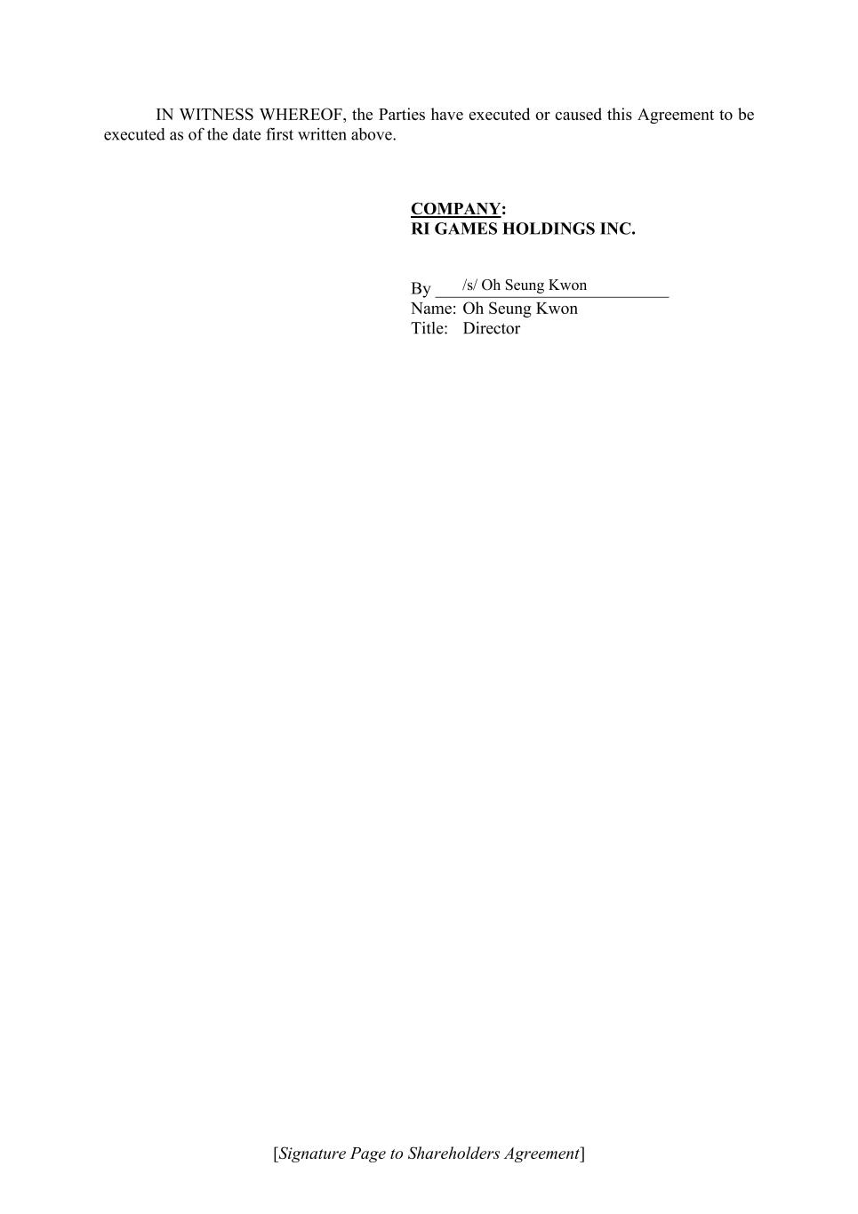
[Signature Page to Shareholders Agreement] IN WITNESS WHEREOF, the Parties have executed or caused this Agreement to be executed as of the date first written above. COMPANY: RI GAMES HOLDINGS INC. By ___________________________ Name: Oh Seung Kwon Title: Director /s/ Oh Seung Kwon

EXHIBIT 31.1
CERTIFICATION
PURSUANT TO RULE 13a-14 AND 15d-14
UNDER THE SECURITIES EXCHANGE ACT OF 1934, AS AMENDED
I, Junkoo Kim, certify that:
1.I have reviewed this quarterly report on Form 10-Q of WEBTOON Entertainment Inc.;
2.Based on my knowledge, this report does not contain any untrue statement of a material fact or omit to state a material fact necessary to make the statements made, in light of the circumstances under which such statements were made, not misleading with respect to the period covered by this report;
3.Based on my knowledge, the financial statements, and other financial information included in this report, fairly present in all material respects the financial condition, results of operations and cash flows of the registrant as of, and for, the periods presented in this report;
4.The registrant’s other certifying officer and I are responsible for establishing and maintaining disclosure controls and procedures (as defined in Exchange Act Rules 13a-15(e) and 15d-15(e)) and internal control over financial reporting (as defined in Exchange Act Rules 13a-15(f) and 15d-15(f)) for the registrant and have:
a.Designed such disclosure controls and procedures, or caused such disclosure controls and procedures to be designed under our supervision, to ensure that material information relating to the registrant, including its consolidated subsidiaries, is made known to us by others within those entities, particularly during the period in which this report is being prepared;
b.Designed such internal control over financial reporting, or caused such internal control over financial reporting to be designed under our supervision, to provide reasonable assurance regarding the reliability of financial reporting and the preparation of financial statements for external purposes in accordance with generally accepted accounting principles;
c.Evaluated the effectiveness of the registrant’s disclosure controls and procedures and presented in this report our conclusions about the effectiveness of the disclosure controls and procedures, as of the end of the period covered by this report based on such evaluation; and
d.Disclosed in this report any change in the registrant’s internal control over financial reporting that occurred during the registrant’s most recent fiscal quarter (the registrant’s fourth fiscal quarter in the case of an annual report) that has materially affected or is reasonably likely to materially affect the registrant’s internal control over financial reporting; and
5.The registrant’s other certifying officer and I have disclosed, based on our most recent evaluation of internal control over financial reporting, to the registrant’s auditors and the audit committee of the registrant’s Board of directors (or persons performing the equivalent functions):
a.All significant deficiencies and material weaknesses in the design or operation of internal control over financial reporting which are reasonably likely to adversely affect the registrant’s ability to record, process, summarize and report financial information; and
EXHIBIT 31.1

b.Any fraud, whether or not material, that involves management or other employees who have a significant role in the registrant’s internal control over financial reporting.
Date: August 10, 2026
/s/ Junkoo Kim
Name: Junkoo Kim
Title: Chairman of the Board and Chief Executive Officer

EXHIBIT 31.2

CERTIFICATION
PURSUANT TO RULE 13a-14 AND 15d-14
UNDER THE SECURITIES EXCHANGE ACT OF 1934, AS AMENDED
I, David J. Lee, certify that:
1.I have reviewed this quarterly report on Form 10-Q of WEBTOON Entertainment Inc.;
2.Based on my knowledge, this report does not contain any untrue statement of a material fact or omit to state a material fact necessary to make the statements made, in light of the circumstances under which such statements were made, not misleading with respect to the period covered by this report;
3.Based on my knowledge, the financial statements, and other financial information included in this report, fairly present in all material respects the financial condition, results of operations and cash flows of the registrant as of, and for, the periods presented in this report;
4.The registrant’s other certifying officer and I are responsible for establishing and maintaining disclosure controls and procedures (as defined in Exchange Act Rules 13a-15(e) and 15d-15(e)) and internal control over financial reporting (as defined in Exchange Act Rules 13a-15(f) and 15d-15(f)) for the registrant and have:
a.Designed such disclosure controls and procedures, or caused such disclosure controls and procedures to be designed under our supervision, to ensure that material information relating to the registrant, including its consolidated subsidiaries, is made known to us by others within those entities, particularly during the period in which this report is being prepared;
b.Designed such internal control over financial reporting, or caused such internal control over financial reporting to be designed under our supervision, to provide reasonable assurance regarding the reliability of financial reporting and the preparation of financial statements for external purposes in accordance with generally accepted accounting principles;
c.Evaluated the effectiveness of the registrant’s disclosure controls and procedures and presented in this report our conclusions about the effectiveness of the disclosure controls and procedures, as of the end of the period covered by this report based on such evaluation; and
d.Disclosed in this report any change in the registrant’s internal control over financial reporting that occurred during the registrant’s most recent fiscal quarter (the registrant’s fourth fiscal quarter in the case of an annual report) that has materially affected or is reasonably likely to materially affect the registrant’s internal control over financial reporting; and
5.The registrant’s other certifying officer and I have disclosed, based on our most recent evaluation of internal control over financial reporting, to the registrant’s auditors and the audit committee of the registrant’s Board of directors (or persons performing the equivalent functions):
a.All significant deficiencies and material weaknesses in the design or operation of internal control over financial reporting which are reasonably likely to adversely affect the registrant’s ability to record, process, summarize and report financial information; and
EXHIBIT 31.2

b.Any fraud, whether or not material, that involves management or other employees who have a significant role in the registrant’s internal control over financial reporting.
Date: August 10, 2026
/s/ David J. Lee
Name: David J. Lee
Title: Chief Financial Officer

EXHIBIT 32.1

CERTIFICATION
PURSUANT TO 18 U.S.C. 1350
(SECTION 906 OF THE SARBANES-OXLEY ACT OF 2002)
Junkoo Kim, Chairman of the Board and Chief Executive Officer of WEBTOON Entertainment Inc. (the “Company”), and David J. Lee, Chief Financial Officer and Chief Operating Officer of the Company, each, hereby certifies, pursuant to Section 906 of the Sarbanes-Oxley Act of 2002, 18 U.S.C. Section 1350, that, to the best of his knowledge:
1.The Quarterly Report on Form 10-Q of the Company for the quarter ended June 30, 2026 (the “Report”) fully complies with the requirements of Section 13(a) or 15(d) of the Securities Exchange Act of 1934; and
2.The information contained in the Report fairly presents, in all material respects, the financial condition and results of operations of the Company.
Date: August 10, 2026
/s/ Junkoo Kim
Name: Junkoo Kim
Title: Chairman of the Board and Chief Executive Officer
/s/ David J. Lee
Name: David J. Lee
Title: Chief Financial Officer

