UNITED STATES
SECURITIES AND EXCHANGE COMMISSION
WASHINGTON, D.C. 20549
FORM 8-K
CURRENT REPORT
Pursuant to Section 13 or 15(d) of the Securities Exchange Act of 1934
Date of Report (Date of earliest event reported): August 10, 2026
WEBTOON Entertainment Inc.
(Exact name of Registrant as Specified in Its Charter)
Delaware |  |  | 001-42144 |  |  | 81-3830533
(State or Other Jurisdiction  of Incorporation) |  |  | (Commission File Number) |  |  | (IRS Employer  Identification No.)
222 N. Pacific Coast Highway
Suite 2300
El Segundo, California |  |  |  |  |  | 90245
(Address of Principal Executive Offices) |  |  |  |  |  | (Zip Code)
Registrant’s Telephone Number, Including Area Code: (323) 424-3795
(Former Name or Former Address, if Changed Since Last Report)
Check the appropriate box below if the Form 8-K filing is intended to simultaneously satisfy the filing obligation of the registrant under any of the following provisions:
☐ Written communications pursuant to Rule 425 under the Securities Act (17 CFR 230.425)
☐ Soliciting material pursuant to Rule 14a-12 under the Exchange Act (17 CFR 240.14a-12)
☐ Pre-commencement communications pursuant to Rule 14d-2(b) under the Exchange Act (17 CFR 240.14d-2(b))
☐ Pre-commencement communications pursuant to Rule 13e-4(c) under the Exchange Act (17 CFR 240.13e-4(c))
Securities registered pursuant to Section 12(b) of the Act:
Title of each class |  |  |  |  |  | Trading  Symbol(s) |  |  |  |  |  | Name of each exchange on which registered
Common stock, par value $0.0001 per share |  |  |  |  |  | WBTN |  |  |  |  |  | Nasdaq Global Select Market
Indicate by check mark whether the registrant is an emerging growth company as defined in Rule 405 of the Securities Act of 1933 (§ 230.405 of this chapter) or Rule 12b-2 of the Securities Exchange Act of 1934 (§ 240.12b-2 of this chapter).
Emerging growth company ☐
If an emerging growth company, indicate by check mark if the registrant has elected not to use the extended transition period for complying with any new or revised financial accounting standards provided pursuant to Section 13(a) of the Exchange Act. ☐

Item 1.01 Entry into a Material Definitive Agreement
Share Purchase Agreement

On August 6, 2026, WEBTOON Entertainment Inc., a Delaware corporation (the “Company”), entered into a Share Purchase Agreement (the “Purchase Agreement”) with Redice & Company, Inc., a joint-stock company established under the laws of the Republic of Korea (the “Seller”), pursuant to which, among other things, the Company agreed to purchase from the Seller and the Seller agreed to sell to the Company, up to 9,000 shares of common stock (the “Shares”) of RI Games Holdings Inc., a joint-stock company established under the laws of the Republic of Korea (“RI Games Holdings”) in two separate closings (the “Transactions”). RI Games Holdings is a South Korea-based game developer focused on developing games based on webcomic intellectual property. The purchase price per share of the Shares is KRW 16,666,667, and the aggregate consideration payable by the Company for the Shares is KRW 150,000,003,000.

The Transactions will be consummated in two separate closings. At the first closing, the Company will purchase 2,999 Shares from the Seller for an aggregate purchase price of KRW 49,983,334,333 (the “First Closing”). Following the First Closing, and subject to the satisfaction of certain additional conditions, including, but not limited to, the achievement of a specified commercial launch milestone with respect to a game under development by one of RI Games Holdings’s subsidiaries, the Company will purchase the remaining 6,001 Shares from the Seller at a second closing for an aggregate purchase price of KRW 100,016,668,667 (the “Second Closing”). Each closing will take place on the seventh business day following satisfaction or waiver of the applicable closing conditions, or at such other date, time, or place as the parties may agree.

Upon completion of both closings, the Company will own approximately sixty percent (60%) of the issued and outstanding shares of common stock of RI Games Holdings. The Company expects to consolidate the financial results of RI Games Holdings and its subsidiaries into the Company’s consolidated financial statements following the Second Closing.

The respective obligations of the Company and the Seller to consummate each closing under the Purchase Agreement are subject to the satisfaction or waiver of certain customary closing conditions, including, among other things: (i) the accuracy of the parties’ representations and warranties, (ii) performance in all material respects of the parties’ respective covenants, (iii) the absence of any law or governmental order prohibiting the consummation of the applicable closing, and (iv) with respect to the Second Closing, the continued effectiveness of the Shareholders Agreement described below. The Purchase Agreement also contains representations, warranties, and covenants of the parties customary for a transaction of this type, as well as indemnification provisions subject to customary limitations.

The Purchase Agreement may be terminated under certain customary circumstances, including by mutual written agreement of the parties, if a closing has not occurred by a specified outside date, or in the event of an uncured material breach by a party, in each case subject to certain limitations and exceptions set forth in the Purchase Agreement.

Shareholders Agreement

In connection with the Transactions, the Company entered into a Shareholders Agreement with the Seller, Tail Han (the “Founder”), and RI Games Holdings (the “Shareholders Agreement”), which will become effective upon the First Closing. If the second closing under the Purchase Agreement does not occur by certain outside date for reasons not attributable to the Seller, the Shareholders Agreement will terminate automatically, substantially all of the related obligations described below will lapse, except for rights and liabilities that have accrued prior to termination and certain provisions that survive in accordance with their terms. The Shareholders Agreement contains various rights and covenants of the parties, including, among others things: (i) provisions relating to the composition of the board of directors of RI Games Holdings and its subsidiaries, and related governance matters; (ii) consent, consultation, and information rights of the shareholders with respect to certain matters relating to RI Games Holdings and its subsidiaries; (iii) certain restrictions on the transfer of equity securities of RI Games Holdings; (iv) contingent rights of the parties to require the purchase or sale of equity securities of RI Games Holdings upon the achievement of certain performance-related conditions, and related capital contribution obligations, in each case subject to the terms and procedures set forth in the Shareholders Agreement (as further described below); and (v) non-competition and non-solicitation covenants applicable to the Seller and the Founder for a specified period following the Second Closing.

From and after the Second Closing until June 30, 2030, the Seller will have the right to require RI Games Holdings to conduct up to four capital increases pursuant to which the Company will be obligated to subscribe for newly issued shares of RI Games Holdings for an aggregate subscription amount of up to KRW 50 billion through third-party

allotments. The parties may also agree to permit a portion of this capital commitment to be drawn and funded between the First Closing and the Second Closing.

In addition, if the aggregate revenue of RI Games Holdings and its subsidiaries during fiscal years 2027 through 2030 equals or exceeds a certain target revenue amount, the Seller will have the right to require RI Games Holdings to conduct an additional capital increase, pursuant to which the Company will be obligated to subscribe for newly issued shares of RI Games Holdings for an aggregate subscription amount determined in accordance with the Shareholders Agreement, up to a certain maximum subscription amount.

The Shareholders Agreement further provides that if the aggregate revenue of RI Games Holdings and its subsidiaries derived from their business equals or exceeds KRW 250 billion during the period commencing on the earlier of (x) January 1, 2027 and (y) the date when a game under development by one of RI Games Holdings’ subsidiaries becomes available for download and/or purchase by the general public, and ending on June 30, 2030 (the “Measurement Period”), the Seller will have the right to require the Company to purchase all, but not less than all, of the Seller’s remaining 6,000 shares of common stock of RI Games Holdings for an aggregate purchase price of no less than KRW 100,000,002,000, payable in a combination of cash and shares of the Company’s common stock, subject to the terms, conditions, and limitations set forth in the Shareholders Agreement. The aggregate number of shares of the Company’s common stock issuable under the Shareholders Agreement cannot exceed 19.9% of the shares of the Company’s common stock issued and outstanding immediately prior to the date of the Shareholders Agreement, unless the Company’s stockholders approve a greater issuance.

If the foregoing revenue threshold is not achieved by the end of the applicable Measurement Period, the Company will have the right, exercisable at any time during the period of six (6) months commencing on the later of (i) November 1, 2030 and (ii) the date on which the revenue report for the final fiscal quarter of the Measurement Period prepared as provided in the Shareholders Agreement is accepted, or deemed accepted, by the Company and the Seller, to require the Seller to purchase 6,001 shares of common stock of RI Games Holdings held by the Company for a purchase price based on the purchase price paid by the Company at the Second Closing, subject to certain adjustments set forth in the Shareholders Agreement.

The foregoing descriptions of the Purchase Agreement, the Shareholders Agreement and the transactions contemplated thereby do not purport to be complete and are subject to, and qualified in their entirety by, the full text of the Purchase Agreement and the Shareholders Agreement, which will be filed as exhibits to the Company’s Quarterly Report on Form 10-Q for the quarter ended June 30, 2026.

Item 2.02 Results of Operations and Financial Condition.
On August 10, 2026, the "Company issued a press release and a letter to shareholders (the "Shareholder Letter") announcing its financial results for the second quarter ended June 30, 2026. Copies of the press release and Shareholder Letter are furnished as Exhibit 99.1 and Exhibit 99.2, respectively, to this Current Report on Form 8-K and are incorporated herein by reference.
The information furnished pursuant to Item 2.02 of this Current Report on Form 8-K, including Exhibit 99.2 attached hereto, is being furnished and shall not be deemed “filed” for purposes of Section 18 of the Securities Exchange Act of 1934, as amended (the "Exchange Act"), or otherwise subject to the liabilities of that section, nor shall it be deemed incorporated by reference into any other filing under the Securities Act of 1933, as amended, or the Exchange Act, except as expressly set forth by specific reference in such a filing.

Item 7.01 Regulation FD Disclosure.
On August 10, 2026, the Company issued a press release announcing that the Company has entered into a definitive agreement to make a strategic investment in RI Games Holdings. A copy of the press release is furnished hereto as Exhibit 99.3 and incorporated herein by reference.
The information furnished pursuant to Item 7.01 of this Current Report on Form 8-K, including Exhibit 99.3 attached hereto, is being furnished and shall not be deemed “filed” for purposes of Section 18 of the Exchange Act, or otherwise subject to the liabilities of that section, nor shall it be deemed incorporated by reference into any other filing under the Securities Act of 1933, as amended, or the Exchange Act, except as expressly set forth by specific reference in such a filing.

Item 9.01 Financial Statements and Exhibits.
(d)The following exhibits are being filed herewith:
Exhibit No. |  |  |  |  |  | Description
99.1 |  |  |  |  |  | Press release dated August 10, 2026
99.2 |  |  |  |  |  | Shareholder Letter dated August 10, 2026
99.3 |  |  |  |  |  | Press release dated August 10, 2026, announcing entry into a definitive agreement to make a strategic investment in RI Games Holdings Inc.
104 |  |  |  |  |  | Cover Page Interactive Data File (embedded within the inline XBRL document)

SIGNATURES
Pursuant to the requirements of the Securities Exchange Act of 1934, the registrant has duly caused this report to be signed on its behalf by the undersigned hereunto duly authorized.
 |  |  |  |  |  |  |  |  | WEBTOON Entertainment Inc.
Date: |  |  | August 10, 2026 |  |  | By: |  |  | /s/ David J. Lee
 |  |  |  |  |  | Name: |  |  | David J. Lee
 |  |  |  |  |  | Title: |  |  | Chief Financial Officer

WEBTOON Entertainment Inc. Reports Second Quarter 2026 Financial Results
Delivered Revenue Within Guidance Range and Adjusted EBITDA Above the High-End of Guidance Range
Second Quarter Revenue Decline of 2.8%; Revenue Growth on a Constant Currency Basis of 5.2%
Net Loss of $14.6 million; Adjusted EBITDA of $5.5 million
Strong Balance Sheet With Cash and Cash Equivalents of Approximately $583.1 million and No Debt
LOS ANGELES, August 10, 2026 (GLOBE NEWSWIRE) -- WEBTOON Entertainment Inc. (Nasdaq: WBTN) (“WEBTOON Entertainment” or “the Company”), a leading global entertainment company and home to some of the world’s largest storytelling platforms, today announced results for its second quarter ended June 30, 2026. More information about these results can be found in the Company’s shareholder letter on the investor relations section of its website.
Second Quarter 2026 Highlights (vs. Second Quarter 2025)
•Total revenue of $338.5 million declined 2.8%, driven by declines in Paid Content and IP Adaptations, partially offset by growth in Advertising.
•Revenue on a constant currency basis was $366.4 million, growing 5.2%, driven by growth in all three revenue streams, Paid Content and Advertising and IP Adaptations.
•Net Loss was $14.6 million, compared to $3.9 million in the prior year, driven primarily by increased marketing investment.
•Adjusted EBITDA was $5.5 million, compared to $9.7 million in the prior year, due to increased marketing investment. Adjusted EBITDA Margin was 1.6%, compared to 2.8% in the prior year.
•Diluted loss per share was $0.11, compared to diluted loss per share of $0.03 in the prior year.
•Adjusted Earnings Per Share was $0.04, compared to $0.07 in the prior year.
•Cash and cash equivalents of approximately $583.1 million plus another $11.2 million of short-term deposits included in prepaid expenses and other current assets.
•Cash outflow from operations was $6.3 million, compared to a cash inflow of $5.7 million in the prior year.
Junkoo Kim, Founder and CEO, said, “We delivered another quarter of solid financial performance, with revenue of $338.5 million, in line with our expectations, and an Adjusted EBITDA of $5.5 million, exceeding the high-end of our previous guidance range.”
Kim continued, “This quarter, we advanced two strategic priorities that further strengthen our flywheel. We are leveraging AI to create more interactive experiences through innovations like byUs, our interactive story chat service, and our AI-Powered Auto Translation program, both of which are driving deeper engagement across our platform. We also continue to experiment with AI-powered initiatives such as Short Animation. At the same time, we are evolving our IP strategy by increasing direct investment and ownership, positioning us to capture more of the long-term value our ecosystem creates.”
Strategic Investment in RI Games Holdings Inc.
Today, WEBTOON Entertainment also issued a press release announcing entry into a definitive agreement to make a strategic investment in RI Games Holdings Inc., giving the Company a dedicated pipeline to develop games from hit webcomics with established, built-in global fandoms. The transaction is expected to support WEBTOON Entertainment's long-term IP strategy by extending successful stories across additional entertainment formats.

Third Quarter 2026 Outlook
For the third quarter 2026, the Company expects:
•Revenue growth on a constant currency basis in the range of 0.7%-3.3%. This represents revenue in the range of $358-$368 million, based on current FX rates.
•Adjusted EBITDA in the range of $0.0-$5.0 million, representing an Adjusted EBITDA Margin in the range of 0.0%-1.4%.
Conference Call & Webcast Details
As previously disclosed, the Company will host a webcast and conference call on August 10, 2026, at 5:30 p.m. Eastern Time, to discuss the Company’s financial results for its second quarter ended June 30, 2026.

A live webcast of the conference call will be available online at https://ir.webtoon.com/.

For those unable to listen to the live webcast, an archived version will be available at the same location for up to one year.

About WEBTOON Entertainment Inc.

WEBTOON Entertainment is a leading global entertainment company and home to some of the world's largest storytelling platforms. As the global leader and pioneer of the mobile webcomic format, WEBTOON Entertainment has transformed comics and visual storytelling for fans and creators.

With its CANVAS UGC platform empowering anyone to become a creator, and a growing roster of superstar WEBTOON Originals creators and series, WEBTOON Entertainment’s passionate fandoms are the new face of pop culture. WEBTOON Entertainment adaptations are available on Netflix, Prime Video, Crunchyroll, and other screens around the world, and the company’s content partners have included Warner Bros. Animation, Discord, HYBE, and Duolingo, among many others.
With approximately 155 million monthly active users, WEBTOON Entertainment’s IP & Creator Ecosystem of aligned brands and platforms include WEBTOON, Wattpad--the world’s leading webnovel platform--WEBTOON Productions, Studio N, Studio LICO, WEBTOON Unscrolled, LINE MANGA, and eBookJapan, among others.
Forward-Looking Statements

This release contains forward-looking statements within the meaning of the safe harbor provisions of the U.S. Private Securities Litigation Reform Act of 1995, and involves risks, assumptions and uncertainties that could cause actual results to differ materially from those expressed or implied by forward-looking statements. Forward-looking statements cover all matters which are not historical facts and include, without limitation, statements or guidance regarding or relating to our future financial position, results of operations and growth, plans and objectives for future capabilities, ability to attract users in both our core and underpenetrated geographies, ability to grow Paid Content, Advertising and IP Adaptations businesses, the impact of our product development initiatives, including our use of AI, our financial condition and liquidity, and other statements concerning the success of our business and strategies. Forward-looking statements may be identified by the use of words such as “anticipate,” “intend,” “plan,” “goal,” “seek,” “believe,” “project,” “estimate,” “expect,” “strategy,” “future,” “likely,” “may,” “should,” “will” and similar references to future periods. Forward-looking statements speak only as of the date on which they are made. They are not assurances of future performance and are based only on our current beliefs, expectations and assumptions regarding the future of our business, future plans and strategies, projections, anticipated events and trends, the economy and other future conditions. Therefore, you should not place undue reliance on any of these forward-looking statements. Although we believe that the forward-looking statements contained in this release are based on reasonable assumptions, you should be aware that many factors could cause actual results to differ materially from those in such forward-looking statements, including, but not limited to: weakness in the economy, market trends, uncertainty and other conditions in the markets in which we operate, and other geopolitical or macroeconomic factors beyond our control; inability to attract, empower, properly support or incentivize our creators; inability to retain, attract and engage with our users; inability to anticipate, understand and appropriately respond to market trends and changing user preferences; failure to retain or increase our paying users; failure to effectively operate in highly competitive markets; inability to innovate and expand our Advertising business; inability to continue to diversify our monetization strategy or to increase revenues from IP Adaptations; failure to realize returns on investments made toward entering new markets and lines of business; failure to control our content-related costs; exposure to significant legal proceedings and regulatory

investigations which may result in significant expenses, fines and reputational damage; failure to provide a safe online environment for children; exposure to claims that we violated third parties’ intellectual property rights; failure to obtain, maintain, protect or enforce our proprietary and intellectual property rights; exposure to liability and adverse effects from the use of AI; rise of conflicts of interests with NAVER Corporation, our majority stockholder; and other risks and uncertainties set forth under the caption “Risk Factors” in our most recent Annual Report on Form 10-K, and in other filings we make with the SEC in the future.
Additionally, forward-looking statements regarding past trends or activities should not be taken as a representation that such trends or activities will continue in the future. Other than in accordance with our legal or regulatory obligations, we undertake no obligations to publicly update or revise any forward-looking statement, whether as a result of new information, future events or otherwise.
Non-GAAP Financial Measures & Definitions
This release contains certain financial information that is not presented in conformity with U.S. GAAP. These non-GAAP measures include Adjusted EBITDA, Adjusted EBITDA Margin, Adjusted Earnings Per Share (Adjusted EPS), revenue on a constant currency basis and revenue growth on a constant currency basis.
We believe that these non-GAAP measures provide users of the Company’s financial information with additional meaningful information to assist in understanding financial results and assessing the Company’s performance from period to period. Management believes these measures are important indicators of operations because they exclude items that may not be indicative of our core operating results and provide a better baseline for analyzing trends in our underlying businesses, and they are consistent with how business performance is planned, reported and assessed internally by management and the board of directors of the Company. Our non-GAAP financial measures should not be considered in isolation, or as substitutes for, financial information prepared in accordance with GAAP. Non-GAAP measures have limitations as they do not reflect all the amounts associated with our results of operations as determined in accordance with GAAP, and should only be used to evaluate our results of operations in conjunction with the corresponding or the most directly comparable GAAP measures. We strongly encourage investors and shareholders to review our financial statements and publicly filed reports in their entirety and not to rely on any single financial measure.
A reconciliation is provided at the end of this release for each historical non-GAAP financial measure to the most directly comparable financial measure stated in accordance with U.S. GAAP. We encourage investors and shareholders to review the related U.S. GAAP financial measures and the reconciliation of these non-GAAP financial measures to their most directly comparable U.S. GAAP financial measures, and not to rely on any single financial measure to evaluate our business. We do not provide a reconciliation of forward-looking non-GAAP financial measures to the most directly comparable U.S. GAAP financial measures on a forward-looking basis because we are unable to predict with reasonable certainty or without unreasonable effort non-recurring items that may arise in the future.
Adjusted EBITDA: We define Adjusted EBITDA as net income (loss), adjusted to remove the impact of interest income, interest expense, income tax expense (benefit) and depreciation and amortization, with further adjustments to eliminate the effects of loss on equity method investments, effect of applying the valuation method of fair value through profit or loss, impairment of goodwill, non-cash stock-based compensation and certain other non-recurring costs.
Adjusted EBITDA Margin: We define Adjusted EBITDA Margin as Adjusted EBITDA divided by revenue.
Adjusted Earnings Per Share (Adjusted EPS): We define Adjusted Earnings Per Share as Earnings Per Share before interest expense, interest income, income tax expense (benefit) and depreciation and amortization with further adjustments to eliminate the effects of loss on equity method investments, effect of applying the valuation method of fair value through profit or loss, impairment of goodwill, non-cash stock-based compensation and certain other non-recurring costs. We calculate Adjusted Earnings Per Share by making the adjustments described herein from Net Income (Loss) and dividing by basic and diluted weighted average shares of common stock outstanding, respectively, for the applicable period.
Revenue on a Constant Currency Basis: We define revenue on a constant currency basis as revenue adjusted to remove the impact of foreign currency rate fluctuations and the impact of deconsolidated and transferred operations. We calculate revenue on a constant currency basis in a given period by applying the average currency exchange rates in the comparable period of the prior year to the local currency revenue in the current period. We calculate revenue on a constant currency

basis in each of our revenue streams – Paid Content, Advertising and IP Adaptations – using the same method as laid out herein.
Revenue Growth on a Constant Currency Basis: We define revenue growth on a constant currency basis as period-over-period growth rates of revenue, adjusted to remove the impact of foreign currency rate fluctuations and the impact of deconsolidated and transferred operations. We calculate revenue growth (as a percentage) on a constant currency basis by determining the increase in current period revenue over prior period revenue, where current period foreign currency revenue is translated using prior period average currency exchange rates.

Financial Statements
WEBTOON Entertainment Inc.
Consolidated Balance Sheets
(unaudited)
(in thousands of USD, except share and per share data)
 |  |  |  |  |  | As of
 |  |  |  |  |  | June 30, 2026 |  |  |  |  |  | December 31, 2025
Assets
Current assets:
Cash and cash equivalents |  |  |  |  |  | $ | 583,145 |  |  |  |  | $ | 581,806
Receivables1, net of allowance for credit losses of $1,917 and $3,378 at June 30, 2026, and December 31, 2025, respectively |  |  |  |  |  | 191,311 |  |  |  |  |  | 176,779
Prepaid expenses and other current assets, net2 |  |  |  |  |  | 72,473 |  |  |  |  |  | 72,647
Total current assets |  |  |  |  |  | 846,929 |  |  |  |  |  | 831,232
Property and equipment, net |  |  |  |  |  | 12,390 |  |  |  |  |  | 8,339
Operating lease right-of-use assets |  |  |  |  |  | 22,674 |  |  |  |  |  | 23,705
Debt and equity securities |  |  |  |  |  | 65,986 |  |  |  |  |  | 69,669
Intangible assets, net |  |  |  |  |  | 144,459 |  |  |  |  |  | 157,804
Goodwill, net |  |  |  |  |  | 328,462 |  |  |  |  |  | 336,825
Equity method investments |  |  |  |  |  | 75,859 |  |  |  |  |  | 80,440
Deferred tax assets |  |  |  |  |  | 24,641 |  |  |  |  |  | 22,302
Other non-current assets, net3 |  |  |  |  |  | 69,028 |  |  |  |  |  | 65,194
Total assets |  |  |  |  |  | $ | 1,590,428 |  |  |  |  | $ | 1,595,510
Liabilities and equity
Current liabilities:
Accounts payable4 |  |  |  |  |  | $ | 133,662 |  |  |  |  | $ | 136,962
Accrued expenses5 |  |  |  |  |  | 60,940 |  |  |  |  |  | 66,690
Current portion of operating lease liabilities6 |  |  |  |  |  | 8,105 |  |  |  |  |  | 9,617
Contract liabilities |  |  |  |  |  | 103,841 |  |  |  |  |  | 89,994
Taxes payable |  |  |  |  |  | 4,080 |  |  |  |  |  | 4,136
Provisions and defined pension benefits |  |  |  |  |  | 7,465 |  |  |  |  |  | 8,766
Other current liabilities |  |  |  |  |  | 3,467 |  |  |  |  |  | 2,457
Total current liabilities |  |  |  |  |  | 321,560 |  |  |  |  |  | 318,622
Non-current liabilities:
Long-term operating lease liabilities7 |  |  |  |  |  | 14,525 |  |  |  |  |  | 14,055
Defined severance benefits |  |  |  |  |  | 22,838 |  |  |  |  |  | 25,069
Deferred tax liabilities |  |  |  |  |  | 6,100 |  |  |  |  |  | 5,755
Other non-current liabilities |  |  |  |  |  | 3,619 |  |  |  |  |  | 3,737
Total liabilities |  |  |  |  |  | 368,642 |  |  |  |  |  | 367,238
Commitments and Contingencies (Note 8)
Redeemable non-controlling interest in subsidiary |  |  |  |  |  | $ | 24,459 |  |  |  |  | $ | 24,540
Stockholders' equity:
Common stock, $0.0001 par value (2,000,000,000 authorized, 135,663,014 shares and 130,776,161 shares issued and outstanding as of June 30, 2026, and December 31, 2025, respectively) |  |  |  |  |  | 14 |  |  |  |  |  | 13
Additional paid-in capital |  |  |  |  |  | 2,187,794 |  |  |  |  |  | 2,137,926
Accumulated other comprehensive loss |  |  |  |  |  | (145,831) |  |  |  |  |  | (114,363)
Accumulated deficit |  |  |  |  |  | (877,827) |  |  |  |  |  | (853,124)
Total stockholders' equity attributable to WEBTOON Entertainment Inc. |  |  |  |  |  | 1,164,150 |  |  |  |  |  | 1,170,452
Non-controlling interests in consolidated subsidiaries |  |  |  |  |  | 33,177 |  |  |  |  |  | 33,280

Total equity |  |  |  |  |  | $ | 1,197,327 |  |  |  |  | $ | 1,203,732
Total liabilities, redeemable non-controlling interest, and equity |  |  |  |  |  | $ | 1,590,428 |  |  |  |  | $ | 1,595,510
1.Includes amounts due from related parties of $59,283 and $55,156 as of June 30, 2026, and December 31, 2025, respectively.
2.Includes amounts due from related parties of $4,881 and $4,730 as of June 30, 2026, and December 31, 2025, respectively.
3.Includes amounts due from related parties of $33,529 and $33,913 as of June 30, 2026, and December 31, 2025, respectively.
4.Includes amounts due to related parties of $20,010 and $18,765 as of June 30, 2026, and December 31, 2025, respectively.
5.Includes amounts due to related parties of $5,898 and $6,849 as of June 30, 2026, and December 31, 2025, respectively.
6.Includes amounts due to related parties of $4,866 and $5,221 as of June 30, 2026, and December 31, 2025, respectively.
7.Includes amounts due to related parties of $2,714 and $5,371 as of June 30, 2026, and December 31, 2025, respectively.

WEBTOON Entertainment Inc.
Consolidated Statements of Operations and Comprehensive Loss
(unaudited)
(in thousands of USD, except share and per share data)
 |  |  |  |  |  | Three Months Ended |  |  |  |  |  |  |  |  |  |  |  | Six Months Ended
 |  |  |  |  |  | June 30, 2026 |  |  |  |  |  | June 30, 2025 |  |  |  |  |  | June 30, 2026 |  |  |  |  |  | June 30, 2025
Revenue1 |  |  |  |  |  | $ | 338,465 |  |  |  |  | $ | 348,271 |  |  |  |  | $ | 659,337 |  |  |  |  | $ | 673,978
Cost of revenue2 |  |  |  |  |  | (250,329) |  |  |  |  |  | (260,992) |  |  |  |  |  | (488,153) |  |  |  |  |  | (515,088)
Marketing3 |  |  |  |  |  | (38,336) |  |  |  |  |  | (31,070) |  |  |  |  |  | (68,856) |  |  |  |  |  | (62,613)
General and administrative expenses4 |  |  |  |  |  | (65,368) |  |  |  |  |  | (64,972) |  |  |  |  |  | (125,927) |  |  |  |  |  | (131,674)
Operating income (loss) |  |  |  |  |  | (15,568) |  |  |  |  |  | (8,763) |  |  |  |  |  | (23,599) |  |  |  |  |  | (35,397)
Interest income |  |  |  |  |  | 4,485 |  |  |  |  |  | 4,910 |  |  |  |  |  | 8,859 |  |  |  |  |  | 10,023
Interest expense |  |  |  |  |  | (17) |  |  |  |  |  | (2) |  |  |  |  |  | (34) |  |  |  |  |  | (4)
Gain (loss) on equity method investments, net |  |  |  |  |  | 988 |  |  |  |  |  | 507 |  |  |  |  |  | 542 |  |  |  |  |  | (62)
Other income (loss), net5 |  |  |  |  |  | 2,472 |  |  |  |  |  | (1,367) |  |  |  |  |  | 467 |  |  |  |  |  | 1,303
Income (loss) before income tax |  |  |  |  |  | (7,640) |  |  |  |  |  | (4,715) |  |  |  |  |  | (13,765) |  |  |  |  |  | (24,137)
Income tax benefit (expense) |  |  |  |  |  | (6,937) |  |  |  |  |  | 832 |  |  |  |  |  | (9,609) |  |  |  |  |  | (1,715)
Net income (loss) |  |  |  |  |  | $ | (14,577) |  |  |  |  | $ | (3,883) |  |  |  |  | $ | (23,374) |  |  |  |  | $ | (25,852)
Net income (loss) attributable to WEBTOON Entertainment Inc. |  |  |  |  |  | (15,248) |  |  |  |  |  | (4,326) |  |  |  |  |  | (24,703) |  |  |  |  |  | (26,715)
Net income (loss) attributable to non-controlling interests and redeemable non-controlling interests |  |  |  |  |  | 671 |  |  |  |  |  | 443 |  |  |  |  |  | 1,329 |  |  |  |  |  | 863
Other comprehensive income (loss):
Foreign currency translation adjustments, net of tax |  |  |  |  |  | (9,171) |  |  |  |  |  | 41,120 |  |  |  |  |  | (32,918) |  |  |  |  |  | 47,692
Share of other comprehensive loss of equity method investments, net of tax |  |  |  |  |  | $ | (48) |  |  |  |  | $ | 568 |  |  |  |  | $ | (63) |  |  |  |  | $ | 425
Total other comprehensive income (loss), net of tax |  |  |  |  |  | (9,219) |  |  |  |  |  | 41,688 |  |  |  |  |  | (32,981) |  |  |  |  |  | 48,117
Total comprehensive income (loss) |  |  |  |  |  | $ | (23,796) |  |  |  |  | $ | 37,805 |  |  |  |  | $ | (56,355) |  |  |  |  | $ | 22,265
Total comprehensive income (loss) attributable to WEBTOON Entertainment Inc. |  |  |  |  |  | $ | (24,072) |  |  |  |  | $ | 35,802 |  |  |  |  | $ | (56,171) |  |  |  |  | $ | 19,803
Total comprehensive income (loss) attributable to non-controlling interests and redeemable non-controlling interests |  |  |  |  |  | $ | 276 |  |  |  |  | $ | 2,003 |  |  |  |  | (184) |  |  |  |  |  | 2,462
Weighted average shares outstanding
Basic |  |  |  |  |  | 135,250,711 |  |  |  |  |  | 130,358,706 |  |  |  |  |  | 134,439,157 |  |  |  |  |  | 129,980,922
Diluted |  |  |  |  |  | 135,250,711 |  |  |  |  |  | 130,358,706 |  |  |  |  |  | 134,439,157 |  |  |  |  |  | 129,980,922
Income (loss) per share attributable to WEBTOON Entertainment Inc.
Basic |  |  |  |  |  | $ | (0.11) |  |  |  |  | $ | (0.03) |  |  |  |  | $ | (0.18) |  |  |  |  | $ | (0.21)
Diluted |  |  |  |  |  | $ | (0.11) |  |  |  |  | $ | (0.03) |  |  |  |  | $ | (0.18) |  |  |  |  | $ | (0.21)
1.Includes amounts earned from related parties of $24,551 and $18,278 for the three months ended June 30, 2026, and June 30, 2025, respectively, and $42,794 and $35,991 for the six months ended June 30, 2026, and June 30, 2025, respectively.

2.Includes amounts incurred from related parties of $28,259 and $28,399 for the three months ended June 30, 2026, and June 30, 2025, respectively, and $55,330 and $56,530 for the six months ended June 30, 2026, and June 30, 2025, respectively.
3.Includes amounts incurred from related parties of $613 and $(2,870) for the three months ended June 30, 2026, and June 30, 2025, respectively, and $(1,116) and $(5,451) for the six months ended June 30, 2026, and June 30, 2025, respectively.
4.Includes amounts incurred from related parties of $8,031 and $7,023 for the three months ended June 30, 2026, and June 30, 2025, respectively, and $15,848 and $13,936 for the six months ended June 30, 2026, and June 30, 2025, respectively.
5.Includes amounts earned from related parties of $384 and $424 for the three months ended June 30, 2026, and June 30, 2025, respectively, and $792 and $835 for the six months ended June 30, 2026, and June 30, 2025, respectively.

WEBTOON Entertainment Inc.
Consolidated Statements of Cash Flows
(unaudited)
(in thousands of USD)
 |  |  | For the Six Months Ended
 |  |  | June 30, 2026 |  |  |  |  |  | June 30, 2025
Operating activities:
Net income (loss) |  |  | $ | (23,374) |  |  |  |  | $ | (25,852)
Adjustments to reconcile net loss to net cash used in operating activities:
Provision for credit losses |  |  | (446) |  |  |  |  |  | 894
Depreciation and amortization |  |  | 15,341 |  |  |  |  |  | 16,844
Operating lease expense |  |  | 5,123 |  |  |  |  |  | 4,479
Gain on foreign currency, net |  |  | (6,790) |  |  |  |  |  | (3,644)
Deferred tax benefit |  |  | (2,773) |  |  |  |  |  | (5,005)
Loss on debt and equity securities, net |  |  | 672 |  |  |  |  |  | 2,376
Change in severance benefit, net |  |  | 1,847 |  |  |  |  |  | 1,165
(Gain) loss on equity method investments, net |  |  | (542) |  |  |  |  |  | 62
Stock-based compensation |  |  | 19,730 |  |  |  |  |  | 25,498
Other non-cash items |  |  | 275 |  |  |  |  |  | (2,336)
Changes in operating assets and liabilities
Changes in receivables |  |  | (23,218) |  |  |  |  |  | (3,088)
Changes in other assets |  |  | (19,600) |  |  |  |  |  | (9,545)
Changes in accounts payable |  |  | (1,828) |  |  |  |  |  | (5,317)
Changes in accrued expenses |  |  | (2,204) |  |  |  |  |  | (16,251)
Changes in contract liabilities |  |  | 18,571 |  |  |  |  |  | 10,286
Changes in other liabilities |  |  | 1,238 |  |  |  |  |  | 8,762
Changes in operating lease liabilities |  |  | $ | (4,678) |  |  |  |  | $ | (3,330)
Net cash used in operating activities |  |  | $ | (18,097) |  |  |  |  | $ | (12,951)
Investing activities:
Proceeds from maturities of short-term investments |  |  | 9,278 |  |  |  |  |  | 32,257
Proceeds from sale of property and equipment |  |  | 82 |  |  |  |  |  | 225
Purchases of property and equipment |  |  | (4,763) |  |  |  |  |  | (2,297)
Purchases of debt and equity securities |  |  | (643) |  |  |  |  |  | (3,790)
Payment made for short-term investments |  |  | (10,167) |  |  |  |  |  | (16,619)
Payment made for loan receivable |  |  | (77) |  |  |  |  |  | (823)
Purchases of intangible assets |  |  | (4,027) |  |  |  |  |  | (4,460)
Other investing activities |  |  | — |  |  |  |  |  | 1,366
Net cash (used in) provided by investing activities |  |  | $ | (10,317) |  |  |  |  | $ | 5,711
Financing activities:
Proceeds from issuance of common stock related to private placement, net |  |  | 32,682 |  |  |  |  |  | —
Other financing activities |  |  | 307 |  |  |  |  |  | 229
Net cash provided by financing activities |  |  | $ | 32,989 |  |  |  |  | $ | 229
Effect of exchange rate changes on cash and cash equivalents |  |  | (3,236) |  |  |  |  |  | 16,155
Cash and cash equivalents:
Net increase in cash and cash equivalents |  |  | 1,339 |  |  |  |  |  | 9,144
Cash and cash equivalents at beginning of the period |  |  | 581,806 |  |  |  |  |  | 572,402
Cash and cash equivalents at end of the period |  |  | $ | 583,145 |  |  |  |  | $ | 581,546
Supplemental disclosure:
Income taxes paid |  |  | $ | 5,978 |  |  |  |  | $ | 14,298
Interest paid |  |  | $ | — |  |  |  |  | $ | 1
Purchase of property and equipment included in accounts payable |  |  | $ | 1,792 |  |  |  |  | $ | —
Purchase of intangible assets included in accounts payable |  |  | $ | 1,162 |  |  |  |  | $ | —
Reclassification of long-term advances to current |  |  | $ | (5,321) |  |  |  |  | $ | 49,443

Increase in right-of-use assets recognized from new lease agreements |  |  | $ | 4,882 |  |  |  |  | $ | 12,477
Reclassification of construction in progress to property and equipment |  |  | $ | 833 |  |  |  |  | $ | —

Reconciliation of Non-GAAP Measures
The following table presents a reconciliation of revenue to revenue on a constant currency basis, and ARPPU to ARPPU on a constant currency basis, respectively, for each of the periods presented.
 |  |  |  |  |  | Three Months Ended June 30, |  |  |  |  |  |  |  |  |  |  |  |  |  |  |  |  |  | Six Months Ended June 30,
(in thousands of USD, except percentages) |  |  |  |  |  | 2026 |  |  |  |  |  | 2025 |  |  |  |  |  | Change |  |  |  |  |  | 2026 |  |  |  |  |  | 2025 |  |  |  |  |  | Change
Total Revenue |  |  |  |  |  | $ | 338,465 |  |  |  |  | $ | 348,271 |  |  |  |  | (2.8%) |  |  |  |  |  | $ | 659,337 |  |  |  |  | $ | 673,978 |  |  |  |  | (2.2%)
Effects of foreign currency rate fluctuations |  |  |  |  |  | 27,929 |  |  |  |  |  | - |  |  |  |  |  | N/A |  |  |  |  |  | 33,420 |  |  |  |  |  | - |  |  |  |  |  | N/A
Revenue on a Constant Currency Basis |  |  |  |  |  | $ | 366,394 |  |  |  |  | $ | 348,271 |  |  |  |  | 5.2% |  |  |  |  |  | $ | 692,757 |  |  |  |  | $ | 673,978 |  |  |  |  | 2.8%
Paid Content Revenue |  |  |  |  |  | $ | 263,941 |  |  |  |  | $ | 274,914 |  |  |  |  | (4.0%) |  |  |  |  |  | $ | 525,379 |  |  |  |  | $ | 535,139 |  |  |  |  | (1.8%)
Effects of foreign currency rate fluctuations |  |  |  |  |  | 22,741 |  |  |  |  |  | - |  |  |  |  |  | N/A |  |  |  |  |  | 27,537 |  |  |  |  |  | - |  |  |  |  |  | N/A
Paid Content Revenue on a Constant Currency Basis |  |  |  |  |  | $ | 286,682 |  |  |  |  | $ | 274,914 |  |  |  |  | 4.3% |  |  |  |  |  | $ | 552,916 |  |  |  |  | $ | 535,139 |  |  |  |  | 3.3%
Advertising Revenue |  |  |  |  |  | $ | 47,124 |  |  |  |  | $ | 45,220 |  |  |  |  | 4.2% |  |  |  |  |  | $ | 86,806 |  |  |  |  | $ | 85,118 |  |  |  |  | 2.0%
Effects of foreign currency rate fluctuations |  |  |  |  |  | 3,282 |  |  |  |  |  | - |  |  |  |  |  | N/A |  |  |  |  |  | 3,823 |  |  |  |  |  | - |  |  |  |  |  | N/A
Advertising Revenue on a Constant Currency Basis |  |  |  |  |  | $ | 50,406 |  |  |  |  | $ | 45,220 |  |  |  |  | 11.5% |  |  |  |  |  | $ | 90,629 |  |  |  |  | $ | 85,118 |  |  |  |  | 6.5%
IP Adaptations Revenue |  |  |  |  |  | $ | 27,400 |  |  |  |  | $ | 28,138 |  |  |  |  | (2.6%) |  |  |  |  |  | $ | 47,152 |  |  |  |  | $ | 53,721 |  |  |  |  | (12.2%)
Effects of foreign currency rate fluctuations |  |  |  |  |  | 1,906 |  |  |  |  |  | - |  |  |  |  |  | N/A |  |  |  |  |  | 2,059 |  |  |  |  |  | - |  |  |  |  |  | N/A
IP Adaptations Revenue on a Constant Currency Basis |  |  |  |  |  | $ | 29,306 |  |  |  |  | $ | 28,138 |  |  |  |  | 4.2% |  |  |  |  |  | $ | 49,211 |  |  |  |  | $ | 53,721 |  |  |  |  | (8.4%)
Paid Content Average Revenue Per Paying User ("ARPPU")
Korea Paid Content Revenue |  |  |  |  |  | $ | 93,521 |  |  |  |  | $ | 80,645 |  |  |  |  | 16.0% |  |  |  |  |  | $ | 180,409 |  |  |  |  | $ | 157,671 |  |  |  |  | 14.4%
Korea ARPPU |  |  |  |  |  | 8.3 |  |  |  |  |  | 7.9 |  |  |  |  |  | 5.0% |  |  |  |  |  | 8.0 |  |  |  |  |  | 7.7 |  |  |  |  |  | 4.6%
Effects of foreign currency rate fluctuations |  |  |  |  |  | 0.7 |  |  |  |  |  | - |  |  |  |  |  | N/A |  |  |  |  |  | 0.4 |  |  |  |  |  | - |  |  |  |  |  | N/A
Korea ARPPU on a Constant Currency Basis |  |  |  |  |  | $ | 9.0 |  |  |  |  | $ | 7.9 |  |  |  |  | 14.8% |  |  |  |  |  | $ | 8.4 |  |  |  |  | $ | 7.7 |  |  |  |  | 10.1%
Japan Paid Content Revenue |  |  |  |  |  | $ | 135,963 |  |  |  |  | $ | 161,076 |  |  |  |  | (15.6%) |  |  |  |  |  | $ | 275,145 |  |  |  |  | $ | 311,477 |  |  |  |  | (11.7%)
Japan ARPPU |  |  |  |  |  | 22.1 |  |  |  |  |  | 23.7 |  |  |  |  |  | (6.7%) |  |  |  |  |  | 22.3 |  |  |  |  |  | 23.0 |  |  |  |  |  | (3.0%)
Effects of foreign currency rate fluctuations |  |  |  |  |  | 2.3 |  |  |  |  |  | - |  |  |  |  |  | N/A |  |  |  |  |  | 1.5 |  |  |  |  |  | - |  |  |  |  |  | N/A
Japan ARPPU on a Constant Currency Basis |  |  |  |  |  | $ | 24.4 |  |  |  |  | $ | 23.7 |  |  |  |  | 2.9% |  |  |  |  |  | $ | 23.8 |  |  |  |  | $ | 23.0 |  |  |  |  | 3.3%
Rest of World Paid Content Revenue |  |  |  |  |  | $ | 34,457 |  |  |  |  | $ | 33,193 |  |  |  |  | 3.8% |  |  |  |  |  | $ | 69,825 |  |  |  |  | $ | 65,991 |  |  |  |  | 5.8%
Rest of World ARPPU |  |  |  |  |  | 6.9 |  |  |  |  |  | 6.6 |  |  |  |  |  | 4.4% |  |  |  |  |  | 6.8 |  |  |  |  |  | 6.5 |  |  |  |  |  | 4.4%
Rest of World ARPPU on a Constant Currency Basis |  |  |  |  |  | $ | 6.9 |  |  |  |  | $ | 6.6 |  |  |  |  | 4.4% |  |  |  |  |  | $ | 6.8 |  |  |  |  | $ | 6.5 |  |  |  |  | 4.4%
1ARPPU is calculated by taking Paid Content revenue and dividing it by the number of monthly paid users ("MPU") for such month, averaged over each month in the given period. ARPPU on a constant currency basis is calculated by dividing Paid Content revenue on a constant currency basis by the number of MPU for such month, averaged over each month in the given period. Where each metric is country specific, the numerator is Paid Content revenue on a constant currency basis by country and the denominator is users by country.

The following table presents a reconciliation of net loss to EBITDA, Adjusted EBITDA and Adjusted EBITDA Margin for each of the periods presented.
 |  |  |  |  |  | Three Months Ended June 30, |  |  |  |  |  |  |  |  |  |  |  | Six Months Ended June 30,
(in thousands of USD, except percentages) |  |  |  |  |  | 2026 |  |  |  |  |  | 2025 |  |  |  |  |  | 2026 |  |  |  |  |  | 2025
Net income (loss) |  |  |  |  |  | $ | (14,577) |  |  |  |  | $ | (3,883) |  |  |  |  | $ | (23,374) |  |  |  |  | $ | (25,852)
Interest income |  |  |  |  |  | (4,485) |  |  |  |  |  | (4,910) |  |  |  |  |  | (8,859) |  |  |  |  |  | (10,023)
Interest expense |  |  |  |  |  | 17 |  |  |  |  |  | 2 |  |  |  |  |  | 34 |  |  |  |  |  | 4
Income tax (benefit) expense |  |  |  |  |  | 6,937 |  |  |  |  |  | (832) |  |  |  |  |  | 9,609 |  |  |  |  |  | 1,715
Depreciation and amortization |  |  |  |  |  | 7,343 |  |  |  |  |  | 8,407 |  |  |  |  |  | 15,341 |  |  |  |  |  | 16,844
EBITDA |  |  |  |  |  | $ | (4,765) |  |  |  |  | $ | (1,216) |  |  |  |  | $ | (7,249) |  |  |  |  | $ | (17,312)
Stock-based compensation expense(1) |  |  |  |  |  | 12,105 |  |  |  |  |  | 8,463 |  |  |  |  |  | 19,730 |  |  |  |  |  | 25,498
Restructuring, advisory and legal fees(2) |  |  |  |  |  | 1,114 |  |  |  |  |  | 1,476 |  |  |  |  |  | 2,381 |  |  |  |  |  | 3,118
(Gain) loss on fair value instruments, net(3) |  |  |  |  |  | (1,989) |  |  |  |  |  | 1,446 |  |  |  |  |  | 638 |  |  |  |  |  | 2,376
(Gain) loss on equity method investments, net(4) |  |  |  |  |  | (988) |  |  |  |  |  | (507) |  |  |  |  |  | (542) |  |  |  |  |  | 62
Adjusted EBITDA(5) |  |  |  |  |  | $ | 5,477 |  |  |  |  | $ | 9,662 |  |  |  |  | $ | 14,958 |  |  |  |  | $ | 13,742
Net income (loss) margin |  |  |  |  |  | (4.3) |  | % |  |  |  | (1.1) |  | % |  |  |  | (3.5) |  | % |  |  |  | (3.8) |  | %
Adjusted EBITDA Margin |  |  |  |  |  | 1.6 |  | % |  |  |  | 2.8 |  | % |  |  |  | 2.3 |  | % |  |  |  | 2.0 |  | %
Weighted average shares outstanding
Basic |  |  |  |  |  | 135,250,711 |  |  |  |  |  | 130,358,706 |  |  |  |  |  | 134,439,157 |  |  |  |  |  | 129,980,922
Diluted |  |  |  |  |  | 135,250,711 |  |  |  |  |  | 130,358,706 |  |  |  |  |  | 134,439,157 |  |  |  |  |  | 129,980,922
Earnings (loss) per share
Basic |  |  |  |  |  | $ | (0.11) |  |  |  |  | $ | (0.03) |  |  |  |  | $ | (0.18) |  |  |  |  | $ | (0.21)
Diluted |  |  |  |  |  | $ | (0.11) |  |  |  |  | $ | (0.03) |  |  |  |  | $ | (0.18) |  |  |  |  | $ | (0.21)
Adjusted EPS(6)
Basic |  |  |  |  |  | $ | 0.04 |  |  |  |  | $ | 0.07 |  |  |  |  | $ | 0.11 |  |  |  |  | $ | 0.11
Diluted |  |  |  |  |  | $ | 0.04 |  |  |  |  | $ | 0.07 |  |  |  |  | $ | 0.11 |  |  |  |  | $ | 0.11
(1)Represents non-cash stock-based compensation expense related to WEBTOON’s equity incentive plan and stock-based compensation plans of NAVER Corp. and Munpia Inc., including amounts which are cash settled.
(2)Represents specific costs that are discrete to the periods presented and are not indicative of our core ongoing operations. For the three months ended June 30, 2026, these amounts were comprised of (i) non-routine legal and professional fees associated with the defense of the 2024 IPO-related shareholder litigation, which are outside the ordinary course of business; (ii) professional fees and severance costs directly related to the strategic restructuring initiative of our Wattpad business; and (iii) a penalty, and related professional fees, arising from a resolved regulatory matter concerning foreign exchange transaction reporting. For the six months ended June 30, 2026, these amounts were comprised of (i) non-routine legal and professional fees associated with the defense of the 2024 IPO-related shareholder litigation, which are outside the ordinary course of business, (ii) one-time advisory fees related to the purchase agreement that do not qualify as equity issuance costs; (iii) professional fees and severance costs directly related to the strategic restructuring initiative of our Wattpad business; and (iv) a penalty, and related professional fees, arising from a resolved regulatory matter concerning foreign exchange transaction reporting. For the three and six months ended June 30, 2025, these amounts included (i) non-routine legal and professional fees associated with the defense of the 2024 IPO-related shareholder litigation, which are outside the ordinary course of business; and (ii) professional fees associated with the initial implementation of Sarbanes-Oxley compliance and IPO readiness.
(3)Represents unrealized net (gain) loss of financial assets measured at FVPL, which include the Company's equity investments.
(4)Represents our proportionate share of recognized losses associated with our investments accounted for using the equity method.
(5)Totals may not foot due to rounding.
(6)The numerator for Adjusted EPS is calculated by adjusting Net Income (Loss) by the same items in the Net Income (Loss) to Adjusted EBITDA reconciliation. The denominator for computing Adjusted EPS is the same as that used for Basic and Diluted EPS.

Contact Information
Investor Relations
Soohwan Kim, CFA
investor@webtoon.com
Corporate Communications
Kiel Hume
webtoonpress@webtoon.com


1NASDAQ: WBTN Shareholder Letter WEBTOON Entertainment Q2 2026

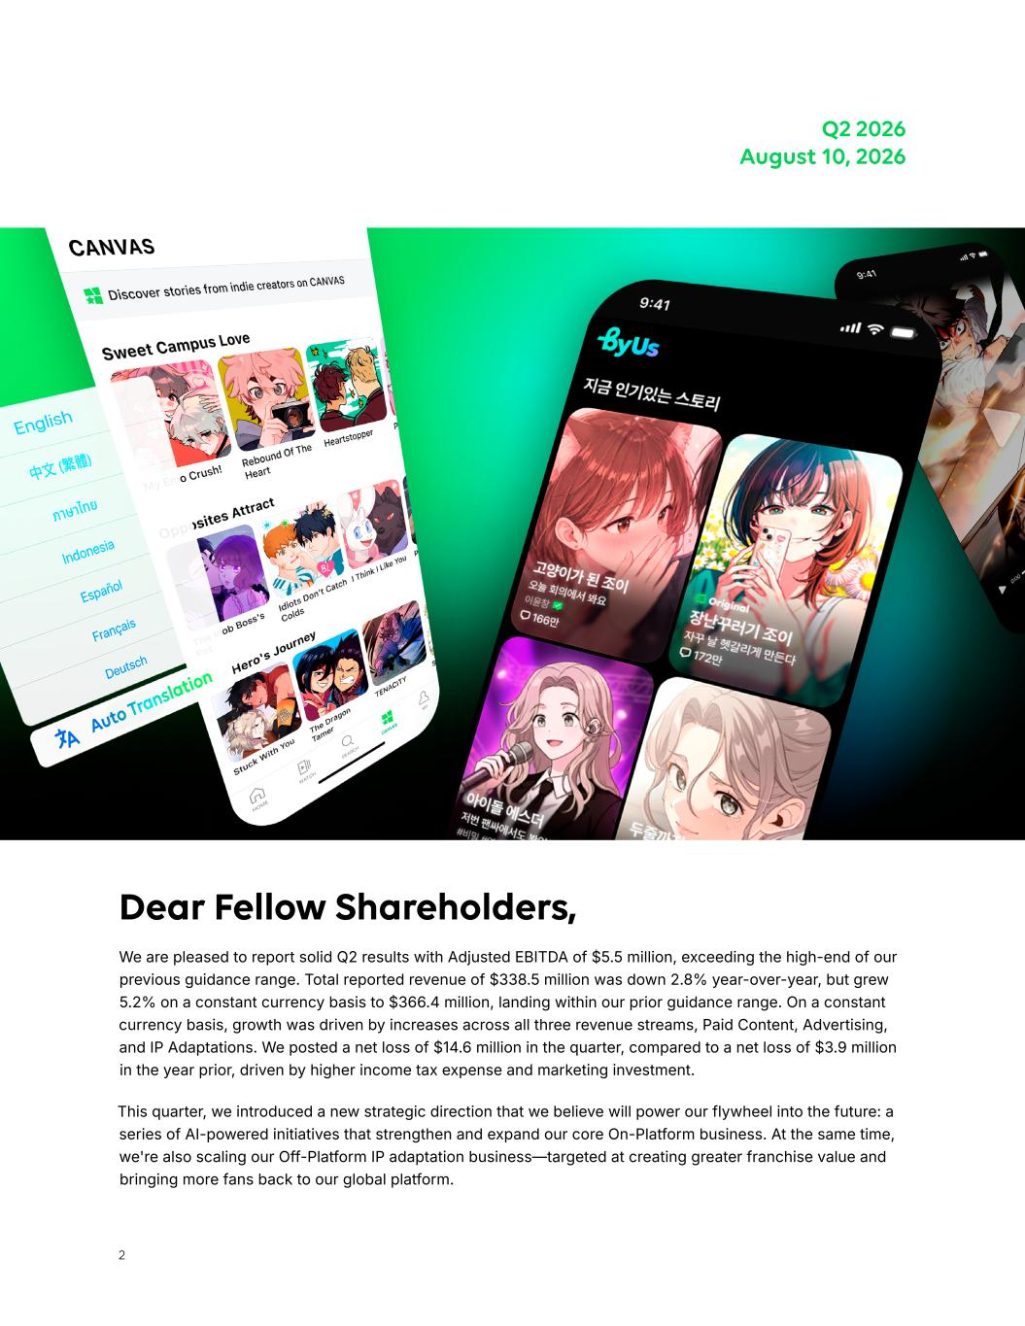
2 Dear Fellow Shareholders, We are pleased to report solid Q2 results with Adjusted EBITDA of $5.5 million, exceeding the high-end of our previous guidance range. Total reported revenue of $338.5 million was down 2.8% year-over-year, but grew 5.2% on a constant currency basis to $366.4 million, landing within our prior guidance range. On a constant currency basis, growth was driven by increases across all three revenue streams, Paid Content, Advertising, and IP Adaptations. We posted a net loss of $14.6 million in the quarter, compared to a net loss of $3.9 million in the year prior, driven by higher income tax expense and marketing investment. This quarter, we introduced a new strategic direction that we believe will power our flywheel into the future: a series of AI-powered initiatives that strengthen and expand our core On-Platform business. At the same time, we're also scaling our Off-Platform IP adaptation business—targeted at creating greater franchise value and bringing more fans back to our global platform. Q2 2026 August 10, 2026

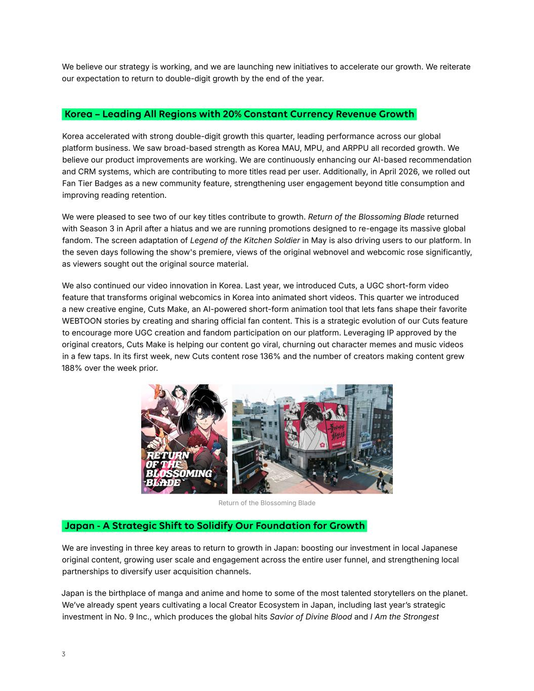
3 Korea accelerated with strong double-digit growth this quarter, leading performance across our global platform business. We saw broad-based strength as Korea MAU, MPU, and ARPPU all recorded growth. We believe our product improvements are working. We are continuously enhancing our AI-based recommendation and CRM systems, which are contributing to more titles read per user. Additionally, in April 2026, we rolled out Fan Tier Badges as a new community feature, strengthening user engagement beyond title consumption and improving reading retention. We were pleased to see two of our key titles contribute to growth. Return of the Blossoming Blade returned with Season 3 in April after a hiatus and we are running promotions designed to re-engage its massive global fandom. The screen adaptation of Legend of the Kitchen Soldier in May is also driving users to our platform. In the seven days following the show's premiere, views of the original webnovel and webcomic rose significantly, as viewers sought out the original source material. We also continued our video innovation in Korea. Last year, we introduced Cuts, a UGC short-form video feature that transforms original webcomics in Korea into animated short videos. This quarter we introduced a new creative engine, Cuts Make, an AI-powered short-form animation tool that lets fans shape their favorite WEBTOON stories by creating and sharing official fan content. This is a strategic evolution of our Cuts feature to encourage more UGC creation and fandom participation on our platform. Leveraging IP approved by the original creators, Cuts Make is helping our content go viral, churning out character memes and music videos in a few taps. In its first week, new Cuts content rose 136% and the number of creators making content grew 188% over the week prior. Korea – Leading All Regions with 20% Constant Currency Revenue Growth We are investing in three key areas to return to growth in Japan: boosting our investment in local Japanese original content, growing user scale and engagement across the entire user funnel, and strengthening local partnerships to diversify user acquisition channels. Japan is the birthplace of manga and anime and home to some of the most talented storytellers on the planet. We’ve already spent years cultivating a local Creator Ecosystem in Japan, including last year’s strategic investment in No. 9 Inc., which produces the global hits Savior of Divine Blood and I Am the Strongest Japan - A Strategic Shift to Solidify Our Foundation for Growth We believe our strategy is working, and we are launching new initiatives to accelerate our growth. We reiterate our expectation to return to double-digit growth by the end of the year. Return of the Blossoming Blade

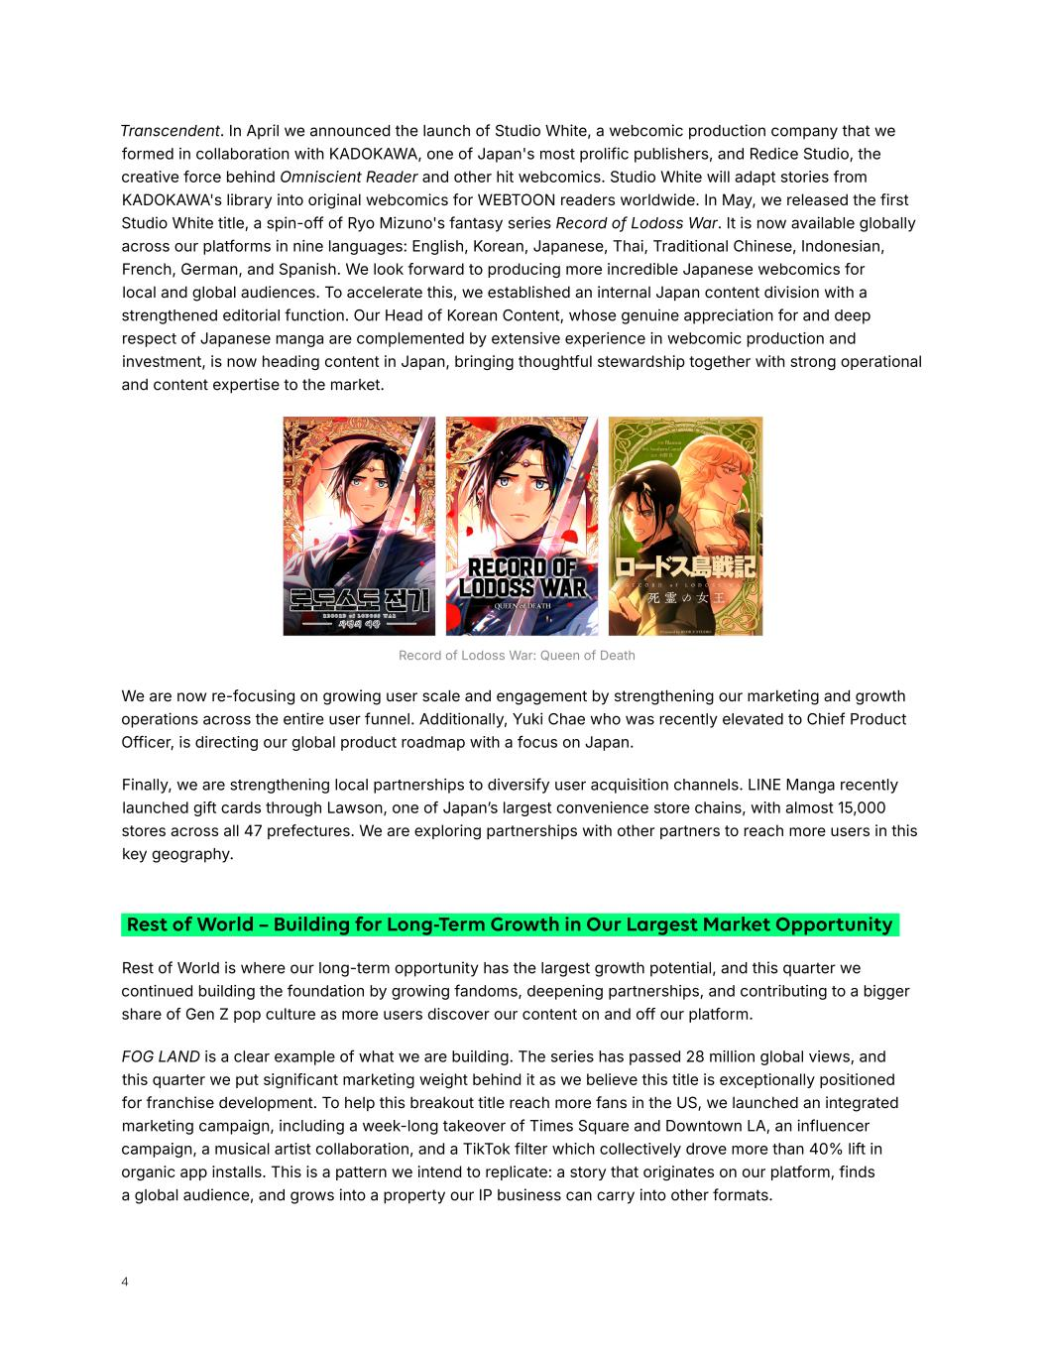
4 Transcendent. In April we announced the launch of Studio White, a webcomic production company that we formed in collaboration with KADOKAWA, one of Japan's most prolific publishers, and Redice Studio, the creative force behind Omniscient Reader and other hit webcomics. Studio White will adapt stories from KADOKAWA's library into original webcomics for WEBTOON readers worldwide. In May, we released the first Studio White title, a spin-off of Ryo Mizuno's fantasy series Record of Lodoss War. It is now available globally across our platforms in nine languages: English, Korean, Japanese, Thai, Traditional Chinese, Indonesian, French, German, and Spanish. We look forward to producing more incredible Japanese webcomics for local and global audiences. To accelerate this, we established an internal Japan content division with a strengthened editorial function. Our Head of Korean Content, whose genuine appreciation for and deep respect of Japanese manga are complemented by extensive experience in webcomic production and investment, is now heading content in Japan, bringing thoughtful stewardship together with strong operational and content expertise to the market. Record of Lodoss War: Queen of Death We are now re-focusing on growing user scale and engagement by strengthening our marketing and growth operations across the entire user funnel. Additionally, Yuki Chae who was recently elevated to Chief Product Officer, is directing our global product roadmap with a focus on Japan. Finally, we are strengthening local partnerships to diversify user acquisition channels. LINE Manga recently launched gift cards through Lawson, one of Japan’s largest convenience store chains, with almost 15,000 stores across all 47 prefectures. We are exploring partnerships with other partners to reach more users in this key geography. Rest of World – Building for Long-Term Growth in Our Largest Market Opportunity Rest of World is where our long-term opportunity has the largest growth potential, and this quarter we continued building the foundation by growing fandoms, deepening partnerships, and contributing to a bigger share of Gen Z pop culture as more users discover our content on and off our platform. FOG LAND is a clear example of what we are building. The series has passed 28 million global views, and this quarter we put significant marketing weight behind it as we believe this title is exceptionally positioned for franchise development. To help this breakout title reach more fans in the US, we launched an integrated marketing campaign, including a week-long takeover of Times Square and Downtown LA, an influencer campaign, a musical artist collaboration, and a TikTok filter which collectively drove more than 40% lift in organic app installs. This is a pattern we intend to replicate: a story that originates on our platform, finds a global audience, and grows into a property our IP business can carry into other formats.

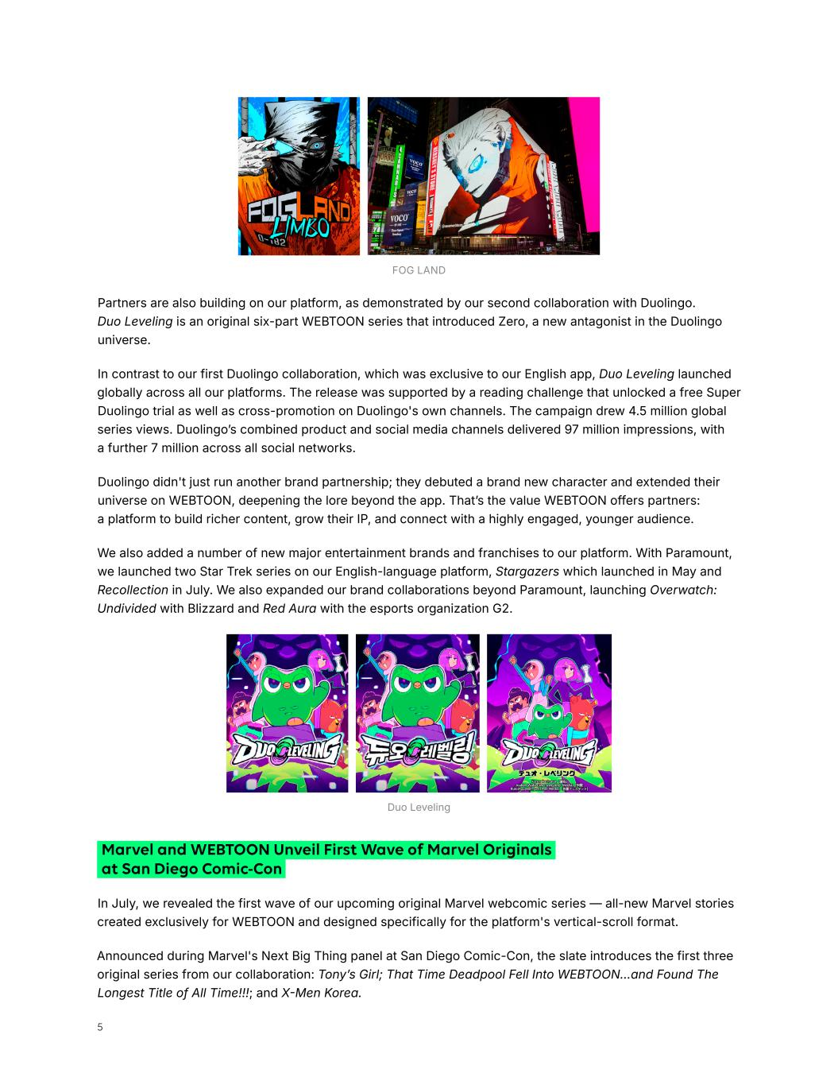
5 Partners are also building on our platform, as demonstrated by our second collaboration with Duolingo. Duo Leveling is an original six-part WEBTOON series that introduced Zero, a new antagonist in the Duolingo universe. In contrast to our first Duolingo collaboration, which was exclusive to our English app, Duo Leveling launched globally across all our platforms. The release was supported by a reading challenge that unlocked a free Super Duolingo trial as well as cross-promotion on Duolingo's own channels. The campaign drew 4.5 million global series views. Duolingo’s combined product and social media channels delivered 97 million impressions, with a further 7 million across all social networks. Duolingo didn't just run another brand partnership; they debuted a brand new character and extended their universe on WEBTOON, deepening the lore beyond the app. That’s the value WEBTOON offers partners: a platform to build richer content, grow their IP, and connect with a highly engaged, younger audience. We also added a number of new major entertainment brands and franchises to our platform. With Paramount, we launched two Star Trek series on our English-language platform, Stargazers which launched in May and Recollection in July. We also expanded our brand collaborations beyond Paramount, launching Overwatch: Undivided with Blizzard and Red Aura with the esports organization G2. Duo Leveling FOG LAND Marvel and WEBTOON Unveil First Wave of Marvel Originals at San Diego Comic-Con In July, we revealed the first wave of our upcoming original Marvel webcomic series — all-new Marvel stories created exclusively for WEBTOON and designed specifically for the platform's vertical-scroll format. Announced during Marvel's Next Big Thing panel at San Diego Comic-Con, the slate introduces the first three original series from our collaboration: Tony’s Girl; That Time Deadpool Fell Into WEBTOON...and Found The Longest Title of All Time!!!; and X-Men Korea.

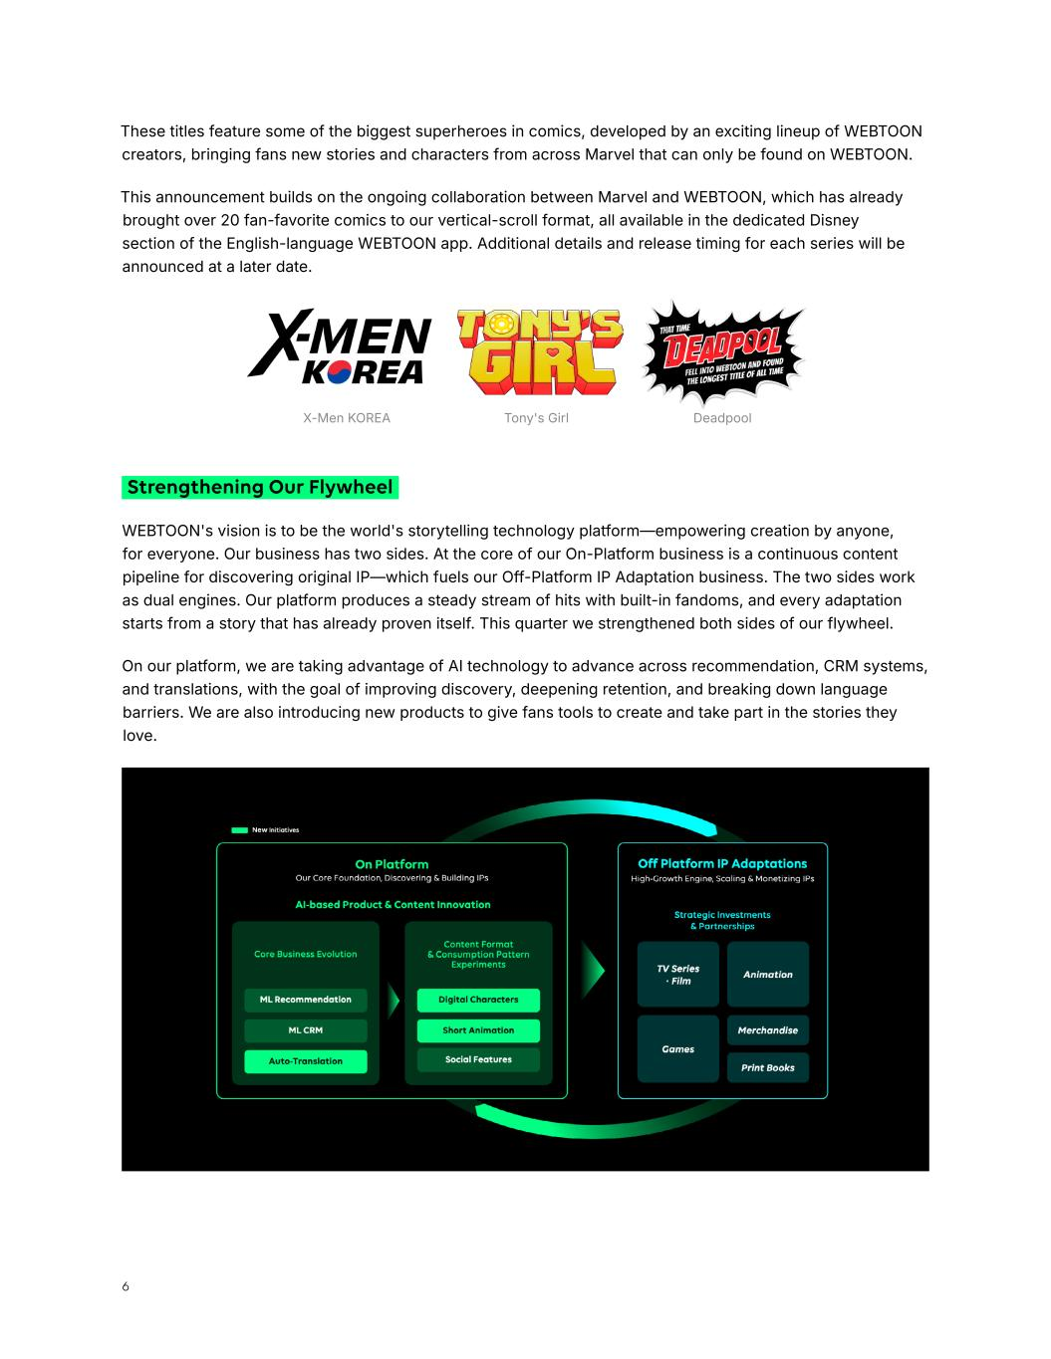
6 Strengthening Our Flywheel WEBTOON's vision is to be the world's storytelling technology platform—empowering creation by anyone, for everyone. Our business has two sides. At the core of our On-Platform business is a continuous content pipeline for discovering original IP—which fuels our Off-Platform IP Adaptation business. The two sides work as dual engines. Our platform produces a steady stream of hits with built-in fandoms, and every adaptation starts from a story that has already proven itself. This quarter we strengthened both sides of our flywheel. On our platform, we are taking advantage of AI technology to advance across recommendation, CRM systems, and translations, with the goal of improving discovery, deepening retention, and breaking down language barriers. We are also introducing new products to give fans tools to create and take part in the stories they love. Tony's Girl DeadpoolX-Men KOREA These titles feature some of the biggest superheroes in comics, developed by an exciting lineup of WEBTOON creators, bringing fans new stories and characters from across Marvel that can only be found on WEBTOON. This announcement builds on the ongoing collaboration between Marvel and WEBTOON, which has already brought over 20 fan-favorite comics to our vertical-scroll format, all available in the dedicated Disney section of the English-language WEBTOON app. Additional details and release timing for each series will be announced at a later date.

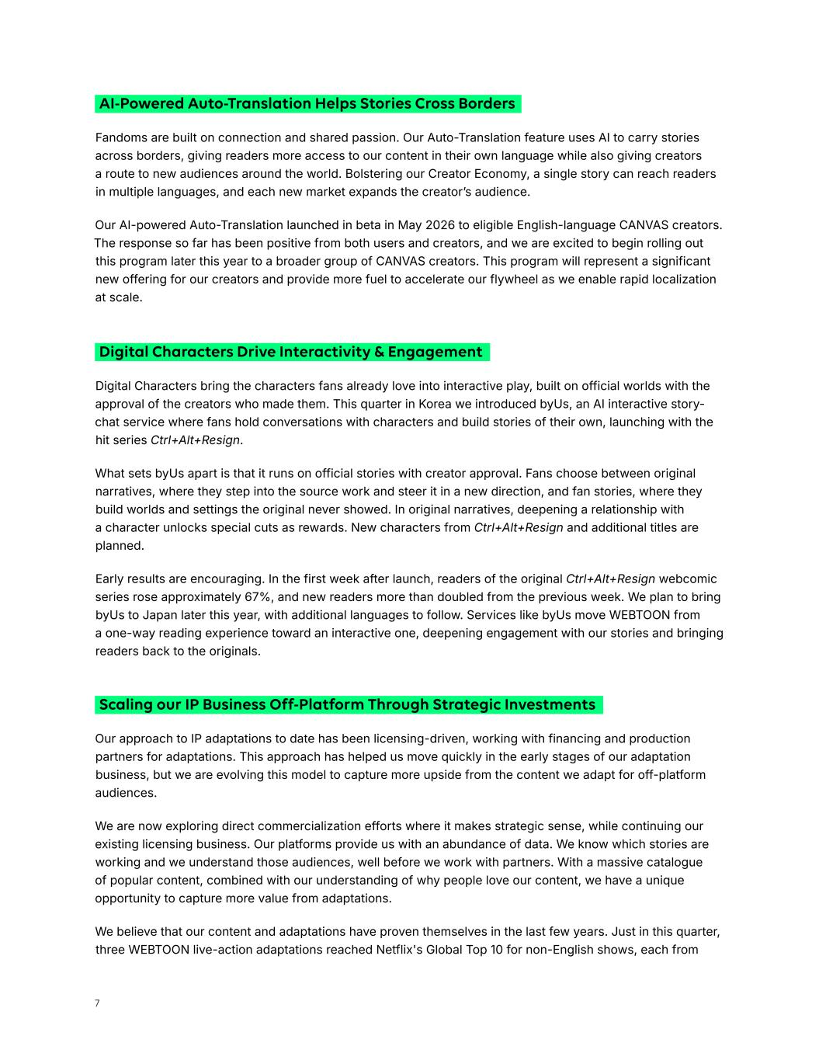
7 Digital Characters Drive Interactivity & Engagement Digital Characters bring the characters fans already love into interactive play, built on official worlds with the approval of the creators who made them. This quarter in Korea we introduced byUs, an AI interactive story- chat service where fans hold conversations with characters and build stories of their own, launching with the hit series Ctrl+Alt+Resign. What sets byUs apart is that it runs on official stories with creator approval. Fans choose between original narratives, where they step into the source work and steer it in a new direction, and fan stories, where they build worlds and settings the original never showed. In original narratives, deepening a relationship with a character unlocks special cuts as rewards. New characters from Ctrl+Alt+Resign and additional titles are planned. Early results are encouraging. In the first week after launch, readers of the original Ctrl+Alt+Resign webcomic series rose approximately 67%, and new readers more than doubled from the previous week. We plan to bring byUs to Japan later this year, with additional languages to follow. Services like byUs move WEBTOON from a one-way reading experience toward an interactive one, deepening engagement with our stories and bringing readers back to the originals. Scaling our IP Business Off-Platform Through Strategic Investments Our approach to IP adaptations to date has been licensing-driven, working with financing and production partners for adaptations. This approach has helped us move quickly in the early stages of our adaptation business, but we are evolving this model to capture more upside from the content we adapt for off-platform audiences. We are now exploring direct commercialization efforts where it makes strategic sense, while continuing our existing licensing business. Our platforms provide us with an abundance of data. We know which stories are working and we understand those audiences, well before we work with partners. With a massive catalogue of popular content, combined with our understanding of why people love our content, we have a unique opportunity to capture more value from adaptations. We believe that our content and adaptations have proven themselves in the last few years. Just in this quarter, three WEBTOON live-action adaptations reached Netflix's Global Top 10 for non-English shows, each from Fandoms are built on connection and shared passion. Our Auto-Translation feature uses AI to carry stories across borders, giving readers more access to our content in their own language while also giving creators a route to new audiences around the world. Bolstering our Creator Economy, a single story can reach readers in multiple languages, and each new market expands the creator’s audience. Our AI-powered Auto-Translation launched in beta in May 2026 to eligible English-language CANVAS creators. The response so far has been positive from both users and creators, and we are excited to begin rolling out this program later this year to a broader group of CANVAS creators. This program will represent a significant new offering for our creators and provide more fuel to accelerate our flywheel as we enable rapid localization at scale. AI-Powered Auto-Translation Helps Stories Cross Borders

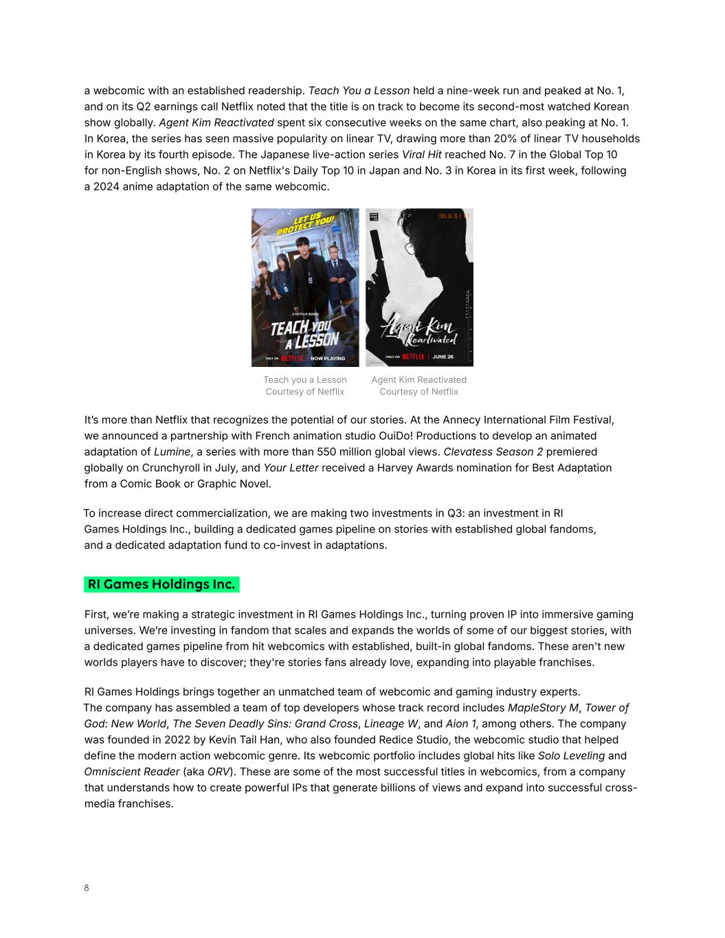
8 Teach you a Lesson Courtesy of Netflix Agent Kim Reactivated Courtesy of Netflix It’s more than Netflix that recognizes the potential of our stories. At the Annecy International Film Festival, we announced a partnership with French animation studio OuiDo! Productions to develop an animated adaptation of Lumine, a series with more than 550 million global views. Clevatess Season 2 premiered globally on Crunchyroll in July, and Your Letter received a Harvey Awards nomination for Best Adaptation from a Comic Book or Graphic Novel. To increase direct commercialization, we are making two investments in Q3: an investment in RI Games Holdings Inc., building a dedicated games pipeline on stories with established global fandoms, and a dedicated adaptation fund to co-invest in adaptations. RI Games Holdings Inc. First, we’re making a strategic investment in RI Games Holdings Inc., turning proven IP into immersive gaming universes. We’re investing in fandom that scales and expands the worlds of some of our biggest stories, with a dedicated games pipeline from hit webcomics with established, built-in global fandoms. These aren't new worlds players have to discover; they're stories fans already love, expanding into playable franchises. RI Games Holdings brings together an unmatched team of webcomic and gaming industry experts. The company has assembled a team of top developers whose track record includes MapleStory M, Tower of God: New World, The Seven Deadly Sins: Grand Cross, Lineage W, and Aion 1, among others. The company was founded in 2022 by Kevin Tail Han, who also founded Redice Studio, the webcomic studio that helped define the modern action webcomic genre. Its webcomic portfolio includes global hits like Solo Leveling and Omniscient Reader (aka ORV). These are some of the most successful titles in webcomics, from a company that understands how to create powerful IPs that generate billions of views and expand into successful cross- media franchises. a webcomic with an established readership. Teach You a Lesson held a nine-week run and peaked at No. 1, and on its Q2 earnings call Netflix noted that the title is on track to become its second-most watched Korean show globally. Agent Kim Reactivated spent six consecutive weeks on the same chart, also peaking at No. 1. In Korea, the series has seen massive popularity on linear TV, drawing more than 20% of linear TV households in Korea by its fourth episode. The Japanese live-action series Viral Hit reached No. 7 in the Global Top 10 for non-English shows, No. 2 on Netflix's Daily Top 10 in Japan and No. 3 in Korea in its first week, following a 2024 anime adaptation of the same webcomic.

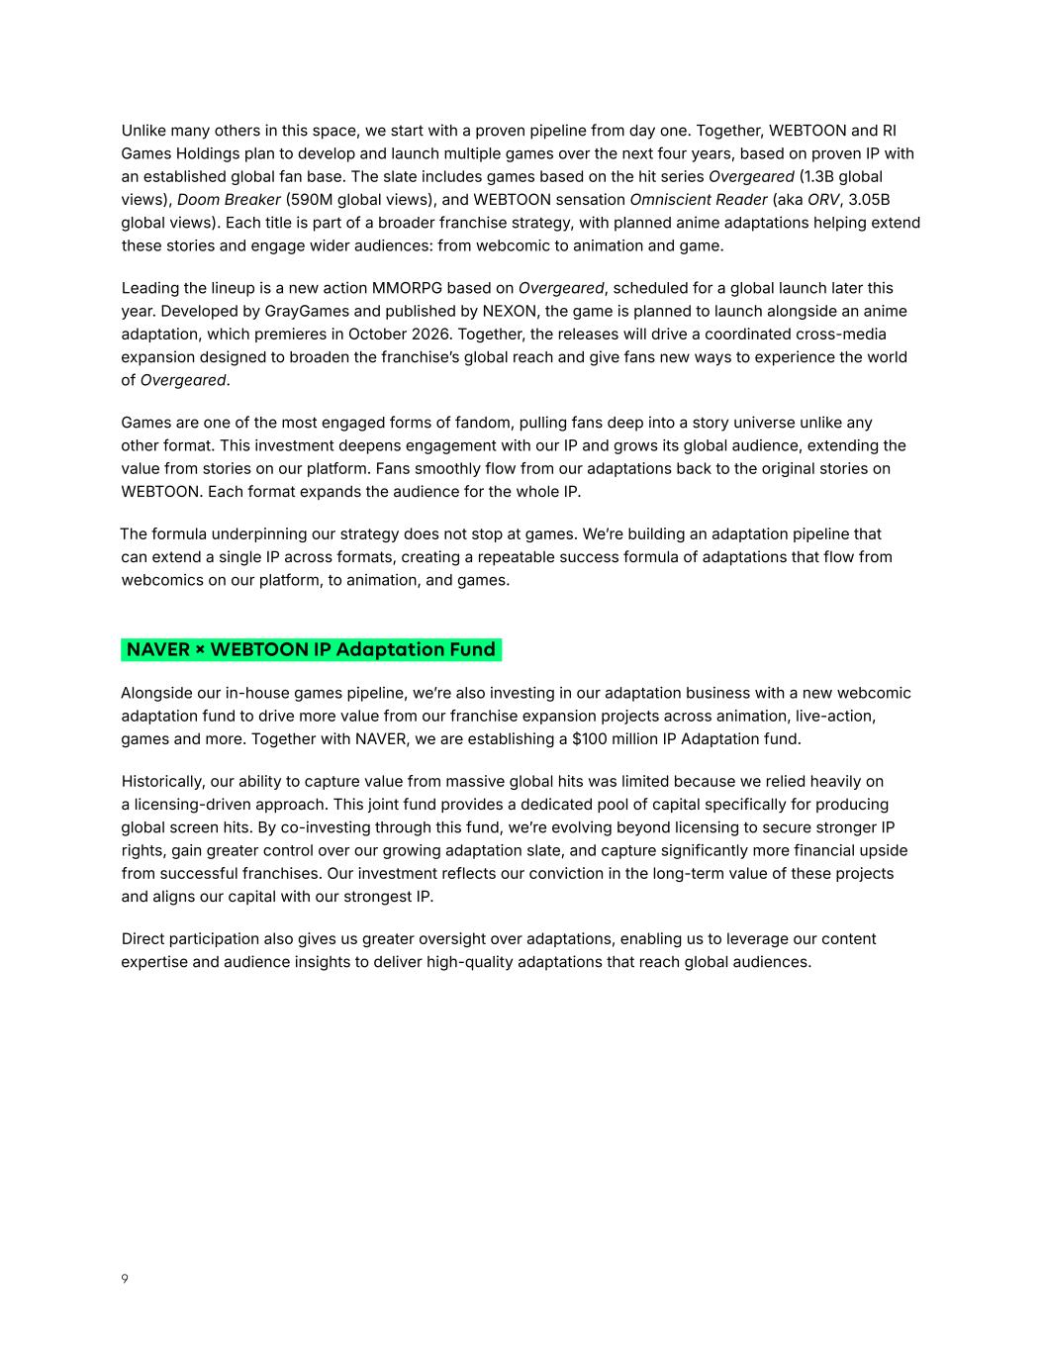
9 NAVER × WEBTOON IP Adaptation Fund Alongside our in-house games pipeline, we’re also investing in our adaptation business with a new webcomic adaptation fund to drive more value from our franchise expansion projects across animation, live-action, games and more. Together with NAVER, we are establishing a $100 million IP Adaptation fund. Historically, our ability to capture value from massive global hits was limited because we relied heavily on a licensing-driven approach. This joint fund provides a dedicated pool of capital specifically for producing global screen hits. By co-investing through this fund, we’re evolving beyond licensing to secure stronger IP rights, gain greater control over our growing adaptation slate, and capture significantly more financial upside from successful franchises. Our investment reflects our conviction in the long-term value of these projects and aligns our capital with our strongest IP. Direct participation also gives us greater oversight over adaptations, enabling us to leverage our content expertise and audience insights to deliver high-quality adaptations that reach global audiences. Unlike many others in this space, we start with a proven pipeline from day one. Together, WEBTOON and RI Games Holdings plan to develop and launch multiple games over the next four years, based on proven IP with an established global fan base. The slate includes games based on the hit series Overgeared (1.3B global views), Doom Breaker (590M global views), and WEBTOON sensation Omniscient Reader (aka ORV, 3.05B global views). Each title is part of a broader franchise strategy, with planned anime adaptations helping extend these stories and engage wider audiences: from webcomic to animation and game. Leading the lineup is a new action MMORPG based on Overgeared, scheduled for a global launch later this year. Developed by GrayGames and published by NEXON, the game is planned to launch alongside an anime adaptation, which premieres in October 2026. Together, the releases will drive a coordinated cross-media expansion designed to broaden the franchise’s global reach and give fans new ways to experience the world of Overgeared. Games are one of the most engaged forms of fandom, pulling fans deep into a story universe unlike any other format. This investment deepens engagement with our IP and grows its global audience, extending the value from stories on our platform. Fans smoothly flow from our adaptations back to the original stories on WEBTOON. Each format expands the audience for the whole IP. The formula underpinning our strategy does not stop at games. We’re building an adaptation pipeline that can extend a single IP across formats, creating a repeatable success formula of adaptations that flow from webcomics on our platform, to animation, and games.


10 Junkoo Kim Founder & CEO, WEBTOON Entertainment Inc. In Closing This quarter we made significant moves to accelerate our business, with AI-powered platform innovations to support engagement and significant investments to expand our off-platform IP adaptation business. We’re evolving our on-platform experience, expanding into interactive fandom and participation, and accelerating our off-platform IP business, to enable the full franchise value from each IP. I would like to express my sincerest thanks to our teammates, content creators, as well as our users who come to our platform daily. Thank you for your continued support of our company and the joy that storytelling brings,

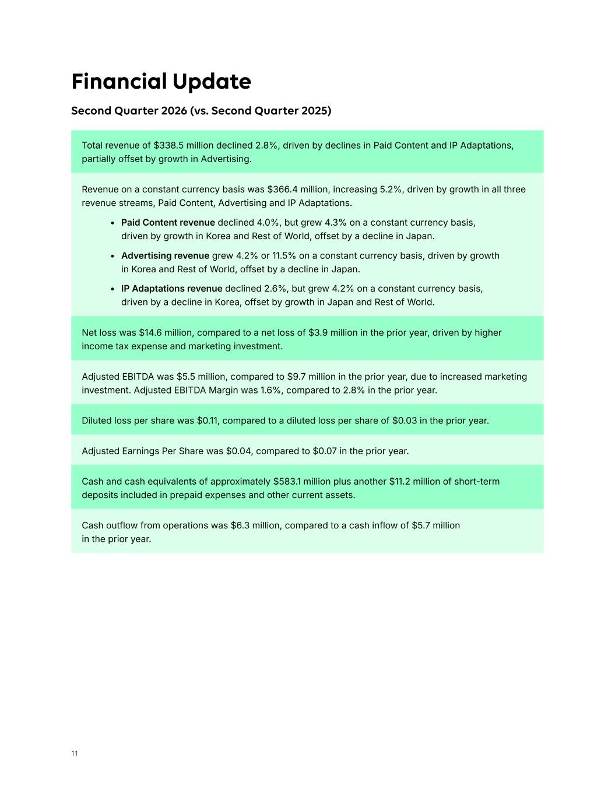
11 Adjusted EBITDA was $5.5 million, compared to $9.7 million in the prior year​​​, due to increased marketing investment. Adjusted EBITDA Margin was 1.6%, compared to 2.8% in the prior year. Cash outflow from operations was $6.3 million, compared to a cash inflow of $5.7 million in the prior year. Net loss was $14.6 million, compared to a net loss of $3.9 million in the prior year, driven by higher income tax expense and marketing investment. Total revenue of $338.5 million declined 2.8%, driven by declines in Paid Content and IP Adaptations, partially offset by growth in Advertising. Diluted loss per share was $0.11, compared to a diluted loss per share of $0.03 in the prior year. Adjusted Earnings Per Share was $0.04, compared to $0.07 in the prior year. Cash and cash equivalents of approximately $583.1 million plus another $11.2 million of short-term deposits included in prepaid expenses and other current assets. Revenue on a constant currency basis was $366.4 million, increasing 5.2%, driven by growth in all three revenue streams, Paid Content, Advertising and IP Adaptations. • Paid Content revenue declined 4.0%, but grew 4.3% on a constant currency basis, driven by growth in Korea and Rest of World, offset by a decline in Japan. • Advertising revenue grew 4.2% or 11.5% on a constant currency basis, driven by growth in Korea and Rest of World, offset by a decline in Japan. • IP Adaptations revenue declined 2.6%, but grew 4.2% on a constant currency basis, driven by a decline in Korea, offset by growth in Japan and Rest of World. Financial Update Second Quarter 2026 (vs. Second Quarter 2025)

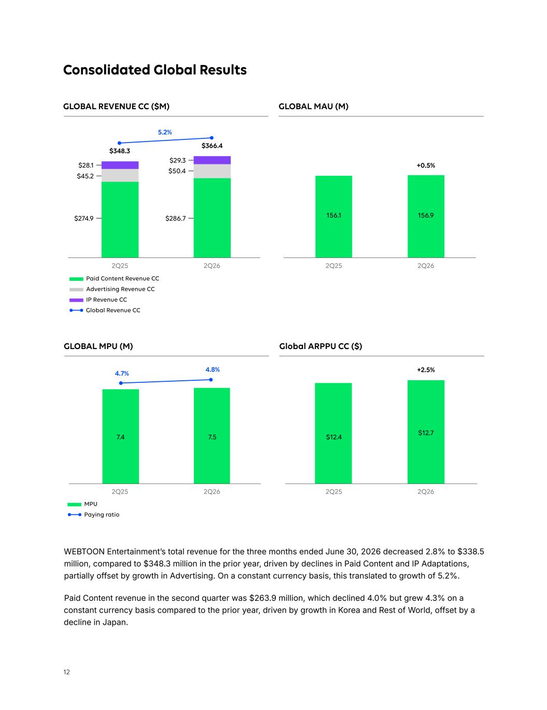
12 Consolidated Global Results GLOBAL REVENUE CC ($M) GLOBAL MPU (M) GLOBAL MAU (M) Global ARPPU CC ($) Paid Content Revenue CC $28.1 $29.3 2Q25 2Q25 2Q25 2Q25 2Q26 2Q26 2Q26 2Q26 $45.2 $50.4 $274.9 $286.7 Advertising Revenue CC IP Revenue CC MPU Paying ratio +0.5% $366.4 $348.3 5.2% +2.5% WEBTOON Entertainment’s total revenue for the three months ended June 30, 2026 decreased 2.8% to $338.5 million, compared to $348.3 million in the prior year, driven by declines in Paid Content and IP Adaptations, partially offset by growth in Advertising. On a constant currency basis, this translated to growth of 5.2%. Paid Content revenue in the second quarter was $263.9 million, which declined 4.0% but grew 4.3% on a constant currency basis compared to the prior year, driven by growth in Korea and Rest of World, offset by a decline in Japan. 4.7% 4.8% Global Revenue CC 156.1 156.9 7.4 7.5 $12.4 $12.7

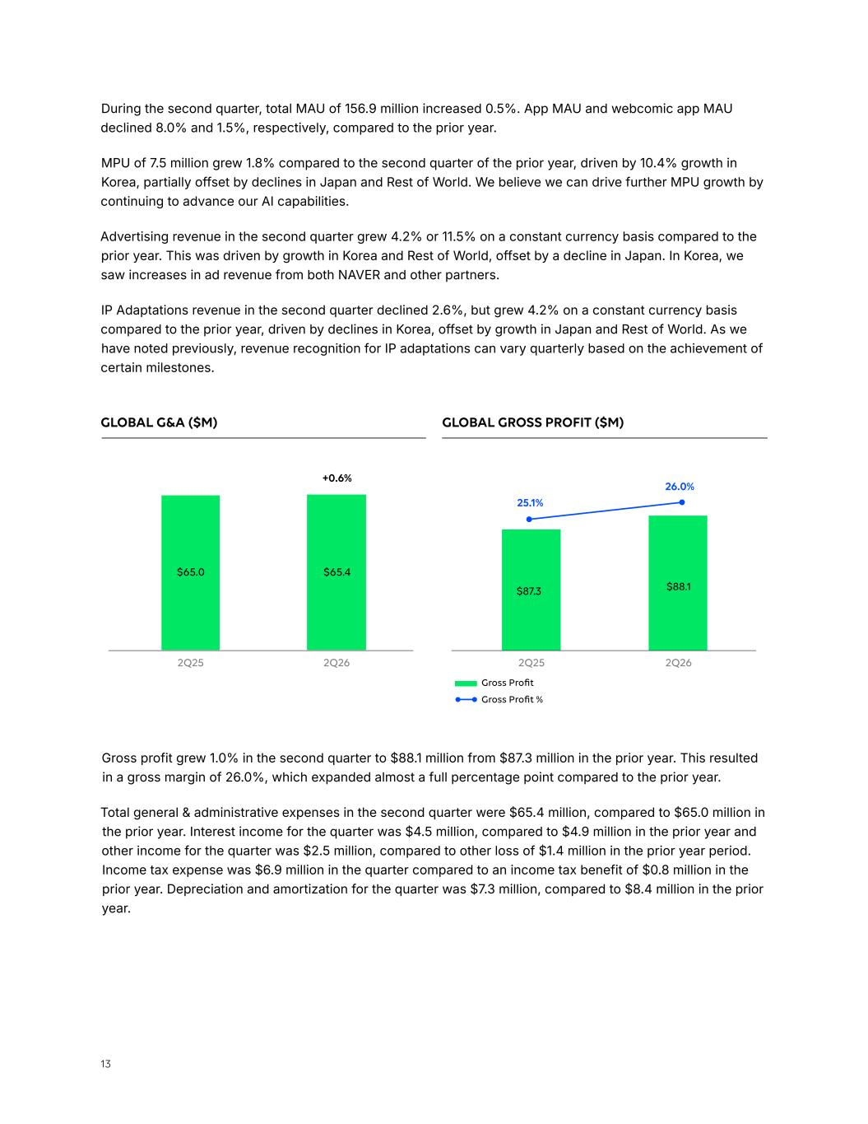
13 During the second quarter, total MAU of 156.9 million increased 0.5%. ​App MAU and webcomic app MAU declined 8.0% and 1.5%, respectively, compared to the prior year. MPU of 7.5 million grew 1.8% compared to the second quarter of the prior year, driven by 10.4% growth in Korea, partially offset by declines in Japan and Rest of World. ​We believe we can drive further MPU growth by continuing to advance our AI capabilities. Advertising revenue in the second quarter grew 4.2% or 11.5% on a constant currency basis compared to the prior year. This was driven by growth in Korea and Rest of World, offset by a decline in Japan. In Korea, we saw increases in ad revenue from both NAVER and other partners. IP Adaptations revenue in the second quarter declined 2.6%, but grew 4.2% on a constant currency basis compared to the prior year, driven by declines in Korea, offset by growth in Japan and Rest of World. As we have noted previously, revenue recognition for IP adaptations can vary quarterly based on the achievement of certain milestones. Gross Profit Gross Profit % +0.6% 25.1% 26.0% GLOBAL G&A ($M) GLOBAL GROSS PROFIT ($M) Gross profit grew 1.0% in the second quarter to $88.1 million from $87.3 million in the prior year. This resulted in a gross margin of 26.0%, which expanded almost a full percentage point compared to the prior year. Total general & administrative expenses in the second quarter were $65.4 million, compared to $65.0 million in the prior year. Interest income for the quarter was $4.5 million, compared to $4.9 million in the prior year and other income for the quarter was $2.5 million, compared to other loss of $1.4 million in the prior year period. Income tax expense was $6.9 million in the quarter compared to an income tax benefit of $0.8 million in the prior year. Depreciation and amortization for the quarter was $7.3 million, compared to $8.4 million in the prior year. 2Q25 2Q252Q26 2Q26 $65.0 $87.3 $65.4 $88.1

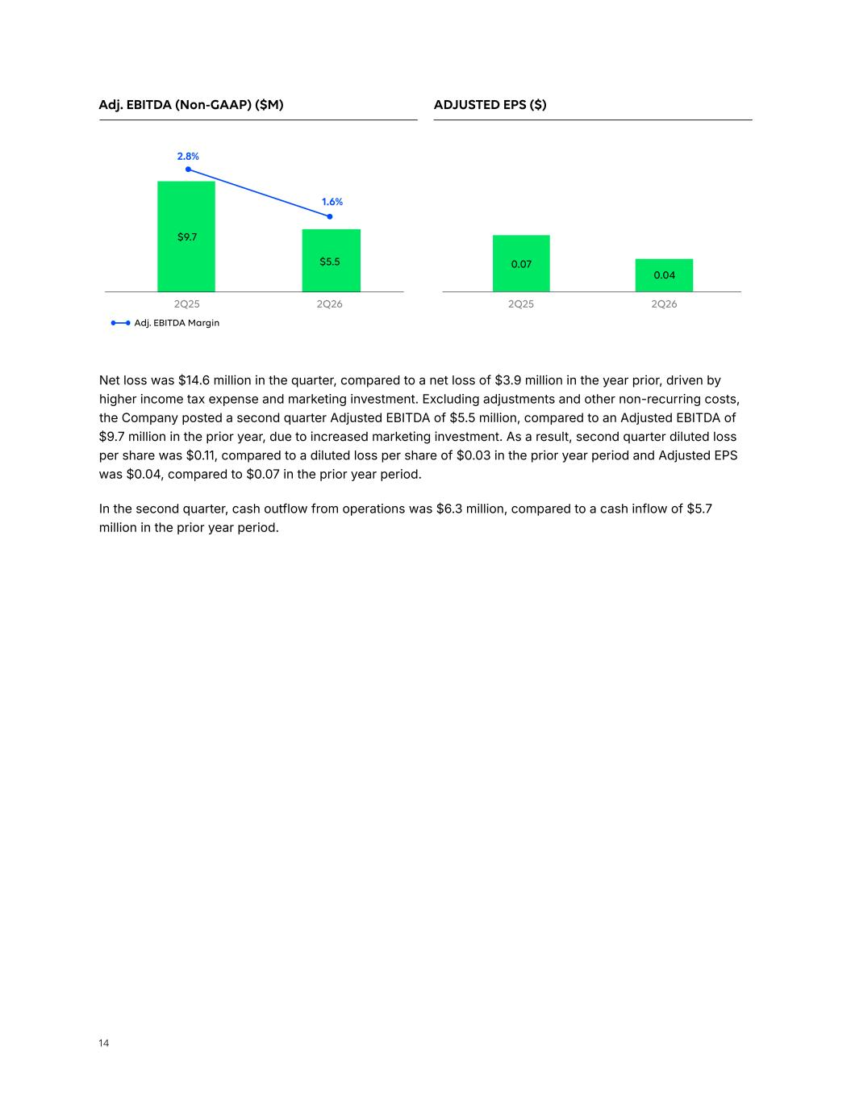
14 2Q25 2Q262Q25 2Q26 Net loss was $14.6 million in the quarter, compared to a net loss of $3.9 million in the year prior, driven by higher income tax expense and marketing investment. Excluding adjustments and other non-recurring costs, the Company posted a second quarter Adjusted EBITDA of $5.5 million, compared to an Adjusted EBITDA of $9.7 million in the prior year, due to increased marketing investment. As a result, second quarter diluted loss per share was $0.11, compared to a diluted loss per share of $0.03 in the prior year period and Adjusted EPS was $0.04, compared to $0.07 in the prior year period. ​​​In the second quarter, cash outflow from operations was $6.3 million, compared to a cash inflow of $5.7 million in the prior year period. Adj. EBITDA Margin Adj. EBITDA (Non-GAAP) ($M) ADJUSTED EPS ($) 2.8% 1.6% $9.7 0.07 0.04 $5.5

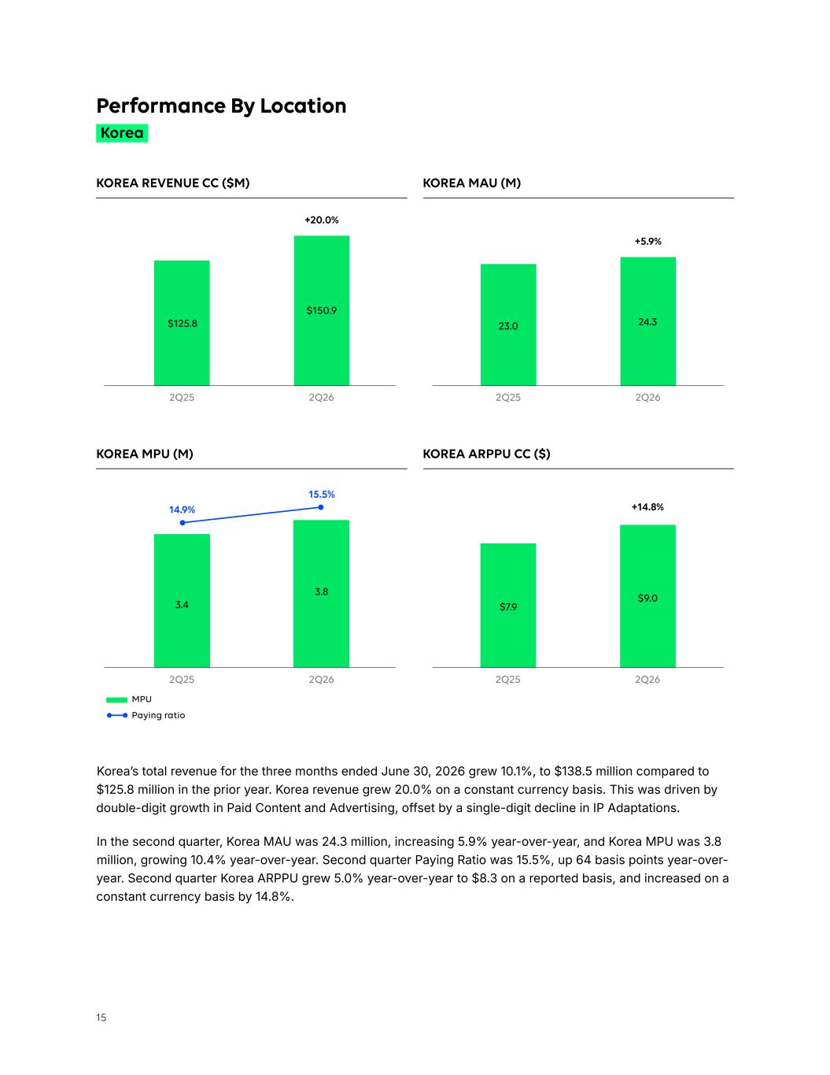
15 +14.8% KOREA MPU (M) KOREA ARPPU CC ($) MPU Paying ratio Korea’s total revenue for the three months ended June 30, 2026 grew 10.1%, to $138.5 million compared to $125.8 million in the prior year. Korea revenue grew 20.0% on a constant currency basis. This was driven by double-digit growth in Paid Content and Advertising, offset by a single-digit decline in IP Adaptations. In the second quarter, Korea MAU was 24.3 million, increasing 5.9% year-over-year, and Korea MPU was 3.8 million, growing 10.4% year-over-year. Second quarter Paying Ratio was 15.5%, up 64 basis points year-over- year. Second quarter Korea ARPPU grew 5.0% year-over-year to $8.3 on a reported basis, and increased on a constant currency basis by 14.8%. Korea Performance By Location KOREA REVENUE CC ($M) KOREA MAU (M) +20.0% +5.9% 14.9% 15.5% 2Q25 2Q25 2Q252Q26 2Q26 2Q26 2Q262Q25 $125.8 3.4 23.0 $7.9 $150.9 3.8 24.3 $9.0

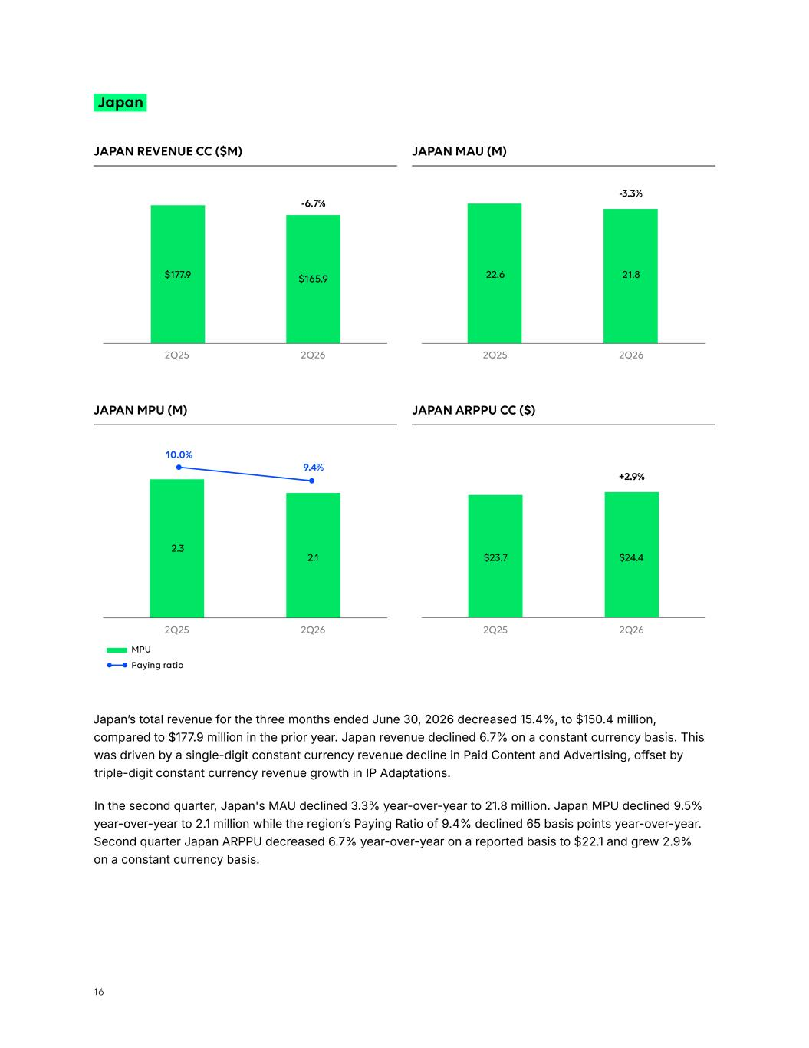
16 -3.3% JAPAN REVENUE CC ($M) JAPAN MAU (M) JAPAN MPU (M) JAPAN ARPPU CC ($) MPU Paying ratio +2.9% Japan -6.7% 10.0% 9.4% Japan’s total revenue for the three months ended June 30, 2026 decreased 15.4%, to $150.4 million, compared to $177.9 million in the prior year. Japan revenue declined 6.7% on a constant currency basis. This was driven by a single-digit constant currency revenue decline in Paid Content and Advertising, offset by triple-digit constant currency revenue growth in IP Adaptations. In the second quarter, Japan's MAU declined 3.3% year-over-year to 21.8 million. Japan MPU declined 9.5% year-over-year to 2.1 million while the region’s Paying Ratio of 9.4% declined 65 basis points year-over-year. Second quarter Japan ARPPU decreased 6.7% year-over-year on a reported basis to $22.1 and grew 2.9% on a constant currency basis. 2Q25 2Q25 2Q25 2Q252Q26 2Q26 2Q26 2Q26 $177.9 2.3 $165.9 2.1 22.6 $23.7 21.8 $24.4

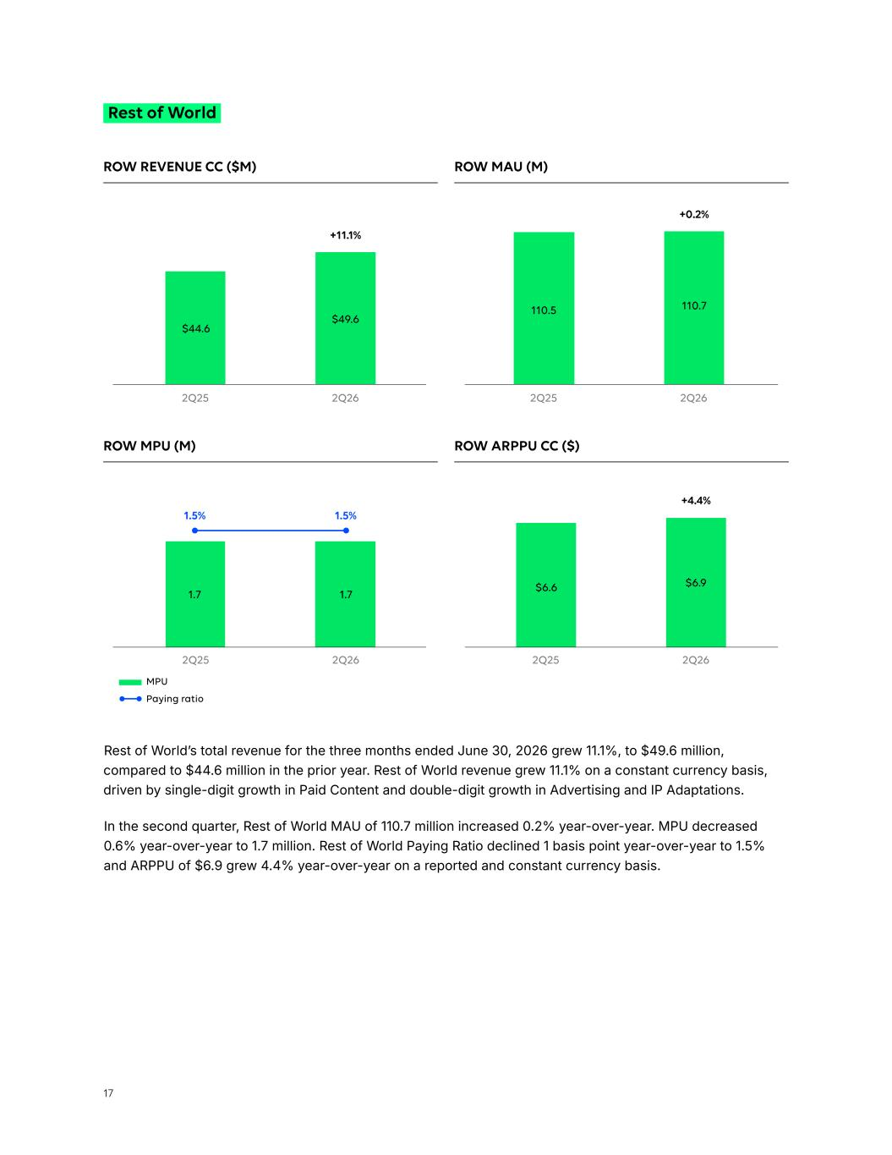
17 ROW REVENUE CC ($M) ROW MAU (M) +0.2% Rest of World +11.1% Rest of World’s total revenue for the three months ended June 30, 2026 grew 11.1%, to $49.6 million, compared to $44.6 million in the prior year. Rest of World revenue grew 11.1% on a constant currency basis, driven by single-digit growth in Paid Content and double-digit growth in Advertising and IP Adaptations. In the second quarter, Rest of World MAU of 1​10.7​​ million ​increased​​​ ​0.2% year-over-year​. MPU decreased 0.6% year-over-year to 1.7 million. Rest of World Paying Ratio declined 1 basis point year-over-year to 1.5% and ARPPU of $6.9 grew 4.4% year-over-year on a reported and constant currency basis. ROW MPU (M) ROW ARPPU CC ($) MPU Paying ratio +4.4% 1.5% 1.5% 2Q25 2Q252Q26 2Q26 2Q25 2Q252Q26 2Q26 $44.6 $49.6 110.5 110.7 1.7 1.7 $6.6 $6.9

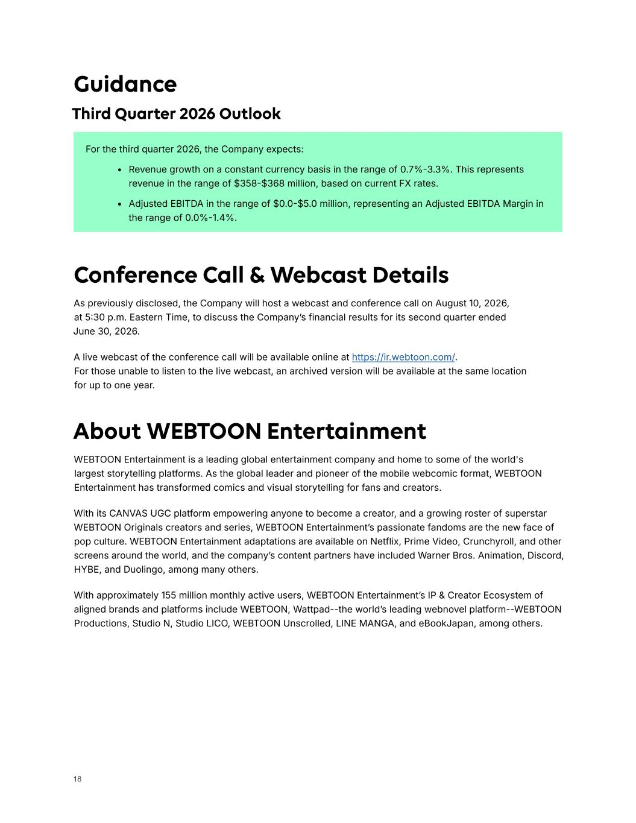
18 For the third quarter 2026, the Company expects: • Revenue growth on a constant currency basis in the range of 0.7%-3.3%. This represents revenue in the range of $358-$368 million, based on current FX rates. • Adjusted EBITDA in the range of $0.0-$5.0 million, representing an Adjusted EBITDA Margin in the range of 0.0%-1.4%. Guidance Third Quarter 2026 Outlook About WEBTOON Entertainment WEBTOON Entertainment is a leading global entertainment company and home to some of the world's largest storytelling platforms. As the global leader and pioneer of the mobile webcomic format, WEBTOON Entertainment has transformed comics and visual storytelling for fans and creators. With its CANVAS UGC platform empowering anyone to become a creator, and a growing roster of superstar WEBTOON Originals creators and series, WEBTOON Entertainment’s passionate fandoms are the new face of pop culture. WEBTOON Entertainment adaptations are available on Netflix, Prime Video, Crunchyroll, and other screens around the world, and the company’s content partners have included Warner Bros. Animation, Discord, HYBE, and Duolingo, among many others. With approximately 155 million monthly active users, WEBTOON Entertainment’s IP & Creator Ecosystem of aligned brands and platforms include WEBTOON, Wattpad--the world’s leading webnovel platform--WEBTOON Productions, Studio N, Studio LICO, WEBTOON Unscrolled, LINE MANGA, and eBookJapan, among others. Conference Call & Webcast Details As previously disclosed, the Company will host a webcast and conference call on August 10, 2026, at 5:30 p.m. Eastern Time, to discuss the Company’s financial results for its second quarter ended June 30, 2026. A live webcast of the conference call will be available online at https://ir.webtoon.com/. For those unable to listen to the live webcast, an archived version will be available at the same location for up to one year.

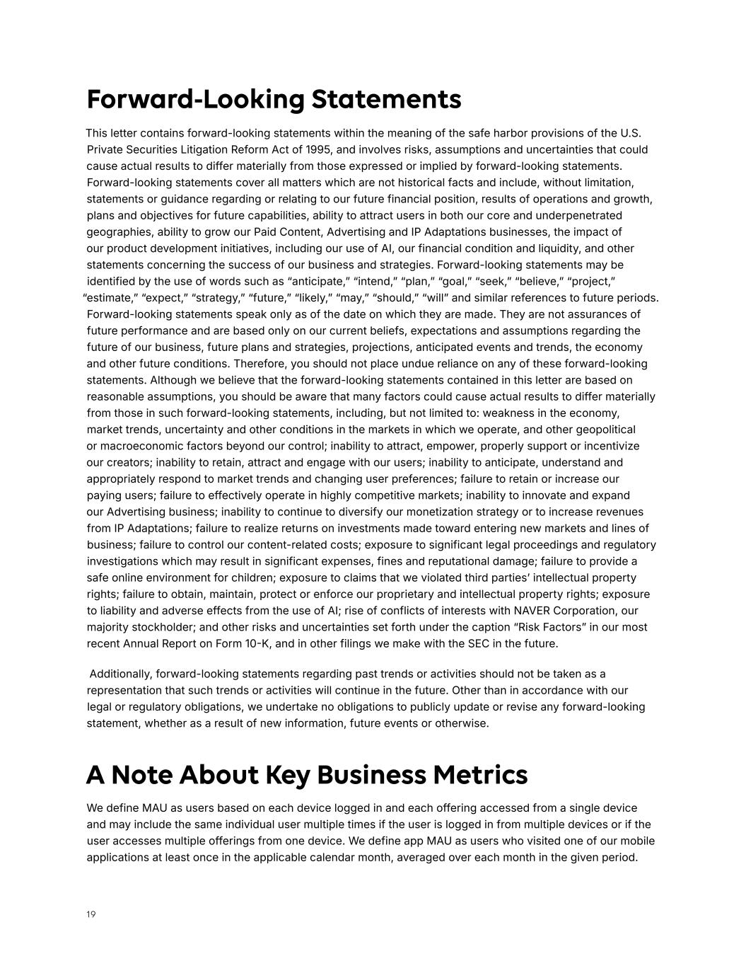
19 Forward-Looking Statements This letter contains forward-looking statements within the meaning of the safe harbor provisions of the U.S. Private Securities Litigation Reform Act of 1995, and involves risks, assumptions and uncertainties that could cause actual results to differ materially from those expressed or implied by forward-looking statements. Forward-looking statements cover all matters which are not historical facts and include, without limitation, statements or guidance regarding or relating to our future financial position, results of operations and growth, plans and objectives for future capabilities, ability to attract users in both our core and underpenetrated geographies, ability to grow our Paid Content, Advertising and IP Adaptations businesses, the impact of our product development initiatives, including our use of AI, our financial condition and liquidity, and other statements concerning the success of our business and strategies. Forward-looking statements may be identified by the use of words such as “anticipate,” “intend,” “plan,” “goal,” “seek,” “believe,” “project,” “estimate,” “expect,” “strategy,” “future,” “likely,” “may,” “should,” “will” and similar references to future periods. Forward-looking statements speak only as of the date on which they are made. They are not assurances of future performance and are based only on our current beliefs, expectations and assumptions regarding the future of our business, future plans and strategies, projections, anticipated events and trends, the economy and other future conditions. Therefore, you should not place undue reliance on any of these forward-looking statements. Although we believe that the forward-looking statements contained in this letter are based on reasonable assumptions, you should be aware that many factors could cause actual results to differ materially from those in such forward-looking statements, including, but not limited to: weakness in the economy, market trends, uncertainty and other conditions in the markets in which we operate, and other geopolitical or macroeconomic factors beyond our control; inability to attract, empower, properly support or incentivize our creators; inability to retain, attract and engage with our users; inability to anticipate, understand and appropriately respond to market trends and changing user preferences; failure to retain or increase our paying users; failure to effectively operate in highly competitive markets; inability to innovate and expand our Advertising business; inability to continue to diversify our monetization strategy or to increase revenues from IP Adaptations; failure to realize returns on investments made toward entering new markets and lines of business; failure to control our content-related costs; exposure to significant legal proceedings and regulatory investigations which may result in significant expenses, fines and reputational damage; failure to provide a safe online environment for children; exposure to claims that we violated third parties’ intellectual property rights; failure to obtain, maintain, protect or enforce our proprietary and intellectual property rights; exposure to liability and adverse effects from the use of AI; rise of conflicts of interests with NAVER Corporation, our majority stockholder; and other risks and uncertainties set forth under the caption “Risk Factors” in our most recent Annual Report on Form 10-K, and in other filings we make with the SEC in the future. Additionally, forward-looking statements regarding past trends or activities should not be taken as a representation that such trends or activities will continue in the future. Other than in accordance with our legal or regulatory obligations, we undertake no obligations to publicly update or revise any forward-looking statement, whether as a result of new information, future events or otherwise. A Note About Key Business Metrics We define MAU as users based on each device logged in and each offering accessed from a single device and may include the same individual user multiple times if the user is logged in from multiple devices or if the user accesses multiple offerings from one device. We define app MAU as users who visited one of our mobile applications at least once in the applicable calendar month, averaged over each month in the given period.

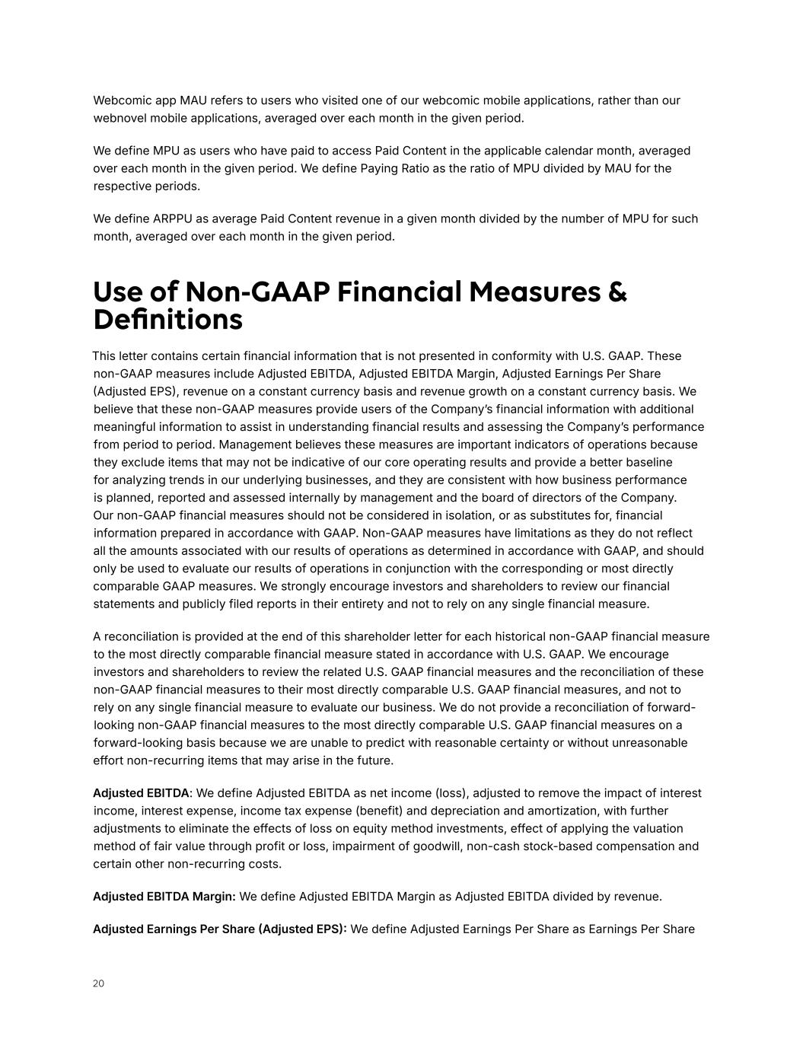
20 Use of Non-GAAP Financial Measures & Definitions This letter contains certain financial information that is not presented in conformity with U.S. GAAP. These non-GAAP measures include Adjusted EBITDA, Adjusted EBITDA Margin, Adjusted Earnings Per Share (Adjusted EPS), revenue on a constant currency basis and revenue growth on a constant currency basis. We believe that these non-GAAP measures provide users of the Company’s financial information with additional meaningful information to assist in understanding financial results and assessing the Company’s performance from period to period. Management believes these measures are important indicators of operations because they exclude items that may not be indicative of our core operating results and provide a better baseline for analyzing trends in our underlying businesses, and they are consistent with how business performance is planned, reported and assessed internally by management and the board of directors of the Company. Our non-GAAP financial measures should not be considered in isolation, or as substitutes for, financial information prepared in accordance with GAAP. Non-GAAP measures have limitations as they do not reflect all the amounts associated with our results of operations as determined in accordance with GAAP, and should only be used to evaluate our results of operations in conjunction with the corresponding or most directly comparable GAAP measures. We strongly encourage investors and shareholders to review our financial statements and publicly filed reports in their entirety and not to rely on any single financial measure. A reconciliation is provided at the end of this shareholder letter for each historical non-GAAP financial measure to the most directly comparable financial measure stated in accordance with U.S. GAAP. We encourage investors and shareholders to review the related U.S. GAAP financial measures and the reconciliation of these non-GAAP financial measures to their most directly comparable U.S. GAAP financial measures, and not to rely on any single financial measure to evaluate our business. We do not provide a reconciliation of forward- looking non-GAAP financial measures to the most directly comparable U.S. GAAP financial measures on a forward-looking basis because we are unable to predict with reasonable certainty or without unreasonable effort non-recurring items that may arise in the future. Adjusted EBITDA: We define Adjusted EBITDA as net income (loss), adjusted to remove the impact of interest income, interest expense, income tax expense (benefit) and depreciation and amortization, with further adjustments to eliminate the effects of loss on equity method investments, effect of applying the valuation method of fair value through profit or loss, impairment of goodwill, non-cash stock-based compensation and certain other non-recurring costs. Adjusted EBITDA Margin: We define Adjusted EBITDA Margin as Adjusted EBITDA divided by revenue. Adjusted Earnings Per Share (Adjusted EPS): We define Adjusted Earnings Per Share as Earnings Per Share Webcomic app MAU refers to users who visited one of our webcomic mobile applications, rather than our webnovel mobile applications, averaged over each month in the given period. We define MPU as users who have paid to access Paid Content in the applicable calendar month, averaged over each month in the given period. We define Paying Ratio as the ratio of MPU divided by MAU for the respective periods. We define ARPPU as average Paid Content revenue in a given month divided by the number of MPU for such month, averaged over each month in the given period.

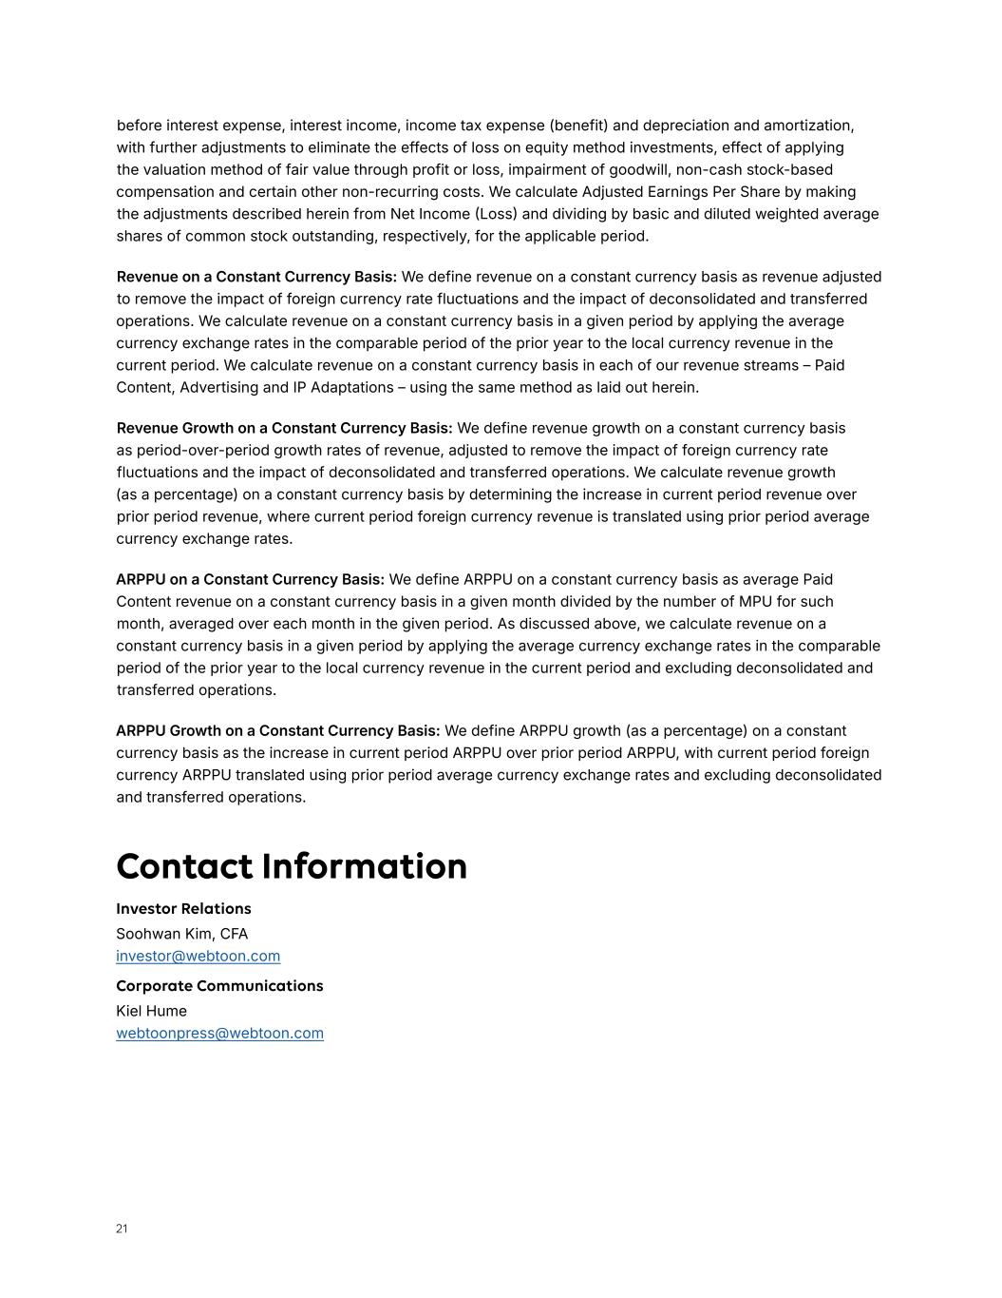
21 before interest expense, interest income, income tax expense (benefit) and depreciation and amortization, with further adjustments to eliminate the effects of loss on equity method investments, effect of applying the valuation method of fair value through profit or loss, impairment of goodwill, non-cash stock-based compensation and certain other non-recurring costs. We calculate Adjusted Earnings Per Share by making the adjustments described herein from Net Income (Loss) and dividing by basic and diluted weighted average shares of common stock outstanding, respectively, for the applicable period. Revenue on a Constant Currency Basis: We define revenue on a constant currency basis as revenue adjusted to remove the impact of foreign currency rate fluctuations and the impact of deconsolidated and transferred operations. We calculate revenue on a constant currency basis in a given period by applying the average currency exchange rates in the comparable period of the prior year to the local currency revenue in the current period. We calculate revenue on a constant currency basis in each of our revenue streams – Paid Content, Advertising and IP Adaptations – using the same method as laid out herein. Revenue Growth on a Constant Currency Basis: We define revenue growth on a constant currency basis as period-over-period growth rates of revenue, adjusted to remove the impact of foreign currency rate fluctuations and the impact of deconsolidated and transferred operations. We calculate revenue growth (as a percentage) on a constant currency basis by determining the increase in current period revenue over prior period revenue, where current period foreign currency revenue is translated using prior period average currency exchange rates. ARPPU on a Constant Currency Basis: We define ARPPU on a constant currency basis as average Paid Content revenue on a constant currency basis in a given month divided by the number of MPU for such month, averaged over each month in the given period. As discussed above, we calculate revenue on a constant currency basis in a given period by applying the average currency exchange rates in the comparable period of the prior year to the local currency revenue in the current period and excluding deconsolidated and transferred operations. ARPPU Growth on a Constant Currency Basis: We define ARPPU growth (as a percentage) on a constant currency basis as the increase in current period ARPPU over prior period ARPPU, with current period foreign currency ARPPU translated using prior period average currency exchange rates and excluding deconsolidated and transferred operations. Contact Information Investor Relations Corporate Communications Soohwan Kim, CFA investor@webtoon.com Kiel Hume webtoonpress@webtoon.com

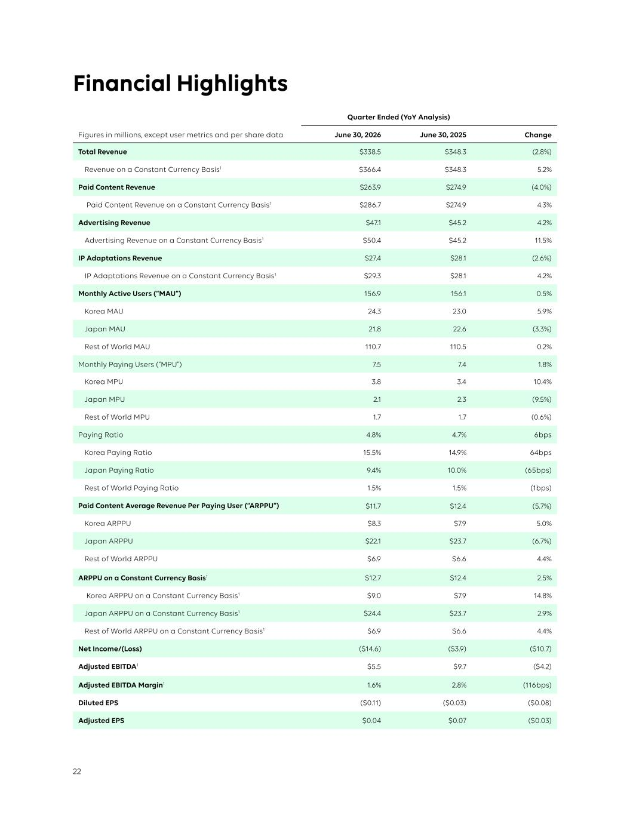
22 Quarter Ended (YoY Analysis) Figures in millions, except user metrics and per share data June 30, 2026 June 30, 2025 Change Total Revenue $338.5 $348.3 (2.8%) Revenue on a Constant Currency Basis1 $366.4 $348.3 5.2% Paid Content Revenue $263.9 $274.9 (4.0%) Paid Content Revenue on a Constant Currency Basis1 $286.7 $274.9 4.3% Advertising Revenue $47.1 $45.2 4.2% Advertising Revenue on a Constant Currency Basis1 $50.4 $45.2 11.5% IP Adaptations Revenue $27.4 $28.1 (2.6%) IP Adaptations Revenue on a Constant Currency Basis1 $29.3 $28.1 4.2% Monthly Active Users (“MAU”) 156.9 156.1 0.5% Korea MAU 24.3 23.0 5.9% Japan MAU 21.8 22.6 (3.3%) Rest of World MAU 110.7 110.5 0.2% Monthly Paying Users (“MPU”) 7.5 7.4 1.8% Korea MPU 3.8 3.4 10.4% Japan MPU 2.1 2.3 (9.5%) Rest of World MPU 1.7 1.7 (0.6%) Paying Ratio 4.8% 4.7% 6bps Korea Paying Ratio 15.5% 14.9% 64bps Japan Paying Ratio 9.4% 10.0% (65bps) Rest of World Paying Ratio 1.5% 1.5% (1bps) Paid Content Average Revenue Per Paying User (“ARPPU”) $11.7 $12.4 (5.7%) Korea ARPPU $8.3 $7.9 5.0% Japan ARPPU $22.1 $23.7 (6.7%) Rest of World ARPPU $6.9 $6.6 4.4% ARPPU on a Constant Currency Basis1 $12.7 $12.4 2.5% Korea ARPPU on a Constant Currency Basis1 $9.0 $7.9 14.8% Japan ARPPU on a Constant Currency Basis1 $24.4 $23.7 2.9% Rest of World ARPPU on a Constant Currency Basis1 $6.9 $6.6 4.4% Net Income/(Loss) ($14.6) ($3.9) ($10.7) Adjusted EBITDA1 $5.5 $9.7 ($4.2) Adjusted EBITDA Margin1 1.6% 2.8% (116bps) Diluted EPS ($0.11) ($0.03) ($0.08) Adjusted EPS $0.04 $0.07 ($0.03) Financial Highlights


23 1 Revenue on a constant currency basis, Paid Content revenue on a constant currency basis, Advertising revenue on a constant currency basis, IP Adaptations revenue on a constant currency basis, ARPPU on a constant currency basis, Korea ARPPU on a constant currency basis, Japan ARPPU on a constant currency basis, Rest of World ARPPU on a constant currency basis, Adjusted EBITDA, Adjusted EBITDA Margin and Adjusted EPS are non-GAAP financial measures. For definitions of these non-GAAP financial measures, see “Non-GAAP Financial Measures & Definitions” of this letter. A reconciliation of non-GAAP financial measures to the most directly comparable U.S. GAAP measure can be found at the end of this letter.

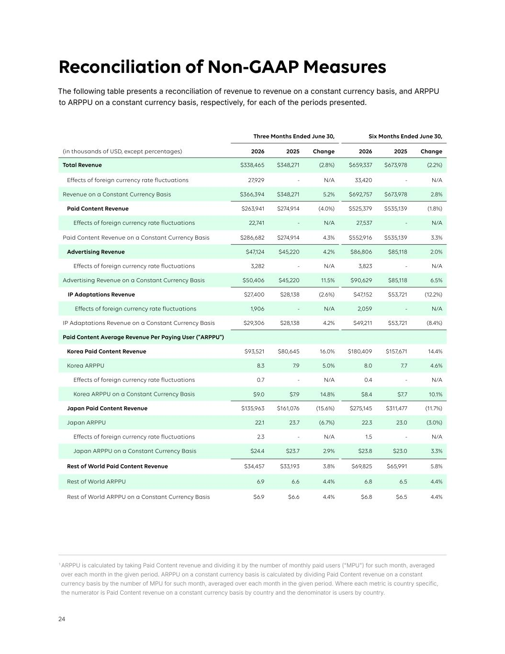
24 Reconciliation of Non-GAAP Measures The following table presents a reconciliation of revenue to revenue on a constant currency basis, and ARPPU to ARPPU on a constant currency basis, respectively, for each of the periods presented. Three Months Ended June 30, Six Months Ended June 30, (in thousands of USD, except percentages) 2026 2025 Change 2026 2025 Change Total Revenue $338,465 $348,271 (2.8%) $659,337 $673,978 (2.2%) Effects of foreign currency rate fluctuations 27,929 - N/A 33,420 - N/A Revenue on a Constant Currency Basis $366,394 $348,271 5.2% $692,757 $673,978 2.8% Paid Content Revenue $263,941 $274,914 (4.0%) $525,379 $535,139 (1.8%) Effects of foreign currency rate fluctuations 22,741 - N/A 27,537 - N/A Paid Content Revenue on a Constant Currency Basis $286,682 $274,914 4.3% $552,916 $535,139 3.3% Advertising Revenue $47,124 $45,220 4.2% $86,806 $85,118 2.0% Effects of foreign currency rate fluctuations 3,282 - N/A 3,823 - N/A Advertising Revenue on a Constant Currency Basis $50,406 $45,220 11.5% $90,629 $85,118 6.5% IP Adaptations Revenue $27,400 $28,138 (2.6%) $47,152 $53,721 (12.2%) Effects of foreign currency rate fluctuations 1,906 - N/A 2,059 - N/A IP Adaptations Revenue on a Constant Currency Basis $29,306 $28,138 4.2% $49,211 $53,721 (8.4%) Paid Content Average Revenue Per Paying User ("ARPPU") Korea Paid Content Revenue $93,521 $80,645 16.0% $180,409 $157,671 14.4% Korea ARPPU 8.3 7.9 5.0% 8.0 7.7 4.6% Effects of foreign currency rate fluctuations 0.7 - N/A 0.4 - N/A Korea ARPPU on a Constant Currency Basis $9.0 $7.9 14.8% $8.4 $7.7 10.1% Japan Paid Content Revenue $135,963 $161,076 (15.6%) $275,145 $311,477 (11.7%) Japan ARPPU 22.1 23.7 (6.7%) 22.3 23.0 (3.0%) Effects of foreign currency rate fluctuations 2.3 - N/A 1.5 - N/A Japan ARPPU on a Constant Currency Basis $24.4 $23.7 2.9% $23.8 $23.0 3.3% Rest of World Paid Content Revenue $34,457 $33,193 3.8% $69,825 $65,991 5.8% Rest of World ARPPU 6.9 6.6 4.4% 6.8 6.5 4.4% Rest of World ARPPU on a Constant Currency Basis $6.9 $6.6 4.4% $6.8 $6.5 4.4% 1 ARPPU is calculated by taking Paid Content revenue and dividing it by the number of monthly paid users ("MPU") for such month, averaged over each month in the given period. ARPPU on a constant currency basis is calculated by dividing Paid Content revenue on a constant currency basis by the number of MPU for such month, averaged over each month in the given period. Where each metric is country specific, the numerator is Paid Content revenue on a constant currency basis by country and the denominator is users by country.

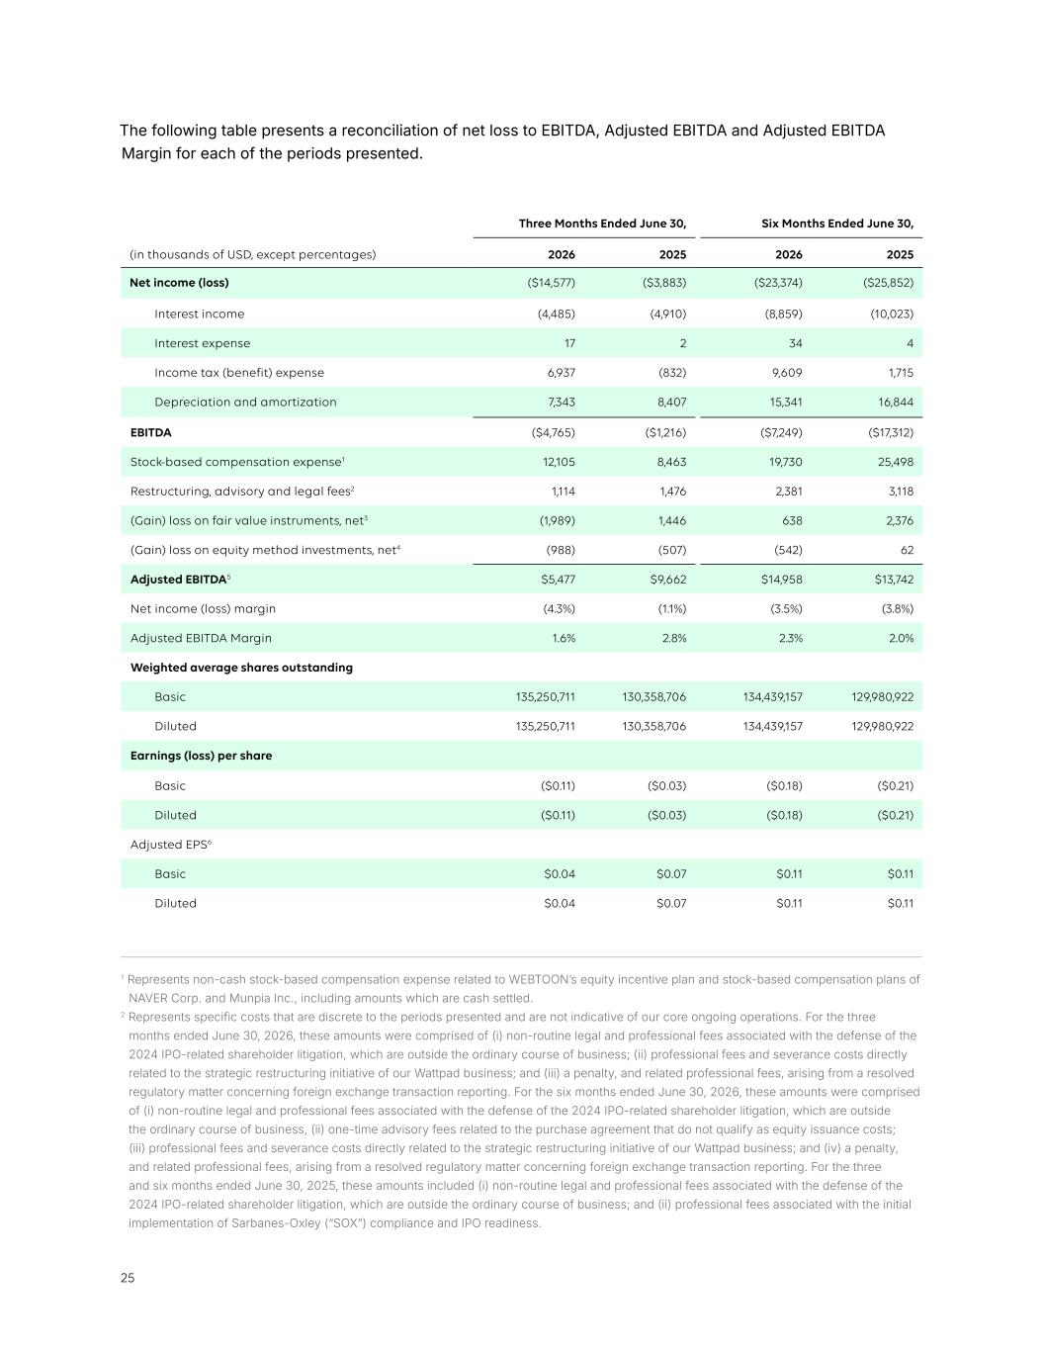
25 The following table presents a reconciliation of net loss to EBITDA, Adjusted EBITDA and Adjusted EBITDA Margin for each of the periods presented. 1 Represents non-cash stock-based compensation expense related to WEBTOON’s equity incentive plan and stock-based compensation plans of NAVER Corp. and Munpia Inc., including amounts which are cash settled. 2 Represents specific costs that are discrete to the periods presented and are not indicative of our core ongoing operations. For the three months ended June 30, 2026, these amounts were comprised of (i) non-routine legal and professional fees associated with the defense of the 2024 IPO-related shareholder litigation, which are outside the ordinary course of business; (ii) professional fees and severance costs directly related to the strategic restructuring initiative of our Wattpad business; and (iii) a penalty, and related professional fees, arising from a resolved regulatory matter concerning foreign exchange transaction reporting. For the six months ended June 30, 2026, these amounts were comprised of (i) non-routine legal and professional fees associated with the defense of the 2024 IPO-related shareholder litigation, which are outside the ordinary course of business, (ii) one-time advisory fees related to the purchase agreement that do not qualify as equity issuance costs; (iii) professional fees and severance costs directly related to the strategic restructuring initiative of our Wattpad business; and (iv) a penalty, and related professional fees, arising from a resolved regulatory matter concerning foreign exchange transaction reporting. For the three and six months ended June 30, 2025, these amounts included (i) non-routine legal and professional fees associated with the defense of the 2024 IPO-related shareholder litigation, which are outside the ordinary course of business; and (ii) professional fees associated with the initial implementation of Sarbanes-Oxley (“SOX”) compliance and IPO readiness. Three Months Ended June 30, Six Months Ended June 30, (in thousands of USD, except percentages) 2026 2025 2026 2025 Net income (loss) ($14,577) ($3,883) ($23,374) ($25,852) Interest income (4,485) (4,910) (8,859) (10,023) Interest expense 17 2 34 4 Income tax (benefit) expense 6,937 (832) 9,609 1,715 Depreciation and amortization 7,343 8,407 15,341 16,844 EBITDA ($4,765) ($1,216) ($7,249) ($17,312) Stock-based compensation expense1 12,105 8,463 19,730 25,498 Restructuring, advisory and legal fees2 1,114 1,476 2,381 3,118 (Gain) loss on fair value instruments, net3 (1,989) 1,446 638 2,376 (Gain) loss on equity method investments, net4 (988) (507) (542) 62 Adjusted EBITDA5 $5,477 $9,662 $14,958 $13,742 Net income (loss) margin (4.3%) (1.1%) (3.5%) (3.8%) Adjusted EBITDA Margin 1.6% 2.8% 2.3% 2.0% Weighted average shares outstanding Basic 135,250,711 130,358,706 134,439,157 129,980,922 Diluted 135,250,711 130,358,706 134,439,157 129,980,922 Earnings (loss) per share Basic ($0.11) ($0.03) ($0.18) ($0.21) Diluted ($0.11) ($0.03) ($0.18) ($0.21) Adjusted EPS6 Basic $0.04 $0.07 $0.11 $0.11 Diluted $0.04 $0.07 $0.11 $0.11


26 3 Represents unrealized net (gain) loss of financial assets measured at FVPL, which include the Company's equity investments. 4 Represents our proportionate share of recognized losses associated with our investments accounted for using the equity method. 5 Totals may not foot due to rounding. 6 The numerator for Adjusted EPS is calculated by adjusting Net Income (Loss) by the same items in the Net Income (Loss) to Adjusted EBITDA reconciliation. The denominator for computing Adjusted EPS is the same as that used for Basic and Diluted EPS.


27


WEBTOON Expands Global IP Business with Strategic Investment in RI Games Holdings Inc.

Dedicated games pipeline built on stories with established global fandom expands WEBTOON’s ecosystem with proven IP

Los Angeles (August 10, 2026) — WEBTOON Entertainment Inc. (Nasdaq: WBTN) today announced it has entered into a definitive agreement to make a strategic investment in RI Games Holdings Inc. The investment gives WEBTOON a dedicated pipeline to develop games from hit webcomics with established, built-in global fandoms. Upon closing, WEBTOON Entertainment will hold a 60% majority stake in RI Games Holdings.

Together, WEBTOON and RI Games Holdings plan to develop and launch multiple games over the next four years, based on proven intellectual property (IP) with an established global fan base. RI Games Holdings operates through two game development studios, GrayGames and Offbeat. The slate includes games based on the hit series Overgeared (1.3B global views), Doom Breaker (590M global views), and WEBTOON sensation Omniscient Reader (aka ORV, 3.05B global views).1 Each title is part of a broader franchise strategy, with planned anime adaptations helping extend these stories and engage wider audiences: from webcomic to animation and game.

Leading the lineup is a new action MMORPG based on the hit webcomic, Overgeared, scheduled for a global launch later this year. Developed by GrayGames and published by NEXON, the game is planned to launch alongside an anime adaptation, which premieres in October 2026. Together, the releases will drive a coordinated cross-media expansion designed to broaden the franchise’s global reach and give fans new ways to experience the world of Overgeared.

"WEBTOON is where global fandoms begin, and with this investment we're taking a more direct role in growing stories into global franchises," said Junkoo Kim, Founder & CEO of WEBTOON Entertainment. "Games are one of the most immersive forms of fandom, and building them from stories fans already love is a powerful way to reach new audiences everywhere. This strengthens our track record of turning original stories into global franchises across animation, television, film, publishing, and now games."

1 View counts are current as of the date of publication

RI Games Holdings was founded in 2022 by Kevin Tail Han, who also founded Redice Studio, the webcomic studio behind some of the biggest titles in webcomics, including Solo Leveling and Omniscient Reader (aka ORV). RI Games Holdings develops games for players around the world, with a team of top developers whose track record includes MapleStory M, Tower of God: New World, The Seven Deadly Sins: Grand Cross, Lineage W, and Aion 1, among others.

"We look forward to partnering with WEBTOON on the next phase of growth for RI Games Holdings," said Kevin Tail Han, Founder of RI Games Holdings. "Driven by our deep understanding of and passion for WEBTOON IP, we aim to create games that deliver immersive interactive experiences, bringing fans together while extending the reach and experience of each IP."

WEBTOON Entertainment’s global IP business adapts stories across animation, television, film, publishing, and games, scaling those fandoms to global audiences. Each new format also brings fresh audiences back to the original series on WEBTOON, deepening engagement with the original stories and expanding the audiences for the whole franchise.

WEBTOON Entertainment’s strong track record of delivering hits for streamers like Netflix, Disney+, Prime Video, and Crunchyroll – including Emmy-nominated Chicken Nugget, Bloodhounds S2, Clevatess S2, and The Legend of Kitchen Soldier – gives the Company confidence in the opportunity presented by an expansion into gaming.
Transaction Structure
WEBTOON Entertainment has agreed to acquire a 60% stake in RI Games Holdings for an aggregate purchase price of approximately $100M, funded with cash on hand. The acquisition will occur in two installments, the first at an initial closing shortly following signing, and the second at a subsequent closing, in each case subject to certain closing conditions.

The agreement also includes performance-based provisions for the remaining stake. If certain milestones are met, RI Games Holdings’ selling shareholder will have the right to sell their remaining 40% stake to WEBTOON on pre-agreed terms, payable in a combination of cash and shares of WEBTOON common stock (with the number of shares issuable subject to a cap). If those milestones are not met, WEBTOON will have the right to sell back a portion of its stake to the selling shareholder.

Second Quarter 2026 Earnings Conference Call & Webcast Details
Also today, WEBTOON Entertainment issued second quarter 2026 financial results. The Company’s management team will host a conference call at 5:30 p.m. ET today to review the results.

A live webcast of the conference call will be available online at https://ir.webtoon.com/.

For those unable to listen to the live webcast, an archived version will be available at the same location for up to one year.

###

About WEBTOON Entertainment
WEBTOON Entertainment is a leading global entertainment company and home to some of the world's largest storytelling platforms. As the global leader and pioneer of the mobile webcomic format, WEBTOON Entertainment has transformed comics and visual storytelling for fans and creators.
With its CANVAS UGC platform empowering anyone to become a creator, and a growing roster of superstar WEBTOON Originals creators and series, WEBTOON Entertainment’s passionate fandoms are the new face of pop culture. WEBTOON Entertainment adaptations are available on Netflix, Prime Video, Crunchyroll, and other screens around the world, and the company’s content partners have included Warner Bros. Animation, Discord, HYBE, and Duolingo, among many others.
With approximately 155 million monthly active users, WEBTOON Entertainment’s IP & Creator Ecosystem of aligned brands and platforms include WEBTOON, Wattpad--the world’s leading webnovel platform--WEBTOON Productions, Studio N, Studio LICO, WEBTOON Unscrolled, LINE MANGA, and eBookJapan, among others.

Forward-Looking Statements
Certain statements in this press release may constitute “forward-looking statements” within the meaning of the Private Securities Litigation Reform Act of 1995, including statements relating to the proposed acquisition of a controlling interest in RI Games Holdings Inc. and the timing and completion of the first and second closings; the development, launch timing and commercial performance of games and related adaptations; plans to develop and launch multiple games over the coming years; the parties’ respective contingent rights to require the purchase or sale of equity interests; and the anticipated benefits of the transaction. These statements are based on the views and assumptions of WEBTOON’s management as of the date of this release and are subject to change. Actual results may differ materially from those expressed or implied, including as a result of the failure to satisfy the conditions to, or to complete, the first or second closing; risks relating to game development, launch timing and commercial performance; the retention of key personnel; the potential issuance of shares of WEBTOON common stock and resulting dilution; and other developments beyond WEBTOON’s control. Additional factors are set forth under “Risk Factors” in WEBTOON’s most recent Annual Report on Form 10-K, its Quarterly Reports on Form 10-Q, and subsequent filings with the U.S. Securities and Exchange Commission. WEBTOON undertakes no obligation to update these statements, except as required by law.

