UNITED STATES
SECURITIES AND EXCHANGE COMMISSION
WASHINGTON, D.C. 20549
FORM 8-K
CURRENT REPORT
Pursuant to Section 13 or 15(d) of the Securities Exchange Act of 1934
Date of Report (Date of earliest event reported): May 11, 2026
WEBTOON Entertainment Inc.
(Exact name of Registrant as Specified in Its Charter)
Delaware |  |  | 001-42144 |  |  | 81-3830533
(State or Other Jurisdiction  of Incorporation) |  |  | (Commission File Number) |  |  | (IRS Employer  Identification No.)
5700 Wilshire Blvd.
Suite 220
Los Angeles, California |  |  |  |  |  | 90036
(Address of Principal Executive Offices) |  |  |  |  |  | (Zip Code)
Registrant’s Telephone Number, Including Area Code: (323) 424-3795
(Former Name or Former Address, if Changed Since Last Report)
Check the appropriate box below if the Form 8-K filing is intended to simultaneously satisfy the filing obligation of the registrant under any of the following provisions:
☐ Written communications pursuant to Rule 425 under the Securities Act (17 CFR 230.425)
☐ Soliciting material pursuant to Rule 14a-12 under the Exchange Act (17 CFR 240.14a-12)
☐ Pre-commencement communications pursuant to Rule 14d-2(b) under the Exchange Act (17 CFR 240.14d-2(b))
☐ Pre-commencement communications pursuant to Rule 13e-4(c) under the Exchange Act (17 CFR 240.13e-4(c))
Securities registered pursuant to Section 12(b) of the Act:
Title of each class |  |  |  |  |  | Trading  Symbol(s) |  |  |  |  |  | Name of each exchange on which registered
Common stock, par value $0.0001 per share |  |  |  |  |  | WBTN |  |  |  |  |  | Nasdaq Global Select Market
Indicate by check mark whether the registrant is an emerging growth company as defined in Rule 405 of the Securities Act of 1933 (§ 230.405 of this chapter) or Rule 12b-2 of the Securities Exchange Act of 1934 (§ 240.12b-2 of this chapter).
Emerging growth company ☐
If an emerging growth company, indicate by check mark if the registrant has elected not to use the extended transition period for complying with any new or revised financial accounting standards provided pursuant to Section 13(a) of the Exchange Act. ☐

Item 2.02 Results of Operations and Financial Condition.
On May 11, 2026, WEBTOON Entertainment Inc. (the "Company") issued a press release and a letter to shareholders (the "Shareholder Letter") announcing its financial results for the first quarter ended March 31, 2026. Copies of the press release and Shareholder Letter are furnished as Exhibit 99.1 and Exhibit 99.2, respectively, to this Current Report on Form 8-K and are incorporated herein by reference.
The information furnished pursuant to Item 2.02 of this Current Report on Form 8-K, including Exhibit 99.2 attached hereto, is being furnished and shall not be deemed “filed” for purposes of Section 18 of the Securities Exchange Act of 1934, as amended (the "Exchange Act"), or otherwise subject to the liabilities of that section, nor shall it be deemed incorporated by reference into any other filing under the Securities Act of 1933, as amended, or the Exchange Act, except as expressly set forth by specific reference in such a filing.

Item 9.01 Financial Statements and Exhibits.
(d)The following exhibits are being filed herewith:
Exhibit No. |  |  |  |  |  | Description
99.1 |  |  |  |  |  | Press release dated May 11, 2026
99.2 |  |  |  |  |  | Shareholder Letter dated May 11, 2026
104 |  |  |  |  |  | Cover Page Interactive Data File (embedded within the inline XBRL document)

SIGNATURES
Pursuant to the requirements of the Securities Exchange Act of 1934, the registrant has duly caused this report to be signed on its behalf by the undersigned hereunto duly authorized.
 |  |  |  |  |  |  |  |  | WEBTOON Entertainment Inc.
Date: |  |  | May 11, 2026 |  |  | By: |  |  | /s/ David J. Lee
 |  |  |  |  |  | Name: |  |  | David J. Lee
 |  |  |  |  |  | Title: |  |  | Chief Financial Officer

WEBTOON Entertainment Inc. Reports First Quarter 2026 Financial Results
Delivered Revenue Within Guidance Range and Adjusted EBITDA Well Above the High-End of Guidance Range
First Quarter Revenue Decline of 1.5% Year-Over-Year; Revenue Growth on a Constant Currency Basis of 0.2%
Net Loss of $8.8 million; Adjusted EBITDA of $9.5 million
Strong Balance Sheet With Cash and Cash Equivalents of Approximately $594.9 million and No Debt
LOS ANGELES, May 11, 2026 (GLOBE NEWSWIRE) -- WEBTOON Entertainment Inc. (Nasdaq: WBTN) (“WEBTOON Entertainment” or “the Company”), a leading global entertainment company and home to some of the world’s largest storytelling platforms, today announced results for its first quarter ended March 31, 2026. More information about these results can be found in the Company’s shareholder letter on the investor relations section of its website.
First Quarter 2026 Highlights (vs. First Quarter 2025)
•Total revenue of $320.9 million declined 1.5%, driven by declines in IP Adaptations and Advertising, partially offset by growth in Paid Content.
•Revenue on a constant currency basis was $326.4 million, growing 0.2%, driven by growth in Paid Content and Advertising, offset by a decline in IP Adaptations.
•Net Loss was $8.8 million, compared to $22.0 million in the prior year, driven primarily by better gross profit.
•Adjusted EBITDA was $9.5 million, compared to $4.1 million in the prior year, due to effective cost controls. Adjusted EBITDA Margin was 3.0%, compared to 1.3% in the prior year.
•Diluted loss per share was $0.07, compared to diluted loss per share of $0.17 in the prior year.
•Adjusted Earnings Per Share was $0.07, compared to $0.03 in the prior year.
•Cash and cash equivalents of approximately $594.9 million plus another $11.1 million of short-term deposits included in prepaid expenses and other current assets.
•Cash outflow from operations was $11.8 million, compared to a cash outflow of $18.7 million in the prior year.
Junkoo Kim, Founder and CEO, said, “We are pleased to share our solid first quarter results with constant currency revenue of $326.4 million, in line with our expectations, and a significant Adjusted EBITDA increase of 132% year-over-year.”
Kim continued, “Importantly, we are continuing to strategically invest across our flywheel. We remain focused on expanding our creator ecosystem, and will introduce major updates to our amateur CANVAS platform throughout the year, positioning us well to produce even more diverse content that our users love. As we look to the rest of the year, we will remain focused on investing in the business to drive further innovation and long-term growth.”
Second Quarter 2026 Outlook
For the second quarter 2026, the Company expects:
•Revenue growth on a constant currency basis in the range of 1.7%-4.6%. This represents revenue in the range of $332-$342 million, based on current FX rates.
•Adjusted EBITDA in the range of $0.0-$5.0 million, representing an Adjusted EBITDA Margin in the range of 0.0%-1.5%.
Conference Call & Webcast Details
As previously disclosed, the Company will host a webcast and conference call on May 11, 2026, at 4:30 p.m. Eastern Time, to discuss the Company’s financial results for its first quarter ended March 31, 2026.

A live webcast of the conference call will be available online at https://ir.webtoon.com/.

For those unable to listen to the live webcast, an archived version will be available at the same location for up to one year.

About WEBTOON Entertainment Inc.

WEBTOON Entertainment is a leading global entertainment company and home to some of the world's largest storytelling platforms. As the global leader and pioneer of the mobile webcomic format, WEBTOON Entertainment has transformed comics and visual storytelling for fans and creators.

With its CANVAS UGC platform empowering anyone to become a creator, and a growing roster of superstar WEBTOON Originals creators and series, WEBTOON Entertainment’s passionate fandoms are the new face of pop culture. WEBTOON Entertainment adaptations are available on Netflix, Prime Video, Crunchyroll, and other screens around the world, and the company’s content partners have included Warner Bros. Animation, Discord, HYBE, and Duolingo, among many others.
With approximately 145 million monthly active users, WEBTOON Entertainment’s IP & Creator Ecosystem of aligned brands and platforms include WEBTOON, Wattpad--the world’s leading webnovel platform--WEBTOON Productions, Studio N, Studio LICO, WEBTOON Unscrolled, LINE MANGA, and eBookJapan, among others.
Forward-Looking Statements

This release contains forward-looking statements within the meaning of the safe harbor provisions of the U.S. Private Securities Litigation Reform Act of 1995, and involves risks, assumptions and uncertainties that could cause actual results to differ materially from those expressed or implied by forward-looking statements. Forward-looking statements cover all matters which are not historical facts and include, without limitation, statements or guidance regarding or relating to our future financial position, results of operations and growth, plans and objectives for future capabilities, ability to attract users in both our core and underpenetrated geographies, ability to grow Paid Content, Advertising and IP Adaptations businesses, the impact of our product development initiatives, including our use of AI, our financial condition and liquidity, and other statements concerning the success of our business and strategies. Forward-looking statements may be identified by the use of words such as “anticipate,” “intend,” “plan,” “goal,” “seek,” “believe,” “project,” “estimate,” “expect,” “strategy,” “future,” “likely,” “may,” “should,” “will” and similar references to future periods. Forward-looking statements speak only as of the date on which they are made. They are not assurances of future performance and are based only on our current beliefs, expectations and assumptions regarding the future of our business, future plans and strategies, projections, anticipated events and trends, the economy and other future conditions. Therefore, you should not place undue reliance on any of these forward-looking statements. Although we believe that the forward-looking statements contained in this release are based on reasonable assumptions, you should be aware that many factors could cause actual results to differ materially from those in such forward-looking statements, including, but not limited to: weakness in the economy, market trends, uncertainty and other conditions in the markets in which we operate, and other geopolitical or macroeconomic factors beyond our control; inability to attract, empower, properly support or incentivize our creators; inability to retain, attract and engage with our users; inability to anticipate, understand and appropriately respond to market trends and changing user preferences; failure to retain or increase our paying users; failure to effectively operate in highly competitive markets; inability to innovate and expand our Advertising business; inability to continue to diversify our monetization strategy or to increase revenues from IP Adaptations; failure to control our content-related costs; exposure to significant legal proceedings and regulatory investigations which may result in significant expenses, fines and reputational damage; failure to provide a safe online environment for children; exposure to claims that we violated third parties’ intellectual property rights; failure to obtain, maintain, protect or enforce our proprietary and intellectual property rights; exposure to liability and adverse effects from the use of AI; rise of conflicts of interests with NAVER Corporation, our majority stockholder; and other risks and uncertainties set forth under the caption “Risk Factors” in our most recent Annual Report on Form 10-K, and in other filings we make with the SEC in the future.
Additionally, forward-looking statements regarding past trends or activities should not be taken as a representation that such trends or activities will continue in the future. Other than in accordance with our legal or regulatory obligations, we undertake no obligations to publicly update or revise any forward-looking statement, whether as a result of new information, future events or otherwise.
Non-GAAP Financial Measures & Definitions
This release contains certain financial information that is not presented in conformity with U.S. GAAP. These non-GAAP measures include Adjusted EBITDA, Adjusted EBITDA Margin, Adjusted Earnings Per Share (Adjusted EPS), revenue on a constant currency basis and revenue growth on a constant currency basis.

We believe that these non-GAAP measures provide users of the Company’s financial information with additional meaningful information to assist in understanding financial results and assessing the Company’s performance from period to period. Management believes these measures are important indicators of operations because they exclude items that may not be indicative of our core operating results and provide a better baseline for analyzing trends in our underlying businesses, and they are consistent with how business performance is planned, reported and assessed internally by management and the board of directors of the Company. Our non-GAAP financial measures should not be considered in isolation, or as substitutes for, financial information prepared in accordance with GAAP. Non-GAAP measures have limitations as they do not reflect all the amounts associated with our results of operations as determined in accordance with GAAP, and should only be used to evaluate our results of operations in conjunction with the corresponding or the most directly comparable GAAP measures. We strongly encourage investors and shareholders to review our financial statements and publicly filed reports in their entirety and not to rely on any single financial measure.
A reconciliation is provided at the end of this release for each historical non-GAAP financial measure to the most directly comparable financial measure stated in accordance with U.S. GAAP. We encourage investors and shareholders to review the related U.S. GAAP financial measures and the reconciliation of these non-GAAP financial measures to their most directly comparable U.S. GAAP financial measures, and not to rely on any single financial measure to evaluate our business. We do not provide a reconciliation of forward-looking non-GAAP financial measures to the most directly comparable U.S. GAAP financial measures on a forward-looking basis because we are unable to predict with reasonable certainty or without unreasonable effort non-recurring items that may arise in the future.
Adjusted EBITDA: We define Adjusted EBITDA as net income (loss), adjusted to remove the impact of interest income, interest expense, income tax expense (benefit) and depreciation and amortization, with further adjustments to eliminate the effects of loss on equity method investments, effect of applying the valuation method of fair value through profit or loss, impairment of goodwill, non-cash stock-based compensation and certain other non-recurring costs.
Adjusted EBITDA Margin: We define Adjusted EBITDA Margin as Adjusted EBITDA divided by revenue.
Adjusted Earnings Per Share (Adjusted EPS): We define Adjusted Earnings Per Share as Earnings Per Share before interest expense, interest income, income tax expense (benefit) and depreciation and amortization with further adjustments to eliminate the effects of loss on equity method investments, effect of applying the valuation method of fair value through profit or loss, impairment of goodwill, non-cash stock-based compensation and certain other non-recurring costs. We calculate Adjusted Earnings Per Share by making the adjustments described herein from Net Income (Loss) and dividing by basic and diluted weighted average shares of common stock outstanding, respectively, for the applicable period.
Revenue on a Constant Currency Basis: We define revenue on a constant currency basis as revenue adjusted to remove the impact of foreign currency rate fluctuations and the impact of deconsolidated and transferred operations. We calculate revenue on a constant currency basis in a given period by applying the average currency exchange rates in the comparable period of the prior year to the local currency revenue in the current period. We calculate revenue on a constant currency basis in each of our revenue streams – Paid Content, Advertising and IP Adaptations – using the same method as laid out herein.
Revenue Growth on a Constant Currency Basis: We define revenue growth on a constant currency basis as period-over-period growth rates of revenue, adjusted to remove the impact of foreign currency rate fluctuations and the impact of deconsolidated and transferred operations. We calculate revenue growth (as a percentage) on a constant currency basis by determining the increase in current period revenue over prior period revenue, where current period foreign currency revenue is translated using prior period average currency exchange rates.

Financial Statements
WEBTOON Entertainment Inc.
Consolidated Balance Sheets
(unaudited)
(in thousands of USD, except share and per share data)
 |  |  |  |  |  | As of
 |  |  |  |  |  | March 31, 2026 |  |  |  |  |  | December 31, 2025
Assets
Current assets:
Cash and cash equivalents |  |  |  |  |  | $ | 594,852 |  |  |  |  | $ | 581,806
Receivables1, net of allowance for credit losses of $1,703 and $3,378 at March 31, 2026 and December 31, 2025 respectively |  |  |  |  |  | 182,781 |  |  |  |  |  | 176,779
Prepaid expenses and other current assets, net2 |  |  |  |  |  | 73,369 |  |  |  |  |  | 72,647
Total current assets |  |  |  |  |  | 851,002 |  |  |  |  |  | 831,232
Property and equipment, net |  |  |  |  |  | 10,594 |  |  |  |  |  | 8,339
Operating lease right-of-use assets |  |  |  |  |  | 20,510 |  |  |  |  |  | 23,705
Debt and equity securities |  |  |  |  |  | 64,348 |  |  |  |  |  | 69,669
Intangible assets, net |  |  |  |  |  | 150,923 |  |  |  |  |  | 157,804
Goodwill, net |  |  |  |  |  | 330,832 |  |  |  |  |  | 336,825
Equity method investments |  |  |  |  |  | 76,212 |  |  |  |  |  | 80,440
Deferred tax assets |  |  |  |  |  | 23,643 |  |  |  |  |  | 22,302
Other non-current assets, net3 |  |  |  |  |  | 65,681 |  |  |  |  |  | 65,194
Total assets |  |  |  |  |  | $ | 1,593,745 |  |  |  |  | $ | 1,595,510
Liabilities and equity
Current liabilities:
Accounts payable4 |  |  |  |  |  | $ | 137,695 |  |  |  |  | $ | 136,962
Accrued expenses5 |  |  |  |  |  | 53,837 |  |  |  |  |  | 66,690
Current portion of operating lease liabilities6 |  |  |  |  |  | 8,679 |  |  |  |  |  | 9,617
Contract liabilities |  |  |  |  |  | 94,640 |  |  |  |  |  | 89,994
Taxes payable |  |  |  |  |  | 7,000 |  |  |  |  |  | 4,136
Provisions and defined pension benefits |  |  |  |  |  | 7,013 |  |  |  |  |  | 8,766
Other current liabilities |  |  |  |  |  | 3,913 |  |  |  |  |  | 2,457
Total current liabilities |  |  |  |  |  | 312,777 |  |  |  |  |  | 318,622
Non-current liabilities:
Long-term operating lease liabilities7 |  |  |  |  |  | 11,673 |  |  |  |  |  | 14,055
Defined severance benefits |  |  |  |  |  | 24,502 |  |  |  |  |  | 25,069
Deferred tax liabilities |  |  |  |  |  | 5,879 |  |  |  |  |  | 5,755
Other non-current liabilities |  |  |  |  |  | 3,683 |  |  |  |  |  | 3,737
Total liabilities |  |  |  |  |  | 358,514 |  |  |  |  |  | 367,238
Commitments and Contingencies (Note 8)
Redeemable non-controlling interest in subsidiary |  |  |  |  |  | $ | 24,336 |  |  |  |  | $ | 24,540
Stockholders' equity:
Common stock, $0.0001 par value (2,000,000,000 authorized, 134,635,086 shares and 130,776,161 shares issued and outstanding as of March 31, 2026, and December 31, 2025, respectively) |  |  |  |  |  | 13 |  |  |  |  |  | 13
Additional paid-in capital |  |  |  |  |  | 2,177,445 |  |  |  |  |  | 2,137,926
Accumulated other comprehensive loss |  |  |  |  |  | (137,007) |  |  |  |  |  | (114,363)
Accumulated deficit |  |  |  |  |  | (862,579) |  |  |  |  |  | (853,124)
Total stockholders' equity attributable to WEBTOON Entertainment Inc. |  |  |  |  |  | 1,177,872 |  |  |  |  |  | 1,170,452
Non-controlling interests in consolidated subsidiaries |  |  |  |  |  | 33,023 |  |  |  |  |  | 33,280

Total equity |  |  |  |  |  | $ | 1,210,895 |  |  |  |  | $ | 1,203,732
Total liabilities, redeemable non-controlling interest, and equity |  |  |  |  |  | $ | 1,593,745 |  |  |  |  | $ | 1,595,510
1.Includes amounts due from related parties of $54,303 and $55,156 as of March 31, 2026, and December 31, 2025, respectively.
2.Includes amounts due from related parties of $4,053 and $4,730 as of March 31, 2026, and December 31, 2025, respectively.
3.Includes amounts due from related parties of $33,786 and $33,913 as of March 31, 2026, and December 31, 2025, respectively.
4.Includes amounts due to related parties of $24,207 and $18,765 as of March 31, 2026, and December 31, 2025, respectively.
5.Includes amounts due to related parties of $6,048 and $6,849 as of March 31, 2026, and December 31, 2025, respectively.
6.Includes amounts due to related parties of $4,953 and $5,221 as of March 31, 2026, and December 31, 2025, respectively.
7.Includes amounts due to related parties of $3,933 and $5,371 as of March 31, 2026, and December 31, 2025, respectively.

WEBTOON Entertainment Inc.
Consolidated Statements of Operations and Comprehensive Loss
(unaudited)
(in thousands of USD, except share and per share data)
 |  |  |  |  |  |  |  | Three Months Ended
 |  |  |  |  |  |  |  |  |  | March 31, 2026 |  |  |  |  |  | March 31, 2025
Revenue1 |  |  |  |  |  |  |  |  |  | $ | 320,872 |  |  |  |  | $ | 325,707
Cost of revenue2 |  |  |  |  |  |  |  |  |  | (237,824) |  |  |  |  |  | (254,096)
Marketing3 |  |  |  |  |  |  |  |  |  | (30,520) |  |  |  |  |  | (31,543)
General and administrative expenses4 |  |  |  |  |  |  |  |  |  | (60,559) |  |  |  |  |  | (66,702)
Operating income (loss) |  |  |  |  |  |  |  |  |  | (8,031) |  |  |  |  |  | (26,634)
Interest income |  |  |  |  |  |  |  |  |  | 4,374 |  |  |  |  |  | 5,113
Interest expense |  |  |  |  |  |  |  |  |  | (17) |  |  |  |  |  | (2)
Gain (loss) on equity method investments, net |  |  |  |  |  |  |  |  |  | (446) |  |  |  |  |  | (569)
Other income (loss), net5 |  |  |  |  |  |  |  |  |  | (2,005) |  |  |  |  |  | 2,670
Income (loss) before income tax |  |  |  |  |  |  |  |  |  | (6,125) |  |  |  |  |  | (19,422)
Income tax expense |  |  |  |  |  |  |  |  |  | (2,672) |  |  |  |  |  | (2,547)
Net income (loss) |  |  |  |  |  |  |  |  |  | $ | (8,797) |  |  |  |  | $ | (21,969)
Net income (loss) attributable to WEBTOON Entertainment Inc. |  |  |  |  |  |  |  |  |  | (9,455) |  |  |  |  |  | (22,389)
Net income (loss) attributable to non-controlling interests and redeemable non-controlling interests |  |  |  |  |  |  |  |  |  | 658 |  |  |  |  |  | 420
Other comprehensive income (loss):
Foreign currency translation adjustments, net of tax |  |  |  |  |  |  |  |  |  | (23,747) |  |  |  |  |  | 6,572
Share of other comprehensive loss of equity method investments, net of tax |  |  |  |  |  |  |  |  |  | $ | (15) |  |  |  |  | $ | (143)
Total other comprehensive income (loss), net of tax |  |  |  |  |  |  |  |  |  | (23,762) |  |  |  |  |  | 6,429
Total comprehensive income (loss) |  |  |  |  |  |  |  |  |  | $ | (32,559) |  |  |  |  | $ | (15,540)
Total comprehensive income (loss) attributable to WEBTOON Entertainment Inc. |  |  |  |  |  |  |  |  |  | $ | (32,099) |  |  |  |  | $ | (15,999)
Total comprehensive income (loss) attributable to non-controlling interests and redeemable non-controlling interests |  |  |  |  |  |  |  |  |  | (460) |  |  |  |  |  | 459
Weighted average shares outstanding
Basic |  |  |  |  |  |  |  |  |  | 133,618,587 |  |  |  |  |  | 129,598,942
Diluted |  |  |  |  |  |  |  |  |  | 133,618,587 |  |  |  |  |  | 129,598,942
Income (loss) per share attributable to WEBTOON Entertainment Inc.
Basic |  |  |  |  |  |  |  |  |  | $ | (0.07) |  |  |  |  | $ | (0.17)
Diluted |  |  |  |  |  |  |  |  |  | $ | (0.07) |  |  |  |  | $ | (0.17)
1.Includes amounts earned from related parties of $18,243 and $17,713 for the three months ended March 31, 2026, and March 31, 2025, respectively.
2.Includes amounts incurred from related parties of $27,071 and $28,131 for the three months ended March 31, 2026, and March 31, 2025, respectively.
3.Includes amounts incurred from related parties of $(1,729) and $(2,581) for the three months ended March 31, 2026, and March 31, 2025, respectively.
4.Includes amounts incurred from related parties of $7,817 and $6,913 for the three months ended March 31, 2026, and March 31, 2025, respectively.
5.Includes amounts earned from related parties of $408 and $411 for the three months ended March 31, 2026, and March 31, 2025, respectively.

WEBTOON Entertainment Inc.
Consolidated Statements of Cash Flows
(unaudited)
(in thousands of USD)
 |  |  | For the Three Months Ended
 |  |  | March 31, 2026 |  |  |  |  |  | March 31, 2025
Operating activities:
Net income (loss) |  |  | $ | (8,797) |  |  |  |  | $ | (21,969)
Adjustments to reconcile net loss to net cash used in operating activities:
Allowance for credit losses |  |  | (749) |  |  |  |  |  | 443
Depreciation and amortization |  |  | 7,998 |  |  |  |  |  | 8,437
Operating lease expense |  |  | 2,541 |  |  |  |  |  | 1,985
Gain on foreign currency, net |  |  | (6,207) |  |  |  |  |  | (2,793)
Deferred tax benefit |  |  | (2,151) |  |  |  |  |  | (1,143)
Loss on debt and equity securities, net |  |  | 2,627 |  |  |  |  |  | 930
Change in severance benefit, net |  |  | 1,562 |  |  |  |  |  | 574
Loss on equity method investments, net |  |  | 446 |  |  |  |  |  | 569
Stock-based compensation |  |  | 7,625 |  |  |  |  |  | 18,253
Other non-cash items |  |  | (2,963) |  |  |  |  |  | (1,369)
Changes in operating assets and liabilities
Changes in receivables |  |  | (11,669) |  |  |  |  |  | 750
Changes in other assets |  |  | (4,122) |  |  |  |  |  | (2,250)
Changes in accounts payable |  |  | 4,083 |  |  |  |  |  | (2,801)
Changes in accrued expenses |  |  | (9,321) |  |  |  |  |  | (15,342)
Changes in contract liabilities |  |  | 7,501 |  |  |  |  |  | (1,450)
Changes in other liabilities |  |  | 2,516 |  |  |  |  |  | (236)
Changes in operating lease liabilities |  |  | $ | (2,767) |  |  |  |  | $ | (1,240)
Net cash used in operating activities |  |  | $ | (11,847) |  |  |  |  | $ | (18,652)
Investing activities:
Proceeds from maturities of short-term investments |  |  | 684 |  |  |  |  |  | 3,446
Proceeds from sale of property and equipment |  |  | 23 |  |  |  |  |  | 77
Purchases of property and equipment |  |  | (3,148) |  |  |  |  |  | (536)
Purchases of debt and equity securities |  |  | — |  |  |  |  |  | (3,789)
Payment made for short-term investments |  |  | (1,368) |  |  |  |  |  | (4,824)
Payment made for loan receivable |  |  | (68) |  |  |  |  |  | (207)
Purchases of intangible assets |  |  | (2,867) |  |  |  |  |  | (2,444)
Other investing activities |  |  | — |  |  |  |  |  | 249
Net cash used in investing activities |  |  | $ | (6,744) |  |  |  |  | $ | (8,028)
Financing activities:
Proceeds from issuance of common stock related to private placement, net |  |  | 32,682 |  |  |  |  |  | —
Proceeds from stock option exercise |  |  | — |  |  |  |  |  | 82
Net cash provided by financing activities |  |  | $ | 32,682 |  |  |  |  | $ | 82
Effect of exchange rate changes on cash and cash equivalents |  |  | (1,045) |  |  |  |  |  | 4,332
Cash and cash equivalents:
Net increase (decrease) in cash and cash equivalents |  |  | 13,046 |  |  |  |  |  | (22,266)
Cash and cash equivalents at beginning of the year |  |  | 581,806 |  |  |  |  |  | 572,402
Cash and cash equivalents at end of the year |  |  | $ | 594,852 |  |  |  |  | $ | 550,136
Supplemental disclosure:
Income taxes paid |  |  | $ | 2,711 |  |  |  |  | $ | 6,826
Reclassification of long-term advances to current |  |  | $ | (10,901) |  |  |  |  | $ | (28,973)
Increase in right-of-use assets recognized from new lease agreements |  |  | $ | 4 |  |  |  |  | $ | 12,007

Reconciliation of Non-GAAP Measures
The following table presents a reconciliation of revenue to revenue on a constant currency basis, and ARPPU to ARPPU on a constant currency basis, respectively, for each of the periods presented.
 |  |  |  |  |  |  |  |  |  | Three Months Ended March 31,
(in thousands of USD, except percentages) |  |  |  |  |  |  |  |  |  |  |  | 2026 |  |  |  |  |  | 2025 |  |  |  |  |  | Change
Total Revenue |  |  |  |  |  |  |  |  |  |  |  | $ | 320,872 |  |  |  |  | $ | 325,707 |  |  |  |  | (1.5%)
Effects of foreign currency rate fluctuations |  |  |  |  |  |  |  |  |  |  |  | 5,491 |  |  |  |  |  | - |  |  |  |  |  | N/A
Revenue on a Constant Currency Basis |  |  |  |  |  |  |  |  |  |  |  | $ | 326,363 |  |  |  |  | $ | 325,707 |  |  |  |  | 0.2%
Paid Content Revenue |  |  |  |  |  |  |  |  |  |  |  | 261,438 |  |  |  |  |  | 260,226 |  |  |  |  |  | 0.5%
Effects of foreign currency rate fluctuations |  |  |  |  |  |  |  |  |  |  |  | 4,797 |  |  |  |  |  | - |  |  |  |  |  | N/A
Paid Content Revenue on a Constant Currency Basis |  |  |  |  |  |  |  |  |  |  |  | $ | 266,235 |  |  |  |  | $ | 260,226 |  |  |  |  | 2.3%
Advertising Revenue |  |  |  |  |  |  |  |  |  |  |  | 39,682 |  |  |  |  |  | 39,898 |  |  |  |  |  | (0.5%)
Effects of foreign currency rate fluctuations |  |  |  |  |  |  |  |  |  |  |  | 541 |  |  |  |  |  | - |  |  |  |  |  | N/A
Advertising Revenue on a Constant Currency Basis |  |  |  |  |  |  |  |  |  |  |  | $ | 40,223 |  |  |  |  | $ | 39,898 |  |  |  |  | 0.8%
IP Adaptations Revenue |  |  |  |  |  |  |  |  |  |  |  | 19,752 |  |  |  |  |  | 25,583 |  |  |  |  |  | (22.8%)
Effects of foreign currency rate fluctuations |  |  |  |  |  |  |  |  |  |  |  | 153 |  |  |  |  |  | - |  |  |  |  |  | N/A
IP Adaptations Revenue on a Constant Currency Basis |  |  |  |  |  |  |  |  |  |  |  | $ | 19,905 |  |  |  |  | $ | 25,583 |  |  |  |  | (22.2%)
Paid Content Average Revenue Per Paying User ("ARPPU")
Korea Paid Content Revenue |  |  |  |  |  |  |  |  |  |  |  | $ | 86,888 |  |  |  |  | $ | 77,027 |  |  |  |  | 12.8%
Korea ARPPU |  |  |  |  |  |  |  |  |  |  |  | $ | 7.8 |  |  |  |  | $ | 7.5 |  |  |  |  | 4.0%
Effects of foreign currency rate fluctuations |  |  |  |  |  |  |  |  |  |  |  | 0.1 |  |  |  |  |  | - |  |  |  |  |  | N/A
Korea ARPPU on a Constant Currency Basis |  |  |  |  |  |  |  |  |  |  |  | $ | 7.9 |  |  |  |  | $ | 7.5 |  |  |  |  | 5.1%
Japan Paid Content Revenue |  |  |  |  |  |  |  |  |  |  |  | 139,182 |  |  |  |  |  | 150,401 |  |  |  |  |  | (7.5%)
Japan ARPPU |  |  |  |  |  |  |  |  |  |  |  | 22.5 |  |  |  |  |  | 22.3 |  |  |  |  |  | 0.9%
Effects of foreign currency rate fluctuations |  |  |  |  |  |  |  |  |  |  |  | 0.6 |  |  |  |  |  | - |  |  |  |  |  | N/A
Japan ARPPU on a Constant Currency Basis |  |  |  |  |  |  |  |  |  |  |  | $ | 23.2 |  |  |  |  | $ | 22.3 |  |  |  |  | 3.7%
Rest of World Paid Content Revenue |  |  |  |  |  |  |  |  |  |  |  | 35,368 |  |  |  |  |  | 32,798 |  |  |  |  |  | 7.8%
Rest of World ARPPU |  |  |  |  |  |  |  |  |  |  |  | 6.8 |  |  |  |  |  | 6.5 |  |  |  |  |  | 4.4%
Rest of World ARPPU on a Constant Currency Basis |  |  |  |  |  |  |  |  |  |  |  | $ | 6.8 |  |  |  |  | $ | 6.5 |  |  |  |  | 4.4%
1ARPPU is calculated by taking Paid Content revenue and dividing it by the number of monthly paid users ("MPU") for such month, averaged over each month in the given period. ARPPU on a constant currency basis is calculated by dividing Paid Content revenue on a constant currency basis by the number of MPU for such month, averaged over each month in the given period. Where each metric is country specific, the numerator is Paid Content revenue on a constant currency basis by country and the denominator is users by country.

The following table presents a reconciliation of net loss to EBITDA, Adjusted EBITDA and Adjusted EBITDA Margin for each of the periods presented.
 |  |  |  |  |  | Three Months Ended March 31,
(in thousands of USD, except percentages) |  |  |  |  |  |  |  | 2026 |  |  |  |  |  | 2025
Net income (loss) |  |  |  |  |  |  |  | $ | (8,797) |  |  |  |  | $ | (21,969)
Interest income |  |  |  |  |  |  |  | (4,374) |  |  |  |  |  | (5,113)
Interest expense |  |  |  |  |  |  |  | 17 |  |  |  |  |  | 2
Income tax expense (benefit) |  |  |  |  |  |  |  | 2,672 |  |  |  |  |  | 2,547
Depreciation and amortization |  |  |  |  |  |  |  | 7,998 |  |  |  |  |  | 8,437
EBITDA |  |  |  |  |  |  |  | $ | (2,484) |  |  |  |  | $ | (16,096)
Stock-based compensation expense(1) |  |  |  |  |  |  |  | 7,625 |  |  |  |  |  | 17,035
Restructuring, advisory and legal fees(2) |  |  |  |  |  |  |  | 1,267 |  |  |  |  |  | 1,642
Loss (gain) on fair value instruments, net(3) |  |  |  |  |  |  |  | 2,627 |  |  |  |  |  | 930
Loss on equity method investments, net(4) |  |  |  |  |  |  |  | 446 |  |  |  |  |  | 569
Adjusted EBITDA(5) |  |  |  |  |  |  |  | $ | 9,481 |  |  |  |  | $ | 4,080
Net income (loss) margin |  |  |  |  |  |  |  | (2.7) |  | % |  |  |  | (6.7) |  | %
Adjusted EBITDA Margin |  |  |  |  |  |  |  | 3.0 |  | % |  |  |  | 1.3 |  | %
Weighted average shares outstanding
Basic |  |  |  |  |  |  |  | 133,618,587 |  |  |  |  |  | 129,598,942
Diluted |  |  |  |  |  |  |  | 133,618,587 |  |  |  |  |  | 129,598,942
Earnings (loss) per share
Basic |  |  |  |  |  |  |  | $ | (0.07) |  |  |  |  | $ | (0.17)
Diluted |  |  |  |  |  |  |  | $ | (0.07) |  |  |  |  | $ | (0.17)
Adjusted EPS(6)
Basic |  |  |  |  |  |  |  | $ | 0.07 |  |  |  |  | $ | 0.03
Diluted |  |  |  |  |  |  |  | $ | 0.07 |  |  |  |  | $ | 0.03
(1)Represents stock-based compensation expense related to WEBTOON’s equity incentive plan and stock-based compensation plans of NAVER Corp. and Munpia Inc., including amounts which are cash settled.
(2)Represents specific costs that are incremental and discrete to the periods presented and are not indicative of our core ongoing operations. For the three months ended March 31, 2026, these amounts were comprised of (i) non-routine legal and professional fees associated with the defense of the 2024 IPO-related shareholder litigation, which are outside the ordinary course of business; (ii) one-time advisory fees related to a purchase agreement, that do not qualify as equity issuance costs; and (iii) professional fees directly related to the strategic restructuring initiative of our Wattpad business. For the three months ended March 31, 2025, these amounts included (i) non-routine legal and professional fees associated with the defense of the 2024 IPO-related shareholder litigation, which are outside the ordinary course of business, and (ii) professional fees associated with the initial implementation of Sarbanes-Oxley (“SOX”) compliance and IPO readiness.
(3)Represents unrealized net loss (gain) of financial assets measured at FVPL, which include the Company's equity investments.
(4)Represents our proportionate share of recognized losses associated with our investments accounted for using the equity method.
(5)Totals may not foot due to rounding.
(6)The numerator for Adjusted EPS is calculated by adjusting Net Income (Loss) by the same items in the Net Income (Loss) to Adjusted EBITDA reconciliation. The denominator for computing Adjusted EPS is the same as that used for Basic and Diluted EPS.

Contact Information
Investor Relations
Soohwan Kim, CFA & Taylor Giles
investor@webtoon.com
Corporate Communications
Kiel Hume
webtoonpress@webtoon.com


1NASDAQ: WBTN Shareholder Letter WEBTOON Entertainment Q1 2026

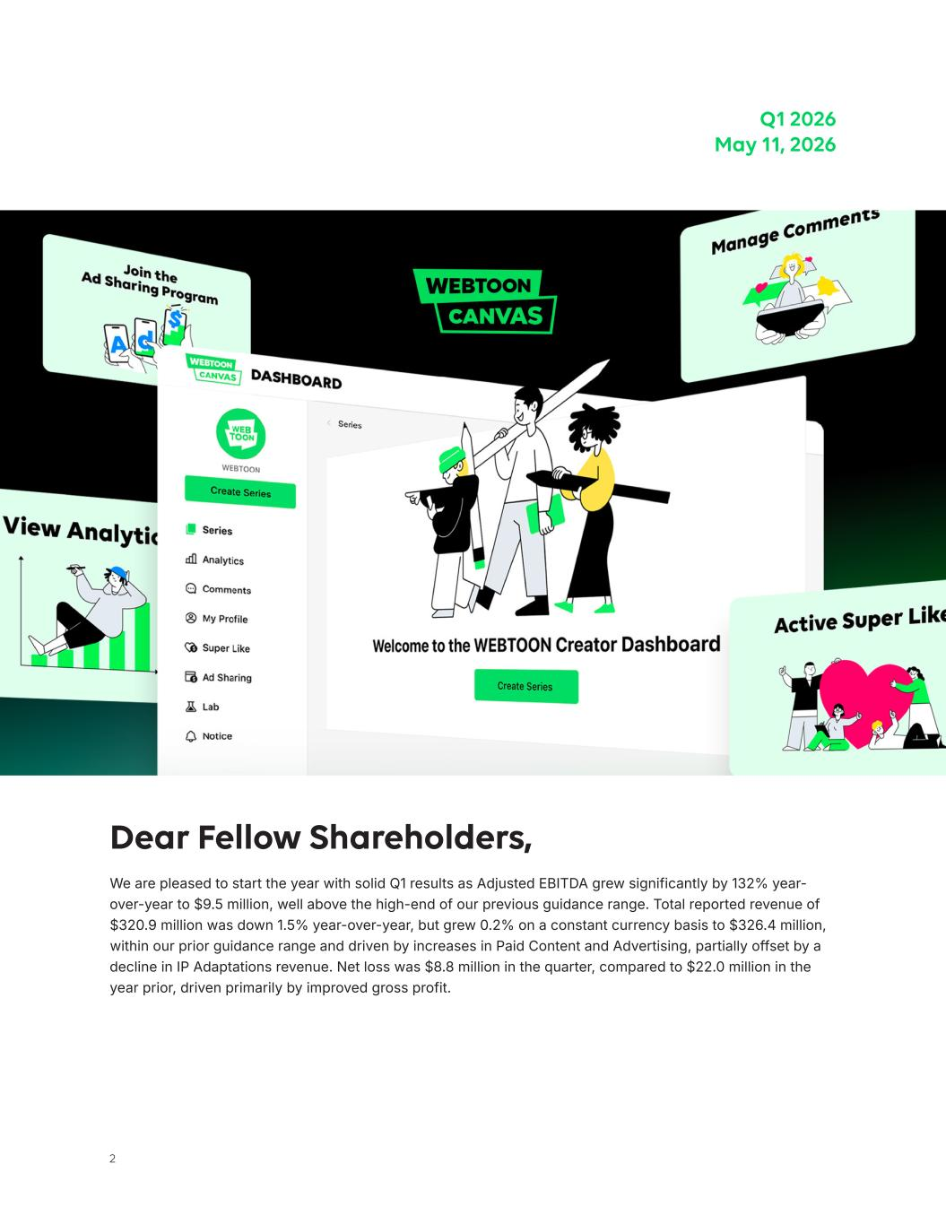
2 Dear Fellow Shareholders, We are pleased to start the year with solid Q1 results as Adjusted EBITDA grew significantly by 132% year- over-year to $9.5 million, well above the high-end of our previous guidance range. Total reported revenue of $320.9 million was down 1.5% year-over-year, but grew 0.2% on a constant currency basis to $326.4 million, within our prior guidance range and driven by increases in Paid Content and Advertising, partially offset by a decline in IP Adaptations revenue. Net loss was $8.8 million in the quarter, compared to $22.0 million in the year prior, driven primarily by improved gross profit. Q1 2026 May 11, 2026

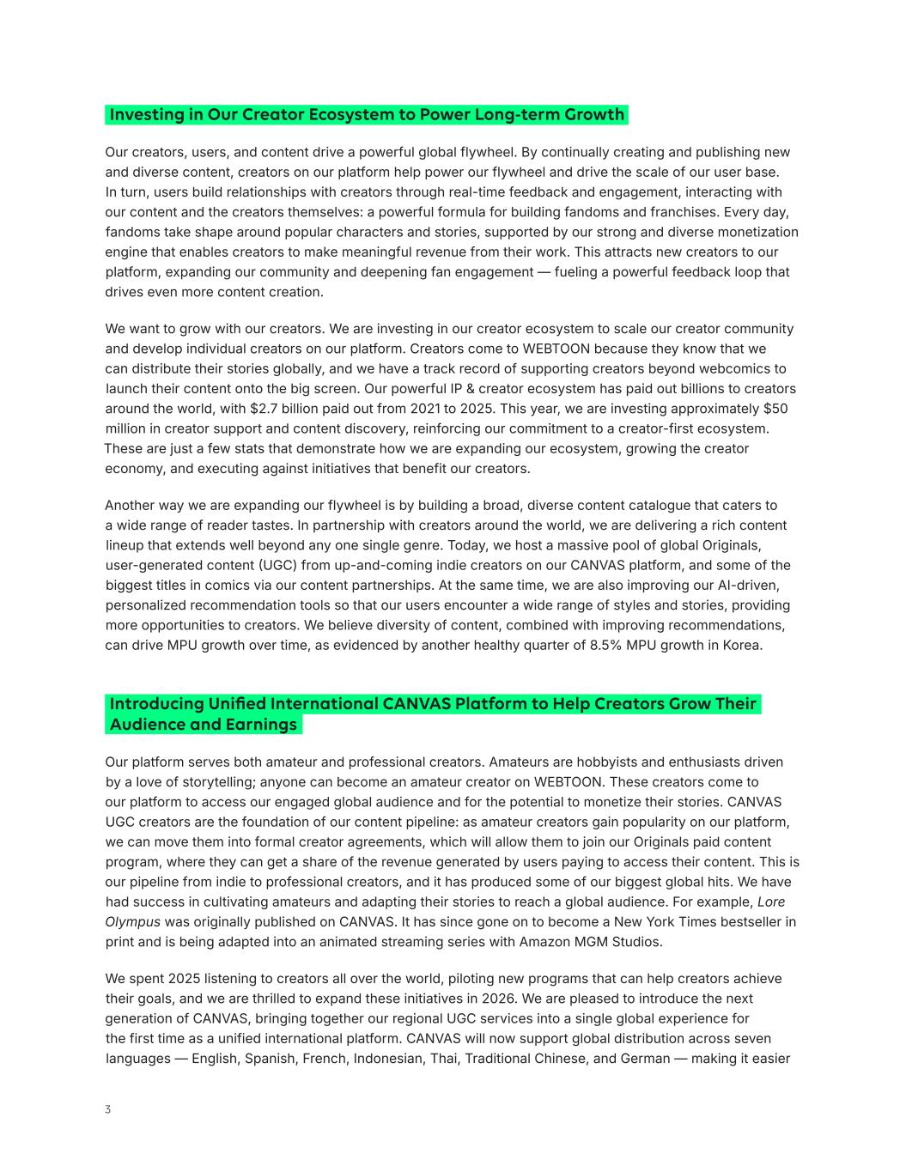
3 Our creators, users, and content drive a powerful global flywheel. By continually creating and publishing new and diverse content, creators on our platform help power our flywheel and drive the scale of our user base. In turn, users build relationships with creators through real-time feedback and engagement, interacting with our content and the creators themselves: a powerful formula for building fandoms and franchises. Every day, fandoms take shape around popular characters and stories, supported by our strong and diverse monetization engine that enables creators to make meaningful revenue from their work. This attracts new creators to our platform, expanding our community and deepening fan engagement — fueling a powerful feedback loop that drives even more content creation. We want to grow with our creators. We are investing in our creator ecosystem to scale our creator community and develop individual creators on our platform. Creators come to WEBTOON because they know that we can distribute their stories globally, and we have a track record of supporting creators beyond webcomics to launch their content onto the big screen. Our powerful IP & creator ecosystem has paid out billions to creators around the world, with $2.7 billion paid out from 2021 to 2025. This year, we are investing approximately $50 million in creator support and content discovery, reinforcing our commitment to a creator-first ecosystem. These are just a few stats that demonstrate how we are expanding our ecosystem, growing the creator economy, and executing against initiatives that benefit our creators. Another way we are expanding our flywheel is by building a broad, diverse content catalogue that caters to a wide range of reader tastes. In partnership with creators around the world, we are delivering a rich content lineup that extends well beyond any one single genre. Today, we host a massive pool of global Originals, user-generated content (UGC) from up-and-coming indie creators on our CANVAS platform, and some of the biggest titles in comics via our content partnerships. At the same time, we are also improving our AI-driven, personalized recommendation tools so that our users encounter a wide range of styles and stories, providing more opportunities to creators. We believe diversity of content, combined with improving recommendations, can drive MPU growth over time, as evidenced by another healthy quarter of 8.5% MPU growth in Korea. Investing in Our Creator Ecosystem to Power Long-term Growth Our platform serves both amateur and professional creators. Amateurs are hobbyists and enthusiasts driven by a love of storytelling; anyone can become an amateur creator on WEBTOON. These creators come to our platform to access our engaged global audience and for the potential to monetize their stories. CANVAS UGC creators are the foundation of our content pipeline: as amateur creators gain popularity on our platform, we can move them into formal creator agreements, which will allow them to join our Originals paid content program, where they can get a share of the revenue generated by users paying to access their content. This is our pipeline from indie to professional creators, and it has produced some of our biggest global hits. We have had success in cultivating amateurs and adapting their stories to reach a global audience. For example, Lore Olympus was originally published on CANVAS. It has since gone on to become a New York Times bestseller in print and is being adapted into an animated streaming series with Amazon MGM Studios. We spent 2025 listening to creators all over the world, piloting new programs that can help creators achieve their goals, and we are thrilled to expand these initiatives in 2026. We are pleased to introduce the next generation of CANVAS, bringing together our regional UGC services into a single global experience for the first time as a unified international platform. CANVAS will now support global distribution across seven languages — English, Spanish, French, Indonesian, Thai, Traditional Chinese, and German — making it easier Introducing Unified International CANVAS Platform to Help Creators Grow Their Audience and Earnings


4 than ever for creators to share their stories, grow their fandoms, and monetize their work all over the world. As part of this change, we will expand our Ad Revenue Share to all supported CANVAS languages, further incentivizing amateur creators around the world to start on WEBTOON. Readers will also benefit from a revamped CANVAS homepage experience, featuring improved discovery and personalized recommendations tailored to reading history and language preferences, making it easier than ever to find new stories to fall in love with. This change to our UGC platform is fueled by our latest innovation: our AI-powered Translation Program to reach new readers around the world in their local languages. Creators will gain more control over their international distribution and localization with the new opt-in Translation Program that allows creators to translate and distribute their series to readers in multiple languages. A beta version of the Translation Program rolled out in May to eligible English-language CANVAS creators before expanding to additional markets later this year. Powered by AI technology, the Translation Program is designed to help CANVAS creators scale their stories across languages and reach new audiences worldwide while preserving what matters most: creative freedom and control of their work, and a direct connection to fans. Our goal is simple: to give creators the support, tools, and opportunities they need to build the careers they dream of on WEBTOON. We will continue investing in creators and the tools that help their stories reach audiences around the world. Creators are the heart of WEBTOON, and everything we do begins with their passion, their stories, and their trust. We are pleased with our ongoing effort to bring iconic comics from Disney, Marvel, Star Wars, and 20th Century Studios, to WEBTOON’s mobile vertical-scroll format. Since the end of the fourth quarter, we have launched additional titles, including Star Wars: Darth Maul - Black, White & Red, Star Wars: The High Republic, Daredevil (2019), and Wings of Starlight. We are excited to team up with Disney to create Mickey x Formula 1®: Racing to the Top!, an original vertical comics series running exclusively on WEBTOON’s global platforms throughout the 2026 Formula 1® race season. The series launched on March 6 during the Formula 1 Australian Grand Prix, with new episodes dropping each race weekend throughout the season. Designed for a new generation of fans, the series introduces new characters, themes, and scenarios that blend the creativity and imagination of Mickey & Friends with the excitement and drama of Formula 1. We look forward to introducing an additional original series later this year. Continued Collaboration with Disney Star Wars™: The High Republic Wings of StarlightStar Wars™: Darth Maul - Black, White & Red Daredevil (2019) Mickey x F1®: Racing to the Top!

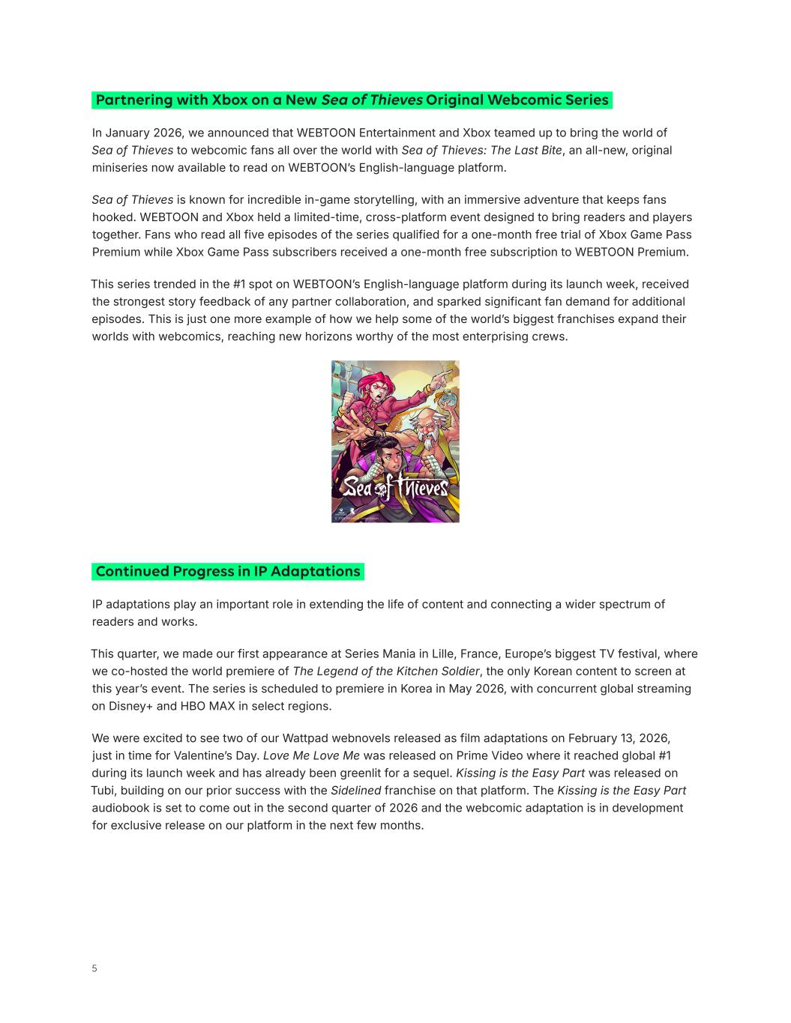
5 In January 2026, we announced that WEBTOON Entertainment and Xbox teamed up to bring the world of Sea of Thieves to webcomic fans all over the world with Sea of Thieves: The Last Bite, an all-new, original miniseries now available to read on WEBTOON’s English-language platform. Sea of Thieves is known for incredible in-game storytelling, with an immersive adventure that keeps fans hooked. WEBTOON and Xbox held a limited-time, cross-platform event designed to bring readers and players together. Fans who read all five episodes of the series qualified for a one-month free trial of Xbox Game Pass Premium while Xbox Game Pass subscribers received a one-month free subscription to WEBTOON Premium. This series trended in the #1 spot on WEBTOON’s English-language platform during its launch week, received the strongest story feedback of any partner collaboration, and sparked significant fan demand for additional episodes. This is just one more example of how we help some of the world’s biggest franchises expand their worlds with webcomics, reaching new horizons worthy of the most enterprising crews. Partnering with Xbox on a New Sea of Thieves Original Webcomic Series IP adaptations play an important role in extending the life of content and connecting a wider spectrum of readers and works. This quarter, we made our first appearance at Series Mania in Lille, France, Europe’s biggest TV festival, where we co-hosted the world premiere of The Legend of the Kitchen Soldier, the only Korean content to screen at this year’s event. The series is scheduled to premiere in Korea in May 2026, with concurrent global streaming on Disney+ and HBO MAX in select regions. We were excited to see two of our Wattpad webnovels released as film adaptations on February 13, 2026, just in time for Valentine’s Day. Love Me Love Me was released on Prime Video where it reached global #1 during its launch week and has already been greenlit for a sequel. Kissing is the Easy Part was released on Tubi, building on our prior success with the Sidelined franchise on that platform. The Kissing is the Easy Part audiobook is set to come out in the second quarter of 2026 and the webcomic adaptation is in development for exclusive release on our platform in the next few months. Continued Progress in IP Adaptations


6 Prime Video Tubi Source: TVING Moving beyond screen adaptations, we are exploring new ways for our users to engage with the platform. We have seen encouraging early results with our AI-enabled Character Chat, which allows users to converse with WEBTOON characters. Our Character Chat precisely analyzes characters' personalities, speech patterns, and story information to stay true to the webcomic. Since launching Character Chat in Korea in June 2024, this feature has accumulated approximately 6 million users, and the cumulative number of messages exchanged between chatbots and users has exceeded 230 million. This service has also proven effective at driving consumption of original WEBTOON series. Among users of the "Seol Hyo-rim" Character Chat from Korea’s Star Three Shop, original episode views increased 97% when comparing one week before and after the chatbot's launch. Over the same period, the number of readers rose by 29%, paying users increased by 22%, and total payment volume increased by 44%. Following positive user engagement in Korea, we launched Character Chat in Japan in February 2026. LINE Manga currently features two characters, with more on the way. We also recently announced a partnership with Genies, a leading avatar company with an established track record of partnering with major sports and entertainment brands including MLB and Sanrio. Through this collaboration, we are developing AI-powered character avatars and digital collectibles that allow fans to engage with their favorite WEBTOON characters in new ways. Creators will have the opportunity to create fully interactive 3D versions of their characters, while fans gain new ways to connect with the stories and worlds they already love. We are targeting a summer 2026 launch for this program, with more details to follow. These character-driven features reflect a deliberate expansion of our move beyond just reading, to create a more engaging relationship between fans, creators, and the characters that bring our platform to life. While still early, we believe both Character Chat and our AI-powered character avatars will allow readers to immerse themselves more deeply into stories and characters, enhancing engagement on the platform. In March, we announced that Yongsoo Kim has been elevated to President to lead global operations. He has also been appointed as a member of the Board of Directors of WEBTOON Entertainment. Since he joined the company in 2022, he has built a successful track record, leading our collaboration with The Walt Disney Company as well as introducing significant initiatives in the U.S. and other key markets outside of Korea and Japan. Transforming our Platform into an Interactive Playground for Fans Recent Leadership Changes Focused on Accelerating Growth and Execution


7 Junkoo Kim Founder & CEO, WEBTOON Entertainment Inc. In Closing I am proud of our continued progress during the first quarter, and I’m excited about the path ahead. As we execute on the foundation we have set for the rest of the year, we will remain focused on driving innovation and growth while staying committed to our mission of democratizing storytelling for creators and users around the world. I am also excited about the strategic progress we have made as a Company and recognition we’ve received for our evolution over the past year. In March, we were named to Fast Company’s annual list of the Most Innovative Companies, appearing at No. 4 in the Media and News category. The recognition underscores our commitment to innovation, our role growing the global creator economy, and the success of our IP & creator ecosystem. This is our second time on this prestigious list, after a previous recognition in 2023. Our success is driven by the dedication of our colleagues, the creativity of our creators, and the passion of our users who come to discover and enjoy their work. We look forward to innovating further to bring even more great stories to everyone around the world. We also introduced other management changes during the quarter to accelerate execution and drive innovation, including shifts from regional structures to integrated global leadership and realigning our tech leadership and structure.

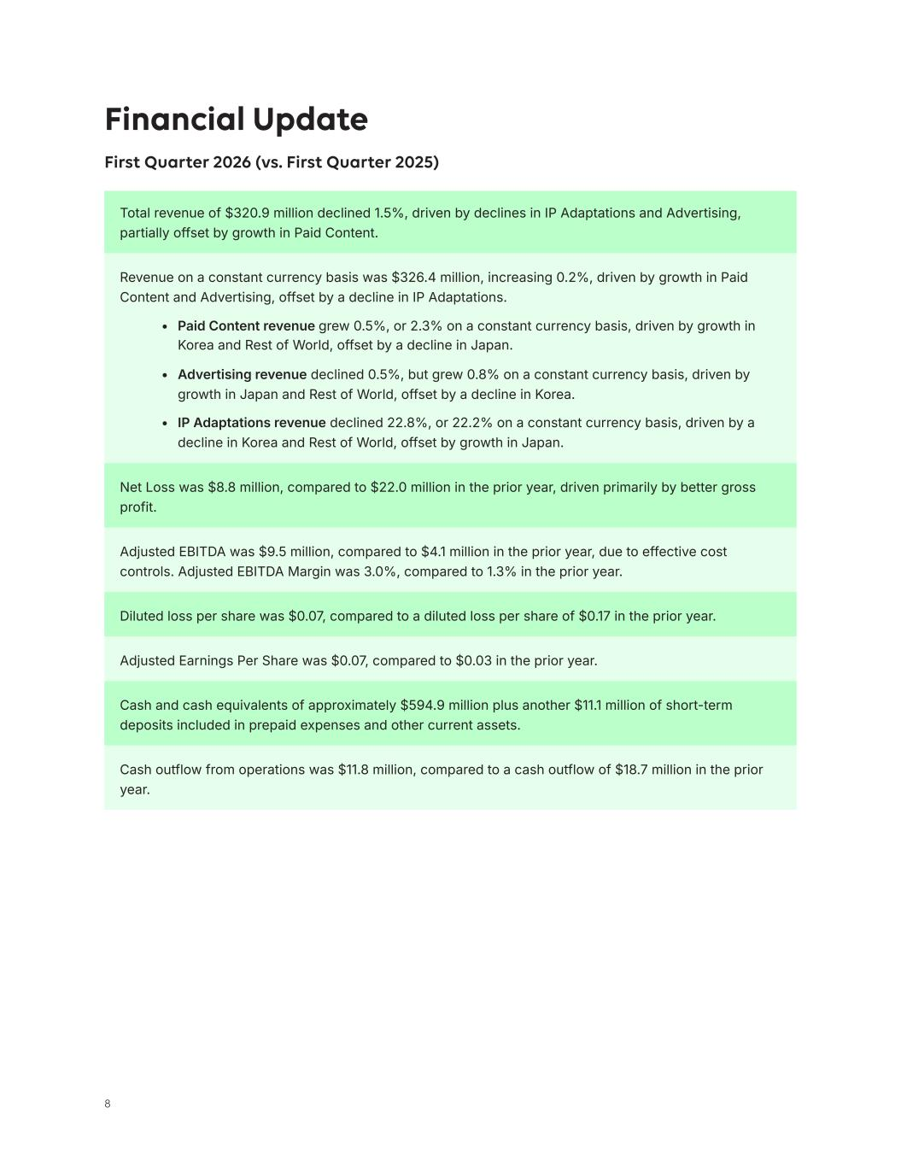
8 Adjusted EBITDA was $9.5 million, compared to $4.1 million in the prior year, due to effective cost controls. Adjusted EBITDA Margin was 3.0%, compared to 1.3% in the prior year. Cash outflow from operations was $11.8 million, compared to a cash outflow of $18.7 million in the prior year. Net Loss was $8.8 million, compared to $22.0 million in the prior year, driven primarily by better gross profit. Total revenue of $320.9 million declined 1.5%, driven by declines in IP Adaptations and Advertising, partially offset by growth in Paid Content. Diluted loss per share was $0.07, compared to a diluted loss per share of $0.17 in the prior year. Adjusted Earnings Per Share was $0.07, compared to $0.03 in the prior year. Cash and cash equivalents of approximately $594.9 million plus another $11.1 million of short-term deposits included in prepaid expenses and other current assets. Revenue on a constant currency basis was $326.4 million, increasing 0.2%, driven by growth in Paid Content and Advertising, offset by a decline in IP Adaptations. • Paid Content revenue grew 0.5%, or 2.3% on a constant currency basis, driven by growth in Korea and Rest of World, offset by a decline in Japan. • Advertising revenue declined 0.5%, but grew 0.8% on a constant currency basis, driven by growth in Japan and Rest of World, offset by a decline in Korea. • IP Adaptations revenue declined 22.8%, or 22.2% on a constant currency basis, driven by a decline in Korea and Rest of World, offset by growth in Japan. Financial Update First Quarter 2026 (vs. First Quarter 2025)

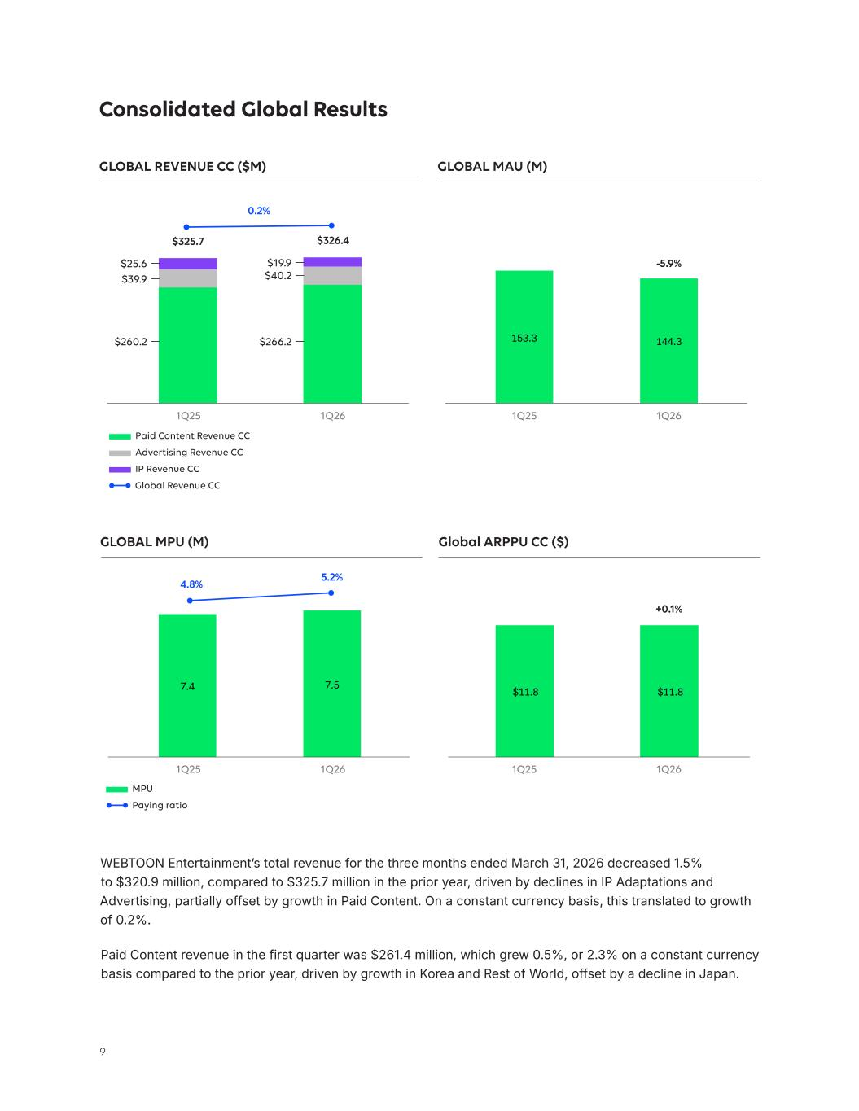
9 $11.8 $11.8 7.4 7.5 153.3 144.3 Consolidated Global Results GLOBAL REVENUE CC ($M) GLOBAL MPU (M) GLOBAL MAU (M) Global ARPPU CC ($) Paid Content Revenue CC $25.6 $19.9 1Q25 1Q25 1Q25 1Q25 1Q26 1Q26 1Q26 1Q26 $39.9 $40.2 $260.2 $266.2 Advertising Revenue CC IP Revenue CC MPU Paying ratio -5.9% $326.4$325.7 0.2% +0.1% WEBTOON Entertainment’s total revenue for the three months ended March 31, 2026 decreased 1.5% to $320.9 million, compared to $325.7 million in the prior year, driven by declines in IP Adaptations and Advertising, partially offset by growth in Paid Content. On a constant currency basis, this translated to growth of 0.2%. Paid Content revenue in the first quarter was $261.4 million, which grew 0.5%, or 2.3% on a constant currency basis compared to the prior year, driven by growth in Korea and Rest of World, offset by a decline in Japan. 4.8% 5.2% Global Revenue CC

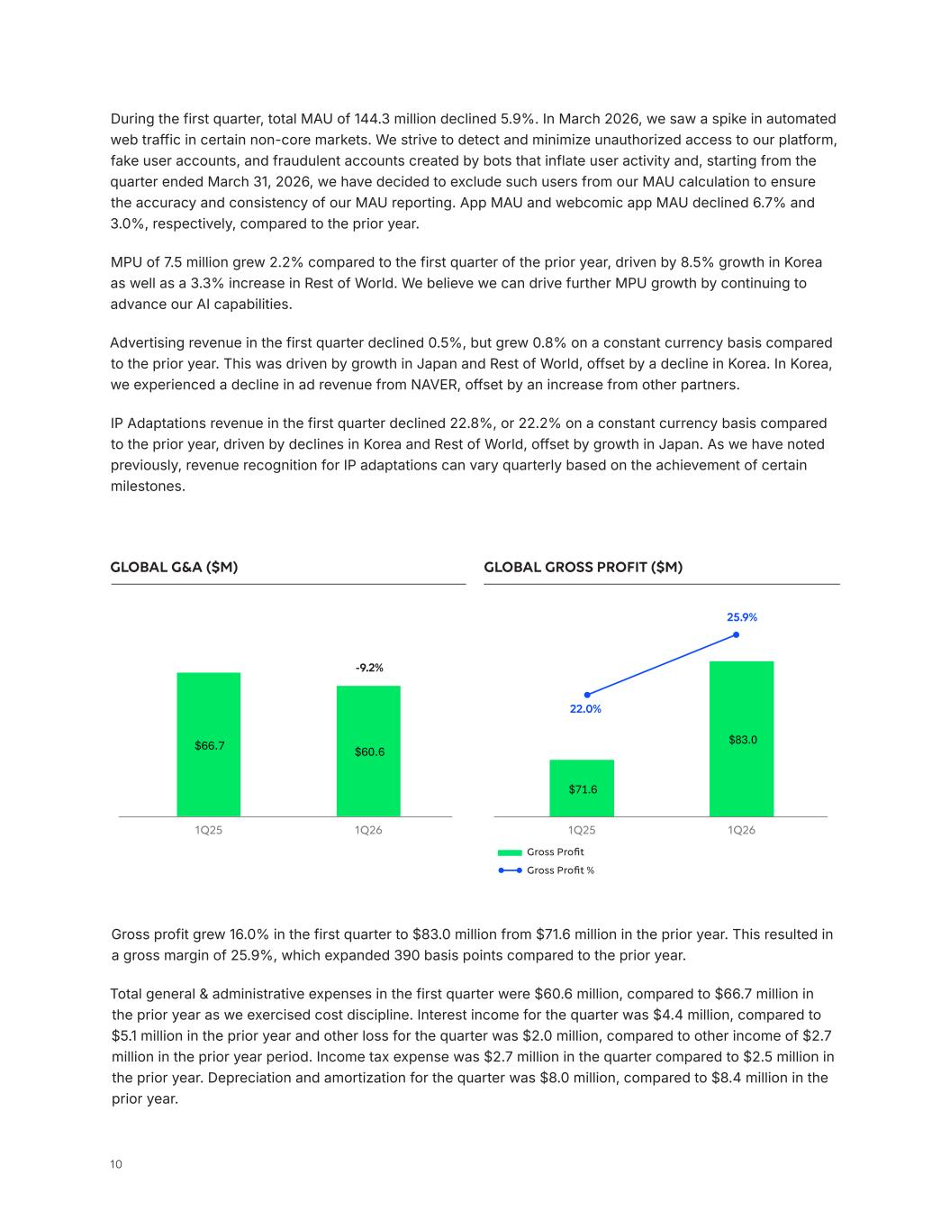
10 $71.6 $83.0 $66.7 $60.6 During the first quarter, total MAU of 144.3 million declined 5.9%. In March 2026, we saw a spike in automated web traffic in certain non-core markets. We strive to detect and minimize unauthorized access to our platform, fake user accounts, and fraudulent accounts created by bots that inflate user activity and, starting from the quarter ended March 31, 2026, we have decided to exclude such users from our MAU calculation to ensure the accuracy and consistency of our MAU reporting. App MAU and webcomic app MAU declined 6.7% and 3.0%, respectively, compared to the prior year. MPU of 7.5 million grew 2.2% compared to the first quarter of the prior year, driven by 8.5% growth in Korea as well as a 3.3% increase in Rest of World. We believe we can drive further MPU growth by continuing to advance our AI capabilities. Advertising revenue in the first quarter declined 0.5%, but grew 0.8% on a constant currency basis compared to the prior year. This was driven by growth in Japan and Rest of World, offset by a decline in Korea. In Korea, we experienced a ​decline in ad revenue from NAVER, offset by an increase from other partners. IP Adaptations revenue in the first quarter declined 22.8%, or 22.2% on a constant currency basis compared to the prior year, driven by declines in Korea and Rest of World, offset by growth in Japan. As we have noted previously, revenue recognition for IP adaptations can vary quarterly based on the achievement of certain milestones. Gross Profit Gross Profit % -9.2% 22.0% 25.9% GLOBAL G&A ($M) GLOBAL GROSS PROFIT ($M) Gross profit grew 16.0% in the first quarter to $83.0 million from $71.6 million in the prior year. This resulted in a gross margin of 25.9%, which expanded 390 basis points compared to the prior year. Total general & administrative expenses in the first quarter were $60.6 million, compared to $66.7 million in the prior year as we exercised cost discipline. Interest income for the quarter was $4.4 million, compared to $5.1 million in the prior year and other loss for the quarter was $2.0 million, compared to other income of $2.7 million in the prior year period. Income tax expense was $2.7 million in the quarter compared to $2.5 million in the prior year. Depreciation and amortization for the quarter was $8.0 million, compared to $8.4 million in the prior year. 1Q25 1Q251Q26 1Q26

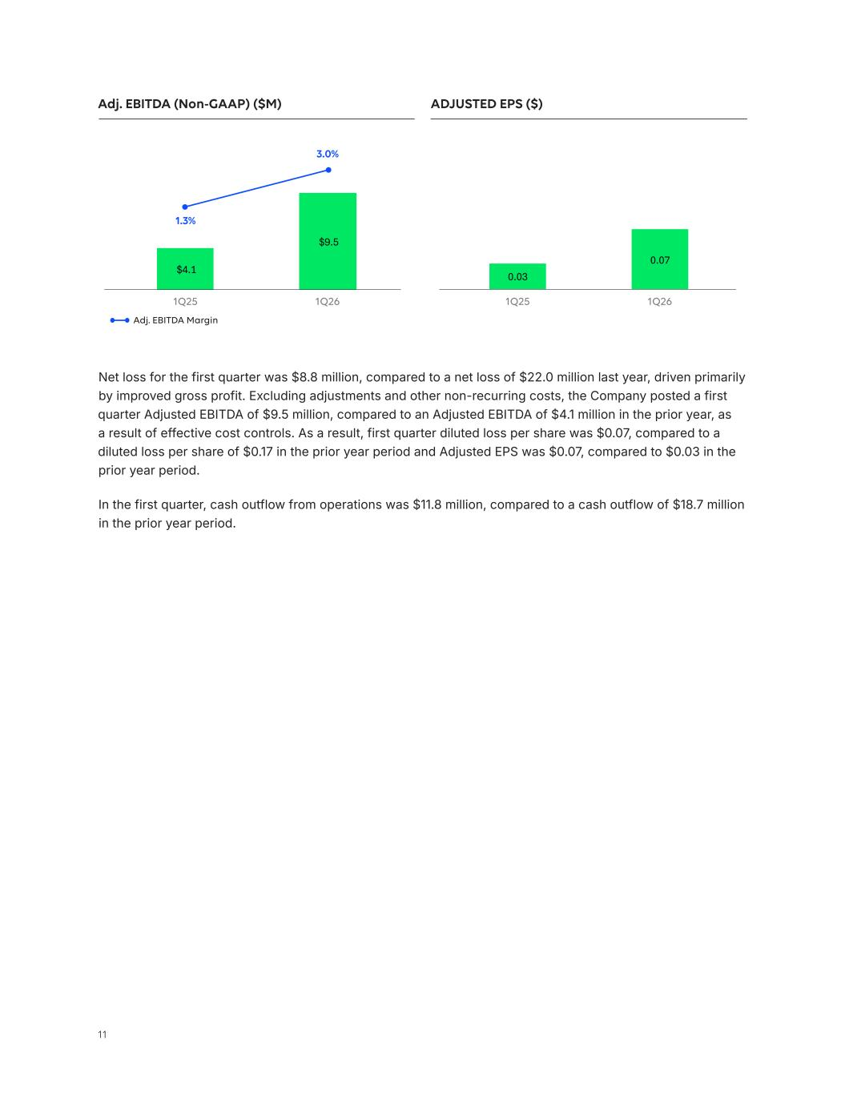
11 0.03 0.07 1Q25 1Q26 $4.1 $9.5 1Q25 1Q26 Net loss for the first quarter was $8.8 million, compared to a net loss of $22.0 million last year, driven primarily by improved gross profit. Excluding adjustments and other non-recurring costs, the Company posted a first quarter Adjusted EBITDA of $9.5 million, compared to an Adjusted EBITDA of $4.1 million in the prior year, as a result of effective cost controls. As a result, first quarter diluted loss per share was $0.07, compared to a diluted loss per share of $0.17 in the prior year period and Adjusted EPS was $0.07, compared to $0.03 in the prior year period. In the first quarter, cash outflow from operations was $11.8 million, compared to a cash outflow of $18.7 million in the prior year period. Adj. EBITDA Margin Adj. EBITDA (Non-GAAP) ($M) ADJUSTED EPS ($) 1.3% 3.0%

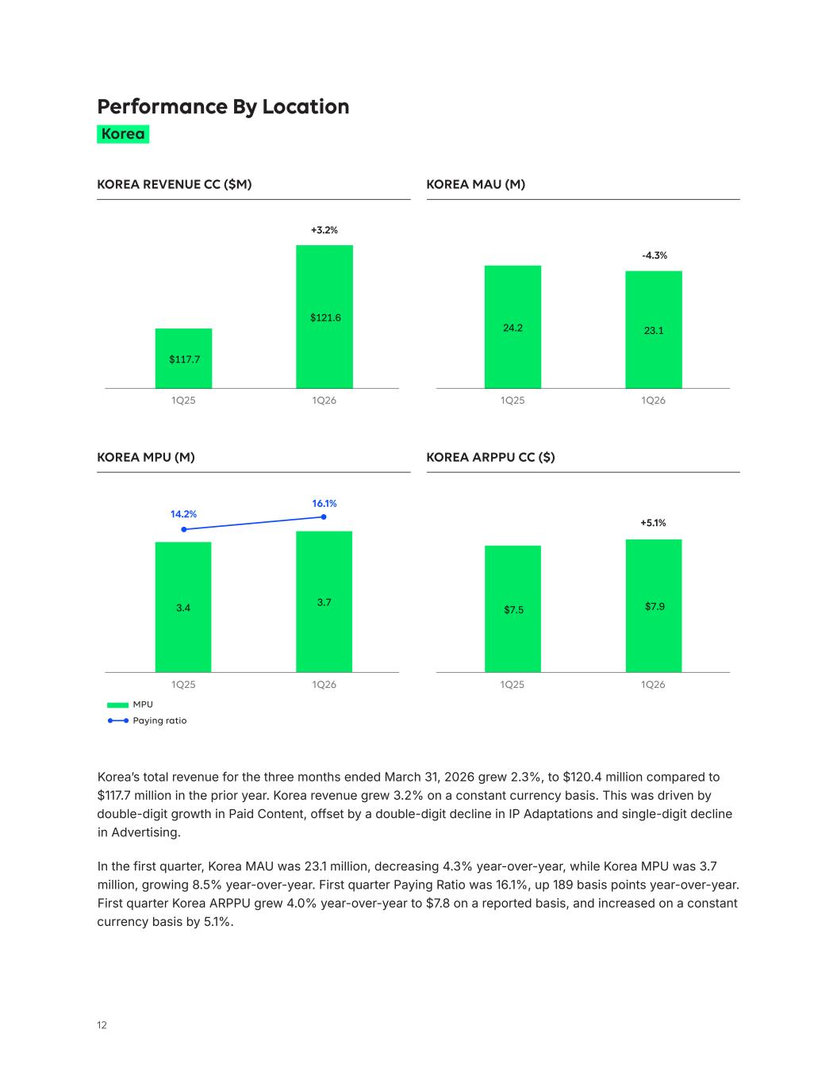
12 $117.7 $121.6 $7.5 $7.9 3.4 3.7 24.2 23.1 +5.1% KOREA MPU (M) KOREA ARPPU CC ($) MPU Paying ratio Korea’s total revenue for the three months ended March 31, 2026 grew 2.3%, to $120.4 million compared to $117.7 million in the prior year. Korea revenue grew 3.2% on a constant currency basis. This was driven by double-digit growth in Paid Content, offset by a double-digit decline in IP Adaptations and single-digit decline in Advertising. In the first quarter, Korea MAU was 23.1 million, decreasing 4.3% year-over-year, while Korea MPU was 3.7 million, growing 8.5% year-over-year. First quarter Paying Ratio was 16.1%, up 189 basis points year-over-year. First quarter Korea ARPPU grew 4.0% year-over-year to $7.8 on a reported basis, and increased on a constant currency basis by 5.1%. Korea Performance By Location KOREA REVENUE CC ($M) KOREA MAU (M) +3.2% -4.3% 14.2% 16.1% 1Q25 1Q25 1Q251Q26 1Q26 1Q26 1Q261Q25

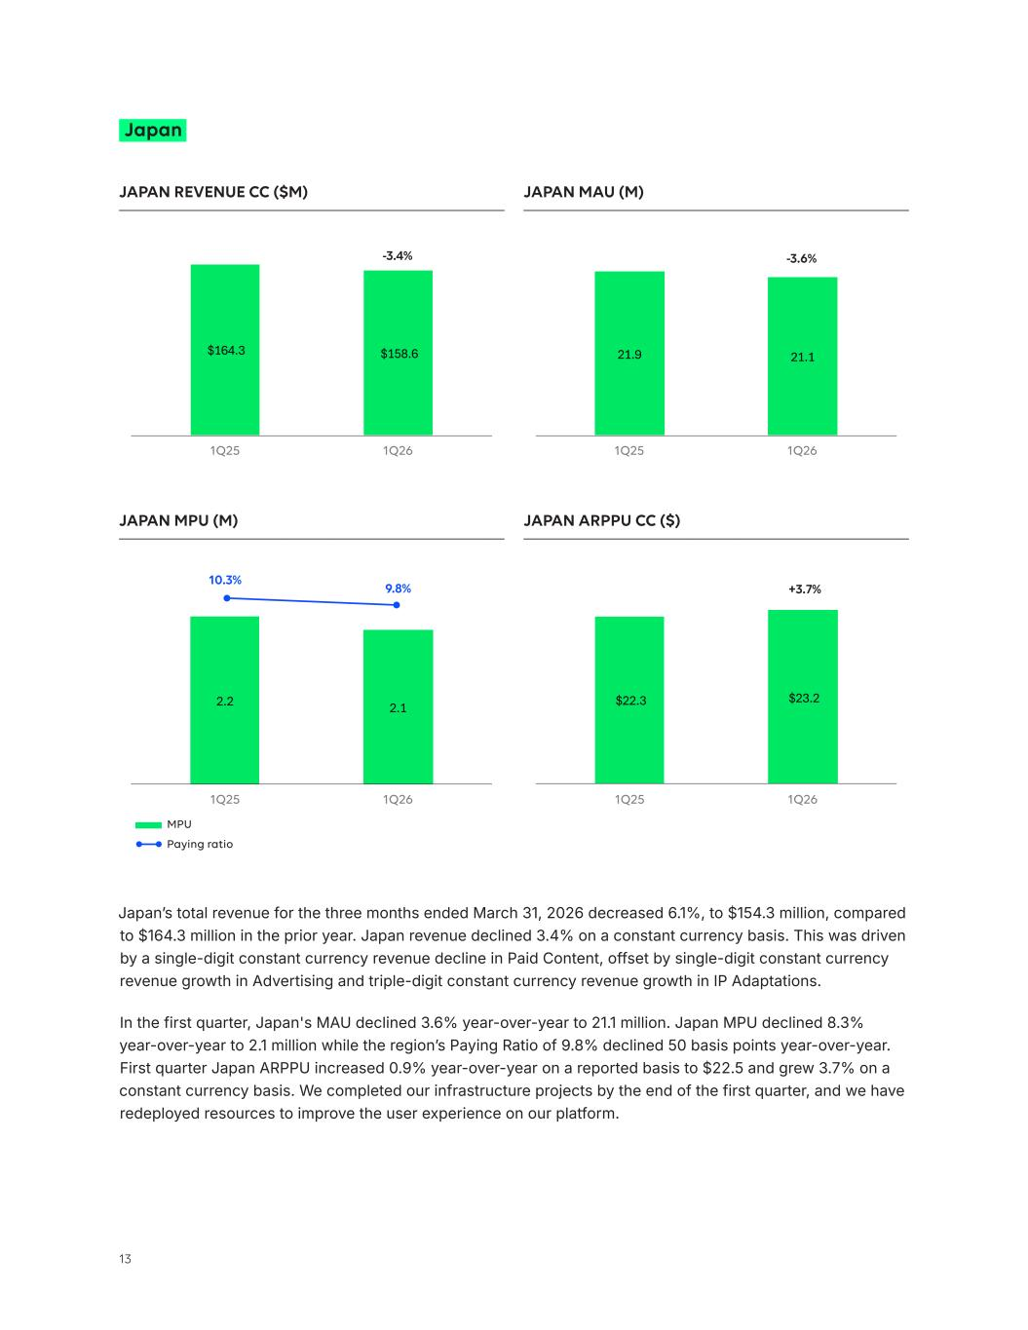
13 $22.3 $23.2 2.2 2.1 21.9 21.1$164.3 $158.6 -3.6% JAPAN REVENUE CC ($M) JAPAN MAU (M) JAPAN MPU (M) JAPAN ARPPU CC ($) MPU Paying ratio +3.7% Japan -3.4% 10.3% 9.8% Japan’s total revenue for the three months ended March 31, 2026 decreased 6.1%, to $154.3 million, compared to $164.3 million in the prior year. Japan revenue declined 3.4% on a constant currency basis. This was driven by a single-digit constant currency revenue decline in Paid Content, offset by single-digit constant currency revenue growth in Advertising and triple-digit constant currency revenue growth in IP Adaptations. In the first quarter, Japan's MAU declined 3.6% year-over-year to 21.1 million. Japan MPU declined 8.3% year-over-year to 2.1 million while the region’s Paying Ratio of 9.8% declined 50 basis points year-over-year. First quarter Japan ARPPU increased 0.9% year-over-year on a reported basis to $22.5 and grew 3.7% on a constant currency basis. We completed our infrastructure projects by the end of the first quarter, and we have redeployed resources to improve the user experience on our platform. 1Q25 1Q25 1Q25 1Q251Q26 1Q26 1Q26 1Q26

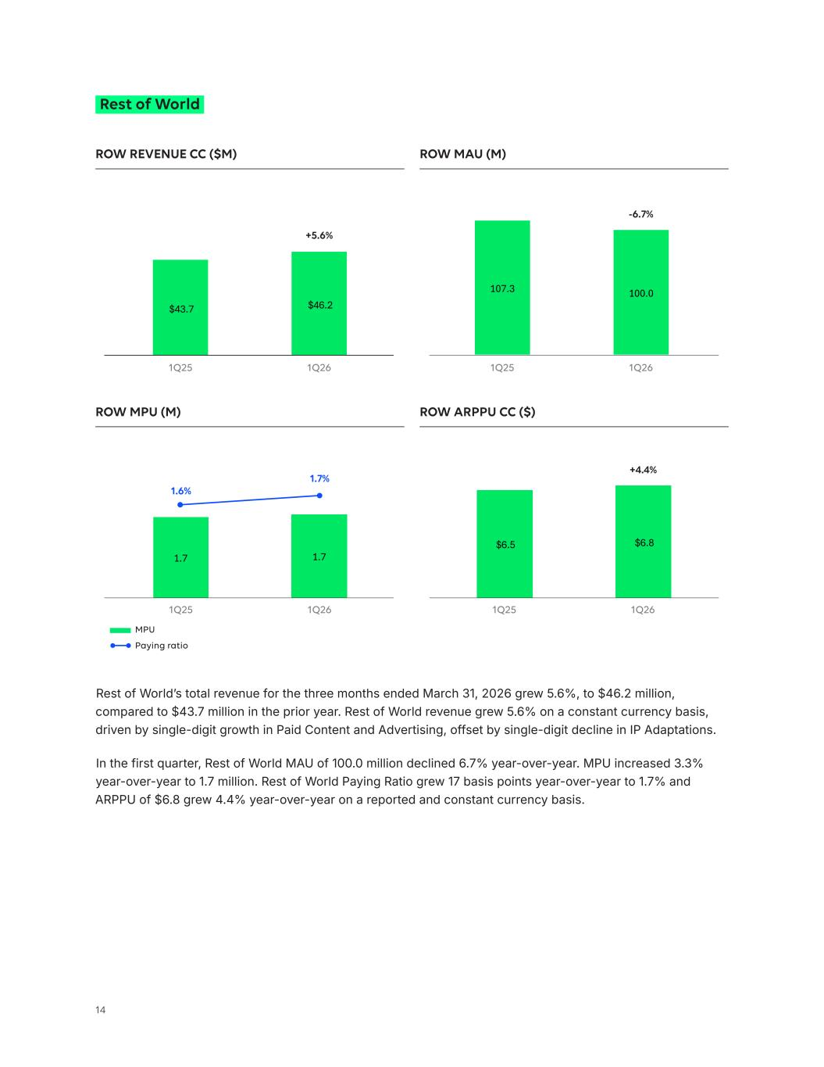
14 $43.7 $46.2 $6.5 $6.8 1.7 1.7 107.3 100.0 ROW REVENUE CC ($M) ROW MAU (M) -6.7% Rest of World +5.6% Rest of World’s total revenue for the three months ended March 31, 2026 grew 5.6%, to $46.2 million, compared to $43.7 million in the prior year. Rest of World revenue grew 5.6% on a constant currency basis, driven by single-digit growth in Paid Content and Advertising, offset by single-digit decline in IP Adaptations. In the first quarter, Rest of World MAU of 100.0 million declined 6.7% year-over-year. MPU increased 3.3% year-over-year to 1.7 million. Rest of World Paying Ratio grew 17 basis points year-over-year to 1.7% and ARPPU of $6.8 grew 4.4% year-over-year on a reported and constant currency basis. ROW MPU (M) ROW ARPPU CC ($) MPU Paying ratio +4.4% 1.6% 1.7% 1Q25 1Q251Q26 1Q26 1Q25 1Q251Q26 1Q26

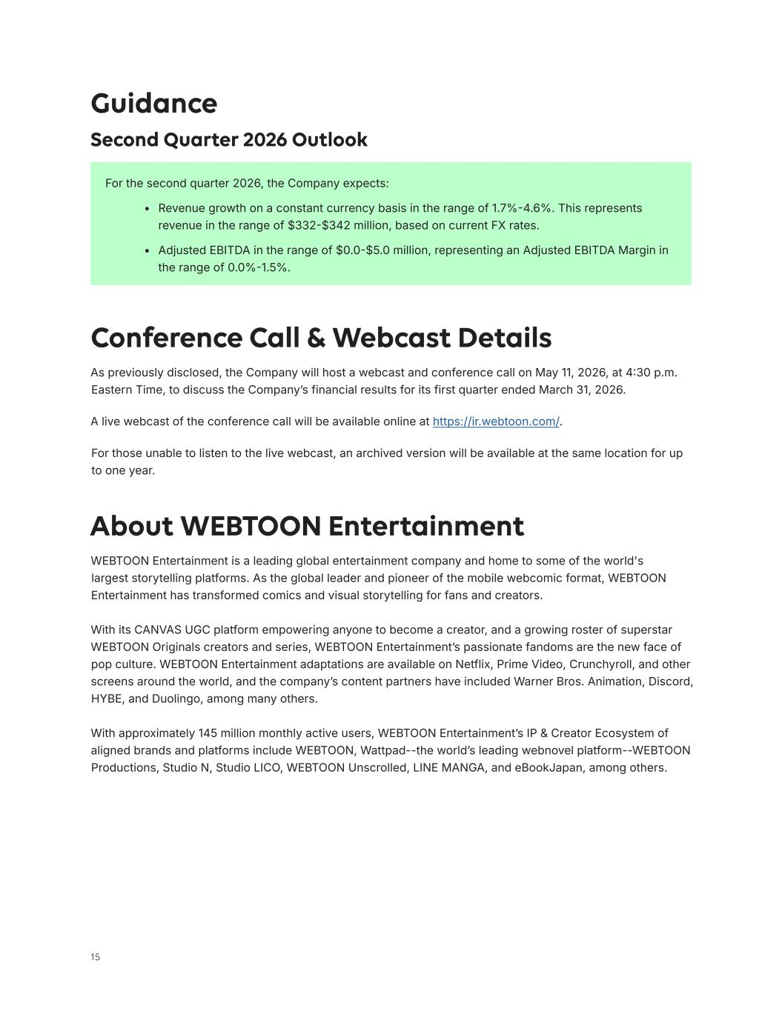
15 For the second quarter 2026, the Company expects: • Revenue growth on a constant currency basis in the range of 1.7%-4.6%. This represents revenue in the range of $332-$342 million, based on current FX rates. • Adjusted EBITDA in the range of $0.0-$5.0 million, representing an Adjusted EBITDA Margin in the range of 0.0%-1.5%. Guidance Second Quarter 2026 Outlook About WEBTOON Entertainment WEBTOON Entertainment is a leading global entertainment company and home to some of the world's largest storytelling platforms. As the global leader and pioneer of the mobile webcomic format, WEBTOON Entertainment has transformed comics and visual storytelling for fans and creators. With its CANVAS UGC platform empowering anyone to become a creator, and a growing roster of superstar WEBTOON Originals creators and series, WEBTOON Entertainment’s passionate fandoms are the new face of pop culture. WEBTOON Entertainment adaptations are available on Netflix, Prime Video, Crunchyroll, and other screens around the world, and the company’s content partners have included Warner Bros. Animation, Discord, HYBE, and Duolingo, among many others. With approximately 145 million monthly active users, WEBTOON Entertainment’s IP & Creator Ecosystem of aligned brands and platforms include WEBTOON, Wattpad--the world’s leading webnovel platform--WEBTOON Productions, Studio N, Studio LICO, WEBTOON Unscrolled, LINE MANGA, and eBookJapan, among others. Conference Call & Webcast Details As previously disclosed, the Company will host a webcast and conference call on May 11, 2026, at 4:30 p.m. Eastern Time, to discuss the Company’s financial results for its first quarter ended March 31, 2026. A live webcast of the conference call will be available online at https://ir.webtoon.com/. For those unable to listen to the live webcast, an archived version will be available at the same location for up to one year.

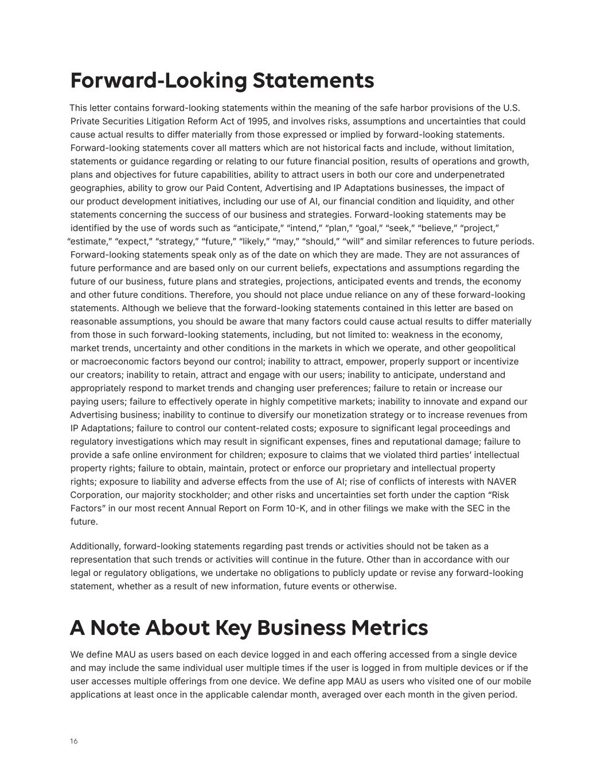
16 Forward-Looking Statements This letter contains forward-looking statements within the meaning of the safe harbor provisions of the U.S. Private Securities Litigation Reform Act of 1995, and involves risks, assumptions and uncertainties that could cause actual results to differ materially from those expressed or implied by forward-looking statements. Forward-looking statements cover all matters which are not historical facts and include, without limitation, statements or guidance regarding or relating to our future financial position, results of operations and growth, plans and objectives for future capabilities, ability to attract users in both our core and underpenetrated geographies, ability to grow our Paid Content, Advertising and IP Adaptations businesses, the impact of our product development initiatives, including our use of AI, our financial condition and liquidity, and other statements concerning the success of our business and strategies. Forward-looking statements may be identified by the use of words such as “anticipate,” “intend,” “plan,” “goal,” “seek,” “believe,” “project,” “estimate,” “expect,” “strategy,” “future,” “likely,” “may,” “should,” “will” and similar references to future periods. Forward-looking statements speak only as of the date on which they are made. They are not assurances of future performance and are based only on our current beliefs, expectations and assumptions regarding the future of our business, future plans and strategies, projections, anticipated events and trends, the economy and other future conditions. Therefore, you should not place undue reliance on any of these forward-looking statements. Although we believe that the forward-looking statements contained in this letter are based on reasonable assumptions, you should be aware that many factors could cause actual results to differ materially from those in such forward-looking statements, including, but not limited to: weakness in the economy, market trends, uncertainty and other conditions in the markets in which we operate, and other geopolitical or macroeconomic factors beyond our control; inability to attract, empower, properly support or incentivize our creators; inability to retain, attract and engage with our users; inability to anticipate, understand and appropriately respond to market trends and changing user preferences; failure to retain or increase our paying users; failure to effectively operate in highly competitive markets; inability to innovate and expand our Advertising business; inability to continue to diversify our monetization strategy or to increase revenues from IP Adaptations; failure to control our content-related costs; exposure to significant legal proceedings and regulatory investigations which may result in significant expenses, fines and reputational damage; failure to provide a safe online environment for children; exposure to claims that we violated third parties’ intellectual property rights; failure to obtain, maintain, protect or enforce our proprietary and intellectual property rights; exposure to liability and adverse effects from the use of AI; rise of conflicts of interests with NAVER Corporation, our majority stockholder; and other risks and uncertainties set forth under the caption “Risk Factors” in our most recent Annual Report on Form 10-K, and in other filings we make with the SEC in the future. Additionally, forward-looking statements regarding past trends or activities should not be taken as a representation that such trends or activities will continue in the future. Other than in accordance with our legal or regulatory obligations, we undertake no obligations to publicly update or revise any forward-looking statement, whether as a result of new information, future events or otherwise. A Note About Key Business Metrics We define MAU as users based on each device logged in and each offering accessed from a single device and may include the same individual user multiple times if the user is logged in from multiple devices or if the user accesses multiple offerings from one device. We define app MAU as users who visited one of our mobile applications at least once in the applicable calendar month, averaged over each month in the given period.

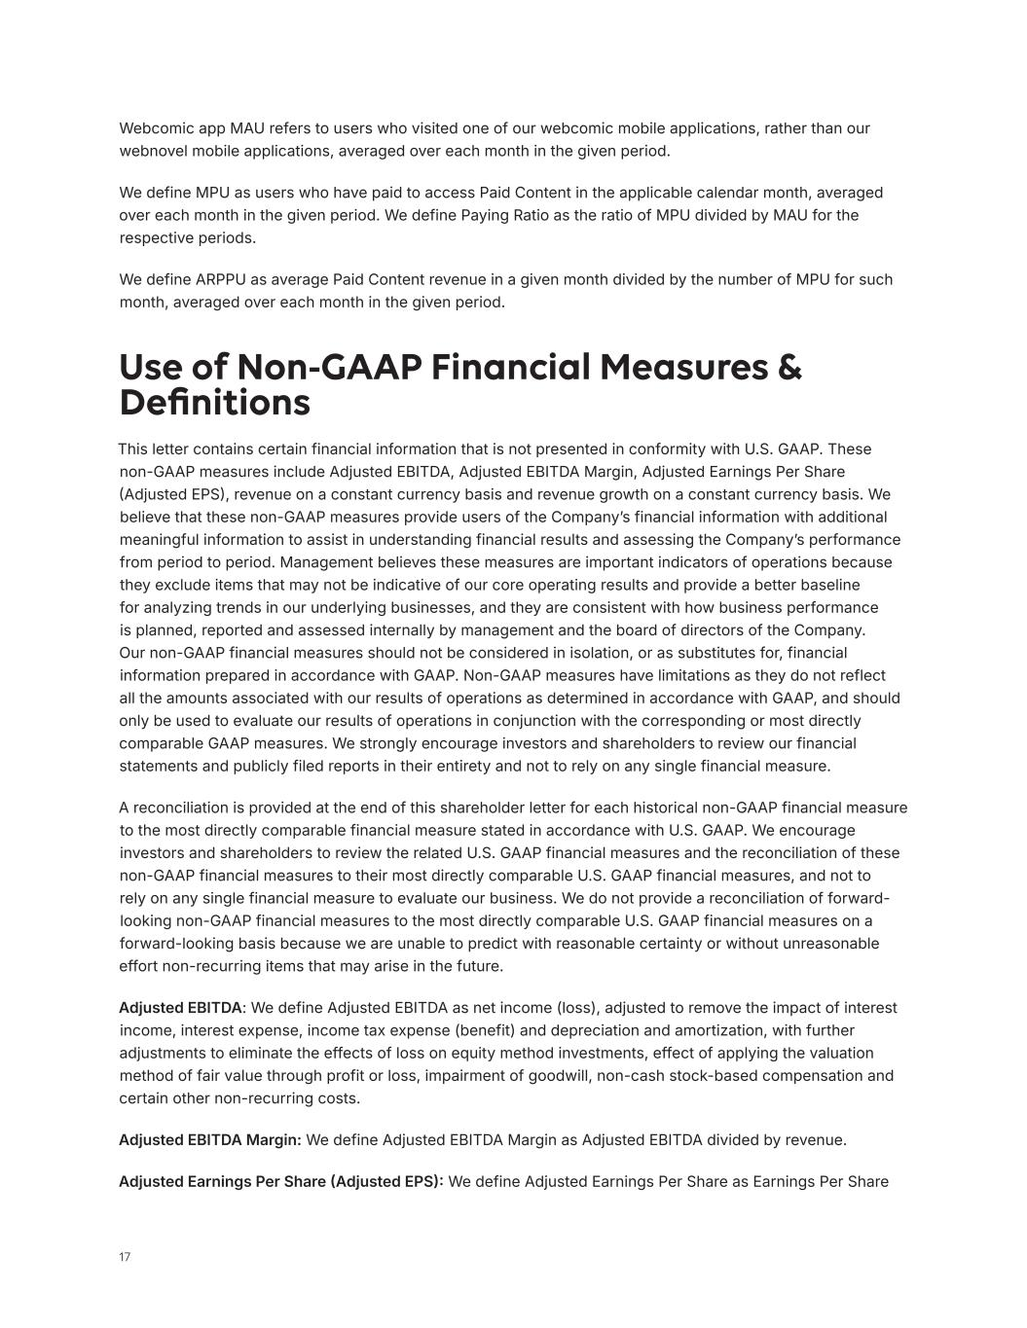
17 Use of Non-GAAP Financial Measures & Definitions This letter contains certain financial information that is not presented in conformity with U.S. GAAP. These non-GAAP measures include Adjusted EBITDA, Adjusted EBITDA Margin, Adjusted Earnings Per Share (Adjusted EPS), revenue on a constant currency basis and revenue growth on a constant currency basis. We believe that these non-GAAP measures provide users of the Company’s financial information with additional meaningful information to assist in understanding financial results and assessing the Company’s performance from period to period. Management believes these measures are important indicators of operations because they exclude items that may not be indicative of our core operating results and provide a better baseline for analyzing trends in our underlying businesses, and they are consistent with how business performance is planned, reported and assessed internally by management and the board of directors of the Company. Our non-GAAP financial measures should not be considered in isolation, or as substitutes for, financial information prepared in accordance with GAAP. Non-GAAP measures have limitations as they do not reflect all the amounts associated with our results of operations as determined in accordance with GAAP, and should only be used to evaluate our results of operations in conjunction with the corresponding or most directly comparable GAAP measures. We strongly encourage investors and shareholders to review our financial statements and publicly filed reports in their entirety and not to rely on any single financial measure. A reconciliation is provided at the end of this shareholder letter for each historical non-GAAP financial measure to the most directly comparable financial measure stated in accordance with U.S. GAAP. We encourage investors and shareholders to review the related U.S. GAAP financial measures and the reconciliation of these non-GAAP financial measures to their most directly comparable U.S. GAAP financial measures, and not to rely on any single financial measure to evaluate our business. We do not provide a reconciliation of forward- looking non-GAAP financial measures to the most directly comparable U.S. GAAP financial measures on a forward-looking basis because we are unable to predict with reasonable certainty or without unreasonable effort non-recurring items that may arise in the future. Adjusted EBITDA: We define Adjusted EBITDA as net income (loss), adjusted to remove the impact of interest income, interest expense, income tax expense (benefit) and depreciation and amortization, with further adjustments to eliminate the effects of loss on equity method investments, effect of applying the valuation method of fair value through profit or loss, impairment of goodwill, non-cash stock-based compensation and certain other non-recurring costs. Adjusted EBITDA Margin: We define Adjusted EBITDA Margin as Adjusted EBITDA divided by revenue. Adjusted Earnings Per Share (Adjusted EPS): We define Adjusted Earnings Per Share as Earnings Per Share Webcomic app MAU refers to users who visited one of our webcomic mobile applications, rather than our webnovel mobile applications, averaged over each month in the given period. We define MPU as users who have paid to access Paid Content in the applicable calendar month, averaged over each month in the given period. We define Paying Ratio as the ratio of MPU divided by MAU for the respective periods. We define ARPPU as average Paid Content revenue in a given month divided by the number of MPU for such month, averaged over each month in the given period.

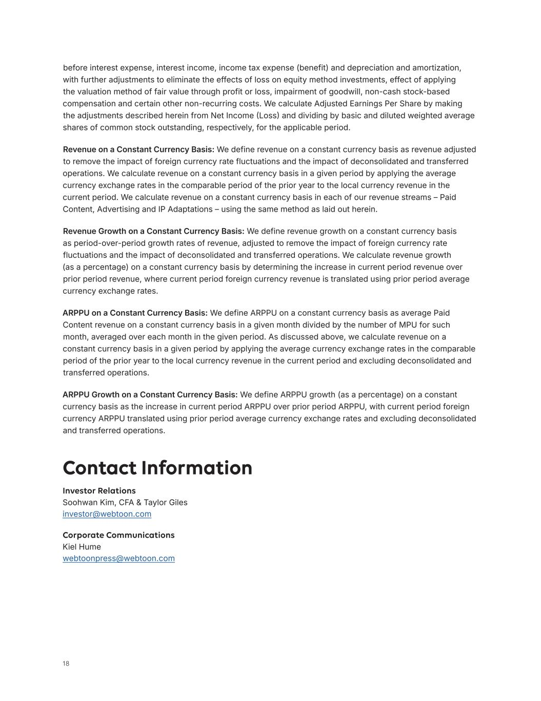
18 before interest expense, interest income, income tax expense (benefit) and depreciation and amortization, with further adjustments to eliminate the effects of loss on equity method investments, effect of applying the valuation method of fair value through profit or loss, impairment of goodwill, non-cash stock-based compensation and certain other non-recurring costs. We calculate Adjusted Earnings Per Share by making the adjustments described herein from Net Income (Loss) and dividing by basic and diluted weighted average shares of common stock outstanding, respectively, for the applicable period. Revenue on a Constant Currency Basis: We define revenue on a constant currency basis as revenue adjusted to remove the impact of foreign currency rate fluctuations and the impact of deconsolidated and transferred operations. We calculate revenue on a constant currency basis in a given period by applying the average currency exchange rates in the comparable period of the prior year to the local currency revenue in the current period. We calculate revenue on a constant currency basis in each of our revenue streams – Paid Content, Advertising and IP Adaptations – using the same method as laid out herein. Revenue Growth on a Constant Currency Basis: We define revenue growth on a constant currency basis as period-over-period growth rates of revenue, adjusted to remove the impact of foreign currency rate fluctuations and the impact of deconsolidated and transferred operations. We calculate revenue growth (as a percentage) on a constant currency basis by determining the increase in current period revenue over prior period revenue, where current period foreign currency revenue is translated using prior period average currency exchange rates. ARPPU on a Constant Currency Basis: We define ARPPU on a constant currency basis as average Paid Content revenue on a constant currency basis in a given month divided by the number of MPU for such month, averaged over each month in the given period. As discussed above, we calculate revenue on a constant currency basis in a given period by applying the average currency exchange rates in the comparable period of the prior year to the local currency revenue in the current period and excluding deconsolidated and transferred operations. ARPPU Growth on a Constant Currency Basis: We define ARPPU growth (as a percentage) on a constant currency basis as the increase in current period ARPPU over prior period ARPPU, with current period foreign currency ARPPU translated using prior period average currency exchange rates and excluding deconsolidated and transferred operations. Contact Information Investor Relations Corporate Communications Soohwan Kim, CFA & Taylor Giles investor@webtoon.com Kiel Hume webtoonpress@webtoon.com

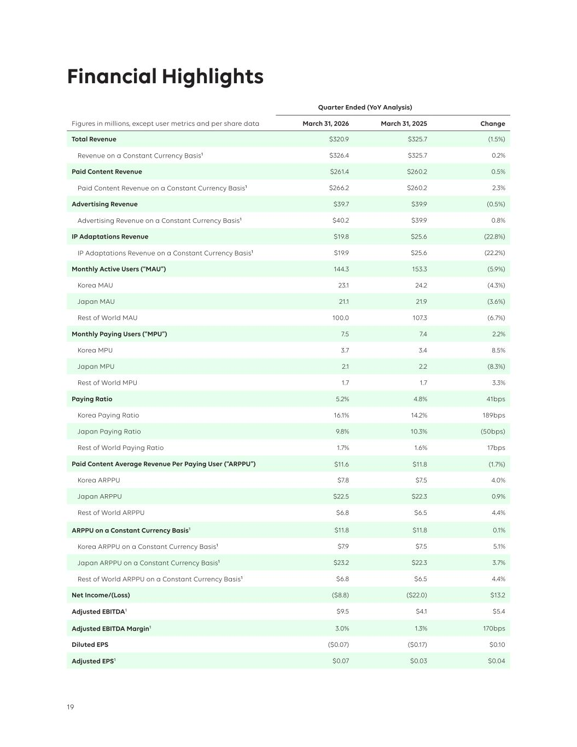
19 Quarter Ended (YoY Analysis) Figures in millions, except user metrics and per share data March 31, 2026 March 31, 2025 Change Total Revenue $320.9 $325.7 (1.5%) Revenue on a Constant Currency Basis1 $326.4 $325.7 0.2% Paid Content Revenue $261.4 $260.2 0.5% Paid Content Revenue on a Constant Currency Basis1 $266.2 $260.2 2.3% Advertising Revenue $39.7 $39.9 (0.5%) Advertising Revenue on a Constant Currency Basis1 $40.2 $39.9 0.8% IP Adaptations Revenue $19.8 $25.6 (22.8%) IP Adaptations Revenue on a Constant Currency Basis1 $19.9 $25.6 (22.2%) Monthly Active Users (“MAU”) 144.3 153.3 (5.9%) Korea MAU 23.1 24.2 (4.3%) Japan MAU 21.1 21.9 (3.6%) Rest of World MAU 100.0 107.3 (6.7%) Monthly Paying Users (“MPU”) 7.5 7.4 2.2% Korea MPU 3.7 3.4 8.5% Japan MPU 2.1 2.2 (8.3%) Rest of World MPU 1.7 1.7 3.3% Paying Ratio 5.2% 4.8% 41bps Korea Paying Ratio 16.1% 14.2% 189bps Japan Paying Ratio 9.8% 10.3% (50bps) Rest of World Paying Ratio 1.7% 1.6% 17bps Paid Content Average Revenue Per Paying User (“ARPPU”) $11.6 $11.8 (1.7%) Korea ARPPU $7.8 $7.5 4.0% Japan ARPPU $22.5 $22.3 0.9% Rest of World ARPPU $6.8 $6.5 4.4% ARPPU on a Constant Currency Basis1 $11.8 $11.8 0.1% Korea ARPPU on a Constant Currency Basis1 $7.9 $7.5 5.1% Japan ARPPU on a Constant Currency Basis1 $23.2 $22.3 3.7% Rest of World ARPPU on a Constant Currency Basis1 $6.8 $6.5 4.4% Net Income/(Loss) ($8.8) ($22.0) $13.2 Adjusted EBITDA1 $9.5 $4.1 $5.4 Adjusted EBITDA Margin1 3.0% 1.3% 170bps Diluted EPS ($0.07) ($0.17) $0.10 Adjusted EPS1 $0.07 $0.03 $0.04 Financial Highlights


20 1 Revenue on a constant currency basis, Paid Content revenue on a constant currency basis, Advertising revenue on a constant currency basis, IP Adaptations revenue on a constant currency basis, ARPPU on a constant currency basis, Korea ARPPU on a constant currency basis, Japan ARPPU on a constant currency basis, Rest of World ARPPU on a constant currency basis, Adjusted EBITDA, Adjusted EBITDA Margin and Adjusted EPS are non-GAAP financial measures. For definitions of these non-GAAP financial measures, see “Non-GAAP Financial Measures & Definitions” of this letter. A reconciliation of non-GAAP financial measures to the most directly comparable U.S. GAAP measure can be found at the end of this letter.

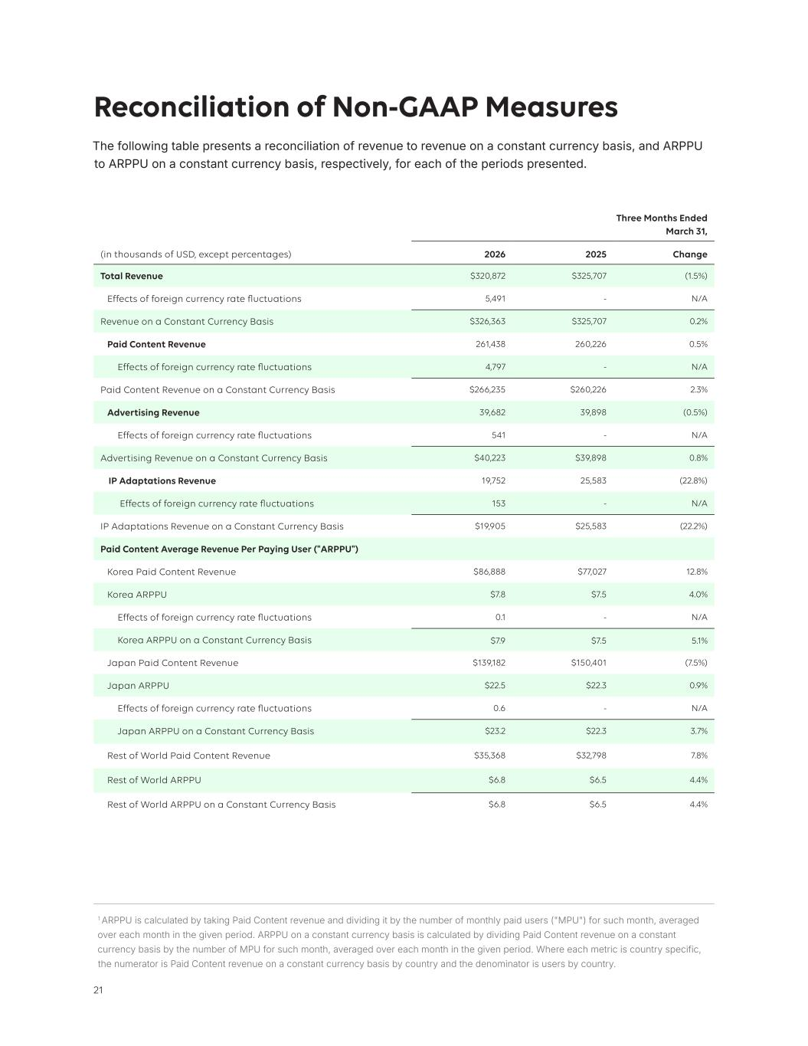
21 Reconciliation of Non-GAAP Measures The following table presents a reconciliation of revenue to revenue on a constant currency basis, and ARPPU to ARPPU on a constant currency basis, respectively, for each of the periods presented. Three Months Ended March 31, (in thousands of USD, except percentages) 2026 2025 Change Total Revenue $320,872 $325,707 (1.5%) Effects of foreign currency rate fluctuations 5,491 - N/A Revenue on a Constant Currency Basis $326,363 $325,707 0.2% Paid Content Revenue 261,438 260,226 0.5% Effects of foreign currency rate fluctuations 4,797 - N/A Paid Content Revenue on a Constant Currency Basis $266,235 $260,226 2.3% Advertising Revenue 39,682 39,898 (0.5%) Effects of foreign currency rate fluctuations 541 - N/A Advertising Revenue on a Constant Currency Basis $40,223 $39,898 0.8% IP Adaptations Revenue 19,752 25,583 (22.8%) Effects of foreign currency rate fluctuations 153 - N/A IP Adaptations Revenue on a Constant Currency Basis $19,905 $25,583 (22.2%) Paid Content Average Revenue Per Paying User ("ARPPU") Korea Paid Content Revenue $86,888 $77,027 12.8% Korea ARPPU $7.8 $7.5 4.0% Effects of foreign currency rate fluctuations 0.1 - N/A Korea ARPPU on a Constant Currency Basis $7.9 $7.5 5.1% Japan Paid Content Revenue $139,182 $150,401 (7.5%) Japan ARPPU $22.5 $22.3 0.9% Effects of foreign currency rate fluctuations 0.6 - N/A Japan ARPPU on a Constant Currency Basis $23.2 $22.3 3.7% Rest of World Paid Content Revenue $35,368 $32,798 7.8% Rest of World ARPPU $6.8 $6.5 4.4% Rest of World ARPPU on a Constant Currency Basis $6.8 $6.5 4.4% 1 ARPPU is calculated by taking Paid Content revenue and dividing it by the number of monthly paid users ("MPU") for such month, averaged over each month in the given period. ARPPU on a constant currency basis is calculated by dividing Paid Content revenue on a constant currency basis by the number of MPU for such month, averaged over each month in the given period. Where each metric is country specific, the numerator is Paid Content revenue on a constant currency basis by country and the denominator is users by country.

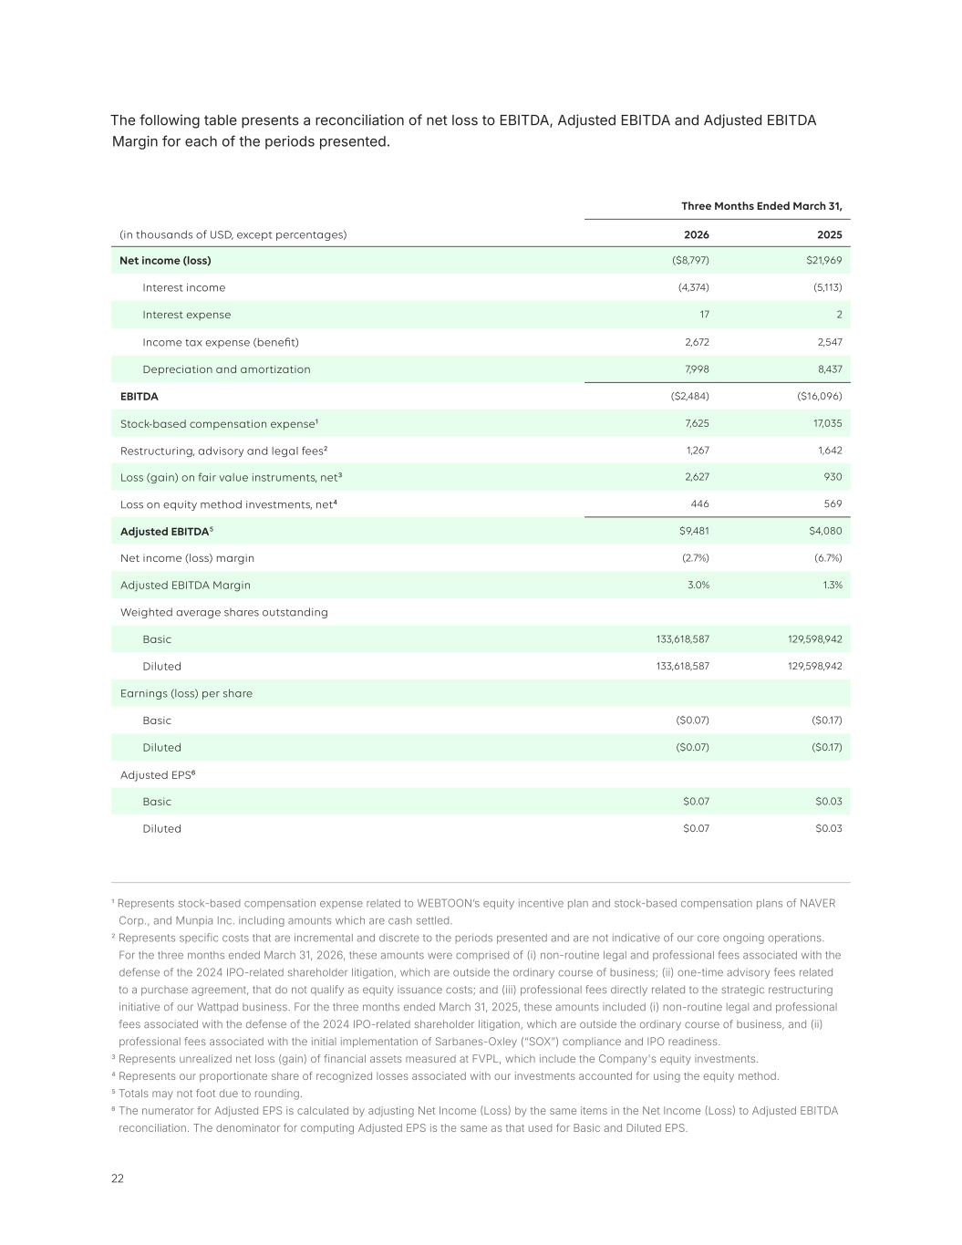
22 The following table presents a reconciliation of net loss to EBITDA, Adjusted EBITDA and Adjusted EBITDA Margin for each of the periods presented. Three Months Ended March 31, (in thousands of USD, except percentages) 2026 2025 Net income (loss) ($8,797) $21,969 Interest income (4,374) (5,113) Interest expense 17 2 Income tax expense (benefit) 2,672 2,547 Depreciation and amortization 7,998 8,437 EBITDA ($2,484) ($16,096) Stock-based compensation expense1 7,625 17,035 Restructuring, advisory and legal fees2 1,267 1,642 Loss (gain) on fair value instruments, net3 2,627 930 Loss on equity method investments, net4 446 569 Adjusted EBITDA5 $9,481 $4,080 Net income (loss) margin (2.7%) (6.7%) Adjusted EBITDA Margin 3.0% 1.3% Weighted average shares outstanding Basic 133,618,587 129,598,942 Diluted 133,618,587 129,598,942 Earnings (loss) per share Basic ($0.07) ($0.17) Diluted ($0.07) ($0.17) Adjusted EPS6 Basic $0.07 $0.03 Diluted $0.07 $0.03 1 Represents stock-based compensation expense related to WEBTOON’s equity incentive plan and stock-based compensation plans of NAVER Corp., and Munpia Inc. including amounts which are cash settled. 2 Represents specific costs that are incremental and discrete to the periods presented and are not indicative of our core ongoing operations. For the three months ended March 31, 2026, these amounts were comprised of (i) non-routine legal and professional fees associated with the defense of the 2024 IPO-related shareholder litigation, which are outside the ordinary course of business; (ii) one-time advisory fees related to a purchase agreement, that do not qualify as equity issuance costs; and (iii) professional fees directly related to the strategic restructuring initiative of our Wattpad business. For the three months ended March 31, 2025, these amounts included (i) non-routine legal and professional fees associated with the defense of the 2024 IPO-related shareholder litigation, which are outside the ordinary course of business, and (ii) professional fees associated with the initial implementation of Sarbanes-Oxley (“SOX”) compliance and IPO readiness. 3 Represents unrealized net loss (gain) of financial assets measured at FVPL, which include the Company's equity investments. 4 Represents our proportionate share of recognized losses associated with our investments accounted for using the equity method. 5 Totals may not foot due to rounding. 6 The numerator for Adjusted EPS is calculated by adjusting Net Income (Loss) by the same items in the Net Income (Loss) to Adjusted EBITDA reconciliation. The denominator for computing Adjusted EPS is the same as that used for Basic and Diluted EPS.


23

